Rt Hon Shabana Mahmood MP
Home Secretary
Home Office
2 Marsham Street
London
SW1P 4DF

08 June 2026
Ref: OPCC/MS/IOR/1132/26


Dear Home Secretary,

HMICFRS PEEL 2025-27: An inspection of Kent Police

I am pleased to provide my formal response to the above report in accordance with section 55(5) of the Police Act 1996 (as amended by section 37 of the Policing and Crime Act 2017).

The inspection assessed Kent Police’s effectiveness, efficiency, and legitimacy, with graded judgements provided in eight core areas of policing. The graded judgements were as follows:

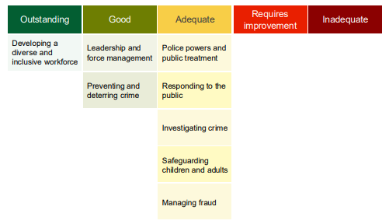

HMICFRS made a number of changes from the PEEL 2023-25 inspection programme, and acknowledge it is not possible to make direct comparisons between the grades awarded in this inspection and those from previous PEEL cycles. This reflects an enhanced focus on outcomes for the public, alongside changes to both the scope and methodology of inspection, including the introduction of new areas of assessment.

As Police and Crime Commissioner, I rely on HMICFRS inspections as an important source of independent assurance regarding the performance of the force. It is therefore reassuring to see that not a single area was graded ‘requires improvement’ or ‘inadequate’.

I am particularly encouraged that the force has been graded as ‘good’ in preventing and deterring crime, and that its leadership and management arrangements have also been assessed as ‘good’. Furthermore, it is particularly pleasing that the force has been graded ‘outstanding’ in relation to developing a diverse and inclusive workforce. This reflects Kent Police’s continued commitment to recognising its officers and staff as its most valuable asset.

HMICFRS also commended the force’s progressive approach to volunteers and special constables, acknowledging how training, support and development opportunities have helped build one of the largest and most engaged special constabularies in the country. The force has over 800 specials and volunteers who are supported in roles that match their skills and aspirations. The provision of accredited training aligned to regular officer standards enhances capability and professionalism, while contributing to improved morale and retention. It also strengthens operational effectiveness, supports engagement with communities, and delivers value for money.

Overall, the report evidences ongoing improvement in the service delivered to residents and businesses across the county. I consider HMICFRS’ assessment of Kent Police to be positive, reflecting the progress made since the previous inspection.

This progress can also be seen through the investment in neighbourhood policing, with more officers than ever providing greater visibility and accessibility within communities. In addition, the force’s performance in respect of handling 999 and 101 calls is now among the strongest nationally. Kent Police also has strong governance, continues to support and develop its workforce to an outstanding level, is making greater use of preventative orders, and has improved outcomes for victims of crime.

Notwithstanding the positive assessment and HMICFRS identifying a number of areas of innovative practice, the force also received eight Areas for Improvement (AFIs). I therefore recognise that further improvement is required, but am assured that the force is not complacent and has already taken steps to start addressing these.

I will monitor progress and hold the Chief Constable to account through my quarterly Performance and Delivery Board meetings and other established governance mechanisms. I know that all Kent Police officers and staff are committed to delivering the highest possible standard of service to the people of Kent.

A summary of the assessed areas and gradings, prepared by Kent Police, accompanies this letter.

Whilst there is still work to do, it is only right that I recognise the continued professionalism, diligence and dedication of the officers, staff and volunteers of Kent Police. I thank them for their ongoing commitment to serving the public, and for their contribution to cutting crime, supporting victims and building trust.

Finally, I would like to express my appreciation to the HMICFRS inspection team for their thorough and professional approach. I value the constructive relationship they maintain with both the force and my office.

Yours sincerely,

Matthew Scott
Kent Police and Crime Commissioner

