Chief Constable’s Report
to
Kent Police and Crime Commissioner’s Performance and Delivery Board

POLICE AND CRIME PLAN: CUT CRIME, SUPPORT VICTIMS, BUILD TRUST
Wednesday 2nd September 2026

- Strategic Overview

The Police Reform and Social Responsibility Act 2011 (Section 7) sets the statutory requirement for the Police and Crime Commissioner (PCC) to have a Police and Crime Plan. This must set out the PCC’s vision and priorities for policing and community safety, as well as the objectives and ambitions that Kent Police will be held to account on.

The Police and Crime Plan set by the Kent PCC is called ‘Cut Crime, Support Victims, Build Trust’ which has been set in consultation with the Chief Constable and the public of Kent.

The Plan complements the Kent Police Pledge set by the Chief Constable, outlining his commitments to staff, our commitment to the public and our priorities and values. At the heart of the Pledge, there is a commitment to provide a high-quality policing service that is delivered with absolute integrity, to support and protect victims, and to catch criminals and solve crime.

Furthermore, the Force has a Control Strategy which sets out the operational priorities for crime prevention, intelligence and enforcement for 2026. This has recently been updated to reflect the priority crime types for Kent Police over the coming year and how the force will tackle risk and harm. The strategy provides a clear direction to ensure the Force works towards the same core operational priorities of violence against women and girls (VAWG), serious violence and harm, exploitation and organised and acquisitive crime. Child Centred Policing remains at the very heart of the new strategy and continues to be a key consideration within each operational priority with exploitation now emphasising a clear focus on child sexual abuse.

The following sections of the report provide a detailed analysis for the most recent quarter (April 2026 – June 2026) of Kent Police performance against an agreed set of measures within the four key priorities of the Police and Crime Plan, namely, Protecting People, Protecting Places, Protecting Property and Productive Partnerships.

- PROTECTING PEOPLE

Victim Based Crime

 | Rolling Year |  |  |  |  | Latest Quarter
 | RY Jun 26 | RY Jun 25 | % change | No. change |  | Apr - Jun 26 | Apr - Jun 25 | % change | No. change
Recorded | 129560 | 136476 | -5.1% | -6916 |  | 31897 | 33321 | -4.3% | -1424
Data Source: Athena

Victim Based Crime (VBC) continues to see a downward trend, with rolling year ending June 2026 reflecting a decrease of -5.1% (-6,916) compared to the same period last year. The most recent quarter, April to June 2026, saw a decrease of -4.1% (-1,424).

While current volumes remain below the peak observed in July 2025, the rise from April to June 2026 indicates a return towards seasonal norms and highlights the need to monitor demand closely as Kent enters the busier summer period.

The most recent quarter continues to see decreases across most crime types against last year with continued reductions in Violence Against the Person, Sexual Offences and Burglary of a home. There has been a marginal increase in vehicle crime, up +2.8% (+42) and Theft offences, up +5.5% (+432).

The VBC solved rate for both rolling year and most recent quarter continues to increase. For the rolling year June 2026, the solved rate was 14.1% with 18,282 solved offences, up +1.4 from 12.7%. The most recent quarter Solved rate was 15.5% with 4,930 solved, up +1.7. The Force has seen an additional 1244 charges for the rolling year with 12,667 being administered compared to the previous year (11,423).

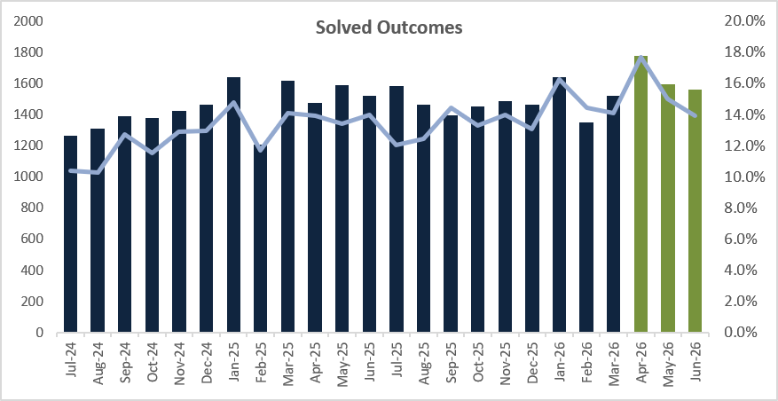
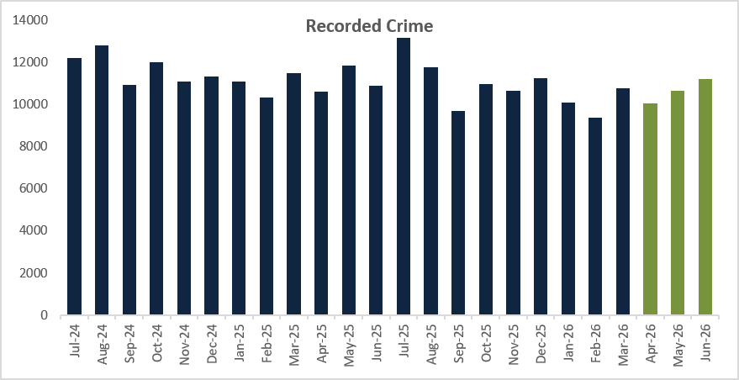

Violence Against Women and Girls (VAWG)

 | Rolling Year |  |  |  |  | Latest Quarter
 | RY Jun 26 | RY Jun 25 | % change | No. change |  | Apr - Jun 26 | Apr - Jun 25 | % change | No. change
Recorded | 33,351 | 36,036 | -7.5% | -2,685 |  | 7,858 | 8,872 | -11.4% | -1,014
Data Source: Athena

VAWG offences decreased by -7.5% (-2,685) in the rolling year ending June 2026, compared to the previous year. The most recent quarter saw an -11.4% reduction (-1,014). Both DA-related and Non-DA-related VAWG continue on a downward trend: DA-related VAWG fell by -3.1% (-580) for the rolling year and by -3.8% (-168) in the last quarter, while non-DA-related VAWG decreased by -12.3% (-2,105) for the rolling year and -19.2% (-846) for the most recent quarter.

Like VBC, there an increasing trend for the three consecutive months, where higher crime volumes are typically recorded during the warmer months and it is likely that there will be further anticipated rises as Kent enters the busier summer period.

The VAWG solved rate for the rolling year June 2026 was 10.6% with 3,539 solved offences, up +0.7 from 9.9%. The Force has seen an additional 183 charges for the rolling year with 2,535 being administered compared to the previous year (2,352). The most recent quarter solved rate was 12.3% with 968 solved, up +2.3 from 10.0% with an increase in the number of charges administered for the quarter.

There is close monitoring of victim withdrawal rates, ensuring the Force identifies barriers for victims and improves its service. For the rolling year June 2026, the victim withdrawal rate was 49.0%, with many of these cases related to DA offences. Although the victim withdrawal rate has seen a slight increase of 0.6 percentage points from 48.4%, the rate for the rolling year is stable.

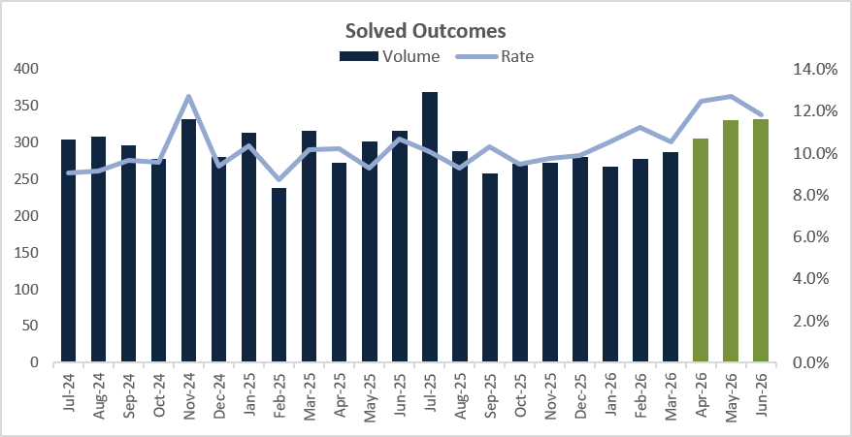
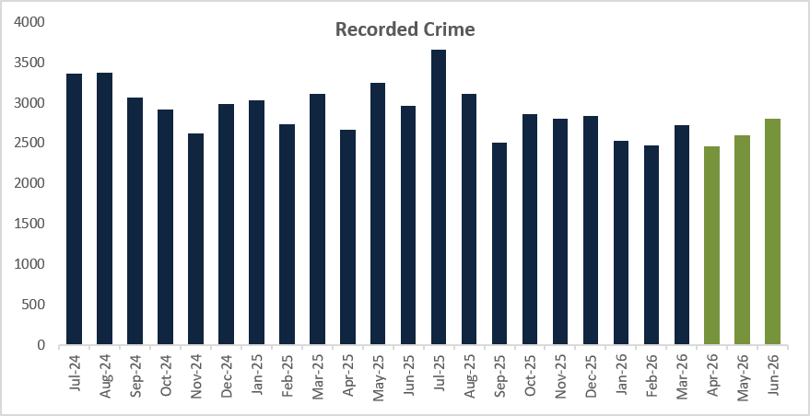

Project Vigilant
Project Vigilant gives Kent Police a practical way to identify and disrupt predatory behaviour in the night-time economy before harm occurs or escalates. The model, originally developed by Thames Valley Police (TVP), uses trained plain-clothed officers to identify concerning behaviour, with uniformed colleagues then able to intervene, safeguard and gather intelligence.
Kent Police were awarded Home Office funding along with TVP to deliver Project Vigilant in a sustained and structured way to test the efficacy of the tactics. The pilot was conducted in Maidstone following analysis of relevant offending, repeat perpetrators and night-time economy risk indicators. The tactics combined trained officer deployments, early identification of concerning behaviour, offender disruption and a local communications campaign designed to strengthen deterrence and public reassurance.
The evaluation is encouraging. Recorded sexual offences and predatory-behaviour linked offences reduced by 35.7% compared with the same period the previous year. The activity also resulted in 14 arrests, including 2 for sexual offences, alongside 43 intelligence submissions and 28 searches. This provides a positive indication of the value of the tactic, while recognising that evaluation of this type should be described carefully and not presented as proving direct causation on its own.
Importantly, over half of recorded interventions involved individuals with previous violence against women and girls, sexual or violence markers. That indicates the activity was not simply general reassurance patrol but was identifying and disrupting people already presenting elevated risk. Officers intervened in precursor behaviours including loitering, inappropriate sexualised behaviour, uninvited contact and aggression.
The associated online awareness campaign reached more than 1.5 million people, with a further July media appeal generating over 90,000 views focused on the summertime night-time economy. Further officers have been trained during 2026 and Project Vigilant continues to support Kent Police’s wider approach to VAWG, early intervention and public reassurance.
Child Criminal Exploitation (CCE)

The Force prioritises CCE through the Control Strategy. This ensures a focus on targeting offenders and effective safeguarding.

The Crime and Policing Act 2026 introduces a standalone offence for adults who intentionally cause or facilitate a child’s involvement in criminal activity. The Act also provides for CCE Prevention Orders and enables statutory guidance to support consistent implementation. Kent’s current position is therefore one of preparation and alignment, while awaiting the final operational guidance that will support use of the new provisions.

In practice, officers and staff are being directed to use professional curiosity, child risk assessment through AWARE principles, intelligence submissions and appropriate referrals, including to Children’s Services and the National Referral Mechanism where exploitation or trafficking indicators are present. This is supported by the Kent and Medway Child Exploitation Identification Tool, Force investigation and safeguarding guidance, child exploitation intelligence, Proactive Management Plans and the Home Office Child Exploitation Disruption Toolkit.

CCE remains nationally under-recorded and Kent is strengthening local insight by adding the classification to crime reports and using this to understand patterns, repeat children, suspects and hotspot areas more effectively. Partnership oversight sits through local and strategic safeguarding arrangements, including the Child Exploitation Oversight Group and the Missing and Child Exploitation Tactical Group. Current development work includes refreshed guidance on CCE, trafficking and exploitation-related recording, improved frontline communications, SPOC arrangements and CPD planned for October and November 2026. A dedicated communications plan will also raise awareness of Child Sexual Exploitation and CCE and encourage improved intelligence submissions.

Rape and Serious Sexual Offences

 | Rolling Year |  |  |  |  | Latest Quarter
 | RY Jun 26 | RY Jun 25 | % change | No. change |  | Apr - Jun 26 | Apr - Jun 25 | % change | No. change
Rape | 1852 | 1970 | -6.0% | -118 |  | 486 | 456 | 6.6% | 30
Serious sexual | 2709 | 2865 | -5.4% | -156 |  | 647 | 707 | -8.5% | -60
Data Source: Athena

The total number of Rape and Serious Sexual Offences experienced a decrease of -5.7% (-274) for the rolling year June 2026, with a decrease seen for both Serious Sexual and Rape offences. However, the most recent quarter has seen a +6.6% increase (+30) in Rape offences, whilst Serious Sexual Offences is down -8.5% (-60). The increase is mainly attributable to Rape of an adult (aged 16 and over).

The Rape Solved rate for the rolling year was 11.0%, with 203 solved offences, up +2.0 from 9.0%, The most recent quarter has also seen an increase in the solved rate, up 7.2 percentage points from 12.3% to 19.5%. Like Rape offences, the Serious Sexual Offences solved rate has increased for the rolling year, up 2.4 percentage points from 9.9% to 12.3% with 43 more solved offences.

The victim satisfaction rate for Rape has seen a marginal decrease for the rolling year June 2026, 96.1% of rape victims were satisfied with the overall service, which is down -0.9 from 97.0%. However, the most recent quarter has seen an improvement with 98.6% of rape victims satisfied compared to 95.2% for the same period last year.

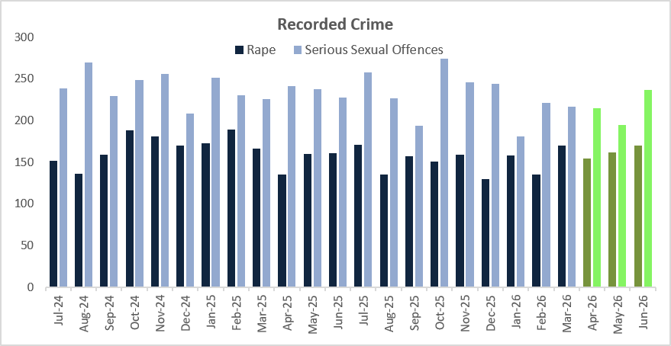

Organised Drug Facilitated Sexual Assault

Organised drug-facilitated sexual assault is a developing national threat picture and one that requires a careful, joined-up response across policing, safeguarding, health and specialist victim services. It involves the use of alcohol, drugs or medication to remove a victim’s capacity to consent, with some offending involving connected individuals, online facilitation, image sharing and victims who may have little or no immediate memory of what has happened.

National work is being led through the National Centre for Violence Against Women and Girls and Public Protection, alongside the National Crime Agency (NCA), Crown Prosecution Service (CPS), police forces and partners. Kent Police has been represented in the national working group, with the resulting guidance bringing together Authorised Professional Practice, operational learning, evidential considerations and advice on early CPS engagement and partnership working.

Kent has translated that national guidance into local investigative arrangements. Two decision pathways have been agreed for investigative ownership, covering both NCA disseminations and existing force investigations. The guidance has been embedded within the Force’s dedicated communication channels and signposted to the teams most likely to identify, investigate or support these cases.

Awareness has been directed across the Force Crime and Incident Response Command’s Learning and Development Team, Duty Managers, Patrol Sergeants, Senior Investigating Officers, Crime Scene Investigators and the Digital Forensics Unit, supported by a force-wide communication. Engagement has also taken place with the Office of the Kent Police and Crime Commissioner on links to commissioned victim and safeguarding services, and a further awareness briefing has been tasked to maintain visibility of the issue across relevant departments. At this stage there is no formal national training requirement, but the force will keep this under review as the threat picture and national guidance develop. The Rape and DA Investigation Team DCIs and Detective Superintendents are aware of the crime type and have processes in place to identify individual or organised drug-facilitated sexual assault investigations requiring urgent development.

Sharing or Threatening to Share Intimate Photograph or Film

In terms of the new offences of ‘Sharing or threatening to share intimate photograph or film’, there has been 698 reports for the rolling year June 2026, of which:
- 401 reports relate to ‘Sharing intimate photograph or film to cause alarm, distress or humiliation, or for sexual gratification’
- 179 reports relate to ‘Sending photograph etc or film of genitals’
- 118 reports relate to ‘Sharing photograph or film of person in intimate state without consent’

In addition, of those 698 reports:
- 49.0% or 342 reports are offences where both the suspect and victim are over 18
- 8.2% or 57 reports are where the suspect and victim are both under 18
- 3.9% or 27 reports are where the suspect is an adult and the victim a child
- 1.7% or 12 reports are where the suspect is a child, but the victim is an adult
- 34.2% or 239 reports are where there is no identified suspect on the report

For the new offence, the solved rate is 9.5% with 66 solved outcomes for the rolling year. 47 Charges have been administered in this period, which equates to a 6.7% Charge rate.

Domestic Abuse (DA)

 | Rolling Year |  |  |  |  | Latest Quarter
 | RY Jun 26 | RY Jun 25 | % change | No. change |  | Apr - Jun 26 | Apr - Jun 25 | % change | No. change
Recorded | 27066 | 27657 | -2.1% | -591 |  | 6274 | 6568 | -4.5% | -294
Data Source: Athena

DA continues to experience a reduction on last year with a -2.1% decrease (-591) for the rolling year June 2026, with the most recent quarter also seeing a decrease compared to last year, down -4.5% (-294). In line with VAWG offences, there is an increasing trend for the three consecutive months, where higher crime volumes are typically recorded during the warmer months and it is likely that there will be further anticipated rises as Kent enters the busier summer period.

The DA solved rate continues to increase for the rolling year June 2026 at 10.5%, up 0.9 on last year (9.6%) with 177 more solved outcomes administered. Likewise, for the most recent quarter the solved rate was 11.4%, up +1.4 from 10.0% with an additional 55 solved outcomes administered on last year.

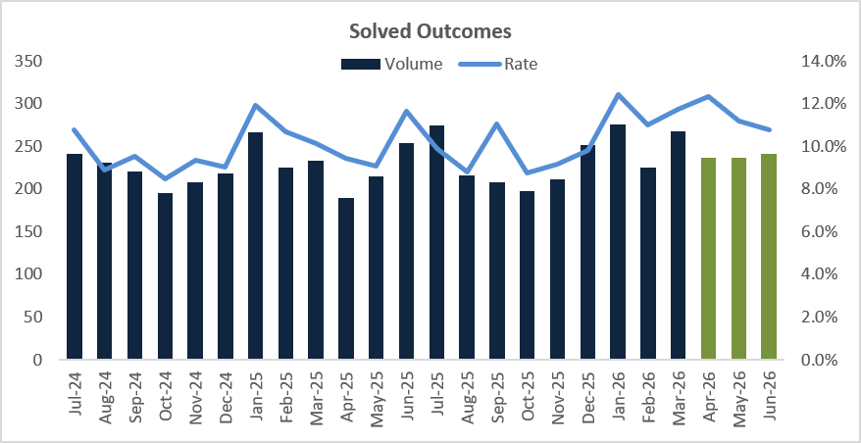
Satisfaction of DA victims has seen a small decrease for the rolling year March 2026, down -3.1 to 90.3% being satisfied with the service they received from Kent Police. For the most recent quarter, 93.0% of DA victims were satisfied overall, which is down 1.0 percentage point on last year. Despite the reduction on last year, the satisfaction rate remains stable on the previous quarter (January - March) where it was also 93.0%.
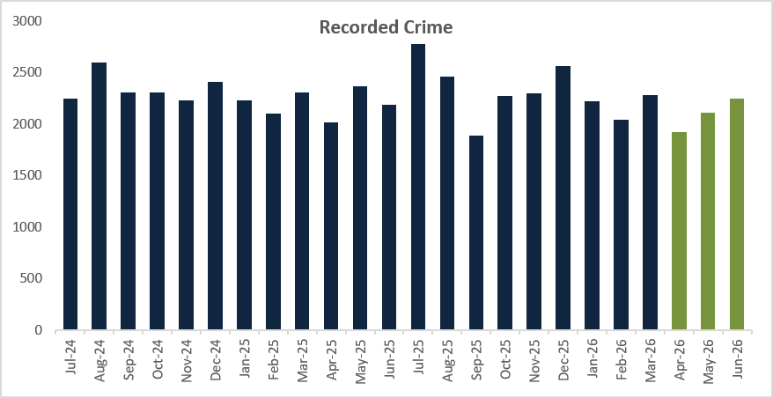

Serious Violence

 | Rolling Year |  |  |  |  | Latest Quarter
 | RY Jun 26 | RY Jun 25 | % change | No. change |  | Apr - Jun 26 | Apr - Jun 25 | % change | No. change
Recorded | 15008 | 15637 | -4.0% | -629 |  | 3679 | 3912 | -6.0% | -233
Data Source: Athena

Serious Violence is defined as Homicide and Violence with Injury offences. For the rolling year June 2026, there has been a -4.0% decrease (-629), which is also reflected for the most recent quarter down -6.0% (-233). Serious Violence has seen an increasing trend for three consecutive months, this being consistent with historical seasonal trends seen across both 2024 and 2025.

Like other crime types, although offences have seen a reduction, crimes that have been solved has seen an increase. For the rolling year June 2026, the solved rate for serious violent offences was 17.5%, up +2.1 from 16.5%, and likewise the most recent quarter saw a 19.5% solved rate, up +2.4 from 17.9%.

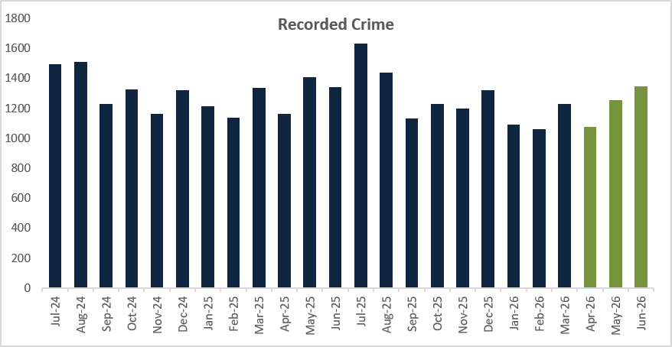

Firearms Licensing

Police Forces are required to deliver a service that is proportionate, rigorous and timely, with performance typically assessed through average turnaround times and completion rates rather than a fixed Service Level Agreement, with sector benchmarking commonly indicating expectations in the region of completion within approximately four months for standard cases, subject to demand, vetting complexity and risk considerations.

In respect of comparative performance, the turnaround time and application completion rate is stable against the rolling 18-month average performance. The 5 yearly cycles of renewals are currently at their lowest with the peak anticipated next year. Measures are in place to mitigate the known demand which include investment in new technology and revised processes.

Nationally, based on the College of Policing published figures in June 2026 taken from the National Firearms Licensing Management System (NFLMS) Kent is the 4th largest FLD in England and Wales with 18,179 certificate holders, first amongst comparable forces for grants and renewals completed within 4 months, achieving a completion rate of 92.38% and is ranked 8th across all police forces, England and Wales.

Knife Crime

There are currently technical issues in relation to the Home Office National Data Quality Improvement Service (NDQIS) system which is being investigated and once resolved, updated performance data will be reported upon.

- PROTECTING PLACES

Calls for Service

 | Rolling Year |  |  |  |  | Latest Quarter
 | RY Jun 26 | RY Jun 25 | % change | No. change |  | Apr - Jun 26 | Apr - Jun 25 | % change | No. change
999 Call Volume | 378,704 | 364,510 | 3.9% | 14194 |  | 100,372 | 94,551 | 6.2% | 5821
999 Call Attrition | 0.47% | 0.44% | 0.03 |  |  | 0.44% | 0.45% | -0.11
101 Call Volume | 245,540 | 255,779 | -4.0% | -10239 |  | 63,202 | 67,434 | -6.3% | -4232
101 Call Attrition | 3.89% | 2.97% | 0.39 |  |  | 5.64% | 3.51% | 0.39
Digital Contact volume | 266,599 | 258,468 | 3.1% | 8131 |  | 66,248 | 66,647 | -0.6% | -399
Total Calls for Service | 890,843 | 878,757 | 1.4% | 12086 |  | 211,971 | 210,695 | 0.6% | 1276
Data Source: Openscape

For the rolling year June 2026, there was a +1.4% increase in Calls for Service, with 12,086 more incidents compared to the previous year. The number of 999 calls also rose by +3.9%, equating to 14,194 additional calls, which led to a slight rise in call attrition - up by +0.39 percentage points. Digital contact continues to see an upward trend, as more members of the public chose to report issues online, through Live Chat, or via Single Online Home. This type of contact increased by +3.1%, adding 8,131 more interactions than the previous year.
For the most recent quarter, the Force experienced a +6.2% increase in 999 calls (+5,821), whilst Digital contact and 101 calls decreased. Digital contact decreased by -0.6% (-399) and 101 calls reduced by -6.3% (-4,232). The increase for the most recent quarter is as expected as we are reaching towards seasonal norms as Kent enters the busier summer period.

In June, only 14 forces exceeding the BCP of 90% of 999s answered in 10 seconds or under, with Kent being at 91.3%. Kent have been above 90% consistently every month since January 2024, exceeding the National target. Performance has improved in July, with BCP at 92.5% (3rd Nationally).

Although attrition rates for 101 are not published, the recent PEEL inspections show that this also remains a national problem. In June we were 5th nationally regarding the speed in which we answer 101s with an average of 40 seconds and for every month of data provided since this has been measured, Kent is top quartile. For the rolling year, our 101 attrition is 3.93%.

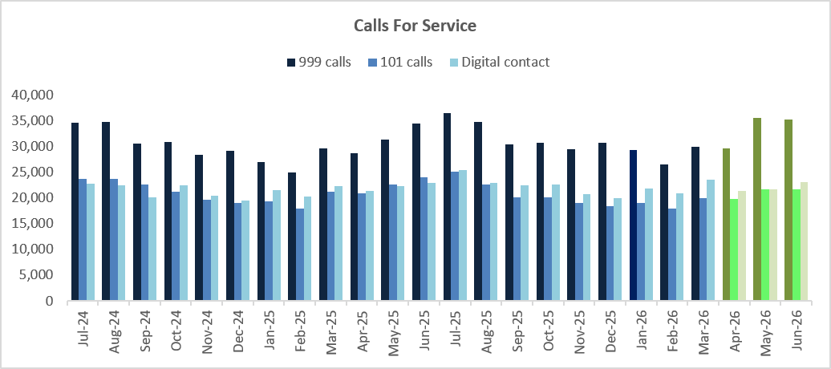

Response Times

 | Rolling Year |  |  |  |  | Latest Quarter
 | RY Jun 26 | RY Jun 25 | % change | No. change |  | Apr - Jun 26 | Apr - Jun 25 | % change | No. change
Incident Volume | 85,070 | 91,503 | -7.0% | -6,433 |  | 19,058 | 23,261 | -18.1% | -4203
Attended in 20 Mins | 56,209 | 49,424 | 13.7% | 6,785 |  | 14,037 | 13,862 | 1.3% | 175
% Attended in 20 Minutes | 66.1% | 54.0% | 12.1 |  |  | 73.7% | 59.6% | 12.6
Median Attendance Time | 00:15:31 | 00:18:44 | -00:03:13 |  |  | 00:14:00 | 00:17:14 | -00:03:14

For the rolling year June 2026, there has been an +13.7% increase in Emergency incidents being attended within 20 minutes, with the median average time to get to a call being 15 minutes 31 seconds, down 3 minutes 13 seconds compared to last year. Similarly, the most recent quarter has seen an increase (+1.3%, +175) and the median average time to attend a call being 14 minutes.

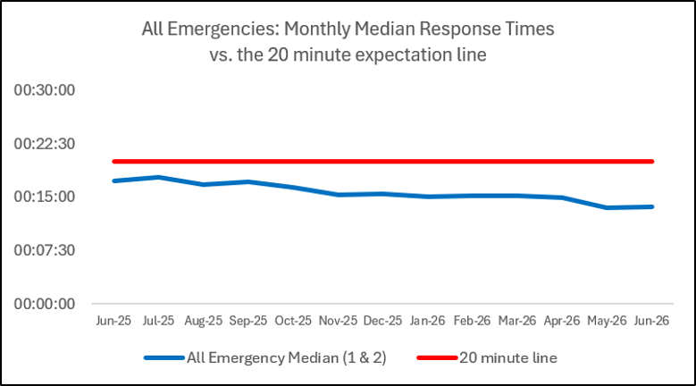

For priority calls, the following data is provided based on the rolling year to June 26 and the most recent quarter only.

Priority | RY Jun 26 | Apr -Jun 26
Incident volume | 16248 | 4634
Attended in one hour | 9398 | 3653
% attended in one hour | 58% | 79%
Median Attendance Time | 00:57:07 | 00:33:26

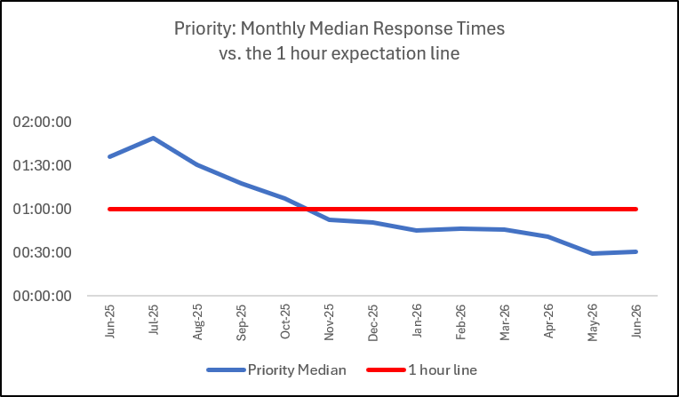

Anti-Social Behaviour

 | Rolling Year |  |  |  |  | Latest Quarter
 | RY Jun 26 | RY Jun 25 | % change | No. change |  | Apr - Jun 26 | Apr – Jun 25 | % change | No. change
Total ASB | 34760 | 27712 | 25.4% | 7048 |  | 9984 | 8340 | 19.7% | 1644
Data Source: STORM Command and Control

There has been a +25.4% increase (+7,048) for the rolling year June 2026, whilst the most recent quarter has seen a +19.7% increase (+1,644) on last year. This is likely in part due to a change in recording practices in June 2025, and with not being able to cross refer, the Force is unable to see what an actual increase is because of the new recording process. Month on month increases from January are in line with seasonal trends and it is likely that there will be further anticipated rises as Kent enters the busier summer period.

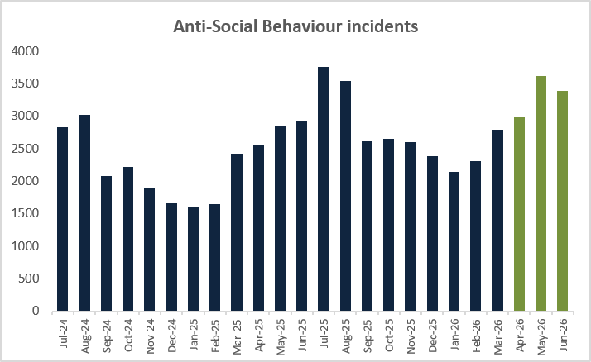

Anti-Social Behaviour (ASB) Awareness Week (29th June to 5th July) saw officers and partners across Kent take targeted action to address the issues causing the greatest concern to local communities, including:

- nuisance vehicles
- youth-related disorder
- street drinking
- shoplifting
- drug activity
- repeat ASB

The week combined visible patrols, enforcement, prevention work and engagement with residents, businesses, schools and local partners.

In the West of the county, activity in Maidstone, Tonbridge and Malling focused on key hotspot locations, with officers engaging communities, working with partners and taking enforcement action. Outcomes included 15 stop searches, nuisance bikes and e-bikes seized, one suspected Class A drug dealer arrested and remanded, cocaine and more than £1,000 cash recovered, with prevention inputs delivered in schools.

In the East of the county, teams in Ashford, Canterbury, Dover, Folkestone and Thanet used patrols, dispersal powers, alcohol seizures, school engagement and partner activity to respond to nuisance vehicles, youth ASB, street drinking and coastal demand. Outcomes included arrests, bike and e-scooter seizures, reduced ASB calls in key locations and continued public updates through ‘My Community Voice’.

In the North of the county, Gravesham, Dartford, Swale and Medway delivered a coordinated response focused on enforcement, engagement and problem solving. Outcomes included at least 14 arrests, 24 stop searches, 119 vehicle or item seized, traffic offences dealt with, Public Spaces Protection Order (PSPO) fines, youth interventions and action to address street racing.

Overall, the week demonstrated the value of visible policing, partnership working and listening to local communities. Activity across Kent helped disrupt harmful behaviour, support vulnerable people and provide reassurance in the areas most affected by ASB.

Activity to Tackle Illegal E-Scooter and E-Bike Use

Kent Police has continued to tackle illegal and anti-social use of e-scooters, modified e-bikes and off-road bikes through a combination of enforcement, education, intelligence gathering, partnership activity and public messaging. During this reporting period, activity focused on:

- hotspot patrols and plain-clothes deployments
- vehicle seizures
- PSPO enforcement
- stop searches
- CCTV and body-worn video review
- school engagement
- retailer visits
- My Community Voice surveys
- follow-up communications to local communities.

In the West of the county, Maidstone Community Safety Unit (CSU) used police bikes, high-visibility patrols, plain-clothes operations and partnership work with Immigration Enforcement, CCTV, Maidstone Borough Council and One Maidstone to deliver a variety of outcomes. Since January 2025, West Division has seized 95 e-scooters and several illegal e-bikes. Wider outcomes included arrests, stop searches, and drug recoveries. A tagging system for legitimate delivery riders is also helping officers distinguish lawful riders from those using unlawful or modified bikes.

In the East of the county, Dover delivered a day of action combining public legality messaging, school and youth engagement, retailer visits, Port of Dover Police intelligence and patrols in areas raised by the community. Two e-scooters or clocked e-bikes were seized and riders issued with Traffic Offence Reports. In Ashford, e-scooter and e-bike enforcement formed part of wider nuisance vehicle problem solving.

Activity in North Kent was directed by community intelligence and local problem solving. In Swanscombe, a day of action followed ‘My Community Voice’ feedback identifying off-road bikes and e-scooters as a top three public priority, resulting in five arrests, 12 stop searches, seven e-scooters seized and six Traffic Offence Reports. Gravesham used plain-clothes PCSOs, Special Constables, Roads Safety officers, Immigration Enforcement and Road Traffic resources across several operations, seizing e-scooters, e-bikes, off-road bikes, stolen motorbikes and nuisance vehicles. Swale deployments led to the arrest of a prolific offender, further vehicle seizures and traffic reports. A Medway operation also resulted in two arrests, 23 e-scooters and seven off-road bikes seized.

Overall, the activity demonstrates a consistent countywide approach combining community engagement, information sharing, partnership working and targeted enforcement. Reports from the public, surveys and partner intelligence helped identify the locations causing greatest concern, enabling officers and partners to respond with education, reassurance and enforcement. The work has removed illegal vehicles from public spaces, disrupted linked offending and supported longer-term problem solving. E-scooter seizures increased from 265 in 2024/25 to 450 in 2025/26, with preventative orders, traffic reports and continued targeting contributing to sustained impact.

Rural Crime

There is no set national definition of rural crime however it may encompass a broad range of offences occurring in non-urban areas, including agricultural theft, livestock rustling, fly-tipping, and wildlife crimes. It is a term used to describe criminal activities and ASB that specifically impact rural communities. Kent Police have been able to define rural wards, and as such the data below is now based on all non-DA related offences committed in rural wards, therefore differing from previous reports.

 | Rolling Year |  |  |  |  | Latest Quarter
 | RY Jun 26 | RY Jun 25 | % change | No. change |  | Apr - Jun 26 | Apr – Jun 25 | % change | No. change
Recorded | 20888 | 22160 | -5.7% | -1272 |  | 5156 | 5596 | -7.9% | -440
Data Source: Athena

For the rolling year June 2026, there has been a -5.7% (-1272) decrease in crimes reported in rural communities compared to the previous year. Acquisitive crimes (Burglary and Vehicle offences) continue to see reductions, as has Violent Crime and Criminal Damage. Theft has seen an increase, attributable to Shoplifting.

The most recent quarter has also seen a decrease, down -7.9% (-440) compared to last year. However, there have been increases in Theft offences and Vehicle Crime for the three-months’ period, up +15.8% (+149) and +18.3% (+59) respectively. The increase in Vehicle Crime is mainly attributable to Theft from Motor Vehicle and vehicle interference offences.

For the rolling year June 2026, the solved rate for Rural Crime was 13.9%, up +2.0 percentage points on last year (11.9%) with 270 more solved outcomes administered. The most recent quarter has also seen an increase in solved rate, up +2.4 from 12.2% to 14.6% with 69 more solved outcomes administered.

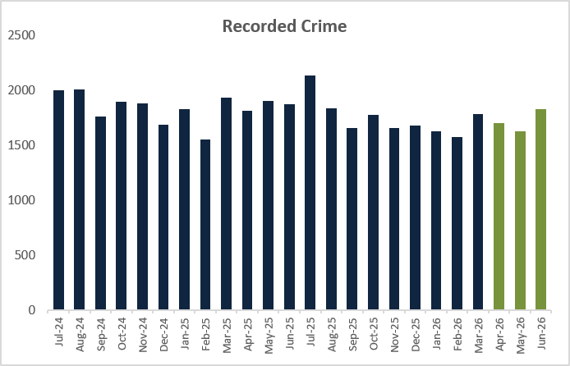

The table below illustrates the offence breakdown of non-DA related offences committed in rural communities in the period.

Road Danger/Vision Zero

 | Rolling Year |  |  |  |  | Latest Quarter
 | RY Jun 26 | RY Jun 25 | % change | No. change |  | Apr - Jun 26 | Apr – Jun 25 | % change | No. change
Killed or seriously injured volume | 73 | 46 | 58.7% | 27 |  | 16 | 11 | 45.5% | 5
Data Source: CRASH National Reporting system

The number Killed or Seriously Injured (KSI) on Kent roads has seen an increase for the rolling year June 2026, up +58.7% (+27). The most recent quarter has seen an increase, up +45.5% (+5), the volume is, however, lower than the previous two quarters. There were 6 KSIs recorded in June 2026, with 5 in both April and May 2026.

Fatal collisions in the reporting quarter included:
- A228 Boyle Way on Wednesday 1st April involving a tipper truck and a pony and trap
- Near Snipeshill on Lower Road, Teynham on Saturday 25th April involving a motorcycle and a van
- M2 between junctions 2 and 3 on Saturday 25th April involving a single motorcycle
- Headcorn Road, Staplehurst on Thursday 11th June involving a single car
- London Road, Ditton on Saturday 13th June involving a single car.

- PROTECTING PROPERTY

Residential Burglary of a Home

 | Rolling Year |  |  |  |  | Latest Quarter
 | RY Jun 26 | RY Jun 25 | % change | No. change |  | Apr – Jun 26 | Apr – Jun 25 | % change | No. change
Recorded | 2283 | 2440 | -6.4% | -157 |  | 496 | 555 | -10.6% | -59
Attendance Rate | 98.0% | 98.7% | -5.2 |  |  | 98.4% | 98.9% | -20.0
Data Source: Athena

Residential burglary of a home has seen a -6.4% decrease (-157) for the rolling year June 2026. Likewise, the most recent quarter has also seen a reduction, down -10.6% (-59). The average monthly volume for the most recent quarter is the lowest since the change to the Home Office Counting Rules in April 2023. The rolling year average has also fallen compared to the previous year.

The solved rate for the rolling year June 2026 was 8.5%, an increase of +0.9 on the previous year (7.6%), with 7 more solved outcomes on the previous year. However, the most recent quarter saw a solved rate of 8.5%, down -1.6 percentage points on last year (10.1%), with 14 less solved outcomes being administered.

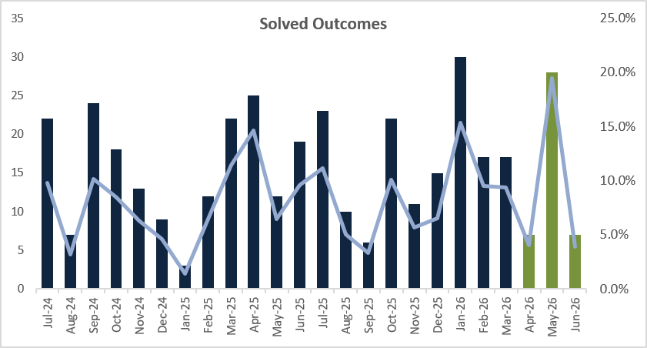
Attendance at Residential burglary sits at 98.0% for the rolling year and 98.4% for the most recent quarter, both marginal decreases on the previous year. For the rolling year there were 46 not attended, and for the most recent quarter 8 not attended. It should however be noted that there may be specific reasons for why these burglaries were not attended.
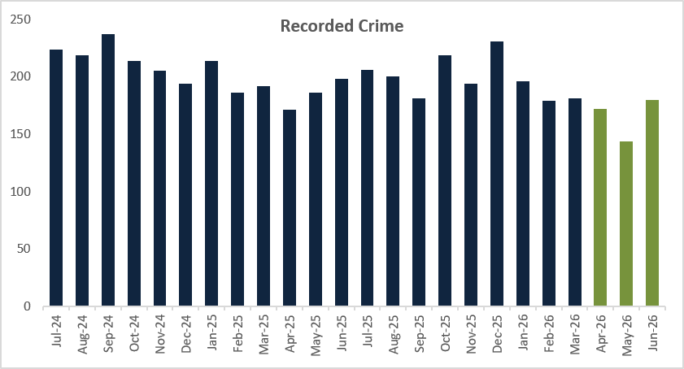
Retail Crime

 | Rolling Year |  |  |  |  | Latest Quarter
 | RY Jun 26 | RY Jun 25 | % change | No. change |  | Apr – Jun 26 | Apr – Jun 25 | % change | No. change
Shoplifting | 17151 | 17091 | +0.4% | +60 |  | 4626 | 4407 | +5.0% | +219
Business Robbery | 753 | 234 | +221.8% | +519 |  | 204 | 188 | +8.5% | +16
Data Source: Athena

Shoplifting offences have increased by +0.4% (+60) for the rolling year June 2026, with the most recent quarter also increasing by +5.0% (+219) compared to the same period last year. This follows two consecutive quarterly reductions in shoplifting. Each month in the most recent quarter is above the comparative month from last year.

The Solved rate for Shoplifting offences has increased by +4.3 from 32.1% to 36.4% for the rolling year and is up +4.4 from 33.3% to 37.7% for the most recent quarter. 1246 charges and 433 community resolutions were administered for the three-months’ period.

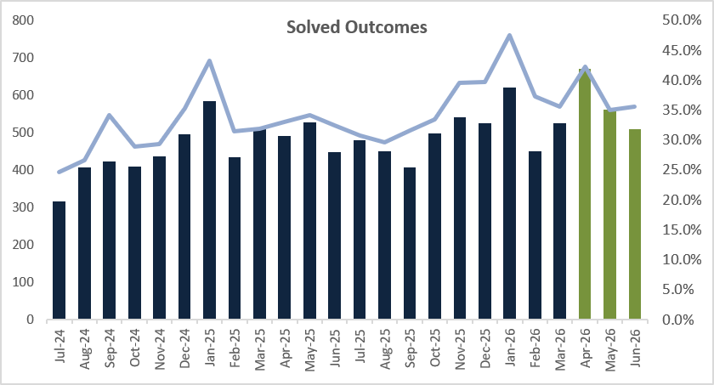
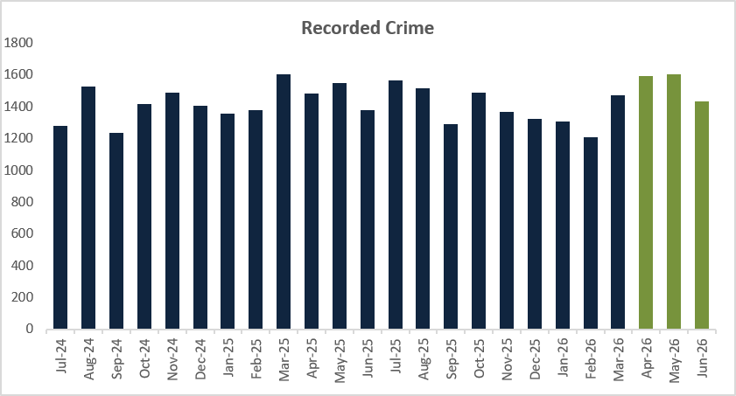

Following the definition change for Business Robbery in the Home Office Counting Rules in April 2025, figures are now comparable for the most recent quarter whilst the rolling year still shows a large increase. The volume of Business Robbery offences increased by 519 for the rolling year. The most recent quarter has increased by +8.5% (+16), mostly attributable to the low volumes experienced in April 2025 when the definition was first amended.

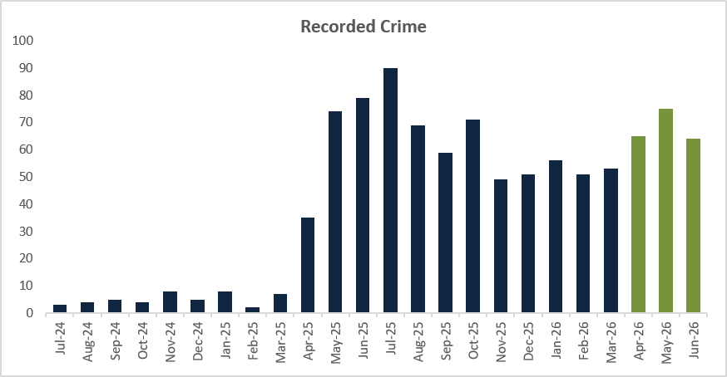

Vehicle Crime

 | Rolling Year |  |  |  |  | Latest Quarter
 | RY Jun 26 | RY Jun 25 | % change | No. change |  | Apr - Jun 26 | Apr – Jun 25 | % change | No. change
TOMV | 3378 | 3709 | -8.9% | -331 |  | 837 | 807 | +3.7% | +30
TFMV | 2939 | 3390 | -13.3% | -451 |  | 686 | 674 | +1.8% | +12
Vehicle Crime | 6317 | 7099 | -11% | -782 |  | 1523 | 1481 | +2.8% | +42
Data Source: Athena

Overall Vehicle Crime has seen an -11.0% decrease (-782) for the rolling year, with both Theft of Motor Vehicle and Theft from Motor Vehicle continuing to see reductions for the rolling year. However, the most recent quarter for overall Vehicle Crime has seen a marginal increase of +2.8% (+42). This is attributable to marginal increases in both TOMV offences (+3.7%, +30) and TFMV offences (+1.8%, +12).

With the continued reduction in recorded offences, the solved rate for Vehicle Crime also sees a decrease with less reports being solved. The solved rate for the rolling year June 2026 was 3.8%, down -0.8 percentage points on last year. The most recent quarter also decreased from 5.3% to 5.0%, down -0.3 percentage points. Theft of Motor Vehicle follows the same trend seeing decreases for both rolling year and the most recent quarter, whilst Theft from Motor Vehicle saw a marginal increase for the most recent quarter, up +1.7 percentage points from 2.1% to 3.8%.
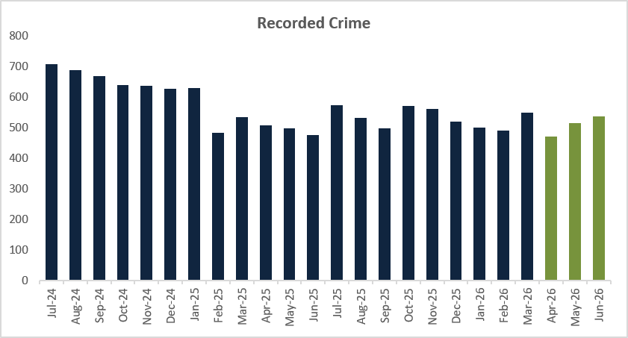
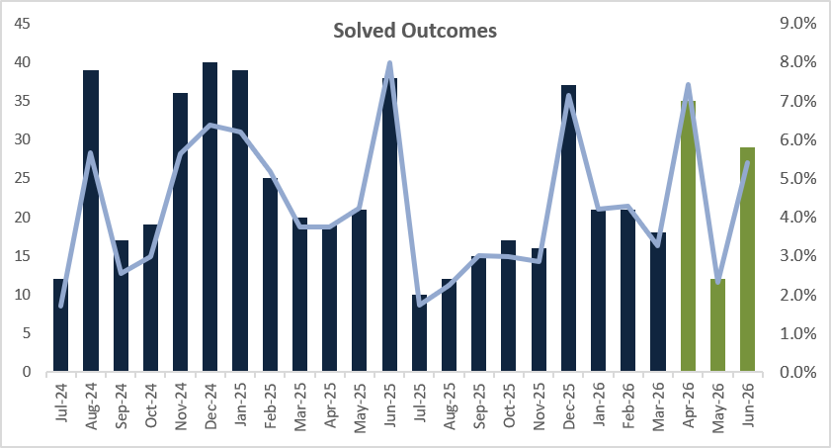
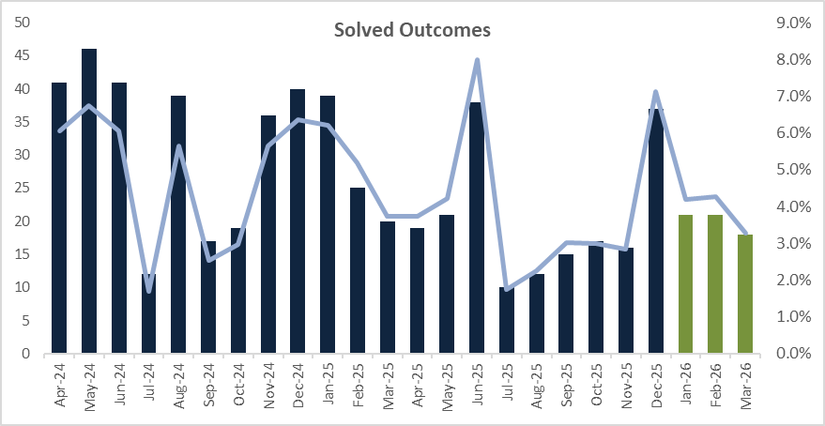
Personal Robbery

 | Rolling Year |  |  |  |  | Latest Quarter
 | RY Jun 26 | RY Jun 25 | % change | No. change |  | Apr - Jun 26 | Apr – Jun 25 | % change | No. change
Recorded | 749 | 833 | -10.1% | -84 |  | 198 | 209 | -5.3% | -11
Data Source: Athena

For the rolling year June 2026, Personal Robbery has decreased by -10.1% (-84) compared to last year. The most recent quarter has also seen a decrease, at -5.3% (-11).

The Solved rate has also experienced a decrease, down -4.7 percentage points from 15.8% to 11.1% for the rolling year. There have been 49 less solved outcomes administered compared to last year. The most recent quarter solved rate has also decreased on last year, down -1.8 percentage points from 12.9% to 11.0%, there have been 5 less solved outcomes administered in this quarter.

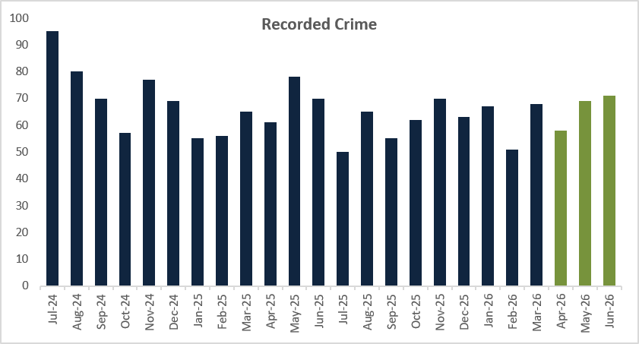

Online Related Offences

 | Rolling Year |  |  |  |  | Latest Quarter
 | RY Jun 26 | RY Jun 25 | % change | No. change |  | Apr - Jun 26 | Apr – Jun 25 | % change | No. change
Recorded | 12613 | 12080 | 4.4% | 533 |  | 3002 | 3226 | -6.9% | -224
Data Source: Athena

Recorded offences with an online marker have seen an increase of +4.4% (+533) for the rolling year and a -6.9% decrease (-224) for the most recent quarter.

For the most recent quarter, the top five offences where the online marker was applied were:
- Harassment – 805 offences, which include putting people in fear of violence.
- Obscene Publications – 446 offences; this is mainly to take or make or distribute indecent photographs of children.
- Blackmail – 358 offences.
- Stalking offences – 346 offences, which include pursue course of conduct in breach of Section 1.
- Malicious Communications – 283 offences, which include sending communication threatening death or serious harm.

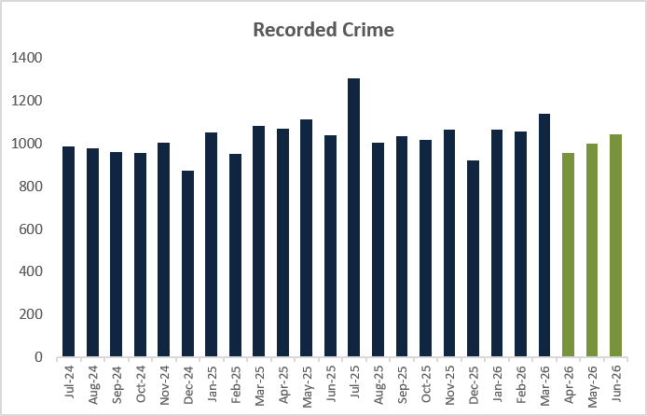

- PRODUCTIVE PARTNERSHIPS

Mental Health

 | Rolling Year |  |  |  |  | Latest Quarter
 | RY Jun 26 | RY Jun 25 | % change | No. change |  | Apr - Jun 26 | Apr – Jun 25 | % change | No. change
Section.136 Detentions | 763 | 708 | 7.8% | 55 |  | 179 | 185 | -3.2% | -6
Concern for Welfare incidents | 39795 | 38462 | 3.5% | 1333 |  | 10708 | 10149 | 5.5% | 559
Concern for Welfare incidents resourced | 20460 | 20932 | -2.3% | -472 |  | 5258 | 5600 | -6.1% | -342
Misper/ Absconder (Care or Hospital) incidents | 12603 | 13154 | -4.2% | -551 |  | 3468 | 3508 | -1.1% | -40
Misper/ Absconder (Care or Hospital) incidents resourced | 9046 | 8899 | 1.7% | 147 |  | 2544 | 2310 | 10.1% | 234

For the rolling year June 2026, Section 136 detentions have seen an increase of +7.8% (+55) compared to last year, which is mainly attributed to the higher volumes recorded in the summer months (June to August). Despite the rolling year increase, the most recent quarter has seen a reduction of -3.2% (-6).

Concern for Welfare incidents have seen an increase in total incidents for the rolling year June 2026 and the most recent quarter is up +3.5% (+1,333), with the latest quarter up +5.5% (+559). However, resourced incidents have seen a reduction for both the rolling year and the most recent quarter. The rolling year is down -2.3% (-472) and the latest quarter is down -6.1% (-342).

The total number of Missing Person / Absconder (Care or Hospital) incidents have decreased for the rolling year June 2026, down -4.2% with 551 less incidents compared to last year. Despite the reduction, officers were resourced to more Missing Person/Absconder incidents, up +1.7% (+147). Like the rolling year, the most recent quarter has seen a decrease in total incidents, down -1.1% (-40) whilst those resourced is up +10.1% (+234).

Hate Crime

 | Rolling Year |  |  |  |  | Latest Quarter
 | RY Jun 26 | RY Jun 25 | % change | No. change |  | Apr - Jun 26 | Apr – Jun 25 | % change | No. change
Recorded | 3530 | 3753 | -5.9% | -223 |  | 829 | 970 | -14.5% |  | -141
Non-Crime | 1056 | 857 | +23.2% | +199 |  | 303 | 265 | +14.3% |  | +38
Total Incidents | 4586 | 4610 | -0.5% | -24 |  | 1132 | 1235 | -8.3% |  | -103

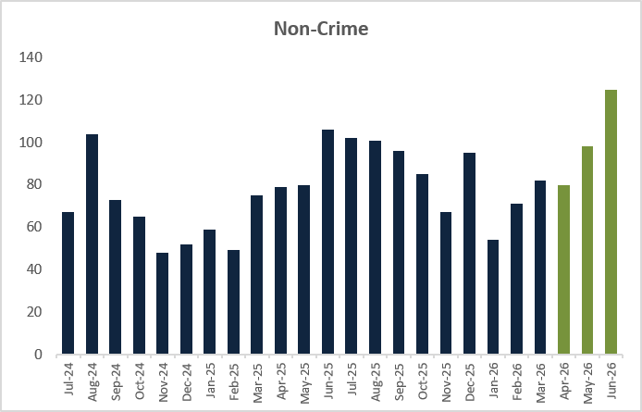
For the rolling year to June 2026, there has been a minimal decrease in the total Hate Crime incidents at -0.5% (-24) which is also reflected in the most recent quarter, at -8.3% (-103). This is attributable to reductions in recorded crime with non-crime incidents seeing an increase for both periods. This indicates that changes from the Home Office relating to recording of Non-Crime Hate Incidents has not had an impact on recording within Kent. Both recorded and non-crime incidents see peaks over the summer months and as such it is likely that there will be further increases as Kent enters the busier summer period.
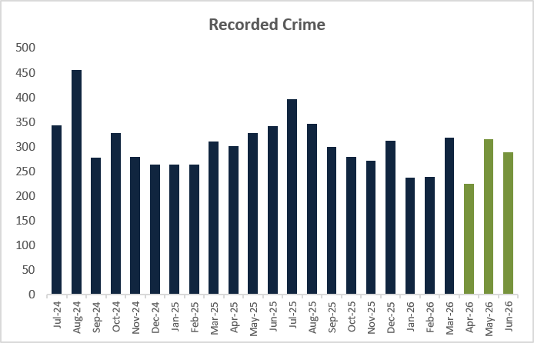
CONCLUSION

In summary, the Force’s Pledge and updated Control Strategy are aligned to work in harmony with the PCC’s Police and Crime Plan for the next two years. As demonstrated in this paper for this reporting period, the Force continues to deliver positive outcomes for victims against an increasingly demanding, complex, and challenging policing landscape. However, the Force is not complacent and absolutely recognises the need to continuously improve and develop, to ensure the trust, confidence and safety of all those who live, work and visit Kent.

