Chief Constable’s Report
to
Kent Police and Crime Commissioner’s Performance and Delivery Board

POLICE AND CRIME PLAN: CUT CRIME, SUPPORT VICTIMS, BUILD TRUST
Wednesday 4th June 2026

- Strategic Overview

The Police Reform and Social Responsibility Act 2011 (Section 7) set the statutory requirement for the Police and Crime Commissioner (PCC) to have a Police and Crime Plan. This must set out the PCC’s vision and priorities for policing and community safety, as well as the objectives and ambitions that Kent Police will be held to account on.

The Police and Crime Plan set by the Kent PCC is called ‘Cut Crime, Support Victims, Build Trust’ which has been set in consultation with the Chief Constable and the public of Kent.

The Plan complements the Kent Police Pledge set by the Chief Constable, outlining his commitments to staff, our commitment to the public and our priorities and values. At the heart of the Pledge, there is a commitment to provide a high-quality policing service that is delivered with absolute integrity, to support and protect victims, and to catch criminals and solve crime.

Furthermore, the Force has a Control Strategy which sets out the operational priorities for crime prevention, intelligence and enforcement for 2025. The key crime types of focus for 2025 are aligned to the refreshed Police and Crime Plan, with a particular focus on violence against women and girls (VAWG), serious violence and harm, organised crime and exploitation.

Nationally, Kent Police is also committed to ensuring delivery against Government set direction and priorities within the ‘Strategic Policing Requirement’ and the ‘Safer Streets Mission’ (Appendix A), for which the PCC is also obligated to report on to the Home Office in the Annual Assurance Statement.

The following sections of the report provide a detailed analysis for the most recent quarter (January 2026 – March 2026) of Kent Police performance against an agreed set of measures within the four key priorities of the Police and Crime Plan, namely, Protecting People, Protecting Places, Protecting Property and Productive Partnerships.

- PROTECTING PEOPLE

Victim Based Crime

 | Rolling Year |  |  |  |  | Latest Quarter
 | RY Mar 26 | RY Mar 25 | % change | Number change |  | Jan - Mar 26 | Jan – Mar 25 | % change | Number change
Recorded crime | 130984 | 139060 | -5.8% | -8076 |  | 30241 | 32896 | -8.1% | -2655
Data Source: Athena

Victim Based Crime maintained its downward trajectory, with rolling year ending March 2026 reflecting a decrease of 5.8% (-8,076) compared to the same period last year. The most recent quarter, January to March 2026, saw a decrease of -8.1% (-2,655). After three consecutive months of a decreasing trend, the number of offences in March rose slightly to 10,778. This figure remains consistent with the average recorded in preceding months.

The most recent quarter continues to see decreases across most crime types against last year with continued reductions in Vehicle Crime, Violence Against the Person, Burglary of a home and Shoplifting. As with the last report, increases continue for Robbery (+79.3%, +153), attributable to the increase in Business Robbery. Criminal Damage has also seen a marginal increase for the three month period, up +0.5% with 22 more offences.

The Victim Based Crime solved rate for both the rolling year and the most recent quarter continues to increase. For the rolling year March 2026, the solved rate was 13.7% with 17,936 solved offences, up +1.3 from 12.4%. In the most recent quarter, the solved rate was 14.9% with 4,507 solved, up +1.3. The force has seen an additional 800 charges for the rolling year with 12,286 being administered compared to the previous year (11,486).

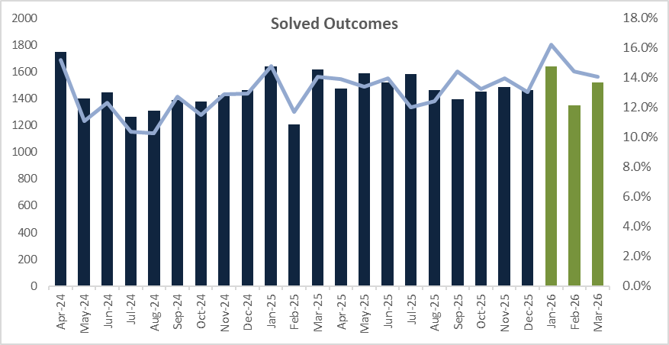
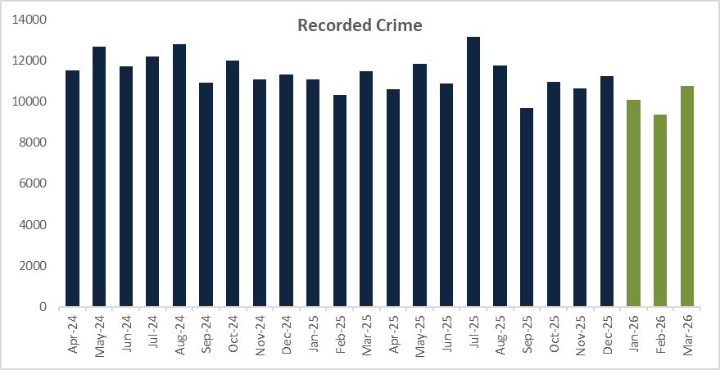

Violence Against Women and Girls (VAWG)

 | Rolling Year |  |  |  |  | Latest Quarter
 | RY Mar 26 | RY Mar 25 | % change | Number change |  | Jan - Mar 26 | Jan – Mar 25 | % change | Number change
Recorded crime | 34,365 | 36,711 | -6.4% | -2,346 |  | 7,731 | 8,865 | -12.8% | -1,134
Data Source: Athena

VAWG offences decreased by -6.4% (-2,346) in the rolling year ending March 2026, compared to the previous year. The most recent quarter saw a -12.8% reduction (-1,134). Both Domestic Abuse (DA)-related VAWG and Non-DA-related VAWG showed decreases: DA-related VAWG fell by -3.9% (-747) for the rolling year and -5.8% (-274) in the last quarter, while Non-DA-related VAWG decreased by -9.2% (-1,599) for the rolling year and -20.7% (-860) for the most recent quarter.

The VAWG solved rate for the rolling year March 2026 was 10.1% with 3,460 solved offences, up +0.3 from 9.8%. The force has seen an additional 21 charges for the rolling year with 2,390 being administered compared to the previous year (2,369). The most recent quarter solved rate was 10.8% with 832 solved, up +1.0 from 9.8% with an increase in the number of charges administered for the quarter.

There are several offences in which victims withdraw or do not support police action after making a report. For the rolling year March 2026, the victim withdrawal rate was 48.4%, with many of these cases related to DA offences. Although this figure remains high, it represents a decrease of 0.42 percentage points from 48.6%, indicating that more victims are now willing to support prosecution.
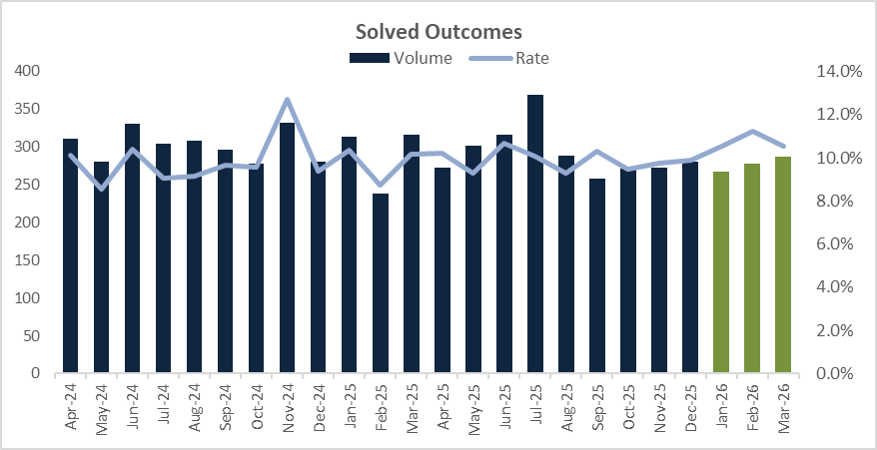
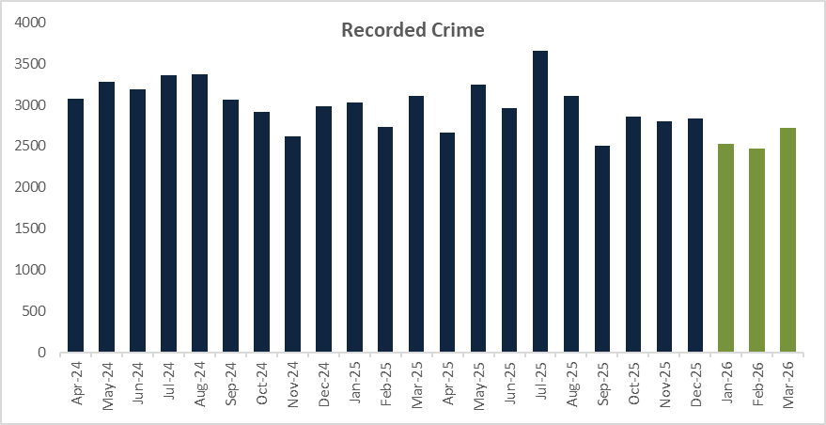

Rape and Serious Sexual Offences

 | Rolling Year |  |  |  |  | Latest Quarter
 | RY Mar 26 | RY Mar 25 | % change | Number change |  | Jan - Mar 26 | Jan – Mar 25 | % change | Number change
Rape | 1822 | 1990 | -8.4% | -168 |  | 463 | 528 | -12.3% | -65
Serious Sexual | 2769 | 2881 | -3.9% | -112 |  | 619 | 707 | -12.4% | -88
Data Source: Athena

The total number of Rape and Serious Sexual Assault offences experienced a decrease of -5.7% (-280) for the rolling year March 2026, with a decrease seen for both. The most recent quarter has also seen reductions for both offences as well.

The Rape solved rate for the rolling year was 9.0%, down -0.8 (9.8%), and there has been a decrease in the number of solved outcomes, falling -15.9% (-31). Due to the small volumes and the investigation length of Rape, it should be noted that fluctuations may occur. Despite a reduction for the rolling year, the most recent quarter solved rate has increased from 8.0% to 8.9%.

The victim satisfaction rate for Rape has seen a marginal decrease. For the rolling year, 95.2% of rape victims were satisfied with the overall service, which is down -1.0 from 96.2%. The most recent quarter has also seen a decrease with 95.7% of victims satisfied with the service received, down -2.9 from 98.6%.

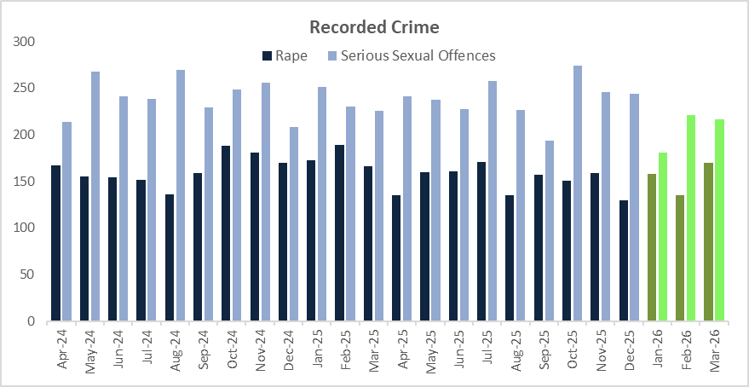

In terms of the new offences of ‘Sharing or threatening to share intimate photograph or film’, for the rolling year March 2026 there has been 661 reports, of which:
- 377 reports relate to ‘Sharing intimate photograph or film to cause alarm, distress or humiliation, or for sexual gratification’
- 169 reports relate to ‘Sending photograph etc or film of genitals’
- 114 reports relate to ‘Share photograph or film of person in intimate state without consent’

In addition,
- 49.4% (327) of reports are offences where both the suspect and victim are over 18.
- 8.7% (58) of reports are where the suspect and victim are both under 18.
- 3.5% (23) of reports are where the suspect is an adult and the victim a child.
- 1.2% (8) of reports are where the suspect is a child, but the victim is an adult.
- 36.2% (239) of reports are where there is no identified suspect on the report.

For the new offences, the solved rate is 8.8% with 58 solved outcomes for the rolling year. 41 Charges have been administered in this period, which equates to a 6.2% Charge rate.

Domestic Abuse

 | Rolling Year |  |  |  |  | Latest Quarter
 | RY Mar 26 | RY Mar 25 | % change | Number change |  | Jan - Mar 26 | Jan – Mar 25 | % change | Number change
Recorded crime | 27360 | 28129 | -2.7% | -769 |  | 6538 | 6636 | -1.5% | -98
Data Source: Athena

DA continues to experience a reduction on last year with a -2.7% decrease (-769) for the rolling year March 2026, with the most recent quarter also seeing a decrease compared to last year, down -1.5% (-98). The monthly volumes for this quarter are consistent with the average recorded in preceding months following the high month in December 25.

The DA solved rate continues to increase; for the rolling year March 2026 it was 10.2%, up 0.7 on last year (9.5%) with 110 more solved outcomes administered. Likewise for the most recent quarter, the solved rate was 11.7%, up +0.8 from 10.9% with an additional 44 solved outcomes administered on last year.

The victim satisfaction rate for DA has seen a small decrease for the rolling year March 2026, down -3.1 to 90.3% of victims being satisfied with the service they received from Kent Police. The most recent quarter has also seen a decrease on the previous year, down -2.9 percentage points from 95.9% to 93.0%, although it is down on last year, the satisfaction rate has improved on the previous quarter (October – December) where it was 89.6%.

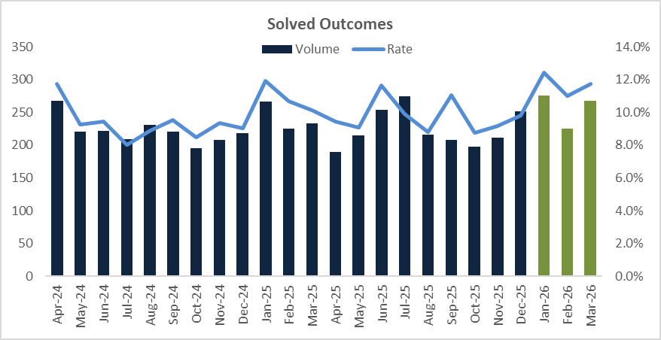
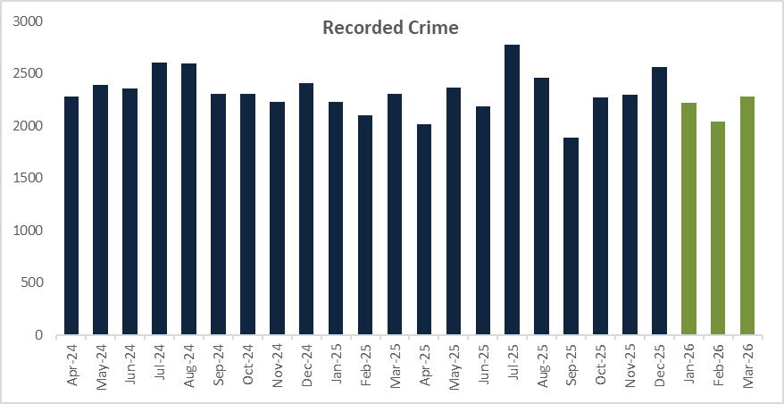

Serious Violence

 | Rolling Year |  |  |  |  | Latest Quarter
 | RY Mar 26 | RY Mar 25 | % change | Number change |  | Jan - Mar 26 | Jan – Mar 25 | % change | Number change
Recorded crime | 15241 | 15910 | -4.2% | -669 |  | 3383 | 3684 | -8.2% | -301
Data Source: Athena

Serious violence is defined as Homicide and Violence with Injury offences. For the rolling year March 2026, there has been a -4.2% decrease (-669), which is also reflected for the most recent quarter down -8.2% (-301), with the months of January and February recording two of the lowest months of the 12 month period.

Similar to other crime types, although offences have seen a reduction, crimes that have been solved have seen an increase. For the rolling year March 2026, the solved rate for serious violent offences was 17.2%, up +2.1 from 15.9%, likewise the most recent quarter saw an 18.0% solved rate, up +2.4 from 17.1%.

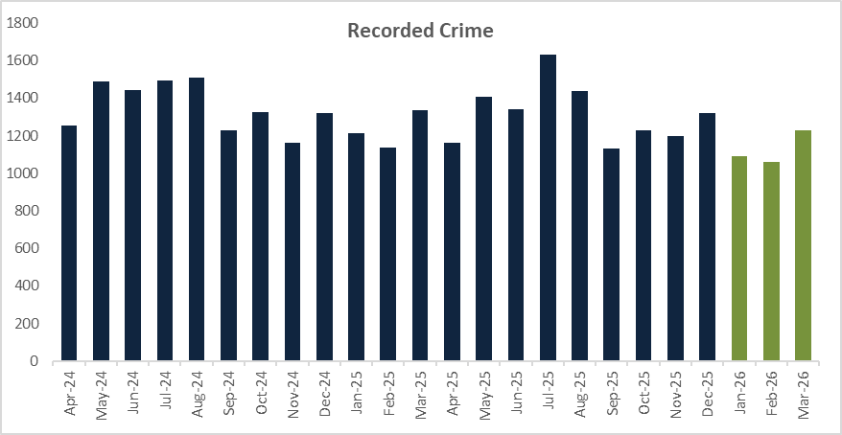

Knife Crime

 | Rolling Year |  |  |  |  | Latest Quarter
 | RY Mar 26 | RY Mar 25 | % change | Number change |  | Jan - Mar 26 | Jan – Mar 25 | % change | Number change
Recorded crime | 883 | 867 | 1.8% | 16 |  | 219 | 228 | -3.9% | -9
Data Source: Home Office published data

For the rolling year March 2026, offences involving a knife or sharp instrument has seen an increase of +1.8% with 16 more offences compared to last year. However, the most recent quarter is seeing a reduction, down -3.9% (-9) on last year. A reduction in Assault with Injury offences where a knife was used, contributed to the reduction for the quarter.
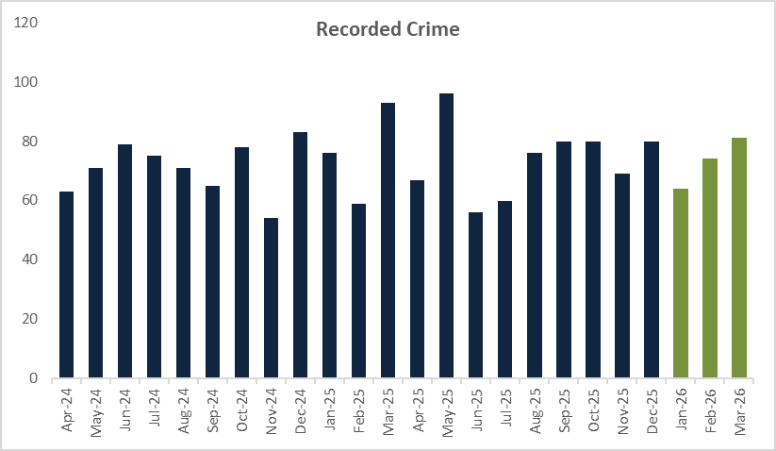

Improving Outcomes for Victims

The Force has been recently recognised by the HMICFRS in the PEEL 2025-27 Assessment for consistently achieving appropriate outcomes for victims, showing “meaningful and sustained improvement” in positive outcome rates for victims of crime over the past two years. This included evidence of high investigative standards, with structures and practices in place to ensure investigators have a suspect-focused, victim centred and context-led approach.

One such way that the Force has applied enhanced investment to supporting the improvement of outcomes is within the dedicated Victim and Witness Care Unit (VWCU).

The VWCU is a dedicated single point of contact as cases enter the Criminal Justice System, providing hearing dates, case progression updates and key decisions throughout the court process. Assistance is provided to complete a Victim Personal Statement, and advice is given on compensation, special measures and practical arrangements to attend trial. Signposting and referrals to partner services are also undertaken, and regular case progression meetings take place to resolve issues ahead of trial. The unit has introduced improvements to strengthen victim and witness support, including:
- An Online Needs Assessment which can be completed online or with a Victim and Witness Care Officer if preferred.
- Therapy dogs at court, in partnership with Citizens in Policing.
- Restorative justice - automatic referrals for some offence types, with the victim’s agreement, to widen access to support.
- Multi-agency MS Teams channel to resolve live issues when cases are at court and reduce adjournments.
- Work with the CPS South East Victim Transformation Programme, including a joint escalation route to resolve issues affecting victims and witnesses.

National Criminal Justice System pressures have a direct impact on victims and on the VWCU’s ability to manage workload and provide consistent support. The pressures on Courts to manage outstanding cases, with increases in receipts being received, have resulted in delays to trials being heard, with some listed several years ahead. For the last financial year, cases were being heard out of Kent, which placed some additional pressures on VWCU to manage and co-ordinate the changes this meant for victims and witnesses. Trial adjournments cause significant trial listings drive re-work and uncertainty; adjournments require repeat preparation and updates. In order to reduce the impact upon victims and witnesses in this regard, Kent Police is undertaking a range of actions, including (but not limited to):
- Additional capacity: investment in five additional Victim and Witness Care Officers for the past two financial years, with funding confirmed again for the 2026/27 financial year.
- Robotic Process Automation (in final design development) to reduce administrative burden and refocus time on victim support.
- Empowering Leadership and Reducing Bureaucracy Programme to remove working practices, where appropriate.
- Participation in the Home Office Review of Witness Care Units to influence and inform national recommendations.
- Virtual Remand Hearings: pilot delivery in two custody suites in Kent, reducing court time for these cases and freeing capacity for trials.

Despite the ongoing challenges, recent recognition for the VWCU include:
- Winner: NPCC/College of Policing National Police Staff Team of the Year Award 2025.
- Nominated: Chief Constable’s Annual Awards Organisational Team of the Year 2025.
- Ongoing feedback from victims, including letters of thanks, describing clear and supportive guidance throughout the court process.

- PROTECTING PLACES

Calls for Service

 | Rolling Year |  |  |  |  | Latest Quarter
 | RY Mar 26 | RY Mar 25 | % change | Number change |  | Jan - Mar 26 | Jan – Mar 25 | % change | Number change
999 call volume | 372,883 | 363,396 | 2.6% | 9487 |  | 85,781 | 81,610 | 5.1% | 4171
999 Call Attrition | 0.47% | 0.44% | 0.03 |  |  | 0.45% | 0.56% | -0.11
101 call volume | 249,772 | 255,824 | -2.4% | -6052 |  | 56,795 | 58,511 | -2.9% | -1716
101 Call Attrition | 3.34% | 2.95% | 0.39 |  |  | 2.47% | 2.08% | 0.39
Digital Contact volume | 266,998 | 254,839 | 4.8% | 12159 |  | 66,182 | 64,091 | 3.3% | 2091
Total Calls for Service | 889,653 | 874,059 | 1.8% | 15,594 |  | 208,758 | 204,212 | 2.2% | 4546
Data Source: Openscape

For the rolling year March 2026, there was a +1.8% increase in Calls for Service, with 15,594 more incidents compared to the previous year. The number of 999 calls also rose by +2.6%, equating to 9,487 additional calls, which led to a slight rise in call attrition - up by +0.03 percentage points. Digital contact continues to see an upward trend, as more members of the public chose to report issues online, through Live Chat or via Single Online Home. This type of contact increased by +4.8%, adding 12,159 more interactions than the previous year.
For the most recent quarter, the force experienced a +5.1% increase in 999 calls (+4,171) compared to the same period last year. Digital contact similarly grew by +3.3% (+2,091) for the quarter. Meanwhile, 101 calls decreased by -2.9%, with 1,716 fewer calls during the quarter.
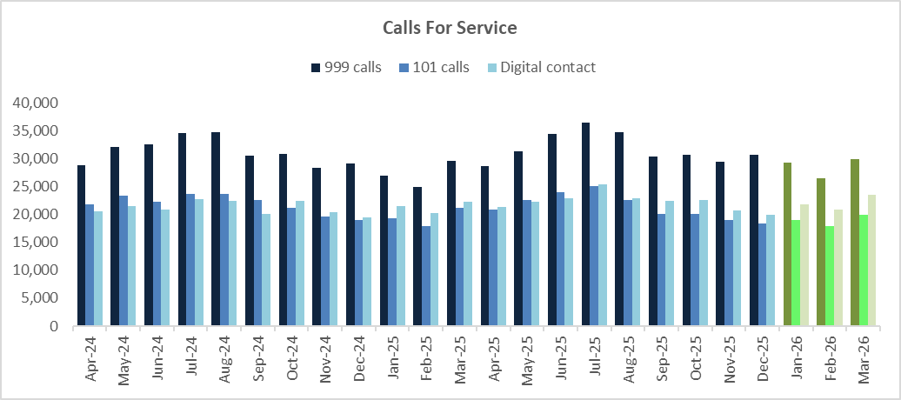

Response Times

All Emergencies | Rolling Year |  |  |  |  | Latest Quarter
All Emergencies | RY Mar 26 | RY Mar 25 | Change | Number change |  | Jan - Mar 26 | Jan - Mar 25 | Change | Number change
Incident Volume | 89,187 | 91,590 | -2.6% | -2,403 |  | 20,020 | 20,680 | -3.2% | -660
Attended in 20 Mins | 55,977 | 47,143 | 18.7% | 8,834 |  | 13,628 | 11,470 | 18.8% | 2158
% Attended in 20 Minutes | 62.8% | 51.5% | 11.3 |  |  | 68.10% | 55.50% | 12.6
Median Attendance Time | 00:16:21 | 00:19:30 | -00:03:09 |  |  | 00:15:08 | 00:18:17 | -00:03:09

For the rolling year March 2026, there has been an +18.7% increase in Emergency incidents being attended within 20 minutes, with the median average time to get to a call being 16 minutes 21 seconds, down 3 minutes 9 seconds compared to last year. Similarly, the most recent quarter has seen an increase (+18.8%, +2158) and the median average time to get to a call being 15 minutes 8 seconds.
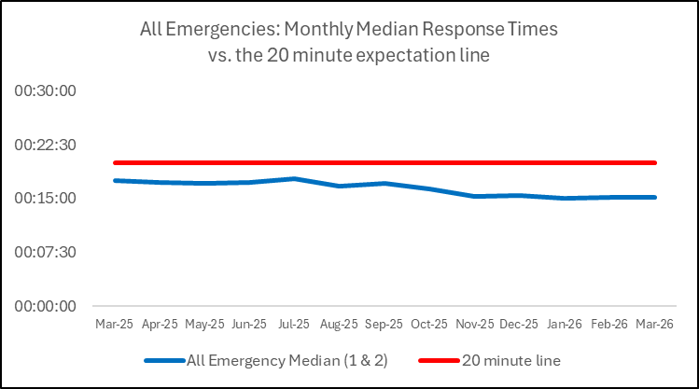

For priority calls, it is not possible to provide a comparison to last year due to a process change in the Force Crime and Incident Response command to the grading of priority calls. Therefore data provided will be based on the rolling year March 2026 and the most recent quarter only.

Priority | RY Mar 26 | Jan-Mar 26
Incident volume | 16869 | 3225
Attended in one hour | 7865 | 1965
% attended in one hour | 47% | 61%
Median Attendance Time | 01:10:41 | 00:45:52

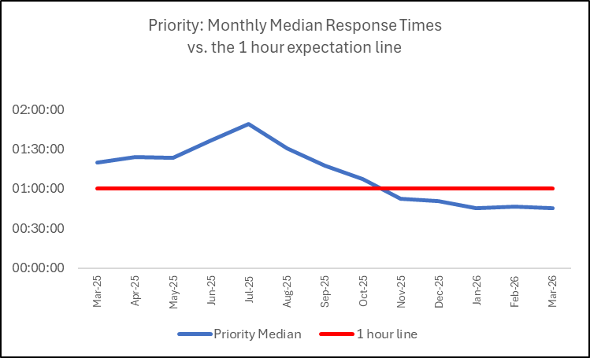

Anti-Social Behaviour

 | Rolling Year |  |  |  |  | Latest Quarter
 | RY Mar 26 | RY Mar 25 | % change | Number change |  | Jan - Mar 26 | Jan – Mar 25 | % change | Number change
Total ASB | 33116 | 27131 | 22.1% | 5985 |  | 7236 | 5657 | 27.9% | 1579
Data Source: STORM Command and Control

There has been a +22.1% increase (+5,985) for the rolling year March 2026, whilst the most recent quarter has seen a +27.9% increase (+1,579) on last year. This is likely attributable in part to a change in recording practices in June 2025 inhibiting the ability to cross refer data. However, month on month increases from January are in line with seasonal trends.

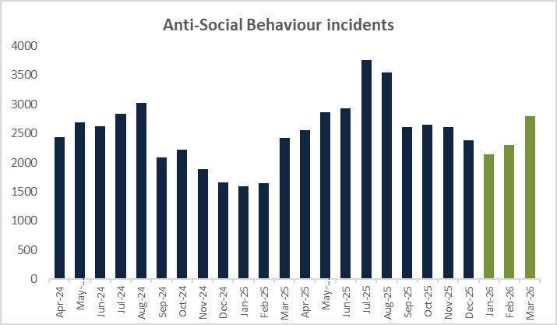

Rural Crime

There is currently no set national definition of rural crime however may encompass a broad range of offences occurring in non-urban areas, including agricultural theft, livestock rustling, fly-tipping, and wildlife crimes. It is a term used to describe criminal activities and ASB that specifically impact rural communities. Kent Police have been able to define rural wards, and as such, the data below is now based on all non-DA related offences committed in those wards, meaning the data will differ from previous reports.

 | Rolling Year |  |  |  |  | Latest Quarter
 | RY Mar 26 | RY Mar 25 | % change | Number change |  | Jan - Mar 26 | Jan – Mar 25 | % change | Number change
Recorded crime | 21342 | 22697 | -6.0% | -1355 |  | 4994 | 5316 | -6.1% | -322
Data Source: Athena

For the rolling year March 2026, there has been a -6.0% (-1355) decrease in crimes reported in rural communities compared to the previous year. Acquisitive crimes (Burglary and Vehicle offences) continue to see reductions, as has Theft, Violent Crime and Criminal Damage.
The most recent quarter has also seen a decrease, down -6.1% (-322) compared to last year. However, there have been marginal increases in Theft offences and Vehicle Crime for the three month period; up +1.2% (+11) and up +7.2% (+29) respectively. The increase in Vehicle Crime is mainly attributable to Theft from Motor Vehicle and Vehicle Interference offences.

For the rolling year March 2026, the solved rate for rural crime was 13.4%, up +1.6 percentage points on last year (11.8%) with 182 more solved outcomes administered. The most recent quarter has also seen an increase in the solved rate, up +2.0 from 13.2% to 15.2% with 60 more solved outcomes administered.

The table below illustrates the offence breakdown of non-DA related offences committed in rural communities in the reporting period.

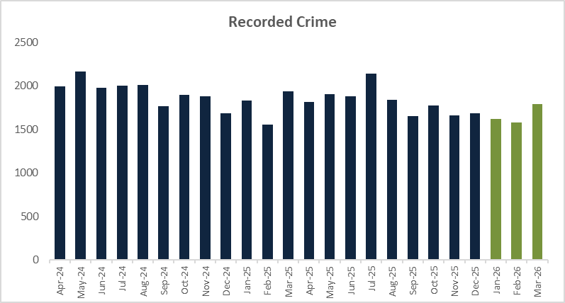

Road Danger/Vision Zero

 | Rolling Year |  |  |  |  | Latest Quarter
 | RY Mar 26 | RY Mar 25 | % change | Number change |  | Jan - Mar 26 | Jan – Mar 25 | % change | Number change
Killed or seriously injured volume | 68 | 56 | 21.4% | 12 |  | 25 | 15 | 66.7% | 10
Data Source: CRASH National Reporting system

The number killed or seriously injured (KSI) on Kent roads has seen an increase for the rolling year March 2026, up +21.4% (+12). The most recent quarter has seen an increase, up +66.7% (+10), with 13 KSIs recorded in January 2026 - the highest volume of the 12 month period and the highest volume since May 2024. There were also 5 in February and 7 in March. Fatal collisions in this quarter included:
- Old Ferry Road, Iwade on Saturday 3rd January involving a single car
- London bound M2 near junction 5 on Sunday 4th January involving a car and motorcycle
- High Street, Herne Bay on Friday 9th January involving a car and motorcycle
- Newington Road, Ramsgate on Friday 9th January involving a single car
- A2070 Ashford Road, Hamstreet near Ashford on Tuesday 13th January involving a tanker and car
- Coastbound M2 near Medway Services on Thursday 15th January involving a single car
- A249 Northbound in Sheppey on Friday 30th January involving 2 cars
- Swale Way, Kemsley on Wednesday 25th February involving a car and lorry

The below table demonstrates the ‘Fatal 4’ enforcement activity for the relevant reporting period. During this time, the Road Safety Unit had multiple joint operations across the county including Gravesend, Folkestone, Margate and Medway. They also supported the Archbishop’s enthronement at Canterbury Cathedral. From 26th January 2026 to 8th February 2026, the Force undertook a Commercial Vehicle Campaign which included stopping in excess of 100 vehicles from both the UK and the EU.

2026 | Speed | Mobile Phone/ Distraction | Seatbelt | Impairment Arrests
January | 5929 | 83 | 98 | 308
February | 5086 | 116 | 132 | 261
March | 6921 | 89 | 104 | 313
NB: Some of the data above is incomplete due to the time it takes to process the offences.

Visible Policing

As per the Kent Police Pledge, the Force is committed to ensuring officers are accessible and visible within communities, enabling engagement and a focus on the issues that matter most to local people. This work is centred on Neighbourhood Policing, with clear local ownership for problem-solving, and working closely with communities and partners. The Force’s operating policing model ensures officers work in clearly defined wards, enabling them to be visible and responsive to local issues, and building strong knowledge of the communities they serve. Every community in Kent is supported by a team of Neighbourhood Officers, focused on prevention, problem-solving and engagement. The key features include:

- A named, dedicated Beat Officer for every ward, providing clear local ownership and consistent local officer visibility.
- Regular foot patrols and engagement in neighbourhoods and town centres.
- Close working with councils, partners, residents and businesses.
- Published details of forthcoming meeting attendance and engagement opportunity.
- Two-way engagement with communities through the use of My Community Voice (MCV), conducting surveys to identify the issues that matter most in their area and providing hyperlocal updates direct to residents on activity undertaken to address them.
- Residents are actively encouraged to view the priorities for their area and engage with their local officers online via the Kent Police website, where they can also view regular updates on local policing activity. This reinforces neighbourhood policing visibility beyond physical patrols and improves public accessibility.

Kent Police has invested in additional Neighbourhood Officers, with 65 new frontline Neighbourhood Policing posts delivered across the county since April 2025. These officers remain in visible, community-focused roles, increasing day-to-day police presence and engagement opportunities. This additional capacity allows officers more time to patrol neighbourhoods and town centres, engage directly with communities, and prevent crime and ASB before issues escalate.

Neighbourhood Task Forces operate in every District, targeting hotspots and persistent problems. Dedicated town centre coverage ensures regular, visible patrols in high footfall areas and night-time economy locations, the targeting of repeat offenders and partnership working in order to provide reassurance and confidence both to the public as well as businesses experiencing persistent antisocial behaviour or retail crime.

Specialist officers, including ASB Teams, Child Centred Policing Teams, Licensing Teams, and Designing Out Crime Officers work alongside local officers focusing on tackling ASB, youth engagement, prevention and deterrence work ensuring local officers are routinely present in neighbourhoods and town centres and, wherever possible, not abstracted into reactive demand.

All of this work is in line with the national Neighbourhood Policing Guarantee, and in addition to this, the Force is making targeted use of a dedicated Digital Content Creator to showcase neighbourhood policing activity across the county. Short-form videos focused specifically on neighbourhood policing have been produced and shared across the Force’s Facebook, Instagram, X, YouTube, LinkedIn and Nextdoor channels, generating an estimated 3.1 million views overall. Content has ranged from enforcement action and court outcomes to proactive community engagement and reassurance activity, helping residents see their local officers at work. Individual videos achieved particularly high reach, including footage of a nuisance driver imprisoned in Sheppey (860,000+ views) and body-worn video tackling ASB in Thanet (780,000+ views). This approach has significantly amplified the profile of neighbourhood policing, reinforced ‘you said, we did’ messaging, and demonstrated Kent Police’s commitment to being visible, accessible and responsive to community concerns.

Ahead of the forthcoming summer period, the Force has undertaken early planning to ensure neighbourhood policing remains highly visible, accessible and focused on community reassurance during what is traditionally a period of increased demand. This planning brings together operational activity, engagement and communications from the outset, with a clear emphasis on proactive town centre presence, consistent community contact and early use of preventative powers where required. Digital and face-to-face visibility have been built into planning assumptions, including the use of hyper-local messaging, scheduled engagement opportunities and early coordination with communications leads, to ensure residents can clearly see and understand the work of their local policing teams as activity scales up over the summer months.

- PROTECTING PROPERTY

Residential Burglary of a Home

 | Rolling Year |  |  |  |  | Latest Quarter
 | RY Mar 26 | RY Mar 25 | % change | Number change |  | Jan - Mar 26 | Jan – Mar 25 | % change | Number change
Recorded crime | 2342 | 2571 | -8.9% | -229 |  | 556 | 592 | -6.1% | -36
Attendance Rate | 98.1% | 98.9% | -0.7 |  |  | 97.0% | 98.0% | -0.7
Data Source: Athena

Residential Burglary of a home has seen an -8.9% decrease (-229) for the rolling year March 2026, likewise the most recent quarter has also seen a reduction, down -6.4% (-36). Following the high number recorded in December 2025, the monthly volumes for this quarter remain consistent with the average recorded in preceding months.

The solved rate for the rolling year March 2026 was 8.8%, a decrease of -0.5 on the previous year (9.3%), with 31 less solved outcomes on the previous year. However, the most recent quarter saw a solved rate of 11.5%, up +5.2 percentage points on last year (6.3%), with an additional 27 solved outcomes being administered.

Attendance at Residential Burglary reports sits at 98.1% for the rolling year and 97.0% for the most recent quarter, both minimal decreases on the previous year. For the rolling year, there were 44 not attended, and for the most recent quarter 17 not attended. It should however be noted that there may be specific reasons for why these burglaries were not attended.

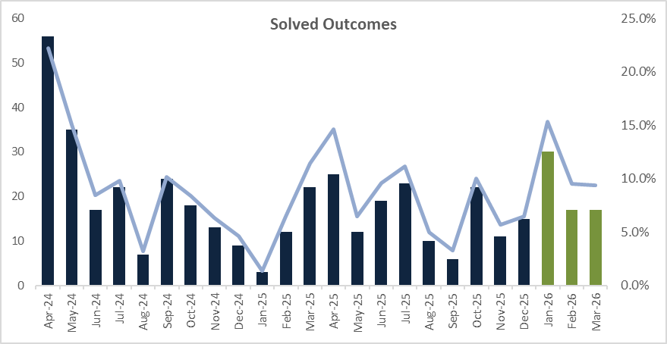
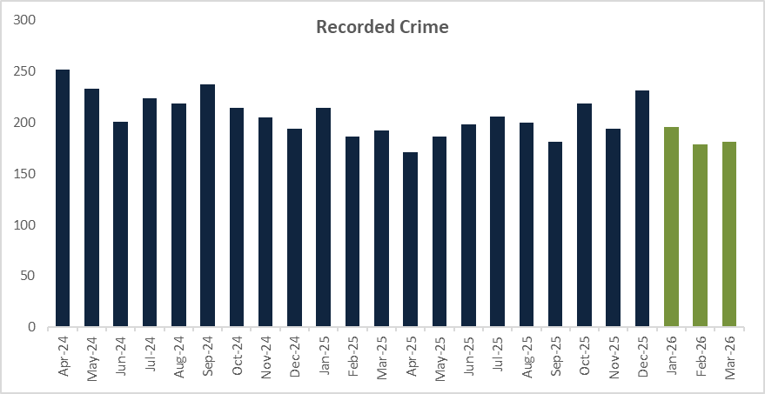

Retail Crime

 | Rolling Year |  |  |  |  | Latest Quarter
 | RY Mar 26 | RY Mar 25 | % change | Number change |  | Jan - Mar 26 | Jan – Mar 25 | % change | Number change
Shoplifting | 16932 | 16839 | 0.6% | 93 |  | 3985 | 4337 | -8.1% | -352
Business Robbery | 737 | 66 | 1016.7% | 671 |  | 160 | 17 | 841.2% | 143
Data Source: Athena

Shoplifting offences have increased by +0.6% (+93) for the rolling year March 2026, however, the most recent quarter recorded a decrease of -8.1% (-352) compared to the same period last year. This is the second quarterly reduction in shoplifting. Following a 4 month decreasing trend from November 2025, the discrete month of March recorded 1,473 offences.

The solved rate for Shoplifting offences has increased by +3.5, from 31.7% to 35.2% for the rolling year and up +4.7 from 35.3% to 40.0% for the most recent quarter, 1134 charges and 415 Community Resolutions were administered for the three-month period.
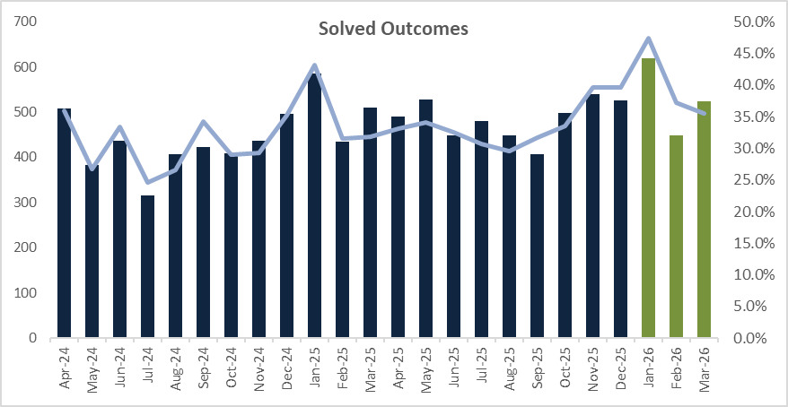
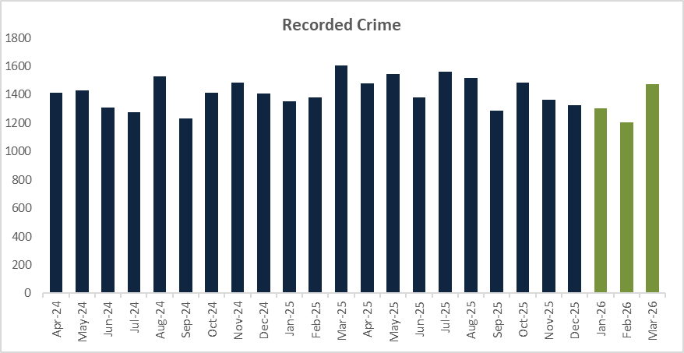

Business Robbery continues to see a substantial increase for both the rolling year and the most recent quarter following the definition in the Home Office Counting Rules introduced in April 2025. The volume of Business Robbery offences increased by 671 for the rolling year and 143 for the most recent quarter. Due to this change, data will not currently be comparable.

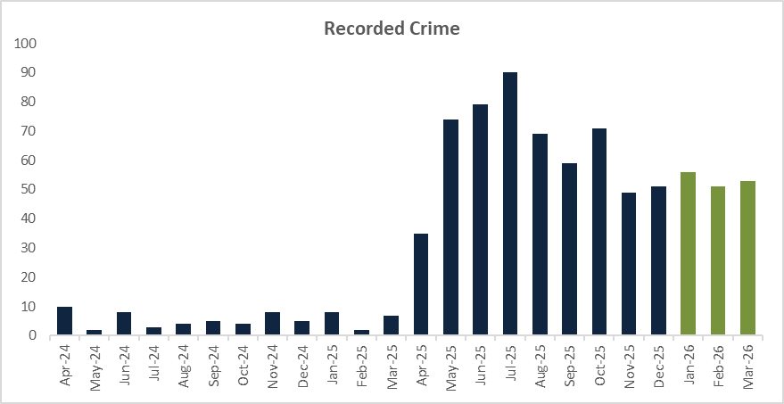

Vehicle Crime

 | Rolling Year |  |  |  |  | Latest Quarter
 | RY Mar 26 | RY Mar 25 | % change | Number change |  | Jan - Mar 26 | Jan – Mar 25 | % change | Number change
TOMV | 3348 | 3887 | -13.9% | -539 |  | 768 | 890 | -13.7% | -122
TFMV | 2927 | 3767 | -22.3% | -840 |  | 773 | 756 | 2.2% | 17
Vehicle Crime | 6275 | 7654 | -18% | -1379 |  | 1541 | 1646 | -6.4% | -105
Data Source: Athena

Overall, Vehicle Crime has seen an -18.0% decrease (-1,379) for the rolling year and a -6.4% decrease (-255) for the most recent quarter, with both Theft of Motor Vehicle and Theft from Motor Vehicle continuing to see reductions for the rolling year. There has been a marginal increase in Theft from Motor Vehicle offences for the quarter up +2.0% with 17 more offences.

With the continued reduction in recorded offences, the solved rate for Vehicle Crime now also sees a decrease with less reports being solved. The solved rate for the rolling year March 2026 was 3.9%, down -1.0 percentage point on last year. The most recent quarter also decreased from 5.1% to 3.9%, down -1.2 percentage points. Theft from Motor Vehicle follows the same trend seeing decreases for both the rolling year and the most recent quarter, whilst Theft of Motor Vehicle saw a marginal increase for the rolling year, up +0.3 percentage points from 5.3% to 5.6%.

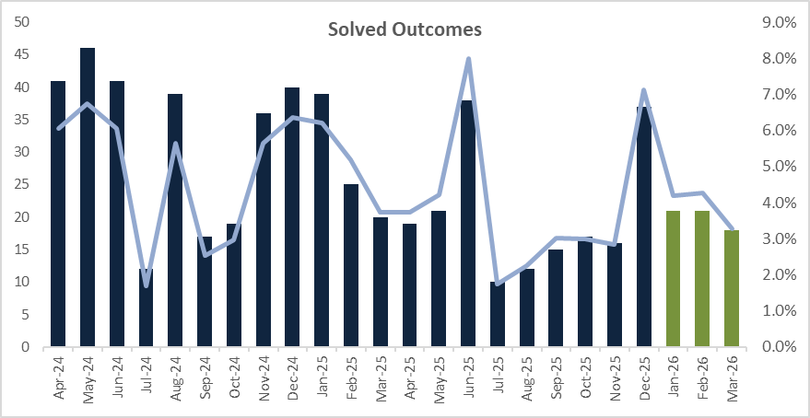
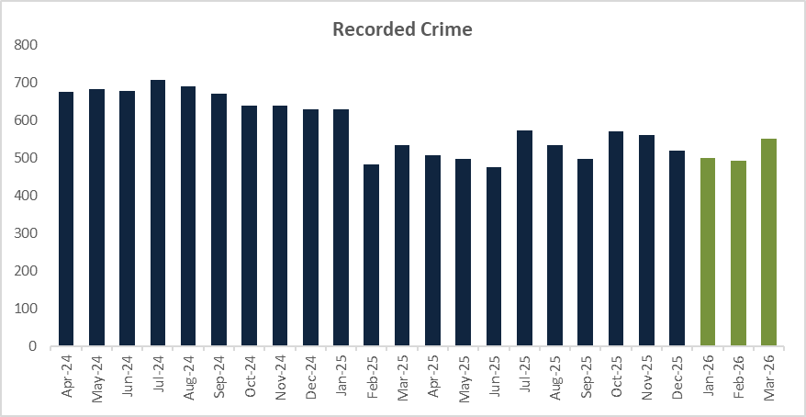

Personal Robbery

 | Rolling Year |  |  |  |  | Latest Quarter
 | RY Mar 26 | RY Mar 25 | % change | Number change |  | Jan - Mar 26 | Jan – Mar 25 | % change | Number change
Recorded crime | 760 | 886 | -14.2% | -126 |  | 186 | 176 | 5.7% | 10
Data Source: Athena

For the rolling year March 2026, Personal Robbery has decreased by -14.2% (-126) compared to last year. However, the most recent quarter has seen a +5.7% increase (+10), which is mainly attributable to offences recorded in January (67) and March (68), both marginal increases on the same months last year.

The solved rate has also experienced a decrease, down -4.9 from 16.5% to 11.6% for the rolling year. There have been 58 less solved outcomes administered compared to last year. The most recent quarter solved rate has also decreased on last year, down -3.5 percentage points from 14.8% to 11.3%, there have been 5 less solved outcomes administered in this quarter.

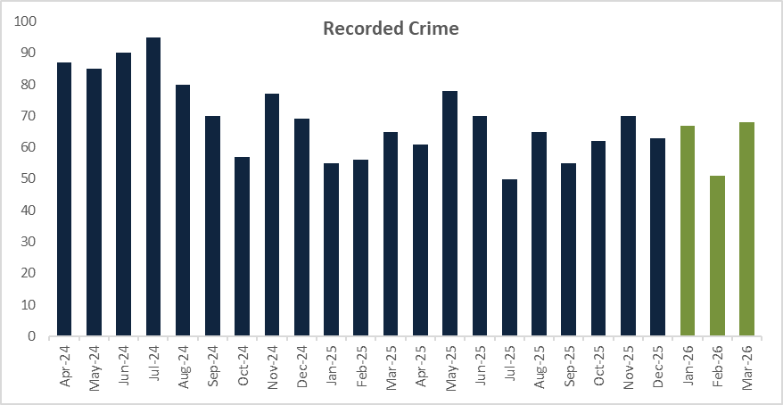

Online Related Offences

 | Rolling Year |  |  |  |  | Latest Quarter
 | RY Mar 26 | RY Mar 25 | % change | Number change |  | Jan - Mar 26 | Jan – Mar 25 | % change | Number change
Recorded crime | 12837 | 11818 | 8.6% | 1019 |  | 3263 | 3091 | 5.6% | 172
Data Source: Athena

Recorded offences with an online marker have seen an increase of +8.6% (+1,019) for the rolling year and a +5.6% increase (+172) for the most recent quarter. For the most recent quarter, the top five offences where the online marker was applied were:
- Harassment – 929 offences, this includes putting people in fear of violence.
- Stalking offences – 487 offences, this includes pursue course of conduct in breach of Section 1
- Obscene Publications – 461 offences, this is mainly to take or make or distribute indecent photographs of children
- Blackmail – 304 offences
- Malicious Communications – 2282 offences, this includes sending communication threatening death or serious harm

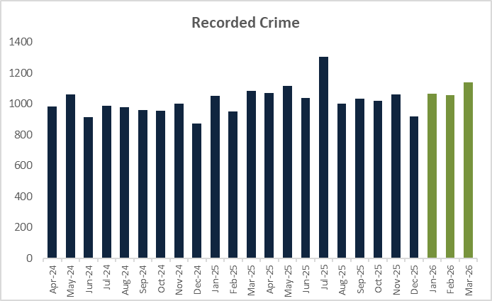

- PRODUCTIVE PARTNERSHIPS

Mental Health

 | Rolling Year |  |  |  |  | Latest Quarter
 | RY Mar 26 | RY Mar 25 | % change | Number change |  | Jan - Mar 26 | Jan – Mar 25 | % change | Number change
Section.136 Detentions | 769 | 695 | 10.6% | 74 |  | 192 | 201 | -4.5% | -9
Concern for Welfare incidents | 39233 | 38038 | 3.1% | 1195 |  | 9097 | 9198 | -1.1% | -101
Concern for Welfare incidents resourced | 20799 | 20432 | 1.8% | 367 |  | 4516 | 4895 | -7.7% | -379
Misper/Absconder (Care or Hospital) incidents | 12644 | 12910 | -2.1% | -266 |  | 2891 | 2909 | -0.6% | -18
Misper/Absconder (Care or Hospital) incidents resourced | 8813 | 8665 | 1.7% | 148 |  | 2109 | 1948 | 8.3% | 161

For the rolling year March 2026, Section 136 detentions have seen an increase of +10.6% (+74) compared to last year, which is mainly attributable to the higher volumes recorded in the summer months (Jun to Aug). Despite the rolling year increase, the most recent quarter has seen a reduction of -4.5% (-9).

Concern for welfare incidents have seen an increase in total and resourced incidents for the rolling year March 2026, with total incidents being up +3.1% (+1,195) and resourced incidents up +1.8% (+367). However, the most recent quarter has seen a reduction for both total incidents and those resourced for Concern for Welfare; totals calls were down -1.1% (-101) and those resourced were down -7.7% (-379).

The total number of MISPER / Absconder (Care or Hospital) incidents have decreased for the rolling year March 2026, down -2.1% with 266 less incidents compared to last year. Despite the reduction, officers were resourced to more MISPER/Absconder incidents, up +1.7% (+148). Like the rolling year, the most recent quarter has seen a decrease in total incidents, down -0.6% (-18), whilst those resourced is up +8.3% (+161).

CONCLUSION

In summary, the Force’s Pledge and Control Strategy are aligned to work in harmony with the PCC’s Police and Crime Plan for the next two years. As demonstrated in this paper for this reporting period, the Force continues to deliver positive outcomes for victims against an increasingly demanding, complex, and challenging policing landscape. However, the Force is not complacent and absolutely recognises the need to continuously improve and develop, to ensure the trust, confidence and safety of all those who live, work and visit Kent.

