Chief Constable’s Report

Kent Police and Crime Commissioner’s Performance and Delivery Board

MAKING KENT SAFER PLAN 2022-25 REPORT

________________________________________________________________

- Strategic Overview

The Police Reform and Social Responsibility Act (Section 7) sets the statutory requirement for the Police and Crime Commissioner (PCC) to have a Police and Crime Plan. This must set out the PCC’s vision and priorities for policing and community safety, as well as the objectives and ambitions that Kent Police will be held to account on.

The Police and Crime Plan set by the Kent PCC for the period 2022-25 was called the ‘Making Kent Safer Plan’, set in consultation with the Chief Constable and the public of Kent. The Plan complemented the Kent Police Pledge set by the Chief Constable, outlining his commitments to staff, our commitment to the public and our priorities and values. At the heart of the Pledge, there is a commitment to provide a high-quality policing service that is delivered with absolute integrity, to support and protect victims, and to catch criminals and solve crime.

Furthermore, the Force has a Control Strategy which is refreshed annually and sets out operational priorities for crime prevention, intelligence and enforcement. The key crime types of focus are aligned to the PCC’s priorities, with a particular focus currently on Violence Against Women and Girls (VAWG), serious violence and harm, organised crime and exploitation.

Nationally, Kent Police is also committed to ensuring delivery against Government set direction and priorities within the Strategic Policing Requirement and the Beating Crime Plan (Appendix A), for which the PCC is also obligated to report on to the Home Office in the Annual Assurance Statement.

During the reporting period 2022-25, Kent Police have undertaken significant changes to the policing model, namely within Neighbourhood Policing and Divisional Investigations, to enhance service delivery.

With ongoing support of the Kent PCC through local precept funding and the Government’s recent Police Officer Uplift Programme, Kent Police has been able to recruit 911 more police officers over the past decade. Following a comprehensive Neighbourhood Policing Review, a new model went live in June 2023 and enables the Force to ensure that officers are visible and accessible in their local communities and town centres. The model has been built upon the principles of: early intervention, effective engagement and meaningful targeted activity; increasing local Community Safety Units’ capability and partnership working; a focus on repeat victims, offenders and locations; early identification of vulnerability and exploitation within the community; and enhancing visibility to deter crime, build confidence and reduce the fear of crime.

Kent Police has further welcomed the Government’s Neighbourhood Policing Guarantee, enabling an additional investment of 65 new police officers, alongside 80 new Special Constables and 40 uniformed volunteers with powers working in visible community safety roles. Every neighbourhood, urban or rural, has a named, contactable officer, and residents and businesses will be given an increased voice to shape neighbourhood policing priorities, and ensure crime and anti-social behaviour (ASB) is both reported and acted on.

In addition, the Force has undertaken a comprehensive Divisional Policing Review, redesigning the investigations’ structure, with the following objectives:
- Improved trust and confidence in the effectiveness of policing.
- Improved service to victims of crime.
- Delivery of a model that enhances the prevention, investigation and detection of crime.
- Improved response to the management of offenders and suspects.
- Improved protection for vulnerable people.
- Reduced bureaucracy and an empowered workforce.

The redesign of the investigations structure has created larger and more resilient teams that ensure a strong focus on Domestic Abuse (DA) and VAWG, whilst applying national guidance through centrally owned, highly skilled teams investigating Rape, Child/Adult Protection, and high-risk and serious DA. The new model went live in October 2024 and will be subject to a Post Implementation Review in 2025 to ensure that the objectives are being met.

- ‘Making Kent Safer’ Plan Priorities

This section of the paper will provide an overview on Kent Police’s performance delivery against the seven Making Kent Safer Plan 2022-25 priorities. The data period used for this purpose will be April 2021 to March 2025 to provide a four-year overview.

Priority: Work with Residents, Communities and Businesses to Prevent Crime and Anti-Social Behaviour

All Crime

FY Period | Recorded Crime | % Change | Number change
April 2021 - March 2022 | 180838 | 9.4% | 15470
April 2022 - March 2023 | 174487 | -3.5% | -6351
April 2023 - March 2024 | 165945 | -4.9% | -8542
April 2024 - March 2025 | 161621 | -2.6% | -4324
4 years’ difference |  | -10.6% | -19217

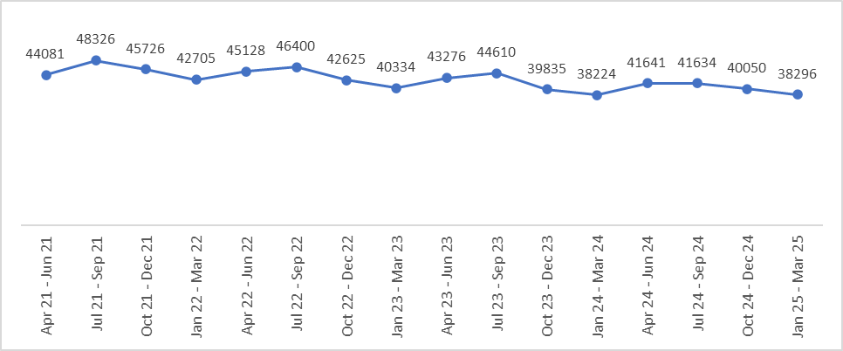

Over the 4 years’ period, All Crime has experienced a -10.6% decrease with 19,217 less crimes. The financial year 2024/25 has seen a -2.6% decrease (4,324 less offences). The peak quarter is usually July to September but for July to September 2024 there was a slight reduction when compared to April to June 2024. Lower volumes are experienced in the second half of each financial year with January to March consistently recording the lowest volumes.

Crimes Against Society have seen a reduction for the 4 years’ period (-14.0%, -3,669 offences) but sees a slight increase for 2024/25 (+0.8%, +190 offences). Drugs offences saw the largest increase within this, up 23.3% (1,196 more offences). It should be noted that the increase can be attributed to enhanced proactive policing activity and therefore levels and trends should not be considered a measure of criminal activity.

When comparing the most recent financial year periods for All Crime, 8.8% more suspects have been arrested and interviewed (+3,710). The All Crime Solved Rate for 2024/25 was 15.1%; an increase of 2.9% from 12.2% last year. Increases have been seen in charges (+1,293 charges) and Community Resolutions (+2,957 CRs), however there have been reductions in Adult Cautions (-50) and Youth Cautions (-79) being administered.

Victim Based Crime

FY Period | Recorded Crime | % Change | Number change
April 2021 - March 2022 | 154608 | 10.3% | 14436
April 2022 - March 2023 | 150153 | -2.9% | -4455
April 2023 - March 2024 | 143574 | -4.4% | -6579
April 2024 - March 2025 | 139060 | -3.1% | -4514
4 years’ difference |  | -10.1% | -15548

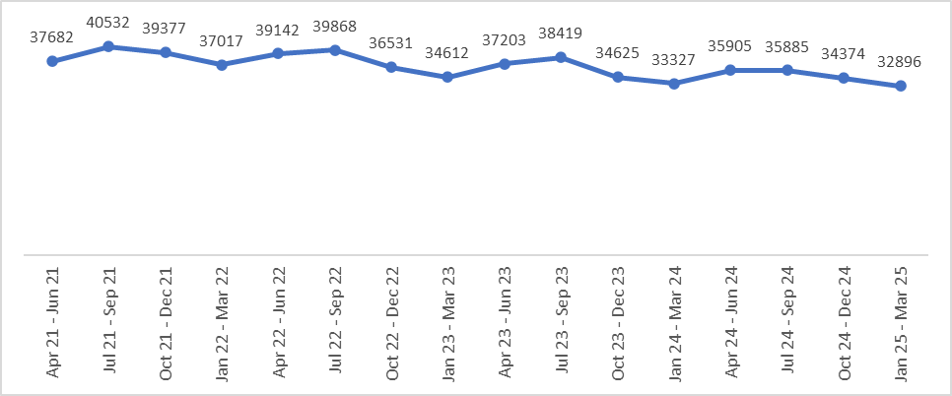

Victim Based Crime (VBC) has experienced a decrease of -10.1% (15,548 less offences) over the 4 years’ period. 2024/25 saw a reduction of -3.1% (4,514 less offences). VBC follows the same trend as All Crime with peaks in July to September, excluding July to September 2024, with the lowest volumes in January to March.

During 2024/25, there were 7.5% more suspects arrested and interviewed (+2,473) compared to the previous year, resulting in a 2.5% increase in the rate of suspects arrested and interviewed to 25.4%. The VBC Solved Rate for 2024/25 was 12.4%; an increase of 2.3% from the 10.1% last year. Following the trend within All Crime, there have been increased charges (+915) and CRs (+1,947) with reductions in Adult Cautions (-10) and Youth Cautions (-76) being administered.

Anti-Social Behaviour

FY Period | Recorded Incidents | % Change | Number change
April 2021 - March 2022 | 56915 | 60.5% | 21445
April 2022 - March 2023 | 32640 | -42.7% | -24275
April 2023 - March 2024 | 28523 | -12.6% | -4117
April 2024 - March 2025 | 27131 | -4.9% | -1392
4 years’ difference |  | -52.3% | -29784

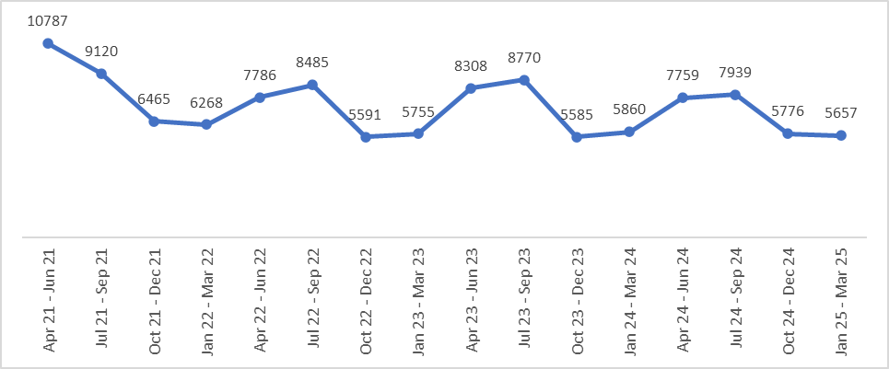

Over the 4 years’ period, ASB has experienced a decrease of -52.3% (29,784 less incidents). This large reduction is attributable to April to September 2021, whereby the inclusion of Covid-19 related incidents resulted in higher volumes. During 2024/25, there has been a -4.9% decrease (-1,392 incidents) compared to the previous financial year. ASB incidents experience a seasonal trend with higher volumes from April to September. The three most recent financial year periods see average monthly volumes of around 2,300 offences, which is lower than the average of 2,900 per month prior to Covid-19 and national lockdowns.

The 3 types of ASB that accounted for the highest proportion of incidents during 2024/25 were:
- Rowdy or Nuisance Gathering in Public/Impeding Public Access – this accounted for 31.4% of total ASB with 8,508 incidents. This is a -10.1% reduction compared to the previous financial year (-959 incidents).
- Drunken or Rowdy Behaviour accounted for 21.5% of total ASB with 5,821 incidents, which is a 3.3% increase, equating to 186 more incidents compared to the previous financial year.
- Motor Vehicle Nuisance on Roads, including Noise accounted for 4,916 incidents, which was 18.1% of the total ASB. During 2024/25, there was a -9.1% decrease with 493 less incidents compared to the previous financial year.

Burglary

Burglary Residential – Home

FY Period | Recorded Crime | % Change | Number change
April 2021 - March 2022 | 3510 | 3.8% | 129
April 2022 - March 2023 | 3340 | -4.8% | -170
April 2023 - March 2024 | 3053 | -8.6% | -287
April 2024 - March 2025 | 2571 | -15.8% | -482
4 years’ difference |  | -26.8% | -939

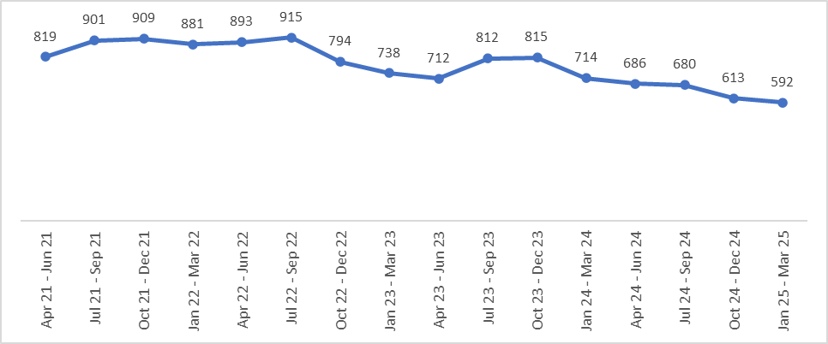

Across the 4 years’ period, Burglary Residential - Home offences have seen a -26.8% decrease (939 less offences) with 2024/25 also seeing a 15.8% decrease (-482 offences) compared to the previous financial year. Overall, there is a decreasing trend in Burglary Residential – Home offences, with the 5 most recent quarters seeing consecutive reductions to the preceding quarter.

The rate of suspects arrested and interviewed has seen a slight reduction of -0.9% to 18.7% for 2024/25 from 19.6% in the previous financial year. The Solved Rate for Burglary Residential - Home has seen a 0.1% increase to 9.3% despite a -15.3% decrease (-43) reduction in solved outcomes.

Burglary Residential - Business and Community

FY Period | Recorded Crime | % Change | Number change
April 2021 - March 2022 | 1727 | 7.5% | 120
April 2022 - March 2023 | 1913 | 10.8% | 186
April 2023 - March 2024 | 1728 | -9.7% | -185
April 2024 - March 2025 | 1509 | -12.7% | -219
4 years’ difference |  | -12.6% | -218

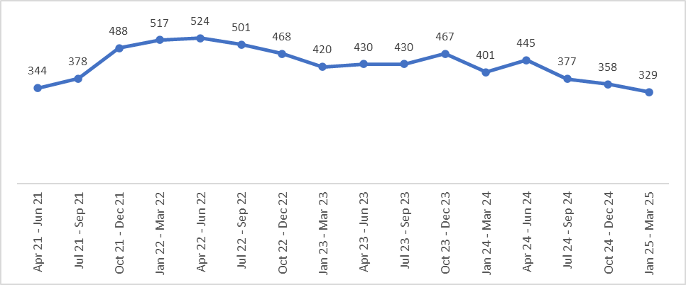

Burglary Business and Community offences have experienced a decrease of -12.6%, with 218 less offences over the 4 years’ period. During 2024/25, there was a reduction of -12.7% (219 less offences). Since April 2022, there has been an overall reducing trend with the most recent 3 quarters seeing the lowest volumes across the 4 years’ period.

Shoplifting

FY Period | Recorded Crime | % Change | Number change
April 2021 - March 2022 | 10859 | 22.9% | 2025
April 2022 - March 2023 | 12704 | 17.0% | 1845
April 2023 - March 2024 | 15137 | 19.2% | 2433
April 2024 - March 2025 | 16839 | 11.2% | 1702
4 years’ difference |  | 55.1% | 5980

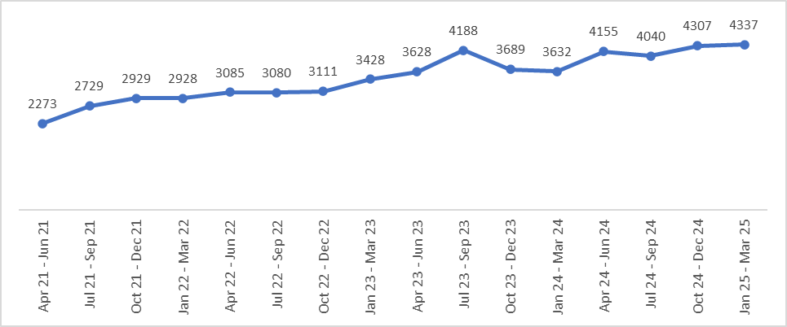

Over the 4 years’ period, Shoplifting offences experienced a 55.1% increase (5,980 more offences), with an 11.2% increase (+1,702 offences) for 2024/25. In contrast to most other crime types, Shoplifting has seen an increasing trend over the reporting period with the most recent 2 quarters experiencing the highest volumes. This reflects national trends reported by the British Retail Consortium whereby a 25% increase was reported for April 2023 to March 2024 compared to the previous year.

In September 2022, a Digital Asset Management System (DAMS) was introduced as a single system to receive, store, manage and share digital assets. This aims to make it easier and more efficient for businesses to submit digital evidence, such as CCTV, leading to earlier interventions to secure timelier outcomes.

FY Period | Suspect Interviewed | % Change | Number change
April 2021 - March 2022 | 3482 | 12.4% | 383
April 2022 - March 2023 | 3866 | 11.0% | 384
April 2023 - March 2024 | 4595 | 18.9% | 729
April 2024 - March 2025 | 5702 | 24.1% | 1107
4 years’ difference |  | 63.8% | 2220

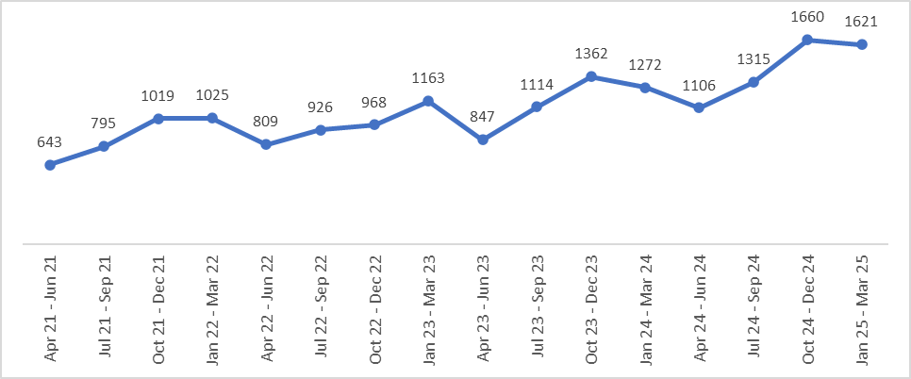

The 4 years’ comparison sees a 63.8% increase, an additional 2,220 offences, for which a suspect has been arrested or interviewed for Shoplifting offences. The trend follows the pattern for recorded Shoplifting offences with the latest 2 quarters seeing the highest volumes across the 4 years’ period.

FY Period | Charge | % Change | Number change
April 2021 - March 2022 | 2172 | -1.6% | -36
April 2022 - March 2023 | 2561 | 17.9% | 389
April 2023 - March 2024 | 3106 | 21.3% | 545
April 2024 - March 2025 | 3682 | 18.5% | 576
4 years’ difference |  | 69.5% | 1510

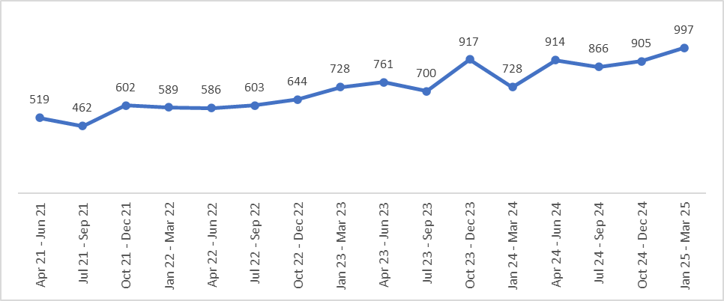

Charge volumes have experienced a 69.5% increase with 1,510 more Charges over the 4 years’ period. During 2024/25, there was an 18.5% increase with an additional 576 Charges. As with recorded Shoplifting offences, there is an increasing trend with 3 of the latest 4 quarters exceeding 900 Charges.

FY Period | Out of Court Disposal | % Change | Number change
April 2021 - March 2022 | 779 | 32.3% | 190
April 2022 - March 2023 | 774 | -0.6% | -5
April 2023 - March 2024 | 966 | 24.8% | 192
April 2024 - March 2025 | 1662 | 72.0% | 696
4 years’ difference |  | 113.4% | 883

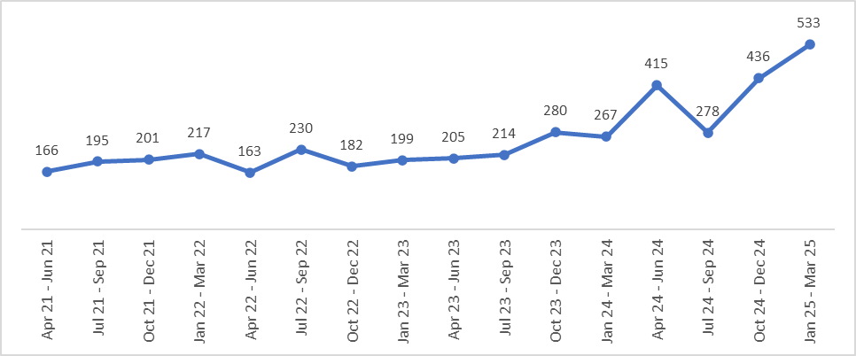

Over the 4 years’ period, Out of Court Disposals for Shoplifting offences have seen a 113.4% increase (+883). During 2024/25, there was an increase of 72% with 696 more Out of Court Disposals. This is attributable to a 91.6% increase (+685) in CRs and a 36.2% increase (+50) in Adult Cautions. Whilst there is an increasing trend over the 4 years’ period, it is since October 2023 that this has become more prominent.

As referenced at the start of this paper, the Force’s new Neighbourhood Policing Model and the further investment from the Neighbourhood Policing Guarantee, will enable an enhanced focus on town centre policing. This will also complement the work being led by the Kent PCC through his Retail Crime Board, launched in September 2024, bringing together representatives of Kent Police, leading retail brands, members of the customer service industry, and Town Centre Managers to share good practice and develop effective partnerships to prevent and tackle shoplifting and other related offences.

Violent Crime

FY Period | Recorded Crime | % Change | Number change
April 2021 - March 2022 | 91471 | 10.1% | 8405
April 2022 - March 2023 | 84302 | -7.8% | -7169
April 2023 - March 2024 | 78348 | -7.1% | -5954
April 2024 - March 2025 | 75140 | -4.1% | -3208
4 years’ difference |  | -17.9% | -16331

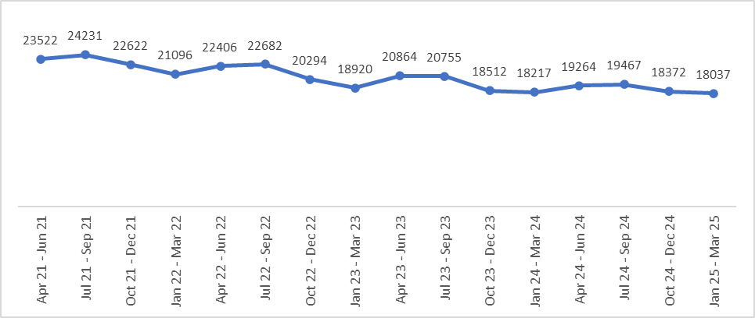

With regards to the Home Office Counting Rules, Violent Crime includes a broad spectrum of offences from non-injury reports to the most serious violence, including homicide. The Force’s Control Strategy features quite heavily in this category, such as Sexual Offences, Domestic Abuse and Robbery.

Violent Crime has experienced a decrease of -17.9%, with 16,331 less offences over the 4 years’ period. During 2024/25, there was a -4.1% decrease (3,208 less offences) compared to the previous year. There is an overall downwards trend with some seasonality evident with peaks in July to September and lowest volumes in January to March.

Robbery

FY Period | Recorded Crime | % Change | Number change
April 2021 - March 2022 | 1192 | -2.0% | -24
April 2022 - March 2023 | 1261 | 5.8% | 69
April 2023 - March 2024 | 1084 | -14.0% | -177
April 2024 - March 2025 | 952 | -12.2% | -132
4 years’ difference |  | -20.1% | -240

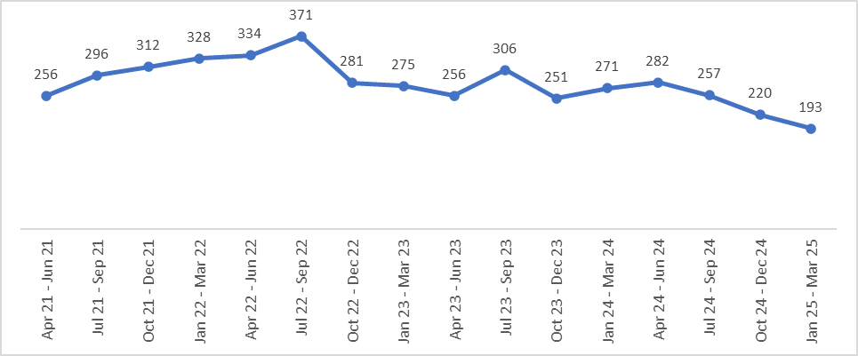

Over the 4 years’ period, Robbery offences have experienced a decrease of -20.1%, with 240 less offences. There is a decrease of -12.2% (132 less offences) for the current financial year. Offences have been on a downward trend following the peak in July 2022 to September 2022, with the average monthly volume of offences at 79 compared to 90 for the previous financial year.

The rate of suspects arrested and interviewed has seen an increase of +0.5% to 35.6%, as well as a 1.8% increase in the Charge Rate to 17.4%.

Hate Crime

FY Period | Recorded Crime | % Change | Number change
April 2021 - March 2022 | 4942 | 25.8% | 1015
April 2022 - March 2023 | 4809 | -2.7% | -133
April 2023 - March 2024 | 4228 | -12.1% | -581
April 2024 - March 2025 | 3813 | -9.8% | -415
4 years’ difference |  | -22.8% | -1129
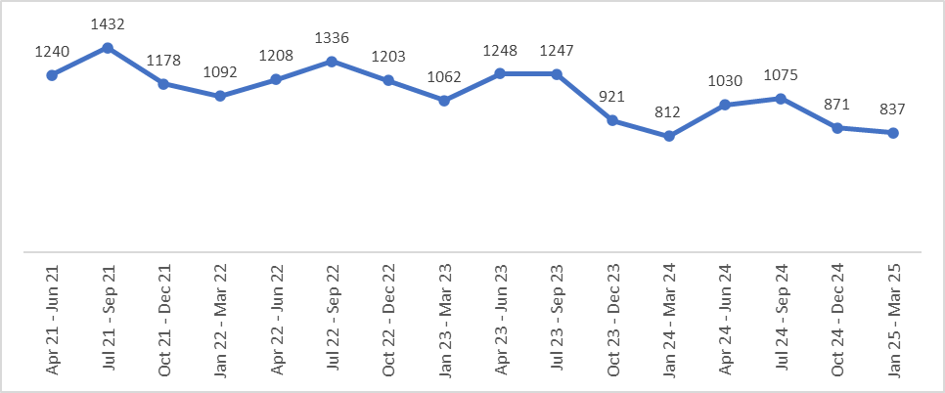

Hate Crime experienced a decrease of -22.8% with 1,129 less offences over the 4 years’ period. During 2024/25, there was a -9.8% decrease (415 less offences). There is an overall decreasing trend with peaks in July to September and lower volumes in January to March (as with overall VBC).
There was a 4.9% increase in the Solved Rate during 2024/25, up to 22.6%. Charge volumes remained stable with Adult Cautions and CRs seeing increases and Youth Cautions decreasing compared to last year.

Priority: Tackle Violence Against Women and Girls

Rape

FY Period | Recorded Crime | % Change | Number change
April 2021 - March 2022 | 2356 | 18.8% | 372
April 2022 - March 2023 | 2364 | 0.3% | 8
April 2023 - March 2024 | 2073 | -12.3% | -291
April 2024 - March 2025 | 1990 | -4.0% | -83
4 years’ difference |  | -15.5% | -366

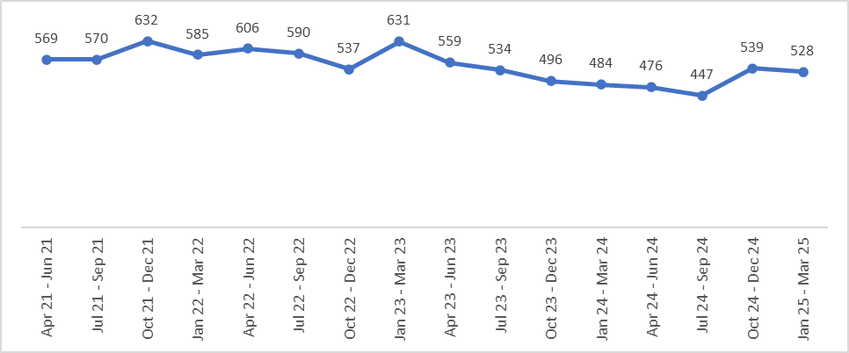

Across the 4 years’ period, Rape offences have experienced a decrease of 15.5%, with 366 less offences. During 2024/25, there was a -4.0% decrease (-83 offences) compared to the previous financial year. Following a peak average monthly volume of almost 200 offences per month between April 2022 to March 2023, Rape offences currently average approximately 165 offences per month.

The charge volume for Rape offences has seen a 36.4% increase (52 more charges) during 2024/25, resulting in a 2.9% increase in the Charge Rate from 6.9% last year to 9.8%.

Sexual Offences

FY Period | Recorded Crime | % Change | Number change
April 2021 - March 2022 | 6886 | 22.5% | 1267
April 2022 - March 2023 | 6583 | -4.4% | -303
April 2023 - March 2024 | 6206 | -5.7% | -377
April 2024 - March 2025 | 6703 | 8.0% | 497
4 years’ difference |  | -2.7% | -183

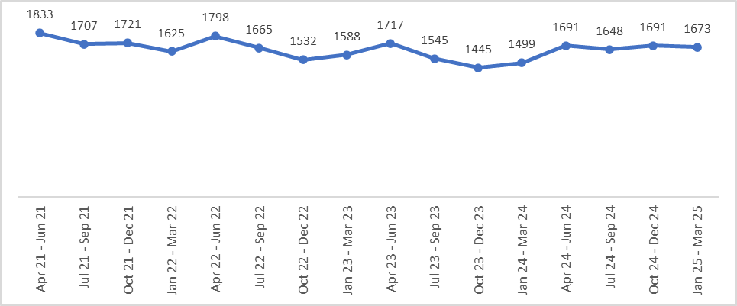

There has been a -2.7% decrease (-183 offences) in Sexual Offences across the 4 years’ period. During 2024/25, there was an increase of 8.0% (497 more offences). The increase is mainly attributable to new offences being introduced in February 2024 relating to the Sharing of Intimate Photograph(s) or Film. This has resulted in 2024/25 not being directly comparable with previous years; April to June experienced the highest volumes across the 4 years’ period.

Over the reporting period, there has been a 21.6% increase (+513) in suspects arrested and interviewed and a 36.5% increase (+206) in charges. During 2024/25, the Charge Rate increased by 2.7% to 12.0%.

Priority: Protect People from Exploitation and Abuse

Domestic Abuse

FY Period | Recorded Crime | % Change | Number change
April 2021 - March 2022 | 38719 | -1.1% | -442
April 2022 - March 2023 | 34752 | -10.2% | -3967
April 2023 - March 2024 | 30134 | -13.3% | -4618
April 2024 - March 2025 | 28129 | -6.7% | -2005
4 years’ difference |  | -27.4% | -10590
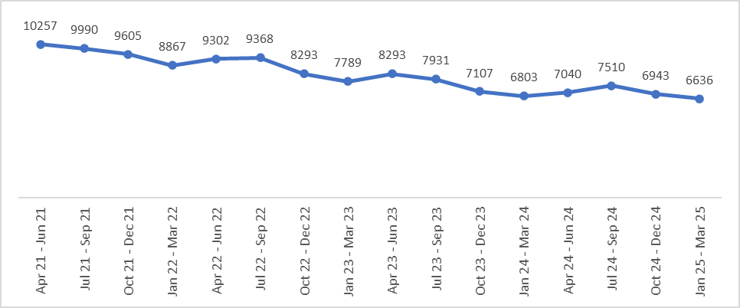

Domestic Abuse (DA) offences have experienced a -27.4% decrease (10,590 less offences) over the 4 years’ period. There is a -6.7% decrease, with 2,005 less offences compared to the previous financial year. There is an overall decreasing trend in DA across the 4 years’ period with peak months between April and September.

In April 2024, the Home Office Counting Rules were amended to no longer require behavioural crimes to be recorded in addition to other substantive offences. This will have an impact on any reductions seen, in addition to the ongoing work Kent Police undertake with partner agencies and charitable organisations to prevent and tackle ASB in our communities.

The current decrease can be attributed to a -7.3% decrease (-1,715) in Violence Against the Person (VAP) offences. Within VAP, Stalking and Harassment offences decreased by -11.6%, (-748), with Coercive and Controlling behaviour increasing by 13.1% (+309). Other VAP offences have seen an -8.7% decrease (1,276 less offences).

The Charge Rate is down slightly by -0.1% to 7.1%, compared to the previous financial year. There has, however, been an increase in the Solved Rate across the Force, from 9.9% to 10.1% for 2024/25. Both charges and Cautions have seen decreases, whilst CRs saw an additional 140 being administered.

Adult Protection

FY Period | Recorded Crime | % Change | Number change
April 2021 - March 2022 | 4748 | 67.8% | 1919
April 2022 - March 2023 | 4814 | 1.4% | 66
April 2023 - March 2024 | 3831 | -20.4% | -983
April 2024 - March 2025 | 3299 | -13.9% | -532
4 years’ difference |  | -30.5% | -1449

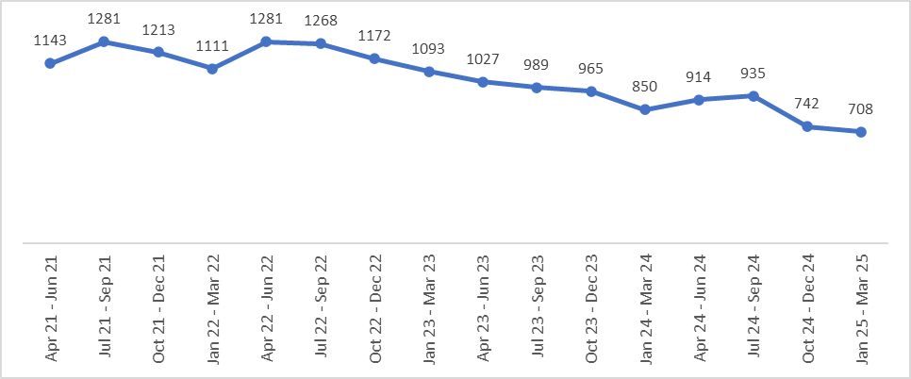

Across the 4 years’ period, Adult Protection related offences saw a decrease of -30.5% with 1,449 less offences. During 2024/25, there was a decrease of -13.9% (-532 offences). There is a reducing trend overall in Adult Protection offences, with the 2 most recent quarters being the lowest across the reporting period.

Violence Against the Person

FY Period | Recorded Crime | % Change | Number change
April 2021 - March 2022 | 83393 | 9.4% | 7162
April 2022 - March 2023 | 76458 | -8.3% | -6935
April 2023 - March 2024 | 71058 | -7.1% | -5400
April 2024 - March 2025 | 67485 | -5.0% | -3573
4 years’ difference |  | -19.1% | -15908

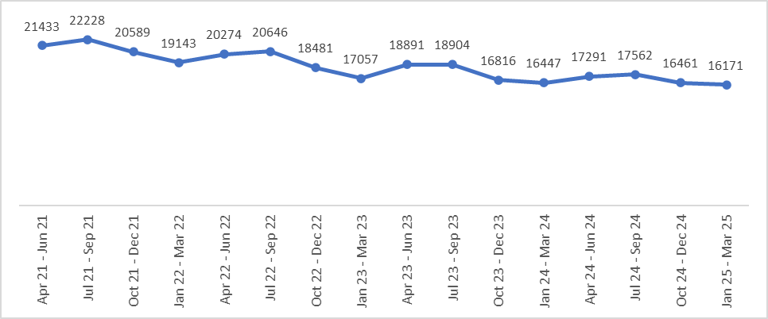

Over the 4 years’ period, Violence Against the Person (VAP) has experienced a decrease of -19.1% (15,908 less offences). During 2024/25, this was a decrease of -5.0% (3,573 less offences). There is an overall downwards trend with peaks in July to September, and the lowest volumes in January to March (as with overall Violent Crime). The proportion of VAP that is DA related has fallen from 37.4% during April 2021 to March 2022, to 32.4% for April 2024 to March 2025. As a result, DA trends will impact on overall VAP to a lesser extent.

The offence of Assault on Emergency Worker also sits within VAP and during 2024/25, there was an increase of 7.4% (+116 offences) but an overall reduction of -7.3% (-132 offences) over the 4 years’ period. In line with the Kent Police Pledge, the Chief Constable is committed to ensuring that the health, safety and wellbeing of the workforce is a priority and anyone who assaults or abuses an officer or staff member in the course of their duties will be dealt with robustly.

Fraud

Action Fraud is the UK’s national reporting centre for fraud, providing a central point of contact for information about fraud and financially motivated internet crime. Action Fraud triage and forward details to the relevant force to carry out an investigation if necessary.

FY Period | Recorded Crime | % Change | Number change
April 2021 - March 2022 | 1464 | 7.2% | 98
April 2022 - March 2023 | 1153 | -21.2% | -311
April 2023 - March 2024 | 1218 | 5.6% | 65
April 2024 - March 2025 | 1346 | 10.5% | 128
4 years’ difference |  | -8.1% | -118

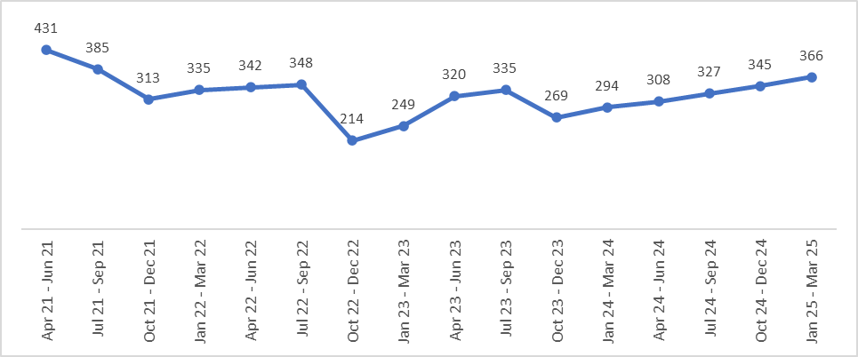

Over the 4 years’ period, there has been an -8.1% decrease (118 less offences) for Fraud reports referred to Kent Police. During 2024/25, there was a 10.5% increase (128 more offences) compared to the previous year. Fraud typically sees an increasing trend from October to September with a reduction before increasing again. However, there was no reduction in October 2024 with quarterly offence volumes continuing to rise.

Priority: Combat Organised Crime, County Lines and Serious Crime

Knife Crime

Knife enabled crime has remained a core focus within the Force’s Control Strategy. In line with our Home Office Annual Data Requirement, the offences involving knives or sharp instruments collection is based on:
- Actual bodily harm and grievous bodily harm or assault with injury and assault with intent to cause serious harm,
- Attempted murder,
- Robbery
- Threats to kill
- Rape
- Sexual assault
- Homicide

FY Period | Recorded Crime | % Change | Number change
April 2021 - March 2022 | 1252 | -9.8% | -136
April 2022 - March 2023 | 1264 | 1.0% | 12
April 2023 - March 2024 | 1022 | -19.1% | -242
April 2024 - March 2025 | 1050 | 2.7% | 28
4 years’ difference |  | -16.1% | -202

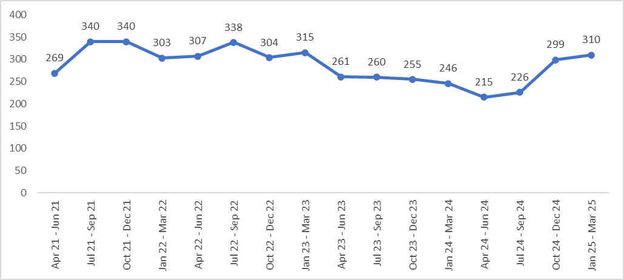
Over the 4 years’ period Knife enabled crime has experienced a -16.1% decrease with 202 less crimes. During 2024/25, there has been an increase of 2.7% with 28 more crimes, however annual volumes for both financial year 2023/24 and 2024/25 are lower than the previous 2 financial years.
The peak quarter is usually July to September but for July to September 2024 there was a lower volume of offences recorded compared to October to December 2024. Offences peaked in July to September 2021, which were the first months following the Covid-19 pandemic when all lockdown restrictions were lifted.

Kent is one of 18 forces nationally that have a funded Violence Reduction Unit (VRU) which has been in place since 2020 and is tasked with providing leadership and strategic coordination of the local response to serious violence, with a particular focus on knife enabled crime. They also work closely with the new Child Centred Policing Teams as a core component of the Force’s Neighbourhood Policing Model.

County Lines and OCGs

Under the Force’s Divisional Review, there is a continued and relentless focus on the pursuit of county lines and those who often seek to exploit those most vulnerable in our communities. We do this by also working in strong partnership with others such as the Metropolitan Police Service and British Transport Police, with operations often attracting local, national and Cabinet Office attention. During the reporting period, the Force has continued to target, disrupt and dismantle a number of county lines; for example an intensification week during March saw in excess of 45 arrests and 52 charges, disrupting 19 county lines and safeguarding many who were being exploited due to this criminality.

OCGs have also remained subject to relentless targeting and disruption, led by the Serious Crime Directorate and supported by other departments across the Force, including the Local Policing Teams. These operations are led in close collaboration with others, and as part of national campaigns. An example of recent activity in this area was the disruption and shutting down of cannabis cultivations as part of Operation Mille. Warrants were carried out at eight properties in towns including Rochester, Meopham, Greenhithe, Maidstone and Tonbridge, and resulted in the arrest of 9 people and seizure of cannabis, cocaine and weapons. The Force will not stop in its prevention and pursuit of such offending, and it remains a core part of our Control Strategy.

Priority: Be Visible and Responsive to the needs of the Communities

Force Crime and Incident Response

999 Contact | April 2021 to March 2022 | April 2022 to March 2023 | April 2023 to March 2024 | April 2024 to March 2025
Calls Received | 354,887 | 382,689 | 384,460 | 363,396
Calls Answered | 349,804 | 377,763 | 383,132 | 361,813
Calls Not Answered | 5,083 | 4,926 | 1,328 | 1,583
% Not Answered | 1.43% | 1.29% | 0.35% | 0.44%
Average Time to Answer | 16 sec | 18 sec | 10 sec | 3 sec
% Answered Under 10 Seconds | 66.74% | 68.49% | 81.41% | 96.59%

101 Contact | April 2021 to March 2022 | April 2022 to March 2023 | April 2023 to March 2024 | April 2024 to March 2025
Calls Received | 360,181 | 312,321 | 275,065 | 255,824
Calls Answered | 286,159 | 208,034 | 250,996 | 248,284
Calls Not Answered | 74,022 | 104,287 | 24,069 | 7,540
% Not Answered | 20.55% | 33.39% | 8.75% | 2.95%
Average Time to Answer | 4 min | 7 min 18 sec | 1 min 6 sec | 31 sec

Digital Contact | April 2021 to March 2022 | April 2022 to March 2023 | April 2023 to March 2024 | April 2024 to March 2025
Online Crime Reports | 39,527 | 48,278 | 47,377 | 48,876
Live Chat | 43,744 | 70,523 | 66,421 | 59,458
Other Digital Contact | 16,591 | 133,176 | 136,977 | 146,505
Total | 99,862 | 252,427 | 250,775 | 254,839
Performance for 999 calls has seen improvements across the reporting period, despite higher call volumes. The average answer time has decreased over the period from 16 seconds to 3 seconds with the proportion answered within 10 seconds increasing from 66.74% to 96.59%.

National comparisons are derived from the ‘Beating Crime Plan’ data. For 2024/25, Kent recorded an average answer time of 5.28 seconds with 94.3% in under 10 seconds, improving on both last year and over the 4 years’ period. Performance for 101 has also improved over the reporting period with 2024/25 seeing an average of 2.95% of calls not answered and an average answer time of 31 seconds, compared to 8.75% not answered and a 1 minute 6 second average time to answer for the previous year. National publication of 101 data is still under development.

Since January 2024, the performance delivery for both 999 and 101 services have consistently improved. The following tables show the national year-on-year comparison for 999 performance:

Average answer time from BT data*
April 2021 to  March 2022 |  |  | April 2022 to  March 2023 |  |  | April 2023 to  March 2024 |  |  |  | April 2024 to  March 2025
Seconds | Nationally |  | Seconds | Nationally |  | Seconds |  | Nationally |  | Seconds |  |  | Nationally
17.10 | 27th |  | 16.40 | 30th |  | 12.87 |  | 31st |  | 5.28 |  |  | 2nd
Calls answered in under 10 seconds
April 2021 to  March 2022 |  |  | April 2022 to  March 2023 |  |  | April 2023 to  March 2024 |  |  |  | April 2024 to  March 2025
% | Nationally |  | % | Nationally |  | % |  | Nationally |  | % |  |  | Nationally
67.3% | 33rd |  | 69.5% | 30th |  | 79.7% |  | 31st |  | 94.3% |  |  | 2nd
Calls answered in over 60 seconds
April 2021 to  March 2022 |  |  | April 2022 to  March 2023 |  |  | April 2023 to  March 2024 |  |  |  | April 2024 to  March 2025
% | Nationally |  | % | Nationally |  | % |  | Nationally |  | % |  |  | Nationally
7.0% | 31st |  | 7.4% | 33rd |  | 4.3% |  | 32nd |  | 0.4% |  |  | 7th
*BT figures do differ from Kent Police internal figures as this includes the BT time to handle.

Rural Crime
Known as the ‘Garden of England’, 85% of land in Kent is rural, with a large proportion of that consisting of farmland, woodland and forestry. Kent Police has retained investment into the policing of our rural communities, with a dedicated Rural Task Force being a core component of the new Neighbourhood Policing Model launched in June 2023. Kent is fortunate to have strong working relationships from within our rural communities, however we continue to enhance our visibility and accessibility in these areas to ensure that the residents and their businesses are protected from harm and ASB.
Whilst there is no set national definition of Rural Crime, it generally encompasses a broad range of offences including agricultural theft, livestock rustling, fly-tipping, and wildlife crimes. Due to the changing landscape of wards in Kent, we are not able to currently define rural or urban wards. However, to provide an example of performance the following table demonstrates performance within the offences of Theft of Agricultural / Farming Equipment and Wildlife offences, as recorded under the Home Office Counting Rules.
FY Period | Recorded Crime | % Change | Number change
April 2021 - March 2022 | 821 | 4.1% | 32
April 2022 - March 2023 | 800 | -2.6% | -21
April 2023 - March 2024 | 680 | -15.0% | -120
April 2024 - March 2025 | 607 | -10.7% | -73
4 years’ difference |  | -26.1% | -214
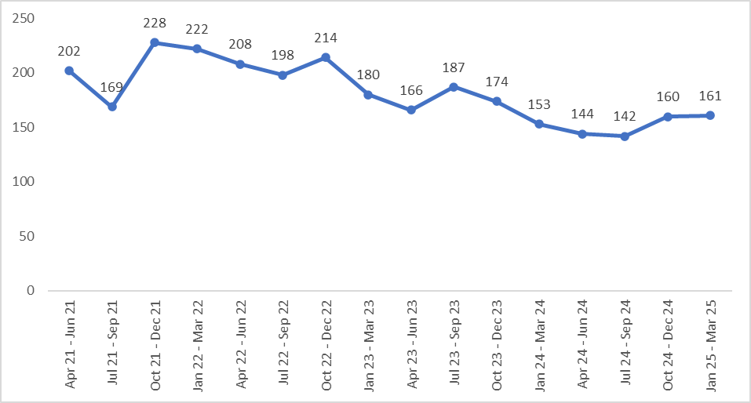
Over the 4 years’ period, Theft of Plant/Agricultural equipment and Wildlife offences has seen a decrease of -26.1% with 214 less crimes. During 2024/25, there has been a -10.7% decrease with 73 less crimes, with year-on-year reductions from 2022/23 to the current financial year. The peak quarter is typically October to December, however for 2023/24 offences were higher in July to September (187).

Moving into 2025/26 and beyond, the Force will continue to engage with rural communities around areas of prevention and enforcement, utilising several platforms such as ‘Farmwatch’ (FW) Whats App, Rural Matters, My Community Voice, public engagement events (ploughing matches, livestock markets etc) and following enquiries with victim and witnesses of crime.

In addition, the Force will be supporting the PCC’s new Rural Crime Board as a core priority within the new Police and Crime Plan, to strengthen partnership working with varying stakeholders such as the National Farmers Union and Kent Wildlife Trust.

Special Constabulary

The Kent Special Constabulary comprises of trained volunteers who routinely give up their personal time to support the Force in achieving its priorities, in line with the Kent Police Pledge.

Special Constables (SCs) have full police powers, uniforms and equipment and work alongside Police Officers and PCSOs to help protect and serve the people of Kent. There is a dedicated team of trainers at the Kent Police College who provide initial learning to all newly recruited SCs, who embark on the Special Constable Learning Programme as part of the Police Education and Qualifications Framework; Kent being one of only two forces nationally to introduce this first.

SCs are a highly dedicated team of individuals who provide support in most frontline policing areas across the county. This includes within the Neighbourhood Policing Model across all 3 Divisions, and in more specialist areas such as Roads Policing, the Rural Task Force, and the Search and Marine Unit. The table below outlines the SC numbers from April 2021 through to April 2025.

 | No. of SCs | Hours Volunteered | Hours per SC
April 2021 | 349 | 135,163 | 387
April 2022 | 281 | 103,538 | 368
April 2023 | 199 | 77,098 | 387
April 2024 | 179 | 71,037 | 396
April 2025 | 175 | 19,249 | 109*
*As at 31st March 2025, it is predicted that average officer hours will be over 400 for 2025.

The primary reason for the decrease in SCs during this time is due to a successful recruitment initiative which supported a significant number of existing SCs to join as regular officers during the Government’s Police Officer Uplift Programme. The total number of SCs has remained static through the early part of 2025 and has just started to see an increase. This has been achieved through a comprehensive SC Recruitment Strategy, which has been complemented by initiatives such as bespoke SC recruitment events for existing Kent Police staff, the development of a ‘leavers pathway’ for regular officers (promoting opportunities within the SC), and a renewed focus on external media campaigns.

While the SC numbers have decreased, the average number of hours completed per SC has risen indicating that they are committing more hours than ever before. This is in keeping with findings from an internal Kent Special Constabulary survey which showed that over 90% of responding officers reported that they agreed or strongly agreed with statements around the positive impact that being a SC has had on them.

Having been the first police organisation to receive HM The Queen’s Award for Voluntary Service, a collective MBE, in 2014, the Kent Special Constabulary will continue to grow from strength from strength, with officers working increasing hours and providing specialist skills and expertise to support a high-quality service to the communities of Kent.

Police Support Volunteers (PSVs) and Community Police Volunteers (CPVs)

In addition to the Kent Special Constabulary, those who volunteer for Kent Police in other capacities also continues to grow.

PSVs give their time freely to support and enhance the day to day work undertaken by police officers and staff, helping to address policing issues, enhance service delivery and strengthen links between policing and the community. They come from all occupational backgrounds and therefore bring many skills to the Force, including retiring officers and staff. They volunteer across many different departments, such as Professional Standards, Victim Justice, Neighbourhood Watch and so on.

Since 2017, the CPV programme has also enabled individuals to be fully trained and support our communities, whilst gaining valuable skills and experience. The CPV roles in Kent has remained strong over recent years, covering areas such as Aviation, Canine, Coastal and Equine (particularly in our rural communities).

An example of a CPV initiative that has developed in recent years is the CPV Therapy Dogs, who are not Police Dogs, but are owned by volunteers. The role was designed and created in 2019 by a serving PC initially to support child centred policing and help tackle Mental Health, allowing the Force to engage with those most vulnerable, raising awareness and signposting opportunities. Given its success, the role has expanded since its inception and there are now 15 volunteers and their dogs countywide. They regularly attend events such as Force Open Days and community events, support health and wellbeing programmes for staff, as well as vulnerable victims and witnesses going through the Criminal Justice System. The below table shows the numbers of PSVs and CPVs for the reporting period:

 | PSVs | Hours Volunteered | CPVs | Hours Volunteered
April 2021 | 162 | 10,558 | 50 | 2,590
April 2022 | 109 | 8,627 | 55 | 3,030
April 2023 | 77 | 8,841 | 75 | 4,027
April 2024 | 77 | 9,410 | 56 | 3,806
March 2025 | 94 | 2,618 | 62 | 1,126

There was a clear reduction in the number of PSVs during the Covid-19 period with opportunities to volunteer being greatly limited. However, a renewed focus on recruitment has led to an increase in numbers; this has included activities such as bespoke Recruitment Discovery Events held at the Kent Police College for members of the public and internal colleagues to discover the opportunities available. At the first event held in January 2025, there were almost 70 people in attendance, of which 95% signed up to receive further contact about one of the volunteering streams.
Priority: Prevent Road Danger and Support Vision Zero

Killed or Seriously Injured (KSI) Casualties

The following figures are based on calendar year, January to December 2021, to 2024:

 | Calendar Year
 | 2021 | 2022 | 2023 | 2024
Total KSIs | 91 | 75 | 72 | 61
Killed | 57 | 57 | 43 | 43
Seriously Injured (SI) | 34 | 18 | 29 | 18
Cat 1 PVC (inc. SI casualties) | 16 | 15 | 11 | 4

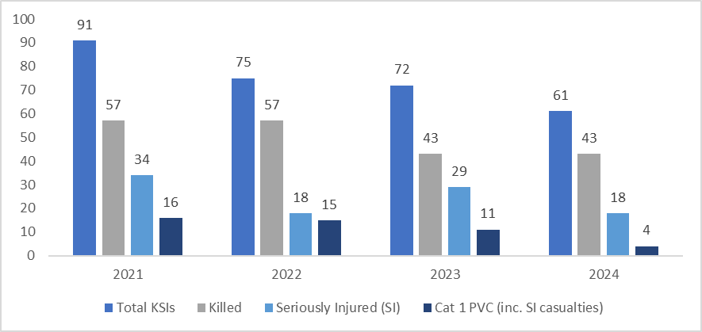
KSI casualties has experienced a -33% decrease over the 4 years’ period, with 30 less KSI casualties, and year-on-year reductions. The number of fatalities has remained stable for the last 2 years with 43 for 2023 and 2024, however, these are lower than the previous 2 years with 57 fatal casualties. The number of Seriously Injured casualties was 18 during 2024, a reduction on 2023. The Cat 1 PVC casualties have also seen year-on-year reductions.

It could be argued that a factor towards the decrease in fatal numbers and an increase in serious injury numbers is due to improvements in car safety features and road layout, and thus a collision that would historically have been fatal is now causing serious injury instead. The Kent and Medway Safer Roads Partnership will continue to analyse this data to inform activity.

Enforcement – ‘Fatal 4’ data
Kent Police maintains a focus on the offences that have the most impact on road deaths, commonly known as the ‘Fatal Four’ which are speed, not wearing seatbelts, driving whilst impaired, and use of mobile phones. During the reporting period, the below table shows the enforcement undertaken by way of automated and mobile cameras, and roadside Traffic Offence Reports, across these four areas:
 | Speed Enforcement | Mobile Phone Enforcement | Seatbelt Enforcement | Drink/Drug Drive Arrests
April 21 – March 22 | 79,613 | 947 | 1,819 | 3,347
April 22 – March 23 | 66,093* | 1,938* | 2,086* | 3,502
April 23 – March 24 | 80,877 | 1,718 | 2,449 | 3,650
April 24 – March 25** | 72,857 | 565 | 33 | 3,406
*Excludes data from October and November 2022
**2024/25 data is currently incomplete with data still working through the system.

Working alongside Divisional teams, the Force has dedicated functions in this area, in the form of the Roads Policing Unit, the Road Safety Unit, and a Special Constabulary Roads Policing Unit; all of whom work to the Force’s priorities and support Vision Zero and national campaigns. The teams continue to use a number of proactive tactics and operations to educate, prevent and enforce road safety, and the number of officers training in Tru Cam enforcement, which can detect multiple offences at one time, has also increased.

Priority: Protect Young People and Provide Opportunities

Child Protection

FY Period | Recorded Crime | % Change | Number change
April 2021 - March 2022 | 11999 | 42.1% | 3554
April 2022 - March 2023 | 11963 | -0.3% | -36
April 2023 - March 2024 | 12339 | 3.1% | 376
April 2024 - March 2025 | 12321 | -0.1% | -18
4 years’ difference |  | 2.7% | 322

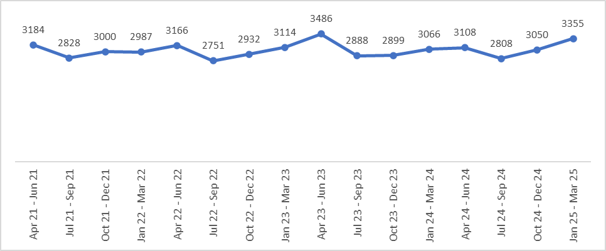

Child Protection related offences have experienced an increase of 2.7% (322 more offences) over the 4 years’ period. During 2024/25, there was a -0.1% decrease (18 less offences) compared to the previous year. The highest volumes are in April to June each year, with July to September accounting for the lowest volumes. This is likely attributable to the long school holidays over the summer. Whilst most notifiable offences have experienced reductions, Stalking and Harassment and Sexual Offences have seen increases.

During the reporting period, there has been a 15.2% (+496) increase in suspects arrested and interviewed for Child Protection offences. The Solved Rate for 2024/25 is 8.8%; an increase of 2.5% compared to the previous year. Charges have experienced a 35.4% increase (+194 charges) to 742, with CRs increasing by 97.4% (+113) to 229. An additional 7 Adult Cautions were administered during 2024/25, with 8 less Youth Cautions compared to the previous financial year.

Cadets and Mini Cadets

The Cadet Programme in Kent has evolved significantly since its inception, with schemes for Junior Cadets, Senior Cadets and Mini Cadets all fully established. Such has been their success, that the Scheme was awarded The King’s Award for Voluntary Service in 2024. The award is the highest recognition a voluntary group can receive in the UK and is the equivalent to a collective MBE. This followed an intensive year-long assessment process involving local and national assessors who examine policies, processes, results and community impact of volunteer groups, as well as conducting interviews and surveys.

This is the second time Kent Police has been recognised for the exceptional quality of its volunteering programmes, having had the Kent Special Constabulary awarded with the Queen’s Award for Voluntary Service back in 2014 as aforementioned. Kent Police is the only organisation in the UK to have been awarded both. The numbers of Cadets for the reporting period are shown in the below table:

 | Senior Cadets | Junior Cadets | Mini Cadets
April 2021 | 311 | 0 | 12*
April 2022 | 368 | 0 | 89
April 2023 | 408 | 13 | 31**
April 2024 | 360 | 40 | 113
March 2025 | 388 | 35 | 140
* First Mini Cadet pilot
** Numbers impacted temporarily by a change in the policing model at that time

The Mini Cadet Programme is the most recent scheme to have been launched, and has proven very popular, enabling Kent Police to engage with 1358 children across 121 schools in the county to date. The Mini Cadet programme is run by dedicated Kent Police volunteer leaders for primary school aged pupils and supports them to learn about helping people, teamwork, responsible citizenship, respect for others, staying safe at home and school, and how to contact emergency services.

The Cadet Schemes are run by a team of hugely dedicated and enthusiastic Volunteer Cadet Leaders who work tirelessly to support young people and provide them with opportunities. The Senior Cadet Programme by way of example, saw the Cadets and the Leaders between October and December 2024 volunteering 2,863 hours in their community, bringing the total of volunteering hours in the year to 13,373, and the total overall hours since the inception of the programme to 46,373.

- Conclusion

In summary, the Force’s Kent Police Pledge and Control Strategy have continued to work in harmony with the PCC’s Police and Crime Plan, focussing heavily on the areas of vulnerability, exploitation, high harm crime and abuse. As demonstrated in this paper, the Force continues to deliver positive outcomes for victims against an increasingly complex and challenging policing landscape.

However, the Force is not complacent and absolutely recognises the need to continuously improve and develop, to ensure the trust, confidence and safety of all those who live, work and visit Kent. The Force is fully supportive of the PCC’s new Police and Crime Plan ‘Cut Crime, Support Victims, Build Trust’ for 2025-29 and will strive to meet the vision and priorities set out, which complement our Pledge to provide a high-quality policing service with absolute integrity, to support and protect victims, and to catch criminals and solve crime.
APPENDIX A

Beating Crime Plan – National Measures

The following information is taken from the Digital Crime and Policing Pack produced by the Home Office, and therefore the date periods may differ for crime types.

- Neighbourhood Crime

Date Period | Recorded Crime | % Change | Number change
January 2021 - December 2021 | 15332 | -14.5% | -2606
January 2022 - December 2022 | 16812 | 9.7% | 1480
January 2023 - December 2023 | 15918 | -5.3% | -894
January 2024 - December 2024 | 16043 | 0.8% | 125

Although total Neighbourhood crime is currently on a 0.8% increase, with 125 more crimes on the previous year, compared to the baseline data of January 2019 to December 2019, Kent is seeing an overall decrease of -36% (-8908 crimes). There are 4 crime types under Neighbourhood Crime (NHC), Personal Robbery, Theft from the Person, Vehicle Crime and Residential Burglary. For the 12 months ending December 2024:
- Vehicle crime has seen a 3.6% increase (+339 crimes) on previous 12 months but below the December 2019 baseline (-30%, -4202)
- Personal robbery has seen a -6.8% decrease (-71 crimes) on previous 12 months and below the December 2019 baseline (-46%, -815)
- Burglary Residential has seen a -3.1% decrease (- 140 crimes) on previous 12 months and below the December 2019 baseline (-45%, -3541)
- Theft from the Person has seen an -0.3% decrease (-3 crimes) on previous 12 months and below the December 2019 baseline (-25%, -350)

- Serious Violence Measures

Offences involving firearms
Date Period | Recorded Crime | % Change | Number change
October 2020 - September 2021 | 136 | 30.8% | 32
October 2021 - September 2022 | 159 | 16.9% | 23
October 2022 - September 2023 | 98 | -38.4% | -61
October 2023 - September 2024 | 98 | 0.0% | 0

For the current 12 months’ period, offences involving firearms remains stable on the previous 12 months with 98 offences record and is below the December 2019 baseline (-11%, -12).

Violence with Injury
Date Period | Recorded Crime | % Change | Number change
February 2021 - January 2022 | 17982 | 5.6% | 960
February 2022 - January 2023 | 18176 | 1.1% | 194
February 2023 - January 2024 | 17494 | -3.8% | -682
February 2024 - January 2025 | 16205 | -7.4% | -1289

For the 12 months to January 2025, there is a -7.4% decrease with 1289 less crimes, there has been a decrease for two consecutive years. Kent is also below the December 2019 baseline (-19%, -3733).

Robbery
Date Period | Recorded Crime | % Change | Number change
February 2021 - January 2022 | 1157 | -13.3% | -178
February 2022 - January 2023 | 1287 | 11.2% | 130
February 2023 - January 2024 | 1090 | -15.3% | -197
February 2024 - January 2025 | 1014 | -7.0% | -76

For the 12 months to January 2025, there is a -7.0% decrease with 76 less crimes, there has been a decrease for two consecutive years. Kent is also below the December 2019 baseline (-48%, -937).

Drug Crime
Date Period | Recorded Crime | % Change | Number change
February 2021 - January 2022 | 4301 | -6.3% | -288
February 2022 - January 2023 | 4529 | 5.3% | 228
February 2023 - January 2024 | 5229 | 15.5% | 700
February 2024 - January 2025 | 6211 | 18.8% | 982

For the 12 months to January 2025 there has been an +18.8% increase with 982 more Drug offences, there has been year on year increases and Kent is currently above the December 2019 baseline (+73%, +2613). There are 3 crime types under Drug crime, Trafficking, Possession and Possession of Cannabis.

For the 12 months ending January 2025:
- Trafficking has seen a +24.4% increase (+532 crimes) on previous 12 months and above the December 2019 baseline (+149%, +1623)
- Possession has seen a -17.0% increase (+157 crimes) on previous 12 months and above the December 2019 baseline (+74%, -459)
- Possession of Cannabis has seen a +14.2% increase (+ 299 crimes) on previous 12 months and above the December 2019 baseline (+28%, +534)

This offence type is influenced by proactive policing, levels and trends should not be considered a measure of criminal activity in relation to drugs. Kent continues to work in strong collaboration with partner agencies and other police forces sharing cross border information and intelligence.

Homicides
Date Period | Homicides (per Million) | Number
January 2021 - December 2021 | 4.7 | 9
January 2022 - December 2022 | 11.1 | 21
January 2023 - December 2023 | 6.9 | 13
January 2024 - December 2024 | 9.0 | 17

Increase for the 12 months to December 2024 to 17 from 13 on the year before however, below the England & Wales average of 10.2 per million.

