Chief Constable’s Report
to
Kent Police and Crime Commissioner’s Performance and Delivery Board

POLICE AND CRIME PLAN: CUT CRIME, SUPPORT VICTIMS, BUILD TRUST
Wednesday 26th November 2025

- Strategic Overview

The Police Reform and Social Responsibility Act 2011 (Section 7) set the statutory requirement for the Police and Crime Commissioner (PCC) to have a Police and Crime Plan. This must set out the PCC’s vision and priorities for policing and community safety, as well as the objectives and ambitions that Kent Police will be held to account on.

The Police and Crime Plan set by the Kent PCC is called ‘Cut Crime, Support Victims, Build Trust’ which has been set in consultation with the Chief Constable and the public of Kent.

The Plan complements the Kent Police Pledge set by the Chief Constable, outlining his commitments to staff, our commitment to the public and our priorities and values. At the heart of the Pledge, there is a commitment to provide a high-quality policing service that is delivered with absolute integrity, to support and protect victims, and to catch criminals and solve crime.

Furthermore, the Force has a Control Strategy which sets out the operational priorities for crime prevention, intelligence and enforcement for 2025. The key crime types of focus for 2025 are aligned to the refreshed Police and Crime Plan, with a particular focus on violence against women and girls (VAWG), serious violence and harm, organised crime and exploitation.

Nationally, Kent Police is also committed to ensuring delivery against Government set direction and priorities within the ‘Strategic Policing Requirement’ and the ‘Safer Streets Mission’ (Appendix A), for which the PCC is also obligated to report on to the Home Office in the Annual Assurance Statement.

The following sections of the report provide a detailed analysis for the most recent quarter of Kent Police performance against an agreed set of measures within the four key priorities of the Police and Crime Plan, namely, Protecting People, Protecting Places, Protecting Property and Productive Partnerships.

- PROTECTING PEOPLE

Victim Based Crime

 | Rolling Year |  |  |  |  | Latest Quarter
 | RY Sep 25 | RY Sep 24 | % change | Number change |  | Jul - Sep 25 | Jul - Sep 24 | % change | Number change
Recorded crime | 135182 | 139742 | -3.3% | -4560 |  | 34591 | 35885 | -3.6% | -1294
Data Source: Athena

Victim Based Crime experienced a -3.3% decrease (-4,560) for the rolling year (RY) to September 2025 compared to the same period last year. The most recent quarter, July to September 2025, saw a decrease of -3.6% (-1,294). Following a high month in July 2025 (13,152 offences), the highest volume since August 2024, the following months saw continued reductions.

Despite the volume recorded in July 2025, the most recent quarter continues to see decreases across most crime types against last year, with continued reductions in vehicle crime (-22.4%, 464), Burglary business and community (-10.6%, -40), Burglary of an unconnected building (-46.1%, -194) and Violence against the person (-3.0%, -534), with reductions in both Violence with and without injury and also Stalking and harassment.

Increases continue against last year for overall Robbery (+51.0%, +131). As explained in the previous report, this is attributable to the change to the Home Office Counting Rules. Sexual offences are up +1.5% (+25), which is due to an increase in Rape offences (+3.6%, +16) and Other sexual offences (+14.7%, +68).

The Victim Based Crime solved rate for both rolling year and most recent quarter continues to increase. For the RY September 2025, the solved rate was 13.1% with 17,756 solved offences, up +1.5 from 11.6%. The most recent quarter Solved rate was 12.8% with 4,439 solved, up +1.8. The Force has seen an additional 359 charges for the rolling year with 11,675 being administered compared to the previous year. Community Resolutions have also seen a substantial increase for the rolling year, up +42.4%, with an additional 1,459 being administered.
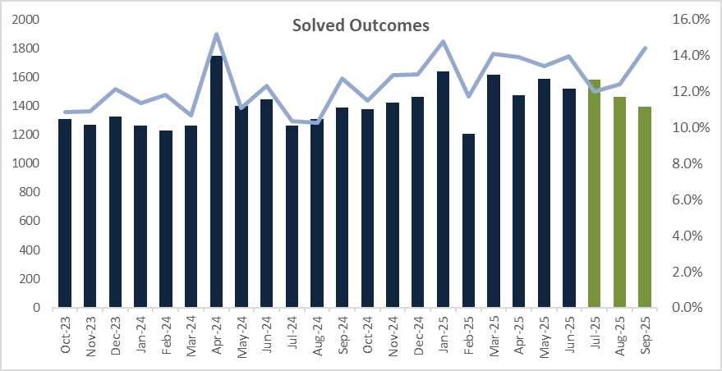
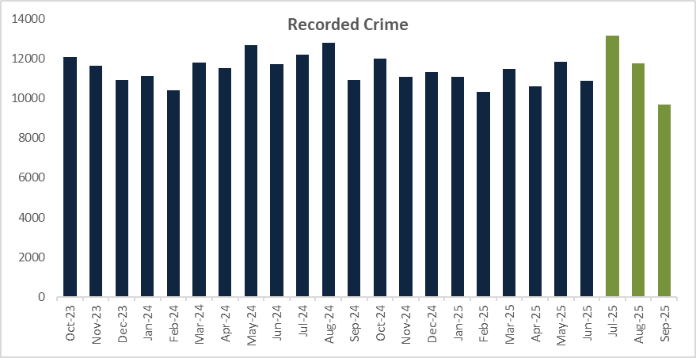

Violence Against Women and Girls (VAWG)

 | Rolling Year |  |  |  |  | Latest Quarter
 | RY Sep 25 | RY Sep 24 | % change | Number change |  | Jul - Sep 25 | Jul - Sep 24 | % change | Number change
Recorded crime | 35,512 | 37,155 | -4.4% | -1,643 |  | 9,268 | 9,792 | -5.4% | -524
Data Source: Athena

VAWG offences experienced a -4.4% decrease (-1,643) for RY September 2025 compared to last year. The most recent quarter saw a decrease of -5.4% (-524), with reductions in both Domestic Abuse related and Non-Domestic Abuse related offences across both time periods. Like Victim Based Crime, a high month was recorded in July 2025 (3,659 offences), the highest volume since July 2023, with the following months also seeing continued reductions.

The VAWG solved rate for both RY and most recent quarter continue to see increases. For the RY September 2025, the solved rate was 10.0% with 3,561 solved offences, up +0.7 from 9.3%. The most recent quarter was 9.9% with 915 solved, up +0.6 from 9.3%.

There are a number of offences where the victim withdraws / does not support police action following reports. For the RY September 2025, the victim withdraws rate was 48.5%, mostly attributable to Domestic Abuse related offences. Although high, the victim withdraws rate has decreased -0.2 from 48.7%.

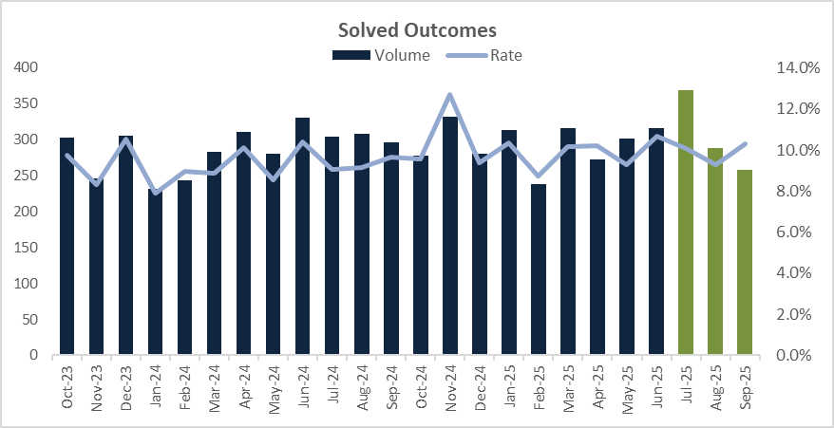
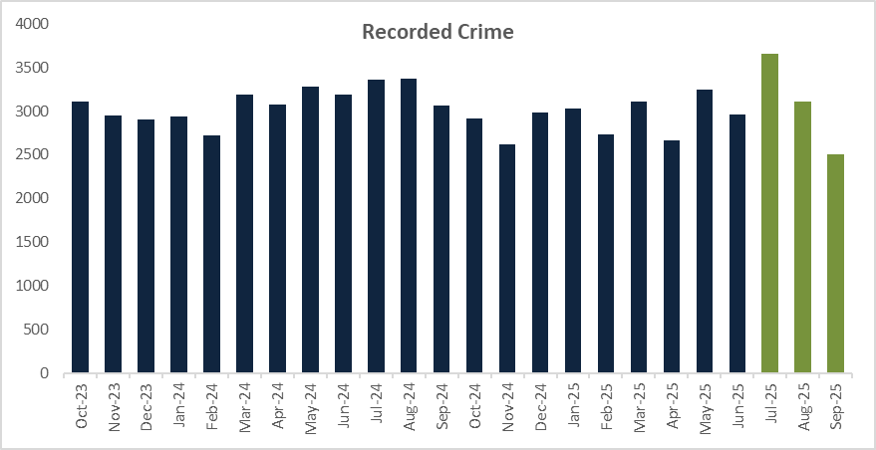

Rape and Serious Sexual Offences (RASSO)

 | Rolling Year |  |  |  |  | Latest Quarter
 | RY Sep 25 | RY Sep 24 | % change | Number change |  | Jul - Sep 25 | Jul - Sep 24 | % change | Number change
Rape | 1986 | 1903 | 4.4% | 83 |  | 463 | 447 | 3.6% | 16
Serious Sexual | 2806 | 2779 | 1.0% | 27 |  | 679 | 738 | -8.0% | -59
Data Source: Athena

Total Rape and Serious Sexual Offences experienced an increase of +2.3% (+110) for RY September 2025, with increases seen in both Serious Sexual and Rape offences. The most recent quarter overall has decreased -3.6% (-43) with a reduction in Serious Sexual offences (-8.0%, -59), whilst Rape offences has increased +3.6% (+16) on last year.

The Rape Solved rate for the RY was 8.2%, down -1.6 (9.3%). There has also been a decrease in the number of solved outcomes falling -13.4% (-116). Given the volumes and complexity of rape investigations, fluctuations may occur.

Although there has been a reduction in the solved rate for the RY September 2025, the victim satisfaction rate increased from 94.7% to 97.4% (+2.7).

Domestic Abuse (DA)

 | Rolling Year |  |  |  |  | Latest Quarter
 | RY Sep 25 | RY Sep 24 | % change | Number change |  | Jul - Sep 25 | Jul - Sep 24 | % change | Number change
Recorded crime | 27271 | 28460 | -4.2% | -1189 |  | 7124 | 7510 | -5.1% | -386
Data Source: Athena

DA continues to experience a reduction on last year with a -4.2% decrease (-1,189) for the RY September 2025, the most recent quarter has also seen a reduction, down -5.1% (-386). Although offences have reduced, the number solved continues to increase. The solved rate for RY September 2025 was 9.9%, up +0.5 from 9.4%. The most recent quarter solved rate has also seen an increase from 8.8% to 9.8%.

Satisfaction of DA victims has seen a small decrease for RY September 2025; down -0.2 to 93.5% being satisfied with the service they received from Kent Police.

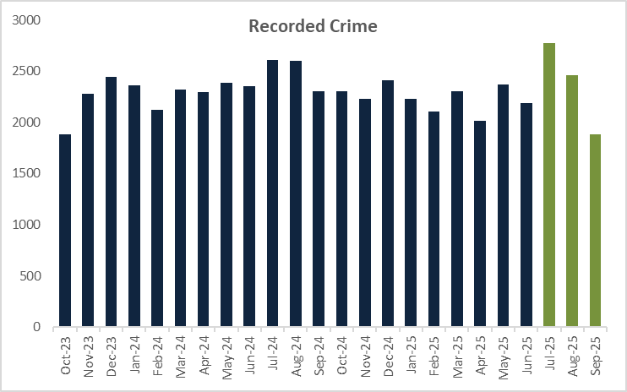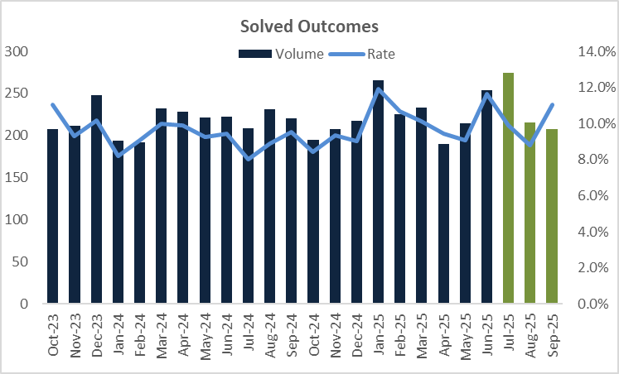

Serious Violence

 | Rolling Year |  |  |  |  | Latest Quarter
 | RY Sep 25 | RY Sep 24 | % change | Number change |  | Jul - Sep 25 | Jul - Sep 24 | % change | Number change
Recorded crime | 15601 | 16247 | -4.0% | -646 |  | 4200 | 4236 | -0.8% | -36
Data Source: Athena

Serious Violence is defined as Homicide and Violence with Injury offences. For the RY September 2025, there has been a -4.0% decrease (-646), which is also reflected for the most recent quarter down -0.8% (-36).

Similar to other crime types, although offences have seen a reduction, crimes that have been solved has seen an increase. For the RY September 2025, the solved rate for serious violent offences was 17.0%, up +1.9 from 15.1%. Again, the most recent quarter solved rate has also increased from 14.1% to 16.1% compared to the same period last year.

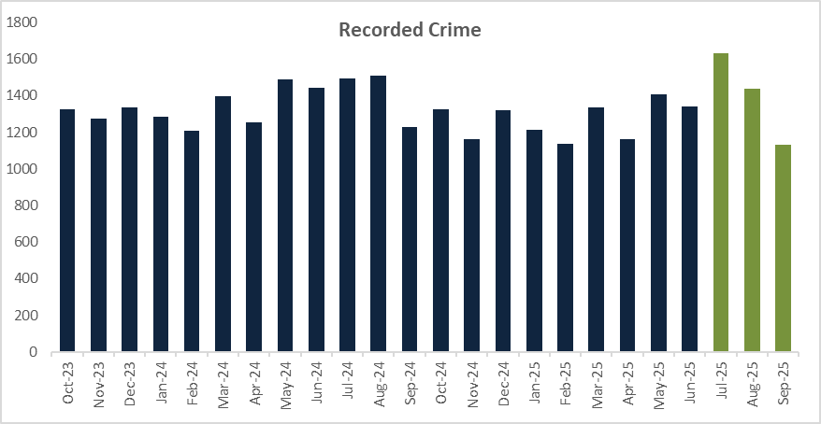

Knife Crime

 | Rolling Year |  |  |  |  | Latest Quarter
 | RY Sep 25 | RY Sep 24 | % change | Number change |  | Jul - Sep 25 | Jul - Sep 24 | % change | Number change
Recorded crime | 884 | 916 | -3.5% | -32 |  | 221 | 211 | 4.7% | 10
Data Source: Home Office published data

Knife crime is based on the Home Office Annual Data Requirement 160, therefore only provides figures for the following offences: Attempted murder, Assault with injury with intent to cause serious harm, Rape, Robbery, Sexual Assault and Threats to kill. For the RY September 2025, offences involving a knife or sharp instrument has seen a decrease of -3.5% with 32 less offences compared to last year. Despite there being a reduction for the RY, the most recent quarter has seen an increase of 4.7% with 10 more offences. This is attributable to a higher volume of offences reported in July 2025 with the following months seeing continued reductions.

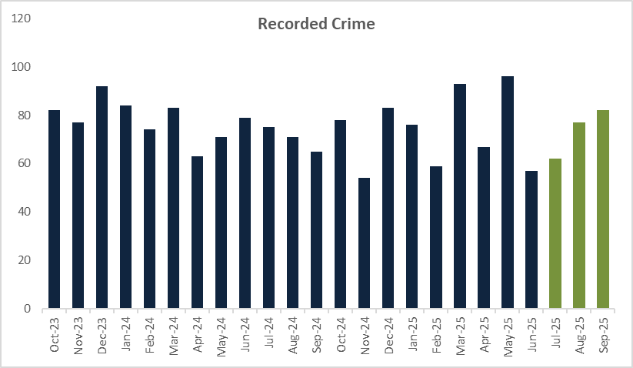

- PROTECTING PLACES

Calls for Service

 | Rolling Year |  |  |  |  | Latest Quarter
 | RY Sep 25 | RY Sep 24 | % change | Number change |  | Jul - Sep 25 | Jul - Sep 24 | % change | Number change
999 call volume | 366,129 | 368,219 | -0.6% | -2090 |  | 101,528 | 99,909 | 1.6% | 1619
999 Call Attrition | 0.49% | 0.28% | 0.21 |  |  | 0.50% | 0.34% | 0.16
101 call volume | 253,781 | 261,335 | -2.9% | -7554 |  | 67,935 | 69,933 | -2.9% | -1998
101 Call Attrition | 2.92% | 3.67% | -0.75 |  |  | 3.59% | 3.75% | -0.16
Digital Contact volume | 263,921 | 247,502 | 6.6% | 16419 |  | 70,829 | 65,376 | 8.3% | 5453
Total Calls for Service | 883,831 | 877,056 | 0.8% | 6775 |  | 240,292 | 235,218 | 2.2% | 5074
Data Source: Openscape

For the RY September 2025, there has been a +0.8% increase with 6,775 more Calls for Service compared to the previous year. Whilst both 999 and 101 call volumes continue to see a decrease, digital contact continues to increase with members of the public choosing to report online, via live chat or through Single Online Home. Digital contact is up +6.6% with an additional +16,419 on the previous year.

For the most recent quarter, the Force has seen a small increase in 999 calls, up 1.6% (+1,619) on the same quarter last year. Digital contact is also up +8.3% (+5,453). However, 101 calls, are down for the quarter, -2.9% with -1,998 less calls. Demand in July 2025 for total calls for service was at its highest with 87,112 calls for service – this is the greatest volume seen since July 2023 (87,236).

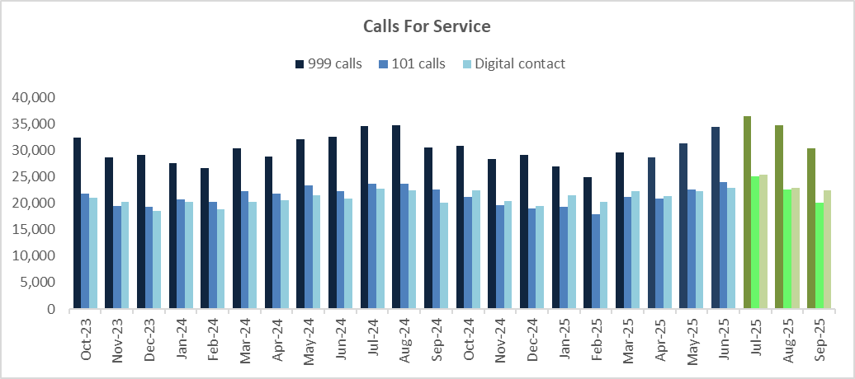

Anti-Social Behaviour

 | Rolling Year |  |  |  |  | Latest Quarter
 | RY Sep 25 | RY Sep 24 | % change | Number change |  | Jul - Sep 25 | Jul - Sep 24 | % change | Number change
Total ASB | 29680 | 27143 | 9.3% | 2537 |  | 9907 | 7939 | 24.8% | 1968
Data Source: STORM Command and Control

There has been a +9.3% increase (+2,537) for the RY and the most recent quarter has seen a +24.8% increase (+1,968) on last year. This is likely in part to be due to a change in recording practices which took place in June 2025, and as such the impact was minimal compared to the current quarter. The Force will therefore continue to monitor the volumes to assess the comparable changes, complemented by the ongoing work of the Neighbourhood Policing Teams in this regard.

Rural Crime

There is no set national definition of rural crime and therefore may encompass a broad range of offences occurring in non-urban areas, including agricultural theft, livestock rustling, fly-tipping, and wildlife crimes. It is a term used to describe criminal activities and ASB that specifically impacts rural communities.

Due to the changing landscape of wards in Kent, those that may have once been classed as rural, land and housing development may now class them as an urban area. Kent Police is not able to define rural or urban wards currently and therefore the below figures are based on offences of theft of agricultural / farming equipment and wildlife offences recorded under the Home Office Counting Rules.

 | Rolling Year |  |  |  |  | Latest Quarter
 | RY Sep 25 | RY Sep 24 | % change | Number change |  | Jul - Sep 25 | Jul - Sep 24 | % change | Number change
Recorded crime | 615 | 613 | 0.3% | 2 |  | 159 | 142 | 12.0% | 17
Data Source: Athena

There has been a +0.3% increase (+2) for the RY compared to the same period last year. The small increase is due to theft of agricultural / farming equipment, as for both time periods there have been no wildlife offences recorded. The most recent quarter to September 2025 has also seen an increase in offences compared to last year as well as on the previous quarter.

There has also been an increase in the solved rate for both the RY September 25 and the most recent quarter. The RY is up +0.2 to 3.3% with 20 offences solved, whilst the most recent quarter has a solved rate of 3.1% up +1.0 with 5 offences solved.

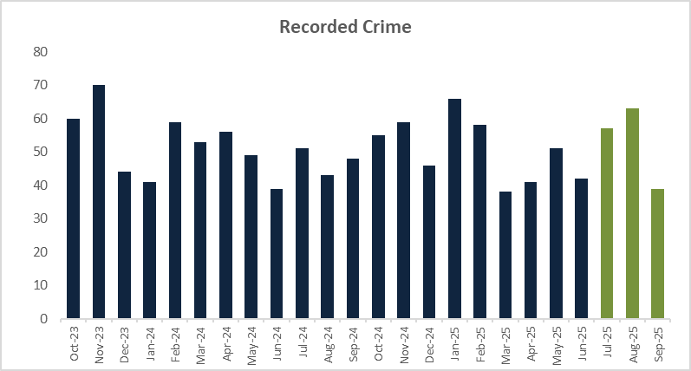

Road Danger/Vision Zero

 | Rolling Year |  |  |  |  | Latest Quarter
 | RY Sep 25 | RY Sep 24 | % change | Number change |  | Jul - Sep 25 | Jul - Sep 24 | % change | Number change
Killed or seriously injured volume | 49 | 73 | -32.9% | -24 |  | 14 | 12 | 16.7% | 2
Data Source: CRASH National Reporting system

The number killed or seriously injured (KSI) on Kent roads continues to see a reduction for the RY, down -32.9% (-24). However, the most recent quarter has seen a very small increase up +16.7% (+2). A higher volume of those KSI were recorded in August 2025 (11 reports), with July and September seeing 2 and 1 reports respectively.

Enforcement

Kent Police continue to focus on the offences that have the most impact on road deaths, commonly known as the ‘Fatal 4’ which are speed, not wearing seatbelts, driving whilst impaired and the use of mobile phones. During this reporting period, numerous Traffic Offence Reports have been issued for the following offences:

 | Speed | Mobile Phone/ Distraction | Seatbelt | Impairment Arrests
July 2024 | 5446 | 112 | 190 | 229
August 2024 | 10484 | 89 | 161 | 262
September 2024 | 6491 | 4 | 84 | 245
Total | 22421 | 205 | 435 | 736
July 2025 | 7585 | 90 | 210 | 275
August 2025 | 8738 | 32 | 137 | 275
September 2025 | TBC | TBC | TBC | 238
Total | 16323 | 122 | 347 | 788
* September figures are still being processed

- PROTECTING PROPERTY

Residential Burglary of a Home

 | Rolling Year |  |  |  |  | Latest Quarter
 | RY Sep 25 | RY Sep 24 | % change | Number change |  | Jul - Sep 25 | Jul - Sep 24 | % change | Number change
Recorded crime | 2347 | 2895 | -18.9% | -548 |  | 587 | 680 | -13.7% | -93
Attendance Rate | 98.3% | 99.3% | -0.7 |  |  | 98.5% | 99.3% | -0.7
Data Source: Athena

Residential Burglary of a home has seen a -18.9% decrease (-548) for the RY September 2025 and a -13.7% decrease (-93) for the most recent quarter compared to the same period last year. Residential burglary continues a decreasing trend and has been since the end of the COVID pandemic in 2021. The solved rate for the RY September 2025 was 7.3%, a decrease of -4.2 on the previous year (11.5%), the most recent quarter also saw a decrease in solved rate, down -1.2 from 7.8% to 16.6%.

Attendance at Residential Burglary sits at 98.3% for the RY and 98.5% for the most recent quarter, both minimal decreases on the previous year. For the RY, there were 41 not attended, and for the most recent quarter 9 not attended. It should however be noted that there may be specific reasons for why these burglaries were not attended such as a victim refusing attendance or being away for an extended period of time.

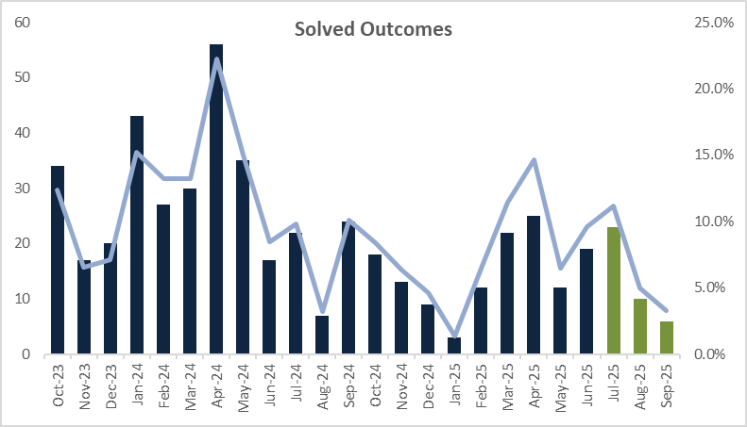
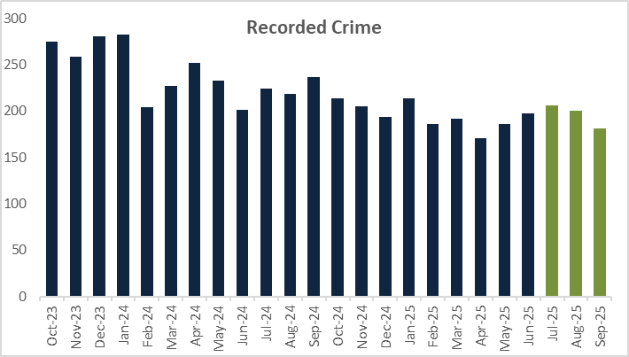

Retail Crime

 | Rolling Year |  |  |  |  | Latest Quarter
 | RY Sep 25 | RY Sep 24 | % change | Number change |  | Jul - Sep 25 | Jul - Sep 24 | % change | Number change
Shoplifting | 17416 | 15516 | 12.2% | 1900 |  | 4365 | 4040 | 8.0% | 325
Business Robbery | 440 | 69 | 537% | 371 |  | 218 | 12 | 1716% | 206
Data Source: Athena

Shoplifting offences has seen a +12.2% increase (+1,900) for the RY and the most recent quarter also shows an increase of +8.0% (+325) compared to last year. As mentioned in the Victim Based Crime update, there has been a change to the Home Office Counting Rules regarding Business Robbery and this may begin to impact Shoplifting volumes, and so the position in this regard will continue to be monitored.

The Solved rate for Shoplifting offences has increased by +2.5 from 30.1% to 32.6% for the RY and is up +2.3 from 28.3% to 30.6% for the most recent quarter. An additional 192 solved outcomes were administered between July and September 2025 and an additional 1,008 for the RY September 2025.

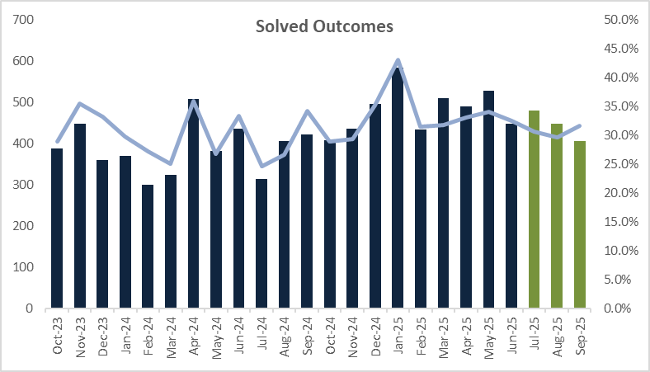
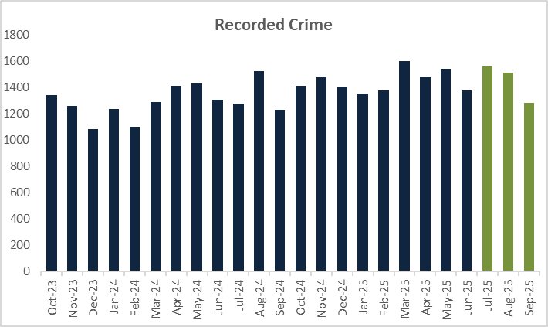

Business Robbery continues to see a substantial increase for both the RY and the most recent quarter following the definition in the Home Office Counting Rules introduced in April 2025. The volume of Business Robbery offences increased by 371 for the RY and 206 for the most recent quarter. Due to the change, data will not currently be comparable.

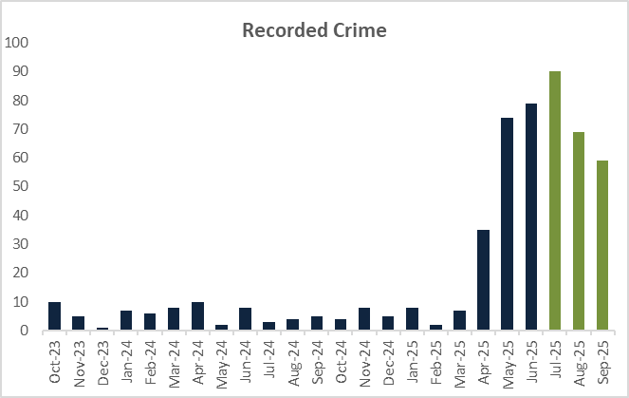

Vehicle Crime

 | Rolling Year |  |  |  |  | Latest Quarter
 | RY Sep 25 | RY Sep 24 | % change | Number change |  | Jul - Sep 25 | Jul - Sep 24 | % change | Number change
TOMV | 3582 | 4130 | -13.3% | -548 |  | 881 | 1008 | -12.6% | -127
TFMV | 3053 | 4272 | -28.5% | -1219 |  | 722 | 1059 | -31.8% | -337
Vehicle Crime | 6635 | 8402 | -21.0% | -1767 |  | 1603 | 2067 | -22.4% | -464
Data Source: Athena

Overall Vehicle Crime has seen a -21.0% decrease (-1,767) for the RY and a -22.4% decrease (-464) for the most recent quarter, with both Theft of Motor Vehicle and Theft from Motor Vehicle seeing reductions.

Despite there being a reduction in recorded offences, the solved rate for Vehicle Crime has increased by +0.9, up from 3.5% to 4.4% for the RY. The Theft of Motor Vehicle solved rate was 6.0% (+2.5), whilst Theft from Motor Vehicle was 2.6% (-0.9).

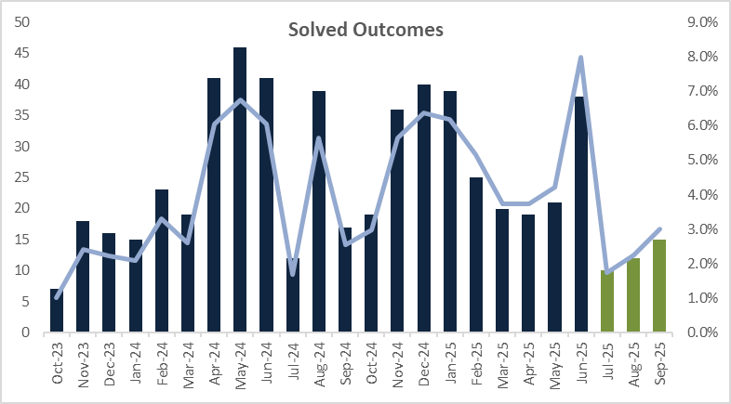
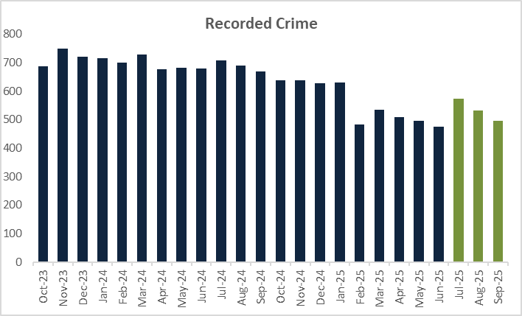

Personal Robbery

 | Rolling Year |  |  |  |  | Latest Quarter
 | RY Sep 25 | RY Sep 24 | % change | Number change |  | Jul - Sep 25 | Jul - Sep 24 | % change | Number change
Recorded crime | 758 | 992 | -23.6% | -234 |  | 170 | 245 | -30.6% | -75
Data Source: Athena

Personal Robbery has decreased by -23.6% (-234) for the RY and by -30.6% (-75) for the most recent quarter. Lower volumes continue to be recorded compared to previous months. There was a small increase in volume in August 2025, but this has since reduced for September 2025. Solved rate has also experienced a small reduction, down -0.6 from 15.9% to 15.3% for the RY. There have been 42 less outcomes administered compared to last year.

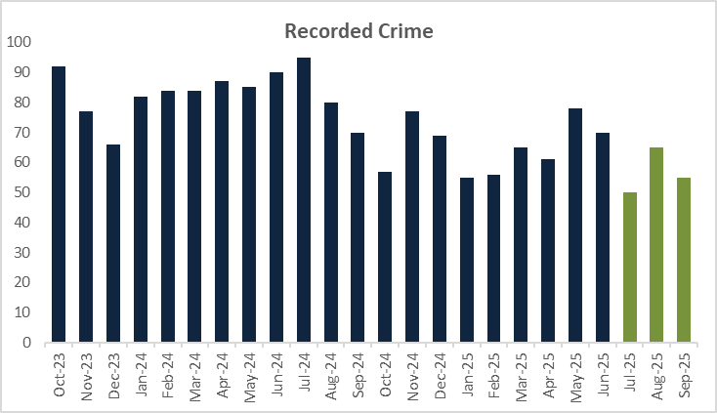

Online Related Offences

 | Rolling Year |  |  |  |  | Latest Quarter
 | RY Sep 25 | RY Sep 24 | % change | Number change |  | Jul - Sep 25 | Jul - Sep 24 | % change | Number change
Recorded crime | 12553 | 11475 | 9.4% | 1078 |  | 3317 | 2932 | 13.1% | 385
Data Source: Athena

Recorded offences with an online marker have seen an increase of +9.4% (+1,078) for the RY and a 10.8% increase (322 more offences) for the most recent quarter. This is reliant on the marker being added to crime reports, therefore may not be indicative of reporting trends but an increase in data accuracy.

For the most recent quarter, the top five offences where the online marker was applied were:
- Harassment – 1,025 offences, this includes putting people in fear of violence.
- Stalking offences – 393 offences, this includes pursue course of conduct in breach of Section 1.
- Obscene Publications – 389 offences, this is mainly to take or make or distribute indecent photographs of children.
- Malicious Communications – 348 offences, this includes sending communication threatening death or serious harm.
- Blackmail – 258 offences.

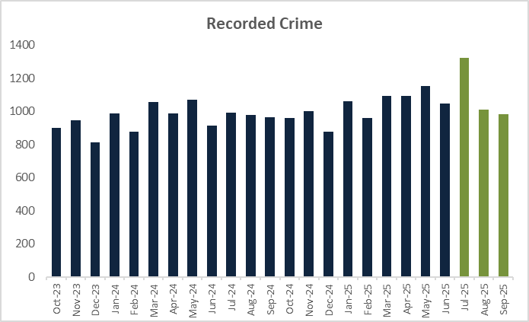

- PRODUCTIVE PARTNERSHIPS

Mental Health

 | Rolling Year |  |  |  |  | Latest Quarter
 | RY Sep 25 | RY Sep 24 | % change | Number change |  | Jul - Sep 25 | Jul - Sep 24 | % change | Number change
Section.136 Detentions | 752 | 727 | 3.4% | 25 |  | 207 | 163 | 27.0% | 44
Concern for Welfare incidents | 39028 | 39415 | -1.0% | -387 |  | 10734 | 10099 | 6.3% | 635
Concern for Welfare incidents resourced | 21260 | 20924 | 1.6% | 336 |  | 5822 | 5442 | 7.0% | 380
Misper/ Absconder (Care or Hospital) incidents | 12729 | 12786 | -0.4% | -57 |  | 3070 | 3488 | -12.0% | -418
Misper/ Absconder (Care or Hospital) incidents resourced | 8631 | 8189 | 5.4% | 442 |  | 2084 | 2346 | -11.2% | -262

For the current quarter July – September 2025, there has been an increase of +27.0%, 44 more, Section 136 detentions. This is predominantly attributable to higher volumes in July and August 2025 compared to the previous year.

Concern for welfare incidents have seen a -1.0% decrease (-387) for the RY, despite the reduction in total incidents. The Force has deployed resources to more incidents, up +1.6% (+336) on last year.

The most recent quarter also shows an increase in total incidents and those resourced, with the total incidents up +6.3% (+635) and those resourced up +7.0% (+380) for the current quarter.

Total Missing Person/Absconder (Care or Hospital) incidents have decreased for both the RY and most recent quarter, down -0.4% (-57) and -12.0% (-418) respectively. However, for the RY, the Force has resourced to more incidents, up +5.4% (+442). During the most recent quarter, as with total incidents, resourcing has shown a reduction, down -11.2% (-262).

CONCLUSION

In summary, the Force’s Pledge and Control Strategy are aligned to work in harmony with the PCC’s new Police and Crime Plan for the next four years. As demonstrated in this paper for this reporting period, the Force continues to deliver positive outcomes for victims against an increasingly demanding, complex, and challenging policing landscape. However, the Force is not complacent and absolutely recognises the need to continuously improve and develop, to ensure the trust, confidence and safety of all those who live, work and visit Kent.

