Performance and Delivery
People Paper – December 2024

1. Introduction
The following briefing paper provides an update with regards to the progress against the force’s headcount requirements, as well as an update on recruitment, application numbers, officer entry routes and examples of activity to promote recruitment and workforce diversity.
In addition, an update on the current PCSO establishment versus strength position has also been provided, which can be found under section 6 and an update on absence, which can be found under section 7.
2. Recruitment Plan
The force headcount as at 31st March 2024 (most recent national milestone) was 4225, which was 2 over the headcount requirement of 4223.

2024/25 Recruitment Plan
As previously reported, the force has had confirmation that for the 2024/25 financial year the maintenance headcount requirement is officially set at 4223. This is the original maintenance headcount requirement of 4218 and the additional recruitment allocation of 5 (totalling 4223).

So far, this financial year to date (April to October 2024), there have been a total of 166 joiners, of which 161 joined as a new recruit (the most recent intake being for 99 on 30th September 2024), 2 have joined under the re-joiner programme and 3 have transferred in from other forces.
There is a recruitment plan in place for the remainder of the 2024/25 financial year, which aims to recruit up to a further 137 officers. Whilst this is subject to change due to factors such as variations in attrition, the recruitment plan is currently made up of 2 further intakes totalling 135 new recruits (Jan 25 and Mar 25) as well as 5 further transfers in throughout the financial year. The next intake is scheduled for 27th January 2025 of up to 43. The recruitment pipeline is strong enough to increase this intake if attrition requires.
College of Policing Entry Route Update
The force launched the new non-accredited entry route – Police Constable Entry Programme (PCEP) in July 2024, with the second intake in September 2024. Currently there are 60 PCEP officers at KPC with plans for a further 62 to be recruited this financial year. The quality assurance and inspection process saw the forces achieve excellent feedback and authorisation to deliver the new product. Further work has been undertaken to optimise the PCDA and DHEP programmes, which are now aligned, with greater emphasis on the vocational focus, including the operationalisation of some assessments.

The forces signed off a new pricing model for PCDA students which, will see the income rise from £1825 per officer to, on average, £4500 per officer over the course of the 3 year programme.

Following communication from NPCC on 21st October 2024, there are future opportunities to draw down additional funding per officer as well as revising the assessment methodology, allowing ‘on the job’ assessment to count towards the End Point Assessment (EPA). Forces will have more flexibility to consider alternatives to the current EPA model, which provides an opportunity to reduce operational abstraction further from 1st April 2025. The finer detail is not yet known; however engagement has commenced with the College of Policing to develop a revised model.

3. Diversity Application Data and Force Representation
Applications
The table below shows the total number of new police constable applications received, broken down by standard entry and the bespoke detective Investigate First Programme for 2019/20, 2020/21, 2021/22, 2022/23, 2023/24 and 1st April to 4th November 2024. This is also broken down by ethnicity and gender:

For the period 1st April to 4th November 2024, there were a total of 1384 applications. Of those, 12.57% were from ethnic minority candidates, and although this is lower than in the previous 2 financial years, it is higher than the proportion of applications in each financial year from 2019/20 to 2021/22. For information, the proportion of 12.57% for this period is higher than the latest economically active population of 11.29% (2021 census).

With regards to gender, 35.62% of applications were from females, which is slightly lower than the 2023/24 full financial year (36.26%) and, of note, the Investigate First Programme continues to attract a high proportion of female applications (45.86%).

The proportion of Investigate First applications from ethnic minority candidates is 13.80%, which is lower than the last full financial year but higher than each of the previous 4 financial years.

In respect of the current overall police officer recruitment pipeline, as at 4th November 2024 there were 525 applications in process. Of the 525, a total of 207 (39.43%) are female and 45 (8.57%) are ethnic minority.

Section 5 provides further information regarding local and national work to promote recruitment.

Force Representation Data: Ethnicity & Gender
As at 31st October 2024, there were 155 (3.79%) ethnic minority officers in force. This is a marginal reduction when compared to the last update as at 31st July 2024 (157 / 3.82%). With regards to female officers, the headcount is currently 1474, which equates to 35.58%. Of note, the current headcount is an increase when compared to the last update (1448 as at 31st July 2024), and the current proportion of 35.58% is the highest on record.

With regards to recruitment for 2023/24, of the total 166 joiners (all entry routes), 8 were ethnic minority (4.82%) and 70 were female (42.17%). At the time of writing (18th November 2024) there are already 3 ethnic minority candidates cleared for the January 2025 intake and a further 4 in process (for a total intake of up to 49). If all are successful, this would equate to 14.29% of the intake.

4. Local & National Work to Enhance Recruitment (including diversity)
Human Resources Corporate Recruitment Team working closely with the Internal Inclusion team review all outreach events and activities to ensure targeted recruitment amongst diverse communities, using best practice and targeted events with finite resources. The outreach seeks to build trust and confidence within the communities and offer interaction with police officers to inspire applications.

The Internal Inclusion team have established a school and college engagement programme with Kent based schools to engage with those students who are completing public and uniformed services courses. The purpose of this engagement is to encourage prospective candidates to engage in the recruitment pathway into policing with a focus on those from under-represented backgrounds. The aims and objectives are to utilise their interest in public service and overcome the perceived barriers to applying for Kent Police.

The Positive Action Engagement Programme (PAEP) programme offers all individuals who classify themselves as ethnic minority, a structured and supported provision to support their potential application. This includes 1-2-1 support, guidance, signposting, support workshops and access to a bespoke positive action support webpage. This support programme is also offered to all eligible ethnic minority candidates who have been unsuccessful at any part of the recruitment process and wish to re-apply.

Since its inception in June 2022, 157 ethnic minority candidates have actively been engaged with. As of 12th November 2024, there are 4 active candidates currently enrolled in the programme, some of whom have been unsuccessful during the recruitment process and are now receiving positive action support, others are new applicants looking for support pre-application. This programme is further supplemented by the positive action support workshops together with the existing buddy scheme, which provides support to all prospective candidates. Overall, since the beginning of the programme, there have been 32 applications. These have included 6 new applications, 18 candidates that have re-applied after failing the application process and 8 candidates who were able to be reinstated back into the process without the need to re-apply from the start. Since its inception there have been 8 ethnic minority candidates join the organisation who would not have done so had it not been for the intervention of the PA engagement process.

The uptake of candidates enrolling in the PAEP continues to be an area of focus. A new tracking process that signposts prospective candidates directly to the programme through a QR code is now utilised by recruitment ambassadors at outreach events to improve the PAEP engagement rates. This process has been running for 6 weeks and has captured data from 25 prospective candidates, who will receive directed communications to encourage applications.

Outreach and Marketing continue to drive interest and applications during this period. During the last reporting period there have been 27 outreach events with a reach of 283 people, 56% of whom were ethnic minorities and 40% were females. The outreach has been wide ranging across the County. The force continues to use social media to positively represent the force, the most recent campaign has been a series of #morethanthebadge podcasts which has sought to shine the light on the personal aspects of being an officer. The force has released 6 podcasts over the last couple of months. Each of the podcasts consists of a dialogue between two members of Kent Police with a significant focus on the person behind the uniform. The guests have included, CC Tim Smith, S/Sgt Opaleye KPM, D/Ch Supt Shaun White and others. The series has resulted in 1,640 downloads, and 5,730 video views.

5. Local & National Work to Enhance Retention
Leaver Analysis
The 2024/25 recruitment plan is based on a projection of 27.00 fte leavers per month, however, the plan is able to flex with attrition fluctuations. For the period 1st April 2024 to 31st October 2024, the average officer leavers were slightly below forecast with an average of 25.97fte.

Resignations continue to be the primary leaver type, with 103 officers resigning in the period 1st April 2024 and 31st October 2024. Across the same period other leavers include 45 retirements, 23 transfers to other forces (including non-home office forces) and 12 leavers for other reasons, including dismissals, ill-health retirement and death in service.

Young in-service officers make up the largest proportion of resignations. Of the 103 officer resignations this financial year to date, 78 (76%) were from officers with less than 5 years’ service. This compares favourably to the 2023/24 year end outturn, which was 81.7% and is also closer to the ‘National Attrition Analysis 2023/24’, which reported the national position for less than 5 years’ serving officers resignations as 72.1%.

The most stated primary reasons for resigning from the young in service are, ‘Alternative employment’ and ‘Health related’. However, the new framework of leaver reasons allows for richer analysis of secondary and contributing reasons, which paints a more accurate picture of the often complex and multifaceted factors surrounding the decision to leave. ‘Better paid jobs outside police service, ‘impact of job on personal life’, and ‘Workload/demand’, are further identified as significant contributors.

At the time of writing (7th November 2024) there are 19 confirmed officer leavers for November 2024, which is below the forecast of 27, and unlikely to increase much further within the month due to the requirement to give a notice period. December has 9 confirmed leavers currently, which is likely to increase. Whilst the attrition continues to fluctuate, the projected attrition remains at 27 per month for the remainder of the financial year. For information, the monthly average leavers for April to October 2024 is 26 per month.

The young in service leavers position continues to support the findings of the ‘Deep Dive’ analysis completed in April 2024 and the resulting ‘Retention Action Plan’. This plan was developed to draw together initiatives in the key identified areas of recruitment, training, interventions and improving understanding of leaver reasons. Specifically, HR Operations, together with L&D, Health Services and Recruitment have focussed on the key areas of:

Improving candidate and recruitment information and engagement with the realities of the officer role - the candidate briefing was refreshed in June 2024 to reinforce the realities of the role and Recruitment Ambassador training was held in October 2024, with the theme and discussion on identifying people who are ‘ready to join.’

Implementing the ‘Touch Point Plan’ to set out the support for student and young in service officers - the L&D foundation training leads have planned in specific support at the key touchpoints throughout probation, including the crucial transition from college to initial posting. This is integral within the welcome pack/handbook that all students receive.

Engaging with district commanders to deliver continuing support upon posting - Foundation Managers and Supervisors have established monthly meetings with district commanders to discuss the initial engagement with new officers arriving on local teams and with those who have recently achieved independent status, as well as the ongoing support for performance and attendance.

Refreshing the leaver process specifically to improve the ‘human’ aspect and user experience - interviews with people who are engaged in the leavers process, (i.e. those who have handed in their notice) have been completed to get ‘customer experience’ feedback and perspective. Early indications are the ‘tone’ of the process can be improved, to be more engaging and recognising of the public service leavers have provided and encourage openness and honesty in discussing leaver reasons.

Reviewing, streamlining and promoting the Retention Ambassador programme - the force Retention Ambassador programme continues to deliver effective early interventions. There are 44 ambassadors spread across 12 commands, who have delivered 73 interventions with individuals since the programme launched in June 2023. There has been a 56% retention success rate, that is measured as individuals remaining employed following the intervention.

To improve the access to retention support, the central referral process has been replaced with a direct contact approach, facilitated via contact details on the webpage. This cuts out bureaucracy and time delays and delivers named support more quickly. News feeds and command team engagement has taken place to promote the programme. Further CPD for the Ambassadors is planned in quarterly sessions in conjunction with leadership training team.

More broadly the force highlights retention initiatives and the positive aspects of working within the organisation through its ‘Keep it Kent’ SharePoint web pages. This includes information, advice, and guidance about:

- Health and Wellbeing support
- Financial wellbeing support
- Development opportunities
- Promotional opportunities
- Flexible working
- Career breaks
- Posting exchange initiative
6. PCSO Update
The PCSO strength was 75.79 fte as at 31st October 2024, which is 25.71 fte under the establishment of 101.50 fte.

An intake of 7.00 PCSOs joined on the 13th May 2024, and a further intake of up to 16 is scheduled for November 2024, with 15 candidates already successful and offered at the selection process and a further 4 in pre-employment.

7. Attendance and Wellbeing
The following table shows the breakdown of average days lost per person for April to October for each year from 2016 to 2024.
The table demonstrates that, for April to October 2024 officers average days lost per person (5.15) is lower than when compared to the previous year (5.23), however, it higher than the 6 years prior to this.
The average days lost per person for April to October 2024 for staff (inc PCSOs) (5.92) is higher than the last 8 years.

Officers

The next graph shows the officer month-on-month absence, in hours lost per person, for 2021/22 to 2024/25.

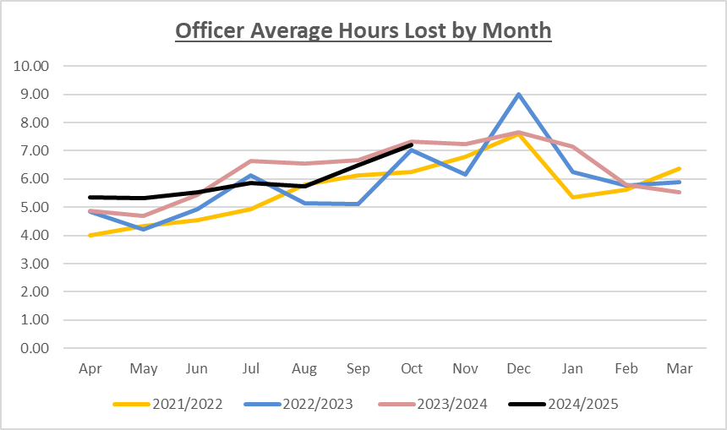
For officers, the graph demonstrates that absence was higher for the first three months of 2024/25, however, positively it has been lower in every month from July 2024 to October 2024 when compared with the same months last year. The most recent month saw 7.22 average hours lost per person compared to 7.33 for October 2023.
With regards to Commands, positively, a total of 12 Commands have lower average days lost per person for the period April to October 2024 compared to the same period in 2023. Notably Crime & Incident Command have one of the highest average days lost per person (11.14), however this is a reduction of 0.38 when compared to the same period last year (11.52).

When reviewing Commands with an average headcount of 25 and over, only 4 have increased, with the most notable being South East Regional Organised Crime Unit (2.15 to 6.89 average days lost per person). However, it should be noted they only have an average headcount of 25, meaning any absence has a greater impact on the figures. Other Commands of note are East Division, which has increased by 1.38 average days lost per person (from 5.26 to 6.64) and Student Constables (from 1.92 to 2.52). With regards to East Division, this predominantly relates to increases in VIT, CID, CSU, VBCT and LPT.

Serious Crime Command has also increased (from 2.49 to 3.29), however positively, this is lower than the force average days lost per person (6.89) so not a significant area of concern. With regards to the other Divisions, North Division has reduced from 6.34 to 6.07 and whilst West Division has increased from 3.86 to 5.05, it is the lowest of the 3 divisions and lower than the force average.

With regards to absence reasons, psychological related absence continues to account for the highest proportion of payroll hours lost for officers (40.72%), however when measured as average days lost per person it has reduced by 0.17 from 2.27 to 2.10. Miscellaneous absence accounts for the second highest proportion of payroll hours (13.02%) and when measured as average days lost per person has increased from 0.61 to 0.67. Other general sickness reasons that have increased by more than 0.03 average days lost per person are digestive (from 0.41 to 0.46), genito/urinary from 0.12 to 0.16, nervous system from 0.02 to 0.06 and respiratory from 0.95 to 0.63.

Staff (including PCSOs)

The following graph shows the staff (including PCSOs) month-on-month absence, in hours lost per person, for 2021/22 to 2024/25.

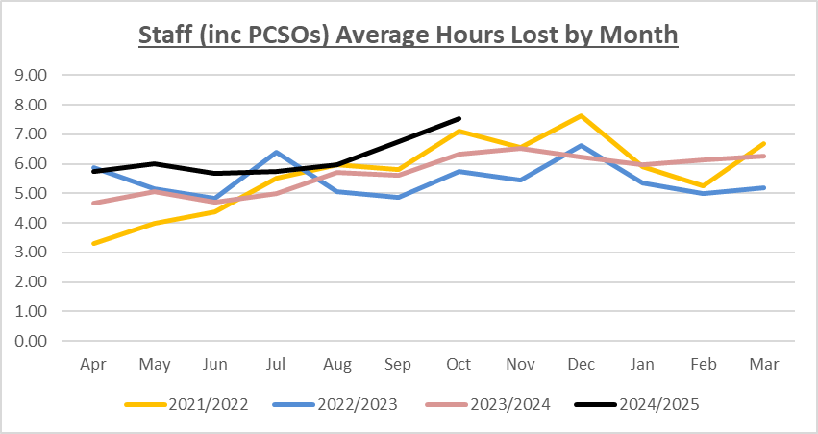

For staff (inc PCSOs), the average hours lost per person were higher in all months so far in 2024 when compared to the same months last year.

With regards to Commands, there have been increases across 14 commands and reductions in 9 commands during the period April to October 2024 compared to the same period in 2023.

Some of the most notable reductions were in Strategic Prevention Command (from 7.66 to 2.68, East Division (from 5.17 to 3.72) and Learning & Development (from 4.09 to 3.36). There were also notable reductions in the Diversity & Inclusion Command and Chief Constables Office however both have low headcounts.

Of the remaining Commands, with a headcount of greater than 25, West Division have the highest average days lost per person (12.58), but this is a reduction when compared to the same period last year (13.20). Other Commands of note are Crime & Incident Response Command who have the third highest average days lost per person (8.74), which is also an increase compared to the same period last year (from 7.61). Professional Standards have increased from 5.77 to 8.00 and Kent Criminal Justice Command have increased from 4.56 to 6.65.

With regards to reasons, for staff (including PCSOs), psychological related absence accounts for the highest proportion of payroll hours lost (30.02%). When measured as average days lost per person it has increased from 1.51 to 1.78. Miscellaneous related absences account for the second highest proportion of payroll hours lost (20.53%) with the average days lost per person also increasing from 0.86 to 1.21, which also represents the greatest increase across the sickness reasons. Other general sickness reasons that have increased by more than 0.03 average days lost per person are cardiac/circulatory (from 0.26 to 0.41), digestive from 0.48 to 0.53, headache/migraine from 0.14 to 0.19 and nervous system from 0.01 to 0.12.

Performance Improve Unit (PIU) & Operational HR

The increase in absence levels has been acknowledged across the force and work is being undertaken at all levels to ensure ongoing support and interventions aimed at reductions. This is being led with strategic oversight through the Force Performance Committee and Chief Officer Management Board whereby actions have been set for Heads of Department to develop bespoke updates on action being taken within their command to help the reduction of staff absence. As a direct result HR Business Partners are in liaison with commands to undertake deep dive reviews in certain areas, PCSOs for example, or to support the design and implementation of strategic intervention groups. These will allow for review specifically the application of force policy, understanding the reason for the increases in absence and to put in place mitigation/plans to ensure a high level of public service is maintained in accordance with the Force Plan.

The PIU and Operational HR retain a focus on attendance through advice and guidance at Local AWMG meetings, assessing the consistency of management interventions to address attendance concerns and enhance compliance with policy L180 Attendance Management continues.

In addition, bi-monthly Attendance Review meetings remain ongoing to ensure holistic trends are identified, actions set, and the HR/PIU teams are aware of best practice and trends to deliver to and support local departments. This meeting is supported by Health Services to ensure all opportunities for support have been explored. The PIU continues to lead on the analytical review of absence data to ensure Heads of Command have accurate information to focus efforts to improve attendance of their staff. Focus areas are identified, and HR/PIU review the processes and interventions in place in those commands to improve the consistency of management interventions being completed.

In response to the increasing absence, the PIU introduced a ‘consultation’ level of intervention to bridge the gap between a ‘quick phone call’ and the Advice Request. A consultation constitutes a significant input from a PIU advisor, and generally the outcome is tangible (such as, PDR objectives, recommendations for an Attendance Support Meeting (ASM) and providing assistance with a plan). Data results show that this intermediate level of support and advice is being utilised. For the six-month period April 2024 to September 2024 53 interventions have been recorded.

Equally, Operational HR in response have commenced an internal absence oversight and review meeting whereby on a bi-monthly basis HR Business Partners and HR Advisers will present HR updates on the top long-term sickness, top Bradford scores and longest recuperative cases. The aim of the oversight meeting is to aid the HR Advisers with guidance to progress cases, to review barriers and to ensure consistency in policy application.

The number of total absence interventions for the six-month period April 2024 to September 2024 indicates an up-turn in overall numbers when compared to the previous six-month period Oct 2023-March 2024, and with the same months 2023.

The number of ASMs recorded for officers for the April-September 2024 period was 255, this was slightly lower than October 2023-March 2024 (308), albeit above the 354 recorded for the same months in 2023. The downturn following the peak winter months would be expected taking into consideration seasonal variations.

The number of ASMs recorded for Police Staff for the April-September 2024 period was 94, this was slightly above October 2023-March 2024 (69) and compares with 91 ASMs recorded for April-September 2023. Also, these figures only record ASM for Police Staff submitted for recording to PIU and do not include other Command/Divisional attendance interventions implemented locally such as Attendance Support plans.

Attendance related Advice Requests have seen a decrease through the April-September 2024 period; 19 have been recorded, which compares with 27 for October 2023-March 2024 and 50 for April-September 2023. However, this downturn should be viewed within the context of the ‘Consultation’ numbers, with attendance related consultations averaging between 8-10 per month.

In the first six months of 2024/2025 there have been four Written Improvement Notices (UPP Stage 1) issued under the UPP regulations. For police staff, 22 formal stages capability processes have been undertaken across all 3 stages in the protocol.

In addition to command led interventions, other force wide workstreams and initiatives continue to be progressed to support a reduction in absence, the Attendance Support Meeting (ASM) form is in the final stage of approval through Operational HR and PIU, this will support the ongoing focus in supporting individuals whilst managing attendance utilising attendance support plans. The next phase in this process has commenced to develop a communication and implementation plan for delivery in early 2025. The implementation plan will include a ‘soundbite’ video, refreshed training inputs which will be shared with Commands and drop in sessions with PIU and Op HR.

Inputs on the ‘Be the Change’ courses and specific CPD sessions for managers continue, with positive feedback, this helps our supervisors and managers better understand processes and tools to manage absence and provide support. Along with colleagues from Health Services the series of CPD sessions, which covered reasonable adjustments, managing risk, managing attendance and creating a supportive environment, will be re-run in November 2024 and a direct communication has been sent to all line managers to encourage attendance at these sessions.

The PIU Head of Department continues to chair the monthly Adjusted Duties Panel for officers, which ensures a consistency of approach, along with representation from the Police Federation, Human Resources and HR Resourcing, across the Force in the cases where officers have permanent workplace adjustments. Every quarter, Command leads are also invited to attend.

Current analysis is being undertaken by the PIU to fully understand the numbers of officers progressing to Adjusted Duty status.

Health and Wellbeing

Occupational Health

The combined FMA and OHA referral to appointment waiting time for the first half of the financial year reduced significantly to 11.4 working days, from the previous 17.5 working days, which was reported for the full 2023/24 financial year. The current (November 2024) waiting time is less than 10 working days, delivering a responsive Occupational Health advice service for the force.

The Occupational Health referrals for the full financial year 2023/24 totalled of 2218 and in the first six months of this financial year, 1134 have been received, equating to 1152 appointments. The projection therefore remains fairly stable for the remainder of this financial year, with only a slight increase projected (2268 referrals and 2304 appointments based on performance rates to date).

Further Occupational Health development and engagement work is underway with innovation and ideas identified from a working group. A development plan is in place with a number of initiatives being progressed, including the re-launch of the manager advice line, clinician outreach activity in 2025 and a client survey form to fully understand how the value of the interventions is perceived. This is supported by the FMA service which now includes an opportunity for the managers to discuss the more complex cases directly with the FMA both pre and/or post the consultation.

Recruitment medicals remain a priority for the Health Surveillance team, in addition to the Hepatitis B vaccination programme and health surveillance activity.

Counselling

The in-house counsellors continue to focus on cases where risk, trauma exposure or a Professional Standards (PSD) element exists, with other matters being referred to the Employee Assistance Programme for support. Furthermore, the team continue to utilise signposting and referral options, (for example to charities), to support access to services. In addition, and to mitigate waiting times further, the team have one part time volunteer and five student counsellors, who as part of their contact hours (150 per person) are also supporting the department. This provides resource to the department and provides them with a placement and mentoring support as they complete their qualification.
Suicide Prevention Month was held in September 2024, with one of the virtual inputs being delivered by the Director of the National Police Wellbeing Service, Mr Andy Rhodes, QPM, OBE. The team also supported and promoted this year’s national Investigator Wellbeing Week of Action being held in November.

In respect of the Sleep Fatigue Recovery Programme (SFR) which was introduced in the last report, 18 out of 20 devices have now been issued to participants within the FCIR. Individuals are activating their devices throughout November, commencing data collection over a period of 120 days. This project sees critical contribution from a control room environment to the national research in the area of fatigue, a priority for the National Police Wellbeing Service. Further feedback will be reported as the project progresses in 2025.

OPAS G2 system

Health and Wellbeing Services have implemented the new OPAS-G2 system, which automates and manages workflows and data for all Health and Wellbeing services, such as management and self-referrals, pre-placement processing, vaccinations, health surveillance, physiotherapy, high risk roles assessments and counselling. The system technical go live within Health and Wellbeing services was delivered as per plan on 6th November 2024 and the projected roll out to the force is scheduled for 14th November 2024.

For the first time, managers will have access to the system with a simplified referral process and individuals referred for services will access their reports within the system. As the workflow is within the G2 system, there will be reduced reliance on attaching documents to emails and thus an increase in data security. In addition, managers will be able to view reports and statistics relating to their teams and have the ability to track the progress of a referral from submission to completion via a dedicated manager dashboard. Organisational level data is also much easier to collate through this system, aiding internal health performance management.

This represents a new means of interaction between Health and Wellbeing Services and will be a much more streamlined way of working for all officers and staff.

