Joint Audit Committee
17 September 2026
Treasury Management
Q1 2026/27 Report

Background

The Chartered Institute of Public Finance and Accountancy (CIPFA) code states clearly that effective scrutiny of the treasury management activities of the Police and Crime Commissioner (PCC) should be delegated to an independent body. The PCC has decided that the Joint Audit Committee (JAC) would be the most appropriate body for this role. This report fulfils the duty to provide a quarterly report on the treasury management activities alongside the treasury management prudential indicators to the committee.

This report outlines the treasury management activities of the PCC for the first quarter of 2026/27. Please note: some tables are reported at the end of July to provide the latest available position.

Key messages
- All treasury activity complied with the approved Treasury Management Strategy (TMS) and CIPFA Code.
- No breaches of prudential indicators or counterparty limits occurred.
- Cash balances were elevated during the period due to timing of income/expenditure.
- No further borrowing is currently forecast for 2026/27, subject to cashflow monitoring.
- Investment returns remain broadly in line with market conditions and approved risk appetite.

Balance Sheet

The Capital Financing Requirement (CFR) represents the authority’s underlying need to borrow to fund capital expenditure. It shows the cumulative amount of capital spending that has not yet been financed by capital grants, capital receipts or revenue contributions and indicates the level of debt that must be supported over the long term. This is updated annually.

Table 1: Balance Sheet Summary
 | 31.3.26  Actual  £m | 31.3.27  Forecast  £m
General Fund Capital Financing Requirement (CFR) | 98.5 | 90.1
Lease and PFI liabilities | -15.6 | -13.7
Loans CFR | 82.9 | 76.4
External borrowing | -36.2 | -23.5
Internal (over) borrowing | 46.7 | 52.9
Balance Sheet Resources | -64.3 | -64.3
Investments | 17.6 | 11.4
Treasury Investments | 17.6 | 10.0
New Borrowing/ (Investment) | 0.0 | -1.4
Net Loans Requirement | 18.6 | 12.1
Liquidity Allowance | 10.0 | 10.0
Liquidity Benchmark | 28.6 | 22.1
Investment Activity

The PCC’s investment strategy is set out in the TMS. The PCC’s objective when investing money has been to strike an appropriate balance between risk and return (minimising the risk of incurring losses from defaults and the risk of receiving unsuitably low investment income) and ensuring liquidity.

The PCC holds invested funds, representing income received in advance of expenditure plus balances and reserves held. During this period, the PCC’s cashflow balance has ranged between £7m and £59 million due to timing differences between income and expenditure, with an average balance of £36m. Not all of this cashflow is available for investment as some is required to manage those timing differences.

At the end of July, the PCC had investments totalling £61.7m with external borrowing of £27.6m leaving a net investment figure of £34.1m arising from its revenue and capital income and expenditure. Table 2 shows the approved investment counterparties and limits.

Table 2: Investment Balances

 | 31.03.26  Balance  £m | 31.03.26  Weighted Average  Rate  % | 31.07.26  Balance  £m | 31.07.26  Weighted Average  Rate  %
UK bank and building societies | 1.0 | 0.3 | 1.9 | 0.1
Local authorities | 0.0 | 0.0 | 5.0 | 0.3
Central government | 0.0 | 0.0 | 0.0 | 0.0
Money market funds | 12.2 | 3.8 | 50.4 | 3.4
Total | 13.2 | 4.1 | 57.3 | 3.8
Externally managed funds | 4.4 | N/A | 4.4 | N/A
Total | 17.6 | N/A | 61.7 | N/A

Investment Benchmarking

Arlingclose provide benchmarking information on a quarterly basis. This is information for their clients only; Chart 1 shows Kent PCC’s treasury position compared to other PCC and Fire authorities and local authorities as at 30th June 2026.

Chart 1: Investment Benchmarking
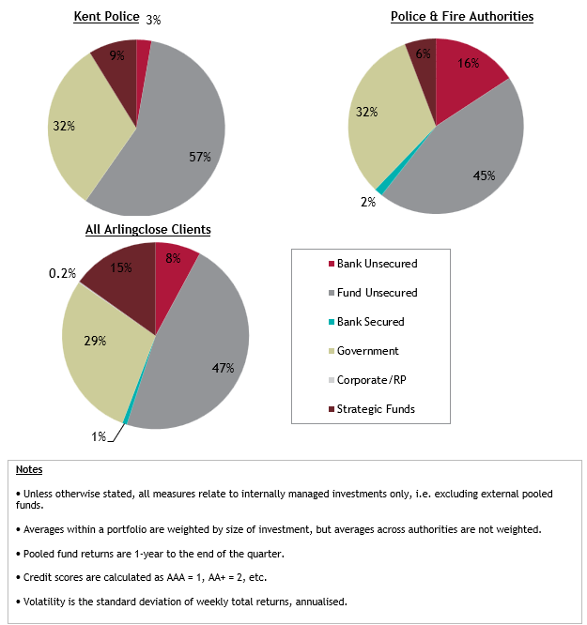

Although benchmarking information is helpful in understanding the wider strategy and risks, care should be taken when making direct comparisons as the size and governance of organisations can be markedly different. It should also be noted that even organisations of a similar size and set up can have a difference in their risk appetite.

Investment Performance

The PCC measures the financial performance of its treasury management activities against the return on investment. Table 3 shows the overall interest return and costs incurred.

Table 3: Overall Interest Return/ Costs
Interest/ Dividend Earned/ (Paid) to 31.07.26 | £m
Cash Balances | 0.064
Money Market Funds | 0.087
CCLA Dividend | 0.050
Total Interest Earned | 0.201
Interest paid on cashflow loans | (0.033)
Interest paid on PWLB loan | (0.687)
Total Interest/ Dividend Earned / (Paid) | (0.519)

Investment Limits

The PCC’s 2026/27 TMS clearly set out the limits for investment in banks, groups, fund managers, registered providers etc. This report confirms that during the period these limits were adhered to.

Risk

The principal treasury management risks remain credit risk, liquidity risk, and interest rate risk. These are managed through the approved TMS, counterparty limits, maturity limits and regular cashflow forecasting. No material changes to treasury risk exposure were identified during the period.

Borrowing Activity

The PCC has borrowed for cashflow purposes during 2026/27. This is where the cash balances on specific days are lower than expected or it is clear that borrowing will be required in future days. The PWLB loan was taken out in 2025/26 over 10 years. All borrowing was in line with the TMS.

The borrowing for the year is listed by maturity date below and includes those loans taken out in 2025/26 but repaid in 2026/27:

Table 4: Borrowing activity.
Date | Counterparty | Interest Rate (%) | Value (£m) | Maturity Date
30/05/25 | Local Authority | 4.50 | 10.0 | 01/06/26
01/06/25 | Local Authority | 4.05 | 3.0 | 01/06/26
01/06/26 | Local Authority | 4.05 | 5.0 | 01/07/26
01/06/26 | Local Authority | 4.05 | 2.0 | 01/07/26
21/01/26 | PWLB | 4.74 | 27.6 | 21/07/36

At this time, the future cashflow position for 2026/27 suggests that further borrowing this year will not be required.

Changes to the Treasury Management Strategy

There were no amendments required to the TMS since its approval in March 2026.

CFO Assurance and Compliance Statement
The PCC CFO can confirm that all treasury management activities undertaken in the first quarter of 2026/27 complied with the approved Treasury Management Strategy and the CIPFA Code.

Appendix A

Prudential Indicators

The PCC measures and manages its capital expenditure and borrowing with references to the indicators contained within the report and the following:
Table 1: Capital Financing Requirement (CFR)

The CFR measures the PCC’s cumulative outstanding amount of debt finance. This increases with new debt-financed capital expenditure and reduces with Minimum Revenue Provision (MRP), and capital receipts used to replace debt. The actual CFR is calculated on an annual basis.

 | 31.3.2026 actual £m | 31.3.2027 forecast £m | 31.3.2028 forecast £m | 31.3.2029 forecast £m
Total CFR | 98.5 | 90.1 | 87.0 | 85.2

Table 2: Gross Debt and the Capital Financing Requirement (CFR)

Statutory guidance is that debt should remain below the capital financing requirement, except in the short term. The PCC has complied and expects to continue to comply with this requirement in the medium term as is shown below.

 | 31.3.2026 actual | 31.3.2027 forecast £m | 31.3.2028 forecast £m | 31.3.2029 forecast £m
Debt (including PFI & leases) | 36.2 | 23.5 | 25.6 | 23.6
Capital Financing Requirement | 98.5 | 90.1 | 87.0 | 85.2

Table 3: Debt and the Authorised Limit and Operational Boundary:

The PCC is legally obliged to set an affordable borrowing limit (also termed the Authorised Limit for external debt) each year. In line with statutory guidance, a lower “operational boundary” is also set as a warning level should debt approach the limit.

 | Debt 31.07.26 | Forecast Maximum Debt 2026/27 | 2026/27 Authorised Limit  £m | 2026/27 Operational Boundary  £m | Complied?  Yes/No
Total debt | 27.6 | 27.6 | 120.00 | 90.00 | Yes

Since the operational boundary is a management tool for in-year monitoring it is not significant if the boundary is breached on occasions due to variations in cash flow, and this is not counted as a compliance failure.

Table 4: Proportion of Financing Costs to Net Revenue Stream:

Although capital expenditure is not charged directly to the revenue budget, interest payable on loans and MRP are charged to revenue.

The net annual charge is known as financing costs; this is compared to the net revenue stream i.e. the amount funded from Council Tax, business rates, and general government grants.
 | 2025/26 actual | 2026/27 forecast | 2027/28 forecast | 2028/29 forecast
Financing costs (£m) | 6.3 | 7.8 | 6.5 | 5.2
Proportion of net revenue stream (%) | 1.4 | 1.7 | 1.4 | 1.1

Table 5: Liability Benchmark:

This indicator compares the PCC’s actual existing borrowing against a liability benchmark that has been calculated to show the lowest risk level of borrowing. The liability benchmark is an important tool to help establish whether the PCC is likely to be a long-term borrower or long-term investor in the future and so shape its strategic focus and decision making. It represents an estimate of the cumulative amount of external borrowing the PCC must hold to fund its current capital and revenue plans while keeping treasury investments at the minimum level of £10m required to manage day-to-day cash flow.

This indicator shows that the level of borrowing will continue to increase to finance the capital programme, but this will result in matching rises in MRP and borrowing costs.
 | 31.3.26 | 31.07.26 | 31.3.27 | 31.3.28
 | Actual | Actual | Forecast | Forecast
 | £m | £m | £m | £m
General Fund CFR | 98.5 | 95.7 | 90.1 | 87.0
Less: Other debt liabilities (PFI, leases) | -15.6 | -13.7 | -13.7 | -11.6
Loans CFR | 82.9 | 82.0 | 76.4 | 75.4
Less: actual external borrowing | -36.2 | -24.9 | -23.5 | -25.6
Internal (over) borrowing | 46.7 | 57.1 | 52.9 | 49.8
Less: Balance sheet resources to fund internal borrowing | -64.3 | -64.3 | -64.3 | -64.3
Investments/ - new borrowing | 17.6 | 7.2 | 11.4 | 14.5
Treasury investments | 17.6 | 10.0 | 10.0 | 10.0
New borrowing (investment) | 0.0 | 2.8 | -1.4 | -4.5
Net loans requirement | 18.6 | 17.7 | 12.1 | 11.1
Plus: Liquidity allowance | 10.0 | 10.0 | 10.0 | 10.0
Liability benchmark | 28.6 | 27.7 | 22.1 | 21.1

Table 6: Maturity Structure of Borrowing:

This indicator is set to control the PCC’s exposure to refinancing risk. The upper and lower limits on the maturity structure of all borrowing were:
 | Upper Limit | Lower Limit | 31.07.2026  Actual | Complied?
Under 12 months | 100% | 0% | 0% | Yes
12 months and within 24 months | 100% | 0% | 0% | Yes
24 months and within 5 years | 100% | 0% | 0% | Yes
5 years and within 10 years | 100% | 0% | 100% | Yes
10 years and above | 100% | 0% | 0% | Yes

Table 7: Long-term Treasury Management Investments:

The purpose of this indicator is to control the PCC’s exposure to the risk of incurring losses by seeking early repayment of its investments. The prudential limits on the long-term treasury management limits are:
 | 2025/26 | 2026/27 | 2027/28 | 2028/29
 | Actual | Forecast | Forecast | Forecast
Limit on principal invested beyond year end | £10m | £10m | £10m | £10m
Actual principal invested beyond year end | £4.4m | £4.4m | £4.4m | £4.4m
Complied? | Yes | Yes | Yes | Yes

Long-term investments with no fixed maturity date include strategic pooled funds, real estate investment trusts and directly held equity but exclude money market funds and bank accounts with no fixed maturity date as these are considered short-term.

