Date:30th August 2026

Summary Report for Kent Police Audit Committee on Internal Audit Recommendations

Section 1:

The update in respect of the future 26/27 audit plan can be seen below.

Audit | Planned start | Status
Victim Services | September 2026 | Fieldwork in progress
OPCC Risk Management | September 2026 | Draft report
Follow Up | September 2026 | Fieldwork in progress
Governance | 09/09/2026
Cryptocurrency | 19/10/2026
Strategic Resourcing - Protected Learning Time | 03/11/2026
IT Business Continuity (Joint with Essex Police) | 10/01/2027
Complaints | 13/01/2027
Capital Accounting | 04/02/2027
High Risk Evidential Property | 03/03/2027
VAT Health check | Q3/4 TBC

The update in respect of the audit work completed 26/27 can be seen below.

Audit | Assurance | Sponsor | Low | Medium | High
Payroll 1.26.27 | Substantial Assurance | Jonathan Castle | 0 | 0 | 0
Force Risk Management | Substantial Assurance | Claire Medhurst | 2 | 0 | 0
Section 2: Audits awaiting draft report or in draft status

Report Name | Update
Follow up Audit APS | Draft
OPCC Risk Management | Draft

Section 3: Audit summary.
The following table shows all live reports for Kent and shows the total amount of high, medium and low recommendations set per report, how many remain outstanding or are awaiting implementation. Recommendations outside of their due date are stated in the last column, and detailed updates follow in Section 5.
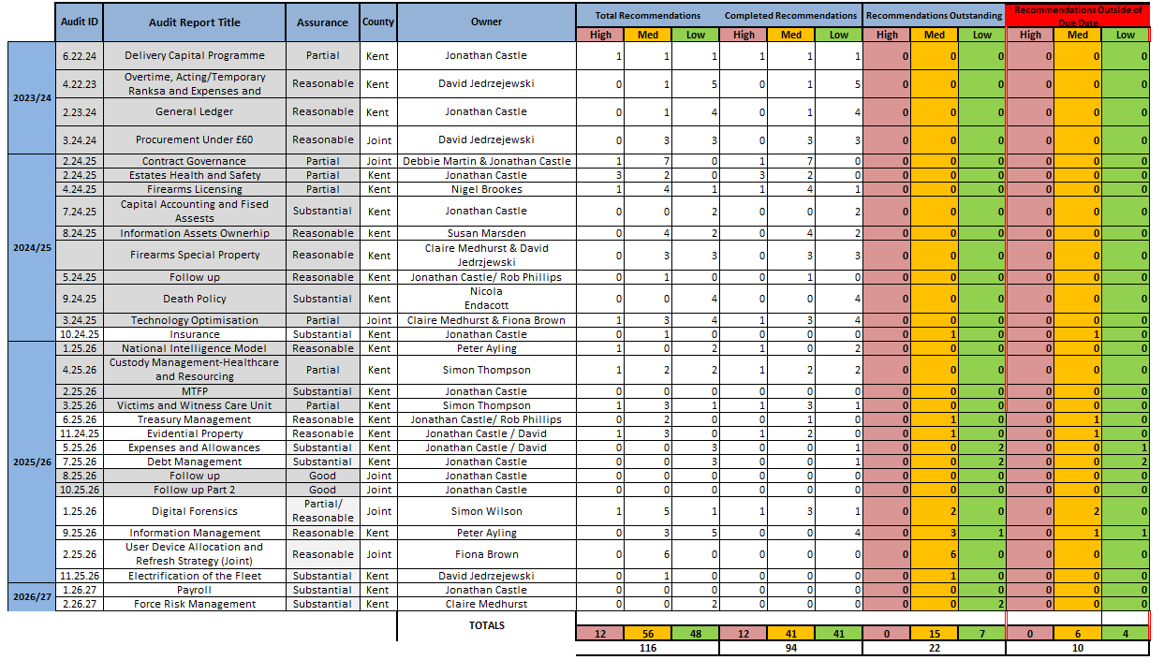
All actions associated with the years 2018 through to 2023 have been reviewed and confirmed as completed. As a result, these years have been removed from the current table above to streamline the report and ensure focus remains on outstanding or ongoing matters.

Section 4:
Recommendations signed off since the last meeting.

Audit Name | Audit Number | Recommendation | Risk | Deadline | Signoff Date
Expenses and Allowance | 5.25.26 | 2 | Low | 31/03/2026 | 5/08/2026
Debt Management | 7.25.25 | 2 | Low | 31/05/2026 | 27/08/2026
Digital Forensics (Joint) | 1.25.26 | 3 | Medium | 30/06/2026 | 27/08/2026
Digital Forensics (Joint) | 1.25.26 | 6 | Medium | 30/06/2026 | 27/08/2026
Digital Forensics (Joint) | 1.25.26 | 1 | High | 30/06/2026 | 27/08/2026
Digital Forensics (Joint) | 1.25.26 | 7 | Low | 30/06/2026 | 27/08/2026
Digital Forensics (Joint) | 1.25.26 | 2 | Medium | 30/06/2026 | 27/08/2026
Contract Governance | 2.24.25 | 1 | Medium | 30/06/2026 | 27/08/2026

The JAC have requested that any actions previously closed due to being superseded were listed here. No additional ones have been added since the last JAC. Please see below:
Audit Name | Audit Number | Recommendation | Risk | Deadline | Comment
Overtime, Acting/Temporary Ranks and Expenses and Allowances | 4.22.23 | 2 | Low | 31/03/2024 | Whilst not fully completed, signed off on the following basis:  - There is only one non-mandatory field as it stands and that is “brief description”.  - There is going to be a complete revamp of the overtime form with a new system that will fully incorporate all changes.  Therefore, this is superseded by that change.
Health and Safety | 3.22.23 | 1 | Low | 10/08/2023 | This Action rather than it being completed normally it was completed due to being superseded by H&S Audit action 2 which remains open still.
Medium Term Financial Plan, Budget Setting, Control and Monitoring | 18.20.21 | 10 | Medium | 31/03/2022 | Please note that they are closed not due to completion but due to being superseded by an action in the new capital delivery report
Key financial controls and month end procedures | 19.20.21 | 3 | Medium | 31/03/2022 | Please note that they are closed not due to completion but due to being superseded by an action in the new capital delivery report. Same action as above
Key financial controls and month end procedures | 19.20.21 | 5 | Medium | 31/12/2021 | Please note that they are closed not due to completion but due to being superseded by an action in the new capital delivery report. Same action as above
Managed Data Centre Effectiveness | 4.23.24 | 3 | Medium | 31/12/2024 | Closed, but not full implemented.  Since the audit ITS have documented into a single spreadsheet the resilience arrangements that are in place for each critical operational system and infrastructure solution, this was not available previously, although the knowledge sat with teams and was recorded against individual systems, this means in the event of an incident that affects more than one system there is an overview that the Critical Incident Commander can refer to, to advise gold and support decision making, alongside the Silver/Resilience plan
Essex and Kent Police Collaboration -  Recharges | 7.18.19 | 1 | Medium | 02/06/2025 | At the JAC pre-brief meeting, the audit Chair agreed that as Kent had discharged all their duty in this respect, the action could be closed despite Essex not finalising their element.
Information Asset Ownership | 8.24.25 | 5 | Medium | 30/11/2025 | There is also one action that is not showing as overdue but relates to an action that was overdue but now closed due to being superseded.

Section 5:
Reports and recommendations outside of due dates

Year | Audit Report Name | Audit Number | Priority | Recommendation | Number | Agreed Implementation Date | Expected Completion Date | Responsible Owner | Update
2025/26 | Treasury Management | 6.25.26 | Medium | We will review and update the Service Level Agreement with Kent County Council on  a periodic basis to ensure that the terms, responsibilities, and service expectations  remain current and aligned with operational and regulatory requirements | 2 | 30/04/2026 | 30/04/2027 | Rob Phillips | We have had a meeting with KCC to discuss, and they are now working on an updated SLA. Not yet complete but making progress.
2024/25 | Insurance | 10.24.25 | Medium | The Force will reconsider digitalising the PVIR Forms so that they automatically upload the  claims data into the LACHS System | 1 | 30/03/2026 | 31/12/2026 | Matthew  Chinavicharana Mole | The work to digitise the PVIR form is currently on the IT programme, but due to other ongoing commitments, it will not be completed until the end of the year.
2024/25 | Evidential Property | 11.24.25 | Medium | A command level report will be introduced which highlights all seized evidential property to  the Superintendents that has been booked out to the OIC’s within their command or division  for a period which exceeds seven days. | 2 | 30/06/2026 | 11/09/2026 | Caitlin Sullivan and Julia  Coddington | We have received the requested report from the supplier of the property management system and this is being demonstrated at the Evidential Property Oversight Group on 11th September.
2025/26 | Expenses and Allowance | 5.25.26 | Low | The SOP will be updated to reiterate that meal allowance claims can only be made on an individual basis, claims for multiple individuals are not permitted as in certain circumstances, subsistence can be liable to income tax. The current SOP is in the process of being reviewed and updated by Kent Corporate Finance. There is a consultation and approval process that the amended SOP will have to go through the timing of which is not at the discretion of Kent Corporate Finance | 1 | 30/06/2026 | 31/10/2026 | Philip Wilson | This action remains in progress due to the complexity of the relevant tax legislation.  We are working with our tax advisers, PSTAX, who are reviewing five years of subsistence claims to assess whether Kent Police's approach is compliant. Discussions are ongoing and no conclusion has yet been reached. This remains a complex issue across policing, with no widely accepted solution having been identified by other forces.
2025/26 | Debt Management | 7.25.25 | Low | Management will ensure all invoices requests are initiated by Corporate Finance team in  accordance with the standard established procedure.  Where invoices are raised by Kent Transport, all supporting documentation for the invoice  requests will be retained on the SAP system. | 1 | 31/06/2026 | 31/10/2026 | Philip Wilson | No action has been taken on this item due to the priority of ensuring that Transport Section’s ability to raise their own Purchase Orders under the new Delegations Project is able to continue
2025/26 | Debt Management | 7.25.25 | Low | Once Business Services have completed their internal debt recovery procedures and  passed the relevant details to the appropriate teams:  • the Head of Asset Management will take forward Estates-related debts  • the Head of Payroll and Pensions will take forward employee-related debts  • a designated contact within Kent Corporate Finance will be responsible for:  o receiving all outstanding debt cases (including Estates and employee related)  o monitoring and reviewing the progress of these debts  o coordinating with relevant departments to ensure timely resolution  Risk or Area: 3. Payment Plans (Employee legacy debtors)  o providing oversight and reporting on the overall status of Kent’s Accounts  Receivable position | 3 | 30/06/2026 | 31/10/2026 | Philip Wilson | Partially completed.  In respect of corporate finance, this has bene completed and evidence seen in this respect.  Further evidence required to address the payroll and Estates part of the action.
2025/26 | Digital Forensics (Joint) | 1.25.26 | Medium | Kent and Essex Police: The Forces will establish a clear timeframe for exhibits to be  transferred to the DF Hub, with officers required to complete the transfer within the agreed  period.  Where exhibits are not transferred within this timeframe, the delay will be escalated to  adequate supervisors to ensure timely action and oversight. | 4 | 30/06/2026 | 30/11/2026 | Andrew Richards, Digital Forensic Delivery Manager | Progress noted. However, further evidence required to close this action.
2025/26 | Digital Forensics (Joint) | 1.25.26 | Medium | Kent and Essex Police: Upon implementation of the 'Pend' lists, the DF team will monitor  cases that remain on 'Pend' beyond an agreed timeframe and escalate outstanding  information requests to supervisors for timely resolution. | 5 | 30/06/2026 | 30/11/2026 | Andrew Richards, Digital Forensic Delivery Manager | Progress noted. However, further evidence required to close this action.
2025/26 | Information Management | 9.25.26 | Medium | We will ensure that the last review date within the Policing Division West IARs is updated to  reflect the most recent review date, and that supporting evidence of the review performed is  retained | 5 | 07/05/2026 | 30/12/2026 | CH/SUPT Neil  Loudon | This remains a work in progress. Since the audit we have had a number of changes within the SLT and a significant change with our IIAs both of which need training.  This training has commenced and it anticipated that the work will be competed by the end of the calendar year.
2025/26 | Information Management | 9.25.26 | Low | For the Policing West and Vulnerability Command Divisions, we will ensure that adequate  governance arrangements are in place to support the review of information asset registers  and dissemination of information asset updates to relevant staff. | 8 | 07/05/2026 | 30/9/2026 | CH/SUPT Neil  Loudon /D/CH/SUPT  Emma Banks | Due to operational demand, absence and changes to the platform the IARs have migrated to, the audit was delayed. This is anticipated to be completed in September.

Progress of the recommendations outside of due dates.

JAC Reports | Recommendations Outstanding of Due Date
June 2021 | 13
September 2021 | 3
December 2021 | 4
March 2022 | 13
June 2022 | 13
September 2022 | 17
December 2022 | 14
March 2023 | 11
June 2023 | 4
July 2023 | 6
August 2023 | 8
October 2023 | 8
November 2023 | 11
December 2023 | 12
January 2024 | 14
February 2024 | 7
April 2024 | 22
May 2024 | 8
August 2024 | 6
November | 7
December | 7
January | 6
February | 6
May | 5
September | 8
November | 6
December | 6
January | 10
February | 7
May | 6
August | 10
Advisory Audit Updates
All advisory audits that the JAC requested updates on (Force Change Team and Off Payroll Workers) have been reported at previous JAC’s. Therefore, there are no additional advisory audits to report on at this point in time.

Kent Monthly Update Report from RSM



