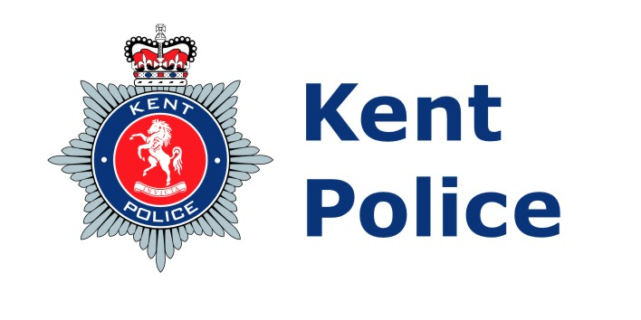
57
18 August
20267

Briefing Paper

HMICFRS Update to Joint Audit Committee 17 September 2026

Summary
This briefing paper provides updates regarding HMICFRS activity for Kent Police to inform the Joint Audit Committee, produced by the Force Inspectorate.

Author: PSE Louisa Neiles – Head of the Force Inspectorate

08
Fall
HMICFRS Publications

Since the last Joint Audit Committee held in June 2026, at the time of writing, there have been no national or thematic reports published by HMICFRS.

PEEL 2025-27 – An Inspection of Kent Police

On 9 April 2026 the Kent PEEL 2025-27 report was published. The force saw an increase in three grades across the core questions - developing a diverse and inclusive workplace (good to outstanding), responding to the public (requires improvement to adequate) and investigating crime (requires improvement to adequate). The report highlighted eight innovative practice areas and eight areas for improvement (AFIs).

The PEEL Improvement Plan for 2025-27 will monitor progress against the AFIs. Progress will be overseen via the Future Improvement and Development Board (FIDB), chaired by the DCC, and the Chief Officers Management Board (COMB), chaired by the Chief Constable, to ensure scrutiny at the very highest level. Regular reporting of progress will also continue to take place through the PCC Performance and Delivery Board and the Joint Audit Committee. A summary of the current position is detailed below following FIDB in June 2026.

- The force needs to record officers' rationales when using force and increase supervisory oversight.

- Changes to the Mobile First platform will be implemented to remind officers of the need to record necessity, proportionality and legal basis.
- Oversight continues through established governance, with commands conducting reviews and feeding lessons learned into these meetings to be cascaded.
- Plans to introduce inbuilt supervisory reviews on Mobile First mirroring the stop and search process.
- Anticipated completion of Mobile First changes by the end of 2026 with a second phase in 2027/28.

- The force should expand its independent scrutiny of stop and search and use of force.

- The independent panel of public volunteers who review officer interactions received positive feedback and will continue.
- Plans are in place to increase the volume of Independent Review Panels alongside further support from district Independent Advisory Groups (IAGs).
- Identified feedback and learning will be embedded within policy and procedure.
- Anticipated completion January 2027.

- The force needs to attend calls for service in line with its internal targets.

- There is a clear and sustained focus on improving attendance to calls for service, supported by strong alignment with Force Control & Incident Response (FCIR) processes and enhanced local ownership of performance.
- FCIR supervisory structures have been enhanced to provide real-time overview, enabling more effective support and scrutiny of call grading decisions.
- Resource management is proactively aligned to demand, with divisions flexing deployment models in anticipation of peak periods.
- Sustained performance improvements continue; however, the agreed service level agreement is not yet met.
- Anticipated completion date April 2027 (performance will be reviewed).

- The force should make sure that it consistently assigns the correct crime outcome type.

- The Outcomes Task and Finish Group was established by the Head of Crime.
- Extensive audit work is being conducted by the Data Audit Team, including a regular audit of every filed, unsolved crime in a 24-hour period.
- The Quality Assurance Framework has been updated to include two additional questions in respect of outcomes.
- A filing checklist has been provided to all officers and supervisors, alongside reinvigoration of the outcome decision-making tool.
- Inspector events have been held to provide key updates and refocus attention on key inspecting functions.
- Governance continues through local Investigative Quality Boards (IQB) feeding into the Force IQB.
- Anticipated completion date April 2027 (performance will be reviewed).

- The force needs to ensure that officers take appropriate action and work with multi-agency partners to reduce the risk of harm to vulnerable people.

- HMICFRS found supervisors were consulted about risk assessments and safeguarding; however, this was often not formally recorded or auditable.
- Key safeguarding fundamentals, including completion of risk assessments, use of the Domestic Violence Disclosure Scheme (DVDS), and timely submission of Operation Encompass notifications to safeguard children affected by domestic abuse, are being reinforced.
- Expectations are being consistently communicated through supervisory briefings, daily management processes and targeted performance discussions, with a clear focus on ensuring that attending officers understand their responsibilities and that safeguarding actions are both timely and effective.
- Governance and oversight have been strengthened through established performance and safeguarding forums, led by Chief Inspectors, where compliance is actively monitored, gaps identified, and early intervention applied where required.
- Anticipated completion date January 2027 (performance will be reviewed).

- The force needs to have a consistent approach to its identification and response to locating and safeguarding missing people.

- A review is underway to understand and address the variance in demand, resourcing, and management of the three Divisional Missing Teams, overseen by ACC Local Policing.
- Accountability for model principles and resourcing will sit with the Divisional Chief Supts with oversight through the Local Policing Exec governance arrangements.
- The missing lead is working on standardising processes and ensuring consistent application of risk assessments, reviews etc.
- The missing lead is working on standardising processes and ensuring consistent application of risk assessments and reviews.
- Anticipated completion date April 2027 (performance will be reviewed).

- To fully understand how fraud affects its communities and the response needed, the force needs effective governance for all fraud offences.

- Fraud improvement proposal agreed and being progressed.
- Introduction of a governance framework aligned to the Force Performance Management Framework.
- A new Force Fraud Governance Board will provide force-wide oversight of fraud investigations.
- Anticipated completion date April 2027.

- The force should make sure it has the capacity to effectively review and support fraud investigations.

- New guidance to be issued on the application of THRIVE for fraud offences providing consistency in assessment and allocation.
- Fraud Investigation Model (FIM) principles will be aligned to the initial plan upon allocation.
- Planned reviews of local investigations with feedback provided to support ongoing learning.
- Continued professional development inputs across themes of fraud and any identified bespoke training needed continue to take place.
- Anticipated completion date April 2027.

An overview on the existing recommendations from previous HMICFRS inspections

The table below details all the open recommendations generated for the force following HMICFRS inspection activity. Not all of these relate to inspections within Kent, as a number emanate from national thematic inspections. All recommendations agreed as complete by HMICFRS have been removed from the table, other than those signed off since the last meeting, which are shaded grey and will be removed from the next report.

The below represents the position agreed at the last FIDB held in June 2026. The next FIDB is due in September 2026 at which point the progress of the outstanding recommendations will be reviewed and updated accordingly.

Recommendation now completed
Work is progressing as expected
Lack of progression, identified as a vulnerability

Inspection | Total Recs | RAG |  |  | Progress
National: Vetting, Misconduct & Misogyny in Police Service | 33 | 26 | 7 | 0 | Improved*
Race Disparity in CJ Decision Making | 4 | 3 | 1 | 0 | Improved
Super complaint: Stalking | 14 | 12 | 3 | 0 | Improved
PEEL Spotlight: ASB | 5 | 4 | 1 | 0 | Improved
Organised Immigration Crime | 4 | 2 | 2 | 0 | Improved
Joint Police & CPS Case Building | 3 | 1 | 2 | 0 | Stable
Group based child sexual exploitation | 4 | 4 | 0 | 0 | Discharged
Diverting children from the criminal justice system | 1 | 0 | 1 | 0 | Stable
Spotlight: Online CSA & MOSOVO | 9 | 3 | 6 | 0 | Improved
* Following an internal inspection of PSD and Vetting, nine recommendations were reopened to allow additional evidence to be recorded to support continued closure. This was due to further publications such as the Angiolini Inquiry Part 2, Casey Report and HMICFRS Integrity Inspection reports, which provided further compliance requirements to consider.

Progress of recommendations is monitored through the governance structures in place, overseen by the Deputy Chief Constable.

