

Local Code of Governance for Kent Police and Kent Police and Crime Commissioner

Both Kent Police and the Office of the Kent Police and Crime Commissioner are committed to ensuring good governance across both organisations, to ensure that the best possible policing service and support for victims are provided for those who live, work, and visit Kent.
This Local Code of Governance provides a public statement that sets out the way in which both organisations will maintain their systems of governance, and how the public can be assured that they are acting in the public interest at all times. Although both the Chief Constable and the Police and Crime Commissioner (PCC) are ‘corporations sole’ and are separate legal entities, they are naturally connected in both their stated aims and in essential business support services such as finance. This Local Code therefore covers both organisations, how they operate independently and areas in which they are linked.
‘Delivering Good Governance in Local Government Framework’, published by CIPFA (the Chartered Institute of Public Finance and Accountancy), provides guidance on the standards for policing governance in the UK. This Framework sets out seven core principles of governance, and how both organisations should strive to meet them. This Local Code covers the legal foundations, oversight arrangements, administrative systems, policies, and processes as well as the culture and values that underpin arrangements for both organisations.

Police and Crime Commissioner (PCC) and their Office
PCC | - Elected by people in Kent  - Sets policing priorities, outlined in a Police and Crime Plan  - Sets Council Tax precept, a local tax for policing  - Commissions services for victims of crime  - Holds Chief Constable to account  - Appoints Chief Constable
Chief Executive (CEO) and Monitoring Officer | - Supports the PCC in delivering Police and Crime Plan  - Head of Paid Service for the Office of the PCC  - Provides advice on legal matters
Chief Finance Officer (CFO) | - S.151 officer, responsible for maintaining professional financial standards, with responsibility to taxpayers  - Develop and be responsible for medium term financial plan, treasury management, revenue and capital budgets  - Provides advice on financial matters
Performance and Delivery Board | - Meets in public for PCC to hold Chief Constable to account for delivery against his Police and Crime Plan  - Reports also cover His Majesty’s Inspectorate of Constabulary, Fire and Rescue Services (HMICFRS) inspections; audit reports; finances; staffing and culture.
Joint Audit Committee (JAC) | - Five independent members to support and monitor the OPCC and Force  - Terms of reference include considering internal and external audit; risk management; statement of accounts and governance  - Meets quarterly, with an additional meeting to consider statement of accounts
Senior Management Team (SMT) | - Two posts required by law: Chief Executive/Monitoring Officer and CFO  - Other members of the SMT are Heads of Commissioning; Governance; People and Standards; and the PCC’s Staff Officer (also covering communications)  - Meets every two weeks (chaired by Chief Executive), and PCC attends monthly (PCC chairs)  - Considers key risks as outlined in risk register, current workstreams, and horizon scanning

Kent Police
Chief Constable | - Leads Kent Police  - Responsible for the direction and control of the force and the management of the budget and use of funds to deliver the objectives set out in the policing plan.  - Accountable to the PCC for the delivery of efficient and effective policing.  - Appoints the force’s officers and staff.
Deputy Chief Constable (DCC) | - Supports the Chief Constable  - Responsible for operational delivery and performance  - Leads the following departments, Professional Standards Department, Performance Management and Corporate Services.
Assistant Chief Constables (ACCs) | Strategic leads for Central Operations, Local Policing, Crime, and Serious Crime Directorate
Assistant Chief Officers (ACOs) | Strategic leads for Corporate Communications & Citizens in Policing, Support Services, Human Resources & Learning and Development  - Includes HR, IT, Change Management, Finance, Communications, Resources, Organisation and Development, Legal Services, Strategic Risk Management and the Force’s Senior Information Risk Owner (SIRO)
CFO | S.151 officer, responsible for ensuring the force's financial affairs are properly administered. This includes developing the medium-term financial plan (MTFP), treasury management, revenue and capital budgets.  - Supports the Chief Constable to deliver the Kent Police Pledge within budget.
Chief Officers’ Management Board (COMB) | - Strategic COMB – attended by Chief Constable, Deputy Chief Constable, Assistant Chief Constables, ACOs, and CFO  - Allows the Chief Officer Team to consider key strategic matters and agree a course of action to progress them.  - Operational COMB – topics discussed:  - Activity over the preceding weekend  - Future events/operations  - Health and Safety and Wellbeing  - Issues to be included in the Chief Constable briefing to the PCC
JAC | - Five independent members  - Terms of reference include considering internal and external audit plans and reports; risk management; statement of accounts  - Meets quarterly, with an additional meeting to consider statement of accounts and annual governance statement
Key Force Boards | - Force Performance, Diversity and Inclusion, Strategic Change and Resourcing Board, Force Improvement and Development and Force Security and Integrity Board.
Divisional command | - Divided into North, East and West Division, and headed by a Chief Superintendent
District command | - Divided into Dartford, Gravesham, Swale and Medway (North); Ashford & Shepway, Canterbury, Dover and Thanet (East); and Maidstone, Sevenoaks, Tonbridge & Malling and Tunbridge Wells (West) - each headed by a Chief Inspector

External assurance and/or oversight is provided by:
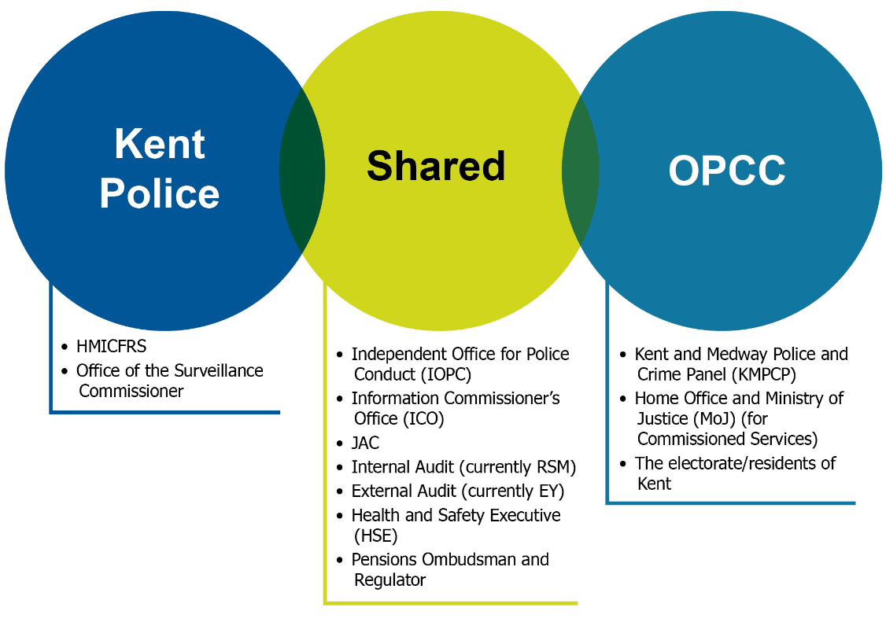

Compliance with all legislation and statutory guidance, including:
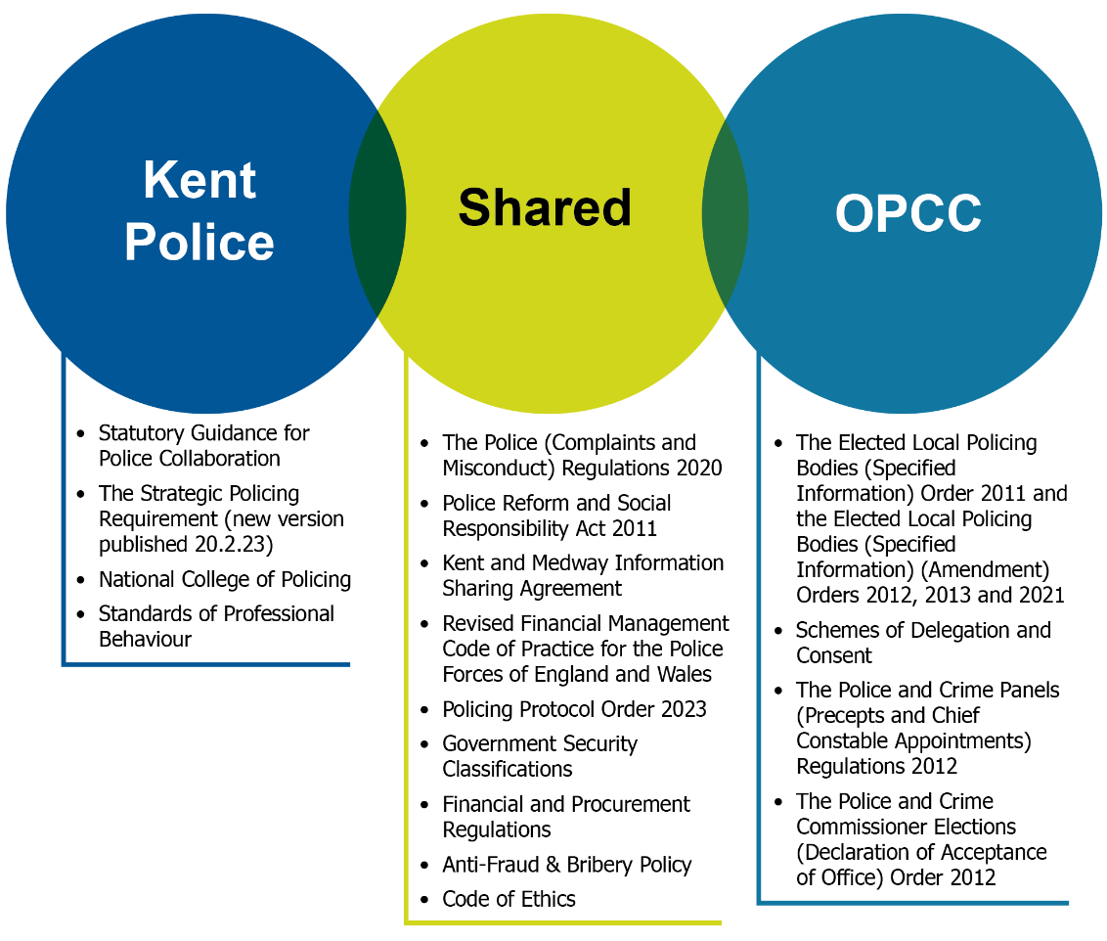

Seven Principles of Good Governance
CIPFA recommends that descriptions of governance are made under seven key principles.

Both organisations
Achieve good governance by the following actions | How assurance is provided
Maintain gifts and hospitality (G&H) register, and senior officers’ expenses. | - G&H and expenses registers for senior officers and the PCC are published on respective organisations’ websites.  - Registers are presented to the JAC annually. This allows scrutiny by both the public and senior officials charged with oversight of both organisations.
Maintain up to date policies on complaints and whistleblowing. | - Policies are kept under review by Senior Leadership Teams (SLTs) to ensure any changes to legislation are accurately reflected.  - Reports provided annually to JAC.
Handle all Freedom of Information (FOI) and Subject Access Requests (SAR) applications in line with the law. | - Both organisations have been inspected by Internal Audit. Recommendations to improve governance have been implemented by both organisations. This area will be subject to regular audits  - ICO is appellate and regulatory body and will take action where needed.

Police and Crime Commissioner (PCC) and their Office
Achieve good governance by the following actions | How assurance is provided
Develops a Police and Crime Plan, reviewed annually to set out vision for policing and community safety. Overarching principle is for integrity and transparency to underpin the plan and work of Kent Police. | - Police and Crime Plan has to be approved by the Police and Crime Panel.  - Plan is also submitted to the JAC for review.  - Police and Crime Plan published on website (and where there has been an election, complies with statutory duty to publish within a year of that election).
Acts in accordance with Nolan Principles. | - Signed Committee on Standards in Public Life Checklist which is published.  - Sworn an oath of office, which is published.  - Publicly committed to abide by Code of Ethics.  - Maintains an effective Independent Custody Visiting Scheme

Kent Police
Achieve good governance by the following actions | How assurance is provided
Operates under a Code of Ethics, and officers subject to Standards of Professional Behaviour. | - Code of Ethics included at the start of all meetings.  - DCC has formal responsibility for ensuring Force compliance with Code of Ethics.  - Professional Standards Department reviews any allegations that Standards of Professional Behaviour have been breached.  - Assessment on ethical standards forms part of HMICFRS’s PEEL inspection.
Maintains an Internal Ethics Committee and also Culture Boards across the Force. | - Actions are recorded by the Chief of Staff and discharged outside of the meeting, with updates from business owners coming back to the Board as agreed.  - Records of the agenda and any presentations are retained by the Chief of Staff and the relevant speakers as appropriate.

Both organisations
Achieve good governance by the following actions | How assurance is provided
Maintain an effective, far reaching engagement strategy with residents of Kent. | - Significant numbers of residents engage directly with both organisations, through websites, social media, public meetings, and external events.
Engage proactively with JAC. | - Requests for ‘Deep Dives’ on risk topics JAC request regularly provided.  - SMT from both organisations in attendance, with PCC and Chief Constable attending annually.  - JAC members attend Risk Star Chamber and a range of OPCC and Force strategic meetings.  - Information available to the public published on OPCC website, and meeting is webcast (non-restricted items).

Police and Crime Commissioner (PCC) and their Office
Achieve good governance by the following actions | How assurance is provided
Consults with residents and victims in the development of the Police and Crime Plan. | - All consultation reports are published on the website and/or included in reports to the Police and Crime Panel, JAC.  - Annual Residents’ survey, meetings and correspondence, used to inform development of Police and Crime Plan.
Engages with residents on specific matters of importance to communities. | - Specific panels or focus groups are established to ensure specific communities or victims are reached.  - Reports, such as the one on Violence against Women and Girls (VAWG), and Custody and Detention Scrutiny Panel Thematic Reviews are published on website.  - Updates on progress made are reported in Annual Report.  - PCC has statutory requirement to engage with public on precept, achieved through annual survey
Holds Chief Constable to account through Performance and Delivery Board. | - All reports and minutes are published on the website.  - Meeting broadcast live via OPCC website.  - Local media and members of KMPCP have standing invitation.
Engages with KMPCP, both through formal meetings and one to ones. | - All reports and minutes are published on KCC’s website.

Kent Police
Achieve good governance by the following actions | How assurance is provided
Neighbourhood Policing Model developed to provide a focus on preventative work and neighbourhood policing, within current financial envelope. | - Developed by DCC in consultation with all officers and staff.  - Reviewed by COMB.  - Reviewed at JAC.
Has nine dedicated community liaison officers (CLO) across the county for liaison with harder-to-reach or marginalised groups. | - CLOs report into and are monitored by the Diversity and Inclusion Academy.  - Provision of specialist tactical advice for communities, and support when there is a critical incident.
Developed ‘My Community Voice’ to enable two-way communication with residents about local crimes and Force initiatives. | - 17,157 current users
Develops a broad range of communication across a wide range of channels, both in person and via technology. | - Over 368 000 followers of Force Facebook and Twitter accounts

Both organisations
Achieve good governance by the following actions | How assurance is provided
Joint commitment to explore and develop a range of collaboration agreements with a wide range of partners.  Collaboration with Essex (which includes Serious Crime, HR, L&D and Support Services) has delivered improved functionality and greater savings. Seven Force (7F) Commercial, to ensure best value for money gained in commissioning and ERSOU  Further collaboration via South Eastern and Eastern Region Police Insurance Consortium (SEERPIC), National Police Air Service (NPAS), 9 Force Athena Consortium and Blue Light Commercial | - Long-standing collaboration with Essex: bi-annual meetings are held, with reports and minutes published.  - Seven Force (7F) Commercial has a Strategic Oversight Board and Executive Board monitor progress and ensure intended outcomes are met.  - Kent and Essex Collaboration Oversight meetings are held bi-annually where the Kent PCC and Essex PFCC hold both Chief Constables to account for the efficiency and effectiveness of collaboration.  - 7F Summit to oversee collaboration across seven Eastern region forces, including ERSOU, ERIN and 7FCS
Established MTFP process improves value for money, and ensures spending aligns with Force and PCC priorities. | - MTFP reviewed by both CFOs, and reported to leaders for oversight.  - MTFP reported to JAC quarterly.  - MTFP presented alongside the PCC’s police and crime plan to the Police and Crime Panel.  - Accounts have received an unqualified opinion from External Auditors.

Police and Crime Commissioner (PCC) and their Office
Achieve good governance by the following actions | How assurance is provided
PCC actively monitors operational and financial progress against his Police and Crime Plan. | - Quarterly hold to account meeting (Performance and Delivery Board) where the CC reports on how he is delivering against the targets in the plan.  - Production of an Annual Report which is published on the website, and presented to both the KMPCP and JAC.
PCC takes active role in improving services, focussing on delivering a joined up criminal justice (CJ) system for the public, by chairing KCJB | - Criminal Justice Board reports to National Criminal Justice Board.  - Home Office and MoJ oversees work of both organisations.
PCC ensures legislative requirement towards victims is met through the commissioning and awarding of grants to local organisations, and monitoring progress. | - All grant-funded services submit mid-year and end of year monitoring reports which are scrutinised by the OPCC team. These are then submitted to the Ministry of Justice (MoJ) and/or Home Office for sign off.  - Regular contract monitoring meetings (relative to amount of funding and size of organisation).  - All services must adhere to clear OPCC conditions of grant and various policies around performance and behaviours.

Kent Police
Achieve good governance by the following actions | How assurance is provided
Force has developed a Control Strategy which covers national policing issues, Kent-specific issues and is set in line with the PCC’s Plan. | - The control strategy is recommended from the Strategic Intelligence Assessment and is produced every year with a 6-month review.  - The governance and monitoring of the Control Strategy is through the Force Strategic Coordination Group which sits every 6 months and ratifies the Control Strategy, in line with College of Policing APP for Intelligence governance and management.
Policing Model in operation is derived from the Control Strategy, to ensure consistency of service delivery across the county and drive performance. | - Policing model is currently being reviewed by Chief Officers to ensure that it meets the needs of the public whilst being able to deliver what is set out in Control Strategy and PCC’s Police and Crime Plan.
The control strategy informs the MTFP to ensure consistency. | - The MTFP is formally updated as part of the budget cycle each January. The MTFP is then included as part of monthly financial reporting where any changes to assumptions are noted along with the potential impact of these.  - The in-year finances are monitored every month and report to COMB monthly by the force CFO.  - This report is then shared with the PCC's CFO who challenges accordingly.  - The most recent available report is then shared with the JAC at the quarterly meeting.

Both organisations
Achieve good governance by the following actions | How assurance is provided
PCC and Force ensure alignment between PCC’s Police and Crime Plan and Force’s Control Strategy; Force agreed to deliver PCP | - Regular meetings between Chief Constable and PCC – formal meeting held weekly, regular informal meetings.  - Members of OPCC SMT attend high-level Force board meetings.  - CFOs meet weekly to monitor financial position and to ensure alignment with Force and OPCC plans.

Police and Crime Commissioner (PCC) and their Office
Achieve good governance by the following actions | How assurance is provided
Consults with the public, and specifically with victims of crime, to help inform Police and Crime Plan. | - Plan is scrutinised by KMPCP, and is provided to the JAC for review.  - Engages in two-way sessions with specifically assembled groups such as Victims’ Panels, and with partner agencies for VAWG, to ensure that the Plan reflects people’s experiences within the CJS.
PCC takes into account a wide range of government plans and local factors to help inform the Plan. | - Plan is scrutinised by the Panel, and is provided to the JAC for review.  - Risk register is presented to JAC quarterly.
Maintains a strategic risk register | - Risk register scrutinised by SMT and PCC at regular meetings  - Risk assessment process subject to periodic audits by internal auditors.
Has an internal performance framework to measure OPCC performance against Police and Crime Plan | - Quarterly reviews of performance by SMT, reported directly to PCC

Kent Police
Achieve good governance by the following actions | How assurance is provided
Has a clear ‘Policing Pledge’ from Chief Constable, setting out priorities and promises to officers and staff, and to the public. | - The Policing Pledge is displayed prominently both internally and externally across all channels.  - PCC holds Chief Constable to account in Performance and Delivery Board.
Creation of a Force Management Statement (FMS) in line with HMICFRS guidance. | - FMS is submitted and reviewed by HMICFRS.  - FMS is publicly available, reported to the JAC and included in the Annual Governance Statement.  - The FMS is part of the force strategic planning cycle which sees it reviewed twice a year by senior and chief officers as part of the Strategic Coordination Group chaired by the Chief Constable.
Maintains a strategic risk register, which is underpinned by departmental/area risk registers. | - Risk register is presented to JAC quarterly  - Risk assessment process subject to periodic audits by internal auditors.  - Risk owners attend Risk Star Chamber sessions with the ACO for Support Services Directorate to test and review the risk to ensure they are being actively managed and monitored

Both organisations
Achieve good governance by the following actions | How assurance is provided
Both organisations committed to on-going change programme which focusses on rationalising the Force estate, and to gain best value from the workforce with smarter working. | - Estates Governance Board and Force Strategic Change Board TOR  - Regular assessments and surveys of how staff have adapted to working remotely and a bespoke staff support association (KPAC – Kent Police Agile Community)  - Recent review and update to the Smarter Working Protocol which provides support to agile workers and their line managers.  - HR reporting mechanisms demonstrate reduction in staff sickness days.
Staff from both organisations have a wide range of development opportunities, and access to in house and external training. | - Monitored by Command Team within Learning & Development Department
Force have comprehensive induction process for new staff in which the OPCC focusses, and has introduced First Line Leaders’ course in line with the College of Policing’s training programme for all newly promoted officers and staff | - Feedback gathered after each induction programme and training course.  - Training is formally assessed to understand impact post-training.

Police and Crime Commissioner (PCC) and their Office
Achieve good governance by the following actions | How assurance is provided
Creation of a succession plan to ensure continuation of service should the PCC become incapacitated, or the role become vacant. | - Information placed on website, and reported to the KMPCP.
Ensure regular meetings for and between teams, with team office days, re-connection days, SMT meetings, and project work | - Staffing structure kept under constant review by Chief Executive, CFO and PCC, to ensure staff can deliver on PCC’s priorities.  - Staff encouraged to attend Office 1-2 days per week to both maintain team structures and encourage wider collaboration with other teams.  - Quarterly Team Development Days and structured training plans for all teams

Kent Police
Achieve good governance by the following actions | How assurance is provided
Developed and maintains a People and Learning Strategy 2024-2027, which is supported by a Learning and Development plan. | - The Strategy is governed and supported through various boards and reporting structures including but not limited to:  - The Strategic Recruitment Oversight Board  - Training needs analysis through the perfect profile  - Resource Deployment Panel (Officers)  - Attendance Management & Wellbeing Groups  - Force Support Forum  - The current People and Learning Strategy is being updated and the 2024-27 strategy was published in April 24. The strategy has 4 key areas of focus: Attract, Develop, Support and Retain.
Developed and maintains a Diversity and Inclusion Strategy | - Diversity and Inclusion Board monitors adherence to Strategy and has input from a range of people and groups, including local culture board chairs, Support Groups and OPCC. Board Chaired by DCC.  - Quarterly reports to COMB.  - Regular engagement with the Independent Advisory Group members, and the IAG Chair attends the Diversity and Inclusion Board
Maintain a significant number of staff support associations, mainly focussed on groups with protected characteristics. | - All staff support associations report to the Staff Support Association Chairs forum and have Chief Officer sponsors
Maintain a Force Culture Board, to ensure Force develops in line with its Kent Police Pledge. | - Chaired by Chief Constable.  - Questions are raised to the Board on the intranet, and all are publicly answered, with action taken where necessary.
Joint Negotiating & Consultative Committee (JNCC) | - To provide a formal consultative and negotiating Forum for officers up to and including the rank of Chief Superintendent and all Police Staff Equivalents to consider:  - Pay  - Conditions of Service  - Leadership and Professional and Development; and to promote, maintain and enhance the Kent Police Culture.

Both organisations
Achieve good governance by the following actions | How assurance is provided
Financial Regulations maintained and reviewed | - Both CFOs review adequacy of current financial regulations on an annual basis  - Information presented to the JAC  - Published on both organisations’ websites.
Both organisations maintain strategic risk registers commensurate to each organisation’s size and complexity. | - Force risk register managed by ACO for SSD, OPCC risk register managed by CFO.  - Presented quarterly to the JAC.  - Additional information to be found in section D.
Internal audit programme in place. | - Programme managed internally by both CFOs, in conjunction with internal auditors.  - Programme presented to and reviewed by JAC, including monitoring adherence to and achievement of recommendations.
JAC identifies areas of significant risk or concern, and conducts deep dives into subject. | - Reports discussed in public and minuted at JAC, with minutes published on OPCC website.
Regular meetings with clients, including private meetings with JAC | - External and internal auditors meet regularly with staff from both organisations, and JAC members, and report formally to JAC.
HMICFRS Value for Money Dashboards used to compare with most similar Forces to assess spend, crime levels and workforce costs | - Considered by Force’s COMB to inform decision-making and budget setting.  - PCC uses them to hold Chief Constable to account  - Reported annually to JAC

Police and Crime Commissioner (PCC) and their Office
Achieve good governance by the following actions | How assurance is provided
HMICFRS reports considered by PCC and his SMT | - Reports presented to PCC’s Performance and Delivery Board, with minutes published on OPCC website.  - OPCC Chief Executive meets weekly with Force DCC to review Force performance, and progress against HMICFRS report.
PCC maintains a Treasury Management Strategy to set out aims and objectives for investing PCC’s funds and potential borrowing | - Reports scrutinised quarterly at the JAC; also considered by Internal Audit
PCC CFO scrutinises monthly financial monitoring reports | - CFO discusses outcomes with PCC and OPCC Chief Executive

Kent Police
Achieve good governance by the following actions | How assurance is provided
ACO for Communications and Citizens in Policing acts as SIRO, with responsibility for Information Assurance and Governance. | - ACO reports to COMB and CC on any significant risks.  - ICO acts as appellate body, conducts ad hoc investigations and supports Force in information risk management.
Force holds a quarterly ‘Star Chamber’ to examine each strategic risk in greater depth and detail. | - Both members of the JAC, and PCC’s CFO attend for additional external scrutiny.  - Reports are provided to COMB.
Holds a Force Security and Integrity Committee. | - Board overseen by DCC.
Force Risk Register | - The Risk Register is presented to COMB on a quarterly basis.

Both organisations
Achieve good governance by the following actions | How assurance is provided
Effective engagement with the range of external organisations outlined in the ‘external assurance’ section of the Local Governance Code. | - Regular meetings held between representatives of both organisations and the external organisations such as HMICFRS, IOPC, etc.  - National organisations publish reports on their websites.
Reporting to the JAC | - All JAC agendas, reports and minutes published on OPCC website.
External auditors, and review of Statement of accounts | - External auditors attend all JAC meetings, and have access to both JAC members and staff when needed.  - JAC holds meeting specifically to review Statement of Accounts, and receives updates throughout the year.
Maintain an Annual Governance Statement | - AGS, which links to this Code of Governance, published on both organisations’ website as a part of statement of accounts.

Police and Crime Commissioner (PCC) and their Office
Achieve good governance by the following actions | How assurance is provided
Attendance at the Police and Crime Panel | - Meetings are webcast live  - Reports, minutes and agendas available on KCC website
Maintain an effective and accessible Publication Scheme | - Reviewed on an annual basis formally by Head of Governance and Chief Executive, with regular refreshes as legislation/guidance changes.
Ensure all documents on website are accessible | - Website now in line with government guidance for accessibility for public bodies.  - Single Online Home team (housed by Metropolitan Police Service) monitors compliance; OPCC scoring over 90%.
PCC has a weekly engagement programme across the county, supported by a range of ad-hoc meetings with members of the public and organisations | - PCC has communications team who ensure that PCC attends events across the county.  - PCC has hosted a range of focussed events with members of the public.  - PCC uses a range of social media to engage directly with public.
PCC holds Chief Constable to account at the Performance and Delivery Board | - Meetings are webcast live  - Reports, minutes and agendas available on OPCC website

Kent Police
Achieve good governance by the following actions | How assurance is provided
Range of communication and reporting systems for the public | - Single Online Home website allows people to both report incidents and request information/make complaints.  - Force Control and Incident Room now has live chat facility.  - My Community Voice is a two-way engagement tool set up by Kent Police for residents, businesses and community groups in Kent and Medway. Enabling users to be updated with news, alerts, appeals engagement events and general policing activities.
Host the Independent Advisory Group to provide external input on diversity and inclusion issues. | - IAG members attend Force meetings in observer capacity.  - Members recruited entirely externally from Kent Police.  - IAG produces reports on key issues facing Police, and also act as Critical Incident Advisors.  - IAG members attend and provide reports to Diversity and Inclusion Board.
Force Inspectorate to carry out reviews of departments and teams to ensure effective operation, separate to formal Internal Audit (as currently provided by RSM) | - Force Inspectorate conduct a programme of internal inspections that focus on policy compliance, areas of risk and working practices providing independent assessment in key areas ensuring impartial and unbiased findings.  - Inspection areas are all approved by the DCC and have to be linked to either the Force Control Strategy, HMICFRS activity or threat, risk and harm. Findings are reported to Chief Officers.

