Summary Report for Kent Police Audit Committee on Internal Audit Recommendations

Date:23rd May 2026

Section 1:

The update in respect of the future 26/27 audit plan can be seen below.

Audit | Planned start | Status
Payroll Debriefed | In quality assurance | Scoping in progress
Force Risk Management | 03/06/2026 | Scoping in progress
Complaints | 13/07/2026
Capital Accounting | 17/08/2026
OPCC Risk Management | 08/09/2026
Governance | 09/09/2026
Cryptocurrency | 19/10/2026
Strategic Resourcing - Protected Learning Time | 03/11/2026
IT Business Continuity (Joint with Essex Police) | 10/01/2027
Follow Up | 15/01/2027
Victim Services | 04/02/2027
High Risk Evidential Property | 03/03/2027
VAT Health check | Q3/4 TBC

The update in respect of the audit work completed 25/26 can be seen below.

Audit | Assurance | Sponsor | Low | Medium | High
National Intelligence Model (NIM)1.25.26 | Reasonable Assurance | Peter Ayling | 2 | 0 | 1
Custody Management-Healthcare and Resourcing 4.25.26 | Partial Assurance | Simon Thompson | 2 | 2 | 1
Medium Term Financial Planning 2.25.26 | Substantial Assurance | Jonathan Castle | 0 | 0 | 0
Victims and Witnesses Care Unit 3.25.26 | Partial Assurance | Simon Thompson | 1 | 3 | 1
Expenses and Allowances 5.25.26 | Substantial Assurance | Jonathan Castle / David Jedrzejewski | 3 | 0 | 0
Treasury Management 6.25.26 | Reasonable Assurance | Jonathan Castle/ Rob Phillips | 0 | 2 | 0
Debt Management 7.25.26 | Substantial Assurance | Jonathan Castle | 3 | 0 | 0
Evidential Property 11.24.25 | Reasonable Assurance | David Jedrzejewski | 0 | 3 | 1
Follow Up 8.25.26 | Good progress | Jonathan Castle | 0 | 0 | 0
Follow Up Part 2 10.25.26 | Good progress | Jonathan Catle | 0 | 0 | 0
Digital Forensics (Joint) | Partial Assurance | Simon Wilson | 1 | 5 | 1
Information Management | Reasonable Assurance | Peter Ayling | 5 | 3 | 0
Section 2: Audits awaiting draft report or in draft status

Report Name | Update
User Device Allocation and Refresh Strategy (Joint) | Draft
Electrical of the Fleet | Draft
Payroll | Draft- Substantial Assurance

Section 3: Audit summary.
The following table shows all live reports for Kent and shows the total amount of high, medium and low recommendations set per report, how many remain outstanding or are awaiting implementation. Recommendations outside of their due date are stated in the last column, and detailed updates follow in Section 5.
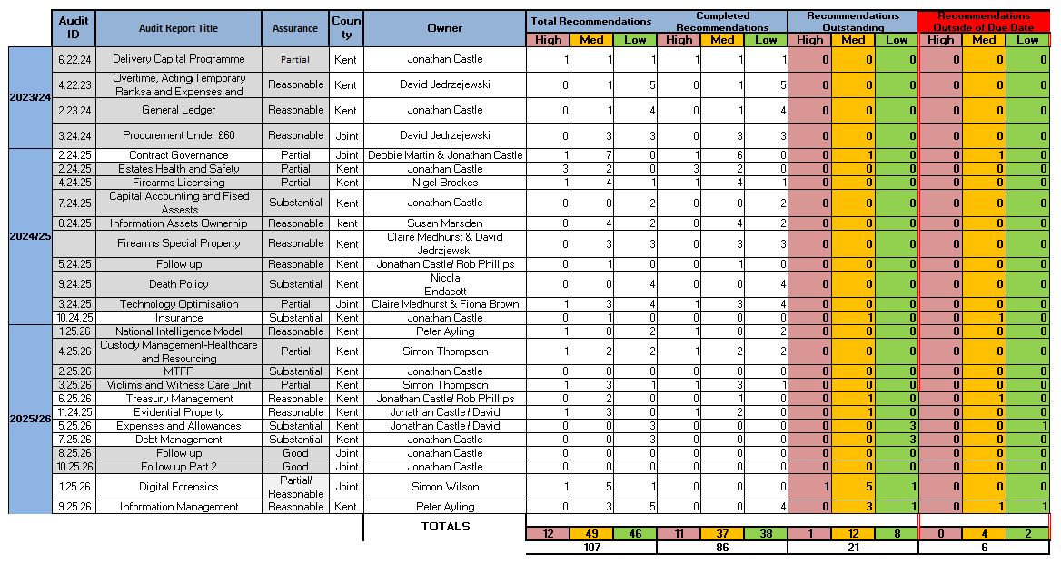
All actions associated with the years 2018 through to 2023 have been reviewed and confirmed as completed. As a result, these years have been removed from the current table above to streamline the report and ensure focus remains on outstanding or ongoing matters.

Also, please note that whilst the above shows 8 overdue actions, 1 action (as noted below) has been closed due to being superseded by a later audit.
Section 4:
Recommendations signed off since the last meeting.

Audit Name | Audit Number | Recommendation | Risk | Deadline | Signoff Date
Treasury Management | 6.25.26 | 1 | Medium | Completed | 24/03/2026
Information Asset Ownership | 8.24.25 | 4 | Medium | 30/04/2026 | 24/03/2026
Information Management | 9.25.26 | 1 | Low | Completed | 14/05/2026
Information Management | 9.25.26 | 2 | Low | 02/06/2026 | 14/05/2026
Information Management | 9.25.26 | 7 | Low | 07/05/2026 | 14/05/2026
Information Asset Ownership | 8.24.25 | 1&6 | Low | 30/04/2025 | 20/05/2026
Information Asset Ownership | 8.24.25 | 2 & 3 | Medium | 30/11/2025 | 20/05/2026
Information Asset Ownership | 8.24.25 | 5 | Medium | 30/11/2025 | 20/05/2026 action that is closed but been superseded by a new one.
Information Management | 9.25.26 | 6 | Low | 07/05/2026 | 21/05/2026
Evidential Property | 11.24.25 | 4 | High | 01/12/2026 | 21/05/2026

The JAC have requested that any actions previously closed due to being superseded were listed here. No additional ones have been added since the last JAC. Please see below:
Audit Name | Audit Number | Recommendation | Risk | Deadline | Comment
Overtime, Acting/Temporary Ranks and Expenses and Allowances | 4.22.23 | 2 | Low | 31/03/2024 | Whilst not fully completed, signed off on the following basis:  - There is only one non-mandatory field as it stands and that is “brief description”.  - There is going to be a complete revamp of the overtime form with a new system that will fully incorporate all changes.  Therefore, this is superseded by that change.
Health and Safety | 3.22.23 | 1 | Low | 10/08/2023 | This Action rather than it being completed normally it was completed due to being superseded by H&S Audit action 2 which remains open still.
Medium Term Financial Plan, Budget Setting, Control and Monitoring | 18.20.21 | 10 | Medium | 31/03/2022 | Please note that they are closed not due to completion but due to being superseded by an action in the new capital delivery report
Key financial controls and month end procedures | 19.20.21 | 3 | Medium | 31/03/2022 | Please note that they are closed not due to completion but due to being superseded by an action in the new capital delivery report. Same action as above
Key financial controls and month end procedures | 19.20.21 | 5 | Medium | 31/12/2021 | Please note that they are closed not due to completion but due to being superseded by an action in the new capital delivery report. Same action as above
Managed Data Centre Effectiveness | 4.23.24 | 3 | Medium | 31/12/2024 | Closed, but not full implemented.  Since the audit ITS have documented into a single spreadsheet the resilience arrangements that are in place for each critical operational system and infrastructure solution, this was not available previously, although the knowledge sat with teams and was recorded against individual systems, this means in the event of an incident that affects more than one system there is an overview that the Critical Incident Commander can refer to, to advise gold and support decision making, alongside the Silver/Resilience plan
Essex and Kent Police Collaboration -  Recharges | 7.18.19 | 1 | Medium | 02/06/2025 | At the JAC pre-brief meeting, the audit Chair agreed that as Kent had discharged all their duty in this respect, the action could be closed despite Essex not finalising their element.
Information Asset Ownership | 8.24.25 | 5 | Medium | 30/11/2025 | There is also one action that is not showing as overdue but relates to an action that was overdue but now closed due to being superseded.
Section 5:
Reports and recommendations outside of due dates

Year | Audit Report Name | Audit Number | Priority | Recommendation | Number | Agreed Implementation Date | Expected Completion Date | Responsible Owner | Update
2024/25 | Contract Governance | 2.24.25 | Medium | The Forces will seek to develop Contract Management Procedures which comprehensively  detail how local and strategic contracts of all values are managed. Alternatively, the Forces  could adopt aspects of the Contract Management Framework from 7Force Commercial  Services.  The Forces will meet with 7Force Commercial Services to identify contracts that require  high levels of contract management.  Following this, the Forces will ensure that all personnel involved with contract management  will receive training on how to effectively manage their contracts | 1 | 30/06/2025 | 31/07/2026 | Esther  Beaumont | The Strategic Contract Management Manual (SRM Handbook) has now been finalised and is at the point of rollout. While earlier milestones were delayed (including final review and intended April 2026 implementation), delivery is now expected by the end of the current month following a short further extension. Appropriate communication and training for SRMs will accompany the rollout.
2025/26 | Treasury Management | 6.25.26 | Medium | We will review and update the Service Level Agreement with Kent County Council on  a periodic basis to ensure that the terms, responsibilities, and service expectations  remain current and aligned with operational and regulatory requirements | 2 | 30/04/2026 | 31/03/2027 | Rob Phillips | Still awaiting KCC engagement on this
2024/25 | Insurance | 10.24.25 | Medium | The Force will reconsider digitalising the PVIR Forms so that they automatically upload the  claims data into the LACHS System | 1 | 30/03/2026 | 31/12/2026 | Matthew  Chinavicharana Mole | Update, the work to digitise the PVIR form is currently on the IT programme, but due to other ongoing commitments, it will not be completed until the end of the year. The commercial applications team owns this part of the process, and they won’t be able to progress with the digitalisation until later in the year.
2025/26 | Expenses and Allowance | 5.25.26 | Low | The Force will ensure all delayed expense claims are supported by a completed 1068 report form or email. | 2 | 31.03.2026 |  | Katrine Beckett | Katrine has provided an email confirming that the 1068 process is no longer required. We have requested additional evidence and are awaiting further information
2025/26 | Information Management | 9.25.26 | Medium | We will ensure that the last review date within the Policing Division West IARs is updated to  reflect the most recent review date, and that supporting evidence of the review performed is  retained | 5 | 07/05/2026 | 30/07/2026 | CH/SUPT Neil  Loudon | All West SLT have now received an IAR CPD input from our info sec team.  We have revisited and refreshed our IIAs and training has been booked over the coming weeks, through Vita.  We have commenced a full review of relevant West division assets and realistically this will require approximately another four weeks to be completed and have the IAR updated correctly
2025/26 | Information Management | 9.25.26 | Low | For the Policing West and Vulnerability Command Divisions, we will ensure that adequate  governance arrangements are in place to support the review of information asset registers  and dissemination of information asset updates to relevant staff. | 8 | 07/05/2026 | 30/9/2026 | CH/SUPT Neil  Loudon /D/CH/SUPT  Emma Banks | The Command is currently in the process of reviewing all registers. A revised completion date has been provided.

Progress of the recommendations outside of due dates.

JAC Reports | Recommendations Outstanding of Due Date
March 2021 | 23
June 2021 | 13
September 2021 | 3
December 2021 | 4
March 2022 | 13
June 2022 | 13
September 2022 | 17
December 2022 | 14
March 2023 | 11
June 2023 | 4
July 2023 | 6
August 2023 | 8
October 2023 | 8
November 2023 | 11
December 2023 | 12
January 2024 | 14
February 2024 | 7
April 2024 | 22
May 2024 | 8
August 2024 | 6
November | 7
December | 7
January | 6
February | 6
May | 5
September | 8
November | 6
December | 6
January | 10
February | 7
May | 6

Advisory Audit Updates
All advisory audits that the JAC requested updates on (Force Change Team and Off Payroll Workers) have been reported at previous JAC’s. Therefore, there are no additional advisory audits to report on at this point in time.

Kent Monthly Update Report from RSM

