Report to the Joint Audit Committee

Date: 11th June 2026

Title: Reviews Update

From: Laura Steward

- Introduction

This report provides an update on the handling of requests for reviews of Police complaints received by the Office of the Police and Crime Commissioner (OPCC). Since 1st April 2024 the OPCC has moved to a financial year reporting process so as to ensure that there is a uniform approach to data reporting in line with that of Kent Police Professional Standards Department (PSD) and the Independent Office for Police Conduct (IOPC).

The report and attachments will therefore cover:

- Reviews process
- Reviews data for the financial year 1st April 2025 to 31st March 2026
- Specific accountability examples for the financial year 2025-2026
- Repeat Reviewers
- Forecast for reviews work for the financial year 2026-2027, & Timeliness of Reviews

- Reviews Process

As reported previously, the Government revised a suite of legislation relating to complaints and conduct matters, which began in 2015. One of the more significant changes meant that from February 2020 OPCCs were required to take responsibility for reviewing a significant proportion of complaints handled by their respective police forces in order to provide judgement on whether the outcome of the complaint and its handling was reasonable and proportionate (i.e., a complaint review is an appeal against the original outcome of the complaint). Previously, this role had been carried out by forces’ own PSDs.

Since the implementation of the new regulations, the OPCC for Kent has received the following level of review requests:

- February 2020 – 31st December 2020: 87 requests (reported on specifically in December 2022)
- January 2021 – 31st December 2021: 229 requests (reported on specifically in December 2022)
- January 2022 – 31st December 2022: 230 requests (reported on specifically in December 2022)
- January 2023 – 31st December 2023: 211 requests (reported on specifically in June 2024)
- January 2024 – 31st March 2024: 70 requests (reported on specifically in June 2024)
- 1st April 2024 – 31st March 2025: 255 requests (reported on specifically in June 2025)
- 1st April 2025 – 31st March 2026: 337 requests (the subject of this report)

The structure of the Reviews team remains unchanged since the last report to the JAC; with the team consisting of one dedicated full-time employee and one part-time employee, with continued assistance from one case worker and the Head of People and Regulation (formerly Head of Standards and Regulation) as and when required. Periods of staff absence due to leave and unplanned events has impacted on the department for a short period of time in the third quarter of the financial year 2025 - 2026.

- Reviews Data, 1st April 2025 – 31st March 2026

For the period 1st April 2025 to 31st March 2026, a total of 337 requests for review were received.

It should be highlighted that due to circumstances outside of our control, 1% (3 in total as at 20.05.2026) of those reviews have not yet been completed at the time of the preparation of this report.

Whilst 64% of requests (217 in total) were not upheld, 209 oversight points were made across those non-upheld matters. A further 62 oversight points were made across reviews which were upheld, giving a total of 271 oversight points being made throughout the financial year.

Oversight points are included where there are improvements that could have been made to the overall service provided by Kent Police in relation to the way the complaint was handled, but not resulting in the review being upheld. For example, this could include administrative processes or errors that are easily rectifiable and have no impact on the actual handling of the complaint. Whilst oversight points are not made on all reviews which are not upheld, some not upheld reviews have multiple oversight points noted.

It is notable that whilst the total number of oversight points made has increased by 51%, all oversight points made in 2025-2026 were accepted by Kent Police as was the case in all previous financial years.

17.5% of the reviews (59 in total) were upheld within this period, with a total of 84 recommendations being made. Recommendations are made where a request for review is upheld and specific issues are required to be addressed in order to bring the complaint handling back to being reasonable and proportionate. It should be noted that Kent Police have a period of 28 days to accept any recommendations made by the OPCC. PSD do not have to accept them, however if they do not accept them full details as to why must be provided.

The recommendations made in 2025-2026 were varied in line with the nature of the complaints and further detail regarding this has been set out in part 5 below. They related to issues including referring allegations back to PSD for recording and handling, insufficient explanation of conclusions reached by Investigating Officers (IOs), and the outcome of complaints requiring amending. All of the recommendations made for this period were accepted and acted upon by Kent Police PSD.

5.3% of the reviews (18 in total) were matters where the OPCC was not the correct review body, a slight increase from 2024-2025 but still notably down in relation to previous years (8.5% (6 reviews in total) for the period January-March 2024 and 7% (15 reviews in total) for the calendar year 2023), showing that Kent PSD have maintained their improvements in relation to their relevant review body (RRB) assessments.

11.8% of the reviews (40 in total) were invalid, with them either being out of time or where the complainant did not provide sufficient grounds for a review to be undertaken. This is the second year that this figure has reduced, although no specific reason for this can be noted.

The financial year 2025-2026 saw a 34.3% increase in the overall number of requests for reviews received compared to the 2024-2025 calendar year.

Whilst there has been a general increase in complaints received by Kent Police, the additional scrutiny work undertaken by the Reviews team in relation to the recording of Outside and Inside Schedule 3 complaints carried out towards the end of the financial year 2024-2025 identified some issues. Now these have been rectified, this has resulted in better initial recording by PSD, meaning more complaints are formally recorded, thus providing more complainants with a right to review.

The breakdown of review outcomes for each quarter of 2025-2026 has been provided below, together with the total outcomes for the full financial year:

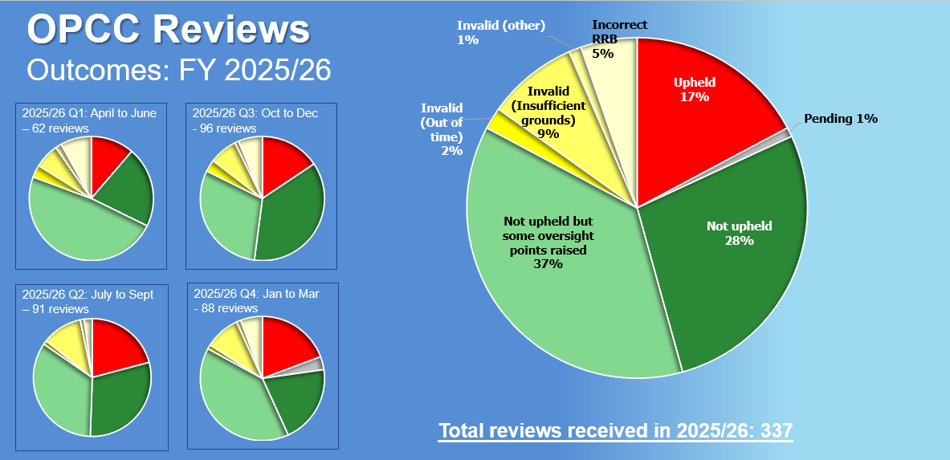

- Specific accountability examples, Financial year 2025-2026

- In 2025 PSD handled a complaint about Kent Police's approach to the circumstances of the death of the complainant's father. PSD determined the service was not acceptable but, on review, the OPCC identified serious concerns regarding aspects of the initial investigating officers' approach to the circumstances of the death which the complaint handler had not directly addressed. Shortly afterwards, the coroner also identified similar concerns.

The OPCC determined the way the complaint had been handled was not Reasonable and Proportionate, insomuch as the complaint handler showed a lack of professional curiosity in not taking steps to rectify clear holes in the investigation into the circumstances of the death.

Through liaison with the Head of People and Standards and senior staff in Kent PSD, and the OIC of the death, further investigations into both the circumstances of the death and the conduct of the officers took place – resulting in an arrest being made in connection with the man's death.

- In 2025, a female contacted Kent Police to complain about the service she had received roughly 20 years earlier. As a child she had made a disclosure of familial abuse and felt it had not been taken seriously enough. PSD initially took No Further Action over the 2025 complaint, on the basis that the passage of time was a barrier to looking into it.

On review, the OPCC determined that while the officers involved 20 years earlier may have left the force, there were sufficient records held to make a judgement as to whether the handling of the female’s disclosure had been acceptable or not at the time. The OPCC upheld the review and PSD then looked into the matter, ruling that the service provided when the female was a child was not acceptable – while noting that there had in the intervening years been significant improvements to the way such allegations are recorded and investigated.
The complainant then requested that her matter be handled in accordance with the separate but rarely-used Victim Code of Practice complaint procedure. As this was an unfamiliar process the OPCC, having proactively sought guidance from the IOPC, gave suggested guidance to PSD as to how best to administratively handle such. However, PSD again handled the complainant’s ongoing dissatisfaction again under the Police Reform Act, leading to a second OPCC complaint review which was again upheld – with a recommendation that PSD writes to the complainant with an explanation letter setting out Kent Police’s position and how the complainant can now escalate the matter under the Victims Code of Practice procedure to the Parliamentary and Health Service Ombudsman (PHSO) in accordance with their wishes.

- General Accountability

Staff in the OPCC engage in a wide range of processes to assist the PCC in holding the Chief Constable to account, as required by the Police Reform Act 2011 (as amended). These continue to include regular meetings between the Heads of Department to consider the information in PSD’s monthly information pack and live cases; monthly audits of complaints (where the review body is not the OPCC) and conduct cases; and reports to both the JAC and to the Commissioner’s Performance and Delivery Board.

To ensure the accountability of Kent Police PSD in relation to complaints and reviews, the Force Complaints Manager and Independent Reviewers of Complaints continue to meet on a monthly basis to discuss any issues or concerns and to address ways in which the service can be improved. This also helps ensure that the Commissioner’s legal duty of holding the Chief Constable to account in this area is effectively undertaken. Those meetings commenced in September 2021.

Any recurrent themes in terms of complaints, oversights, and recommendations are discussed on a monthly basis. Whilst the OPCC no longer tracks all these via a monthly implementation tracker (as it was found to be too administratively heavy for PSD), all recommendations and oversights are noted for PSD on Centurion via a specific “OPCC to PSD for Action workflow” which is then address primarily by the Force Complaints DS.

The OPCC still retains details of all recommendations and oversights made to identify themes and allow for dip testing to ensure PSD have actioned the recommendations and oversight points made. At the conclusion of a year, recurrent issues are considered. Any reoccurring issues – a recommendation or oversight on three or more occasions in the financial year - is categorised as an ‘annual theme’.

Throughout the year, invariably some issues are identified both as an oversight point and also as a recommendation. It is clear that the number of oversight points raised helps to address broader issues with complaint handling. Improving broader complaint handling can in turn lead to a better service in future and so prevent later complaints from requiring a review to be upheld.

It should be noted that the OPCC has increasingly been making oversight points whilst the level of recommendations has remained fairly consistent when considering the overall increase in numbers.

Recommendations

The number of recommendation themes is far lower than oversight themes. There are four general themes categories (Allegations, Insufficient Explanation of Conclusions, Outcome to be amended, and Apathy/Incorrect NFA Decisions). The specific issues within some of these themes can be further divided into subcategories for improved scrutiny and reporting measures:

The categories and subcategories for recommendations for the 2025-2026 financial year are:
- Allegations – 23 recommendations in total, equating to a total of 27% of all recommendations made
  - Missed allegations (13)
  - Failure to agree allegations (3)
  - Bundling (7)
- Insufficient Explanation of Conclusions – 5 recommendations in total, equating to a total of 5.7% of all recommendations made
- Outcome to be amended – 13 recommendations in total, equating to a total of 15.5% of all recommendations made
  - To Service Acceptable (2)
  - To Service Unacceptable (8)
  - To Unable to Determine (3)
- Apathy/Incorrect NFA decisions – 15 recommendations in total, equating to a total of 18% of all recommendations made

It is notable that “Outcome to be amended: to Unable to determine”, which had not been a theme in the financial year 2024-2025 and was removed from the themes register according, has returned to the themes register for the financial year 2025-2026. Further, although there are only two entries in relation to subcategory “Outcome to be amended: to Service Acceptable”, due to this falling within the general theme of “Outcome to be Amended”, they have been included within the overall figures.

No themes have been removed from the recommendations themes register in 2025-2026. It should be noted however that specific past themes which had been removed in financial year 2024-2025 - such as addressing the issue of IOs sometimes including inappropriate language and personal comments within their reports, and lessons in relation to missing Body Worn Video (BWV) footage - remain absent from the themes for the financial year 2025-2026 which shows PSD have maintained their improved performance in regards those issues.

Kent PSD have made significant improvements in relation to allegation recording.

Whilst the number of recommendations made in relation to allegations has increased in 2025-2026, this is largely attributable to the increase in reviews undertaken. When considered as a percentage of all recommendations made, the proportion of recommendations made relating to allegations has reduced from 60% in 2023 to 45.7% in 2024-2025 and further reducing to 27% of all recommendations made in 2025-2026.

In relation to the 23 recommendations made this financial year regarding allegations, these have been further subcategorised as being:

- Missed allegations – 56.5% (13 recommendations in total) of the recommendations for this category. This figure is an increase of 6.5% compared to financial year 2024-2025.
- Bundling - 30% (7). This shows a 24% increase, from 6% in financial year 2024-2025; and
- Failure to agree allegations - 13% (3). This shows a 31% reduction, from 44% for the financial year 2024-2025

As outlined above, ‘bundling’ is where the OPCC has found PSD to have recorded multiple individual complaint points within one over-arching complaint allegation, when they should be recorded individually. Whilst there has been no specific reason for the increase in Bundling in 2025-2026 it can, to an extent, be attributed to an increase in the number of lengthy AI-generated complaint submissions received by PSD.

In relation to the 13 recommendations made for the financial year 2025-2026 of Outcome to be amended, 61.5% (8) recommendations related to the need to have the outcome amended to Service Unacceptable, 23% (3) related to the need to have the outcome amended to Unable to Determine, and 15% (2) related to the need to have the outcome amended to Service Acceptable.

It should be noted that in 2023, all recommendations regarding Outcome to be amended related to the need to be changed to Service Unacceptable. This shows Kent PSD and IOs have become more willing to find Service Unacceptable, but more improvements in this area can still be made.

In relation to the recommendations regarding Apathy/Incorrect ‘No Further Action’ (NFA) decisions, it should be noted that this has seen another significant increase in financial year 2025-2026: from 3 recommendations in calendar year 2023, to 7 in 2024-2025, to 15 in 2025-2026.

Thia increase in large part can be attributed to an influx of reviews where the complainant has sought to challenge PSD taking No Further Action simply due to the complaint not being made in a timely fashion.

Historically guidance had permitted PSD to take NFA in such circumstances, but the IOPC has provided further guidance that the outcome would be more appropriately recorded as Unable to Determine, thus resulting in the OPCC upholding a number of such reviews. Having discussed this trend with PSD during the course of this financial year, the OPCC anticipates there will be fewer upheld reviews for Apathy/Incorrect ‘No Further Action’ (NFA) decisions going forward into the financial year 2026-2027.

The total number of NFA matters being reviewed overall in the financial year 2025-2026 has slightly reduced from 51 (20% of all reviews received) in the financial year 2024-2025 to 48 (14% of all reviews received).

Oversight Points

In the financial year 2024-2025, 10 general categories of themes for oversight points were identified. In the financial year 2025-2026, this has increased to 15 general categories of themes for oversight points. As with the recommendations categories above, for improved scrutiny and reporting measures there are subcategories to some of the general categories.

The main categories for oversight points for the 2025-2026 financial year are:
- Complaint not suitable for OS3 – 39 oversights in total, equating to a total of 14.4% of all oversight points made
  - At the outset (28)
  - Failure to refer back to PSD (11)
- Failure to consider impact of live proceedings on complaint handling – 3 oversights in total, equating to a total of 1% of all oversight points made
- Unnecessary file creation – 4 oversights in total, equating to a total of 1.5% of all oversight points made
- Lack of Complaint Handling Form/AA recording decision or rationale – 8 oversights in total, equating to a total of 3% of all oversight points made
- Allegations – 19 oversights in total, equating to a total of 7% of all oversight points made
  - Missed Allegations (4)
  - Failure to agree allegations/subjects (8)
  - Bundling (7)
- Failure to address IOPC questions – 6 oversights in total, equating to a total of 2.2% of all oversight points made
- Report Content – 20 oversights in total, equating to a total of 7.3% of all oversight points made
  - Content of report confusing to lay person due to structure and/or content (5)
  - Officer account discrepancies (3)
  - Professionalism re spelling, grammatical, numerical inaccuracies (12)
- Contact – 26 oversights in total, equating to a total of 9.6% of all oversight points made
  - Failure to make contact via preferred method (3)
  - Lack of contact from IO (5)
  - Failure to explain complaints process/next steps (10)
  - Failure to evidence contact during course of complaint handling (8)
- Additional information could have been provided – 14 oversights in total, equating to a total of 5% of all oversight points made
- Outcome to be amended – 5 oversights in total, equating to a total of 1.8% of all oversight points made
  - To Unable to determine (1)
  - To NFA (2)
  - To Service Acceptable (2)
  - To Service Unacceptable (0)
- Missed Lessons – 7 oversights in total, equating to a total of 2.6% of all oversight points made
  - BWV Specific re activation or retention (4)
  - Other (3)
- Failure to either identify or act upon further potential operational matters – 10 oversights in total, equating to a total of 3.7% of all oversight points made
  - In general (7)
  - In relation to potential conduct issues (3)
- CCTV/BWV not retained for review – 6 oversights in total, equating to a total of 2.2% of all oversight points made
- Centurion – 58 oversights in total, equating to a total of 21.4% of all oversight points made
  - Failure to link matters on Centurion (3)
  - Incorrect Centurion entries (19)
  - Lack of background papers/IO failure to retain papers/evidence (22)
  - Lessons tab incomplete/amendments required (14)
- Timeliness – 21 oversights in total, equating to a total of 7.8% of all oversight points made
  - Of responses (3)
  - Re general complaint handling (18)

It should be noted that 11 additional themes for the oversight register have been identified and included in the financial year 2025-2026. These are:

- Failure to consider impact of live proceedings on complaint handling
- Unnecessary file creation
- Failure to address IOPC questions
- Report Content: Content of report confusing to lay person due to structure and/or content
- Report Content: officer account discrepancies not noted
- Contact: failure to make contact via preferred method
- Additional information could have been provided
- Failure to either identify or act upon further potential operational matters
- CCTV/BWV not retained for review
- Centurion: Lessons tab incomplete/amendments required
- Timeliness: Timeliness of responses

In relation to the retention of CCTV/BWV it is notable that the IOPC has also raised this oversight point with Kent Police in relation to complaint reviews where the IOPC is the correct RRB. A such it is anticipated that Kent Police will address this is in the coming financial year and a reduction will be seen accordingly in 2026-2027.

It should be noted that Failure to address IOPC questions and Timeliness of responses had been removed from the oversight register in the financial year 2024-2025. However, due to an increase in circumstances where they were noted as oversight points, both categories return for the financial year 2025-2026.

In relation to oversights that had been made specifically in reference to Timeliness of responses, it has been noted and raised by Kent OPCC with Kent PSD that a significant proportion of those occasions relate to circumstances where a delay has occurred to absence of the Investigating Officer whether that be through pre planned or un planned leave.

Specific past themes which had been removed in financial year 2024-2025 - such as addressing the issue of IOs sometimes including inappropriate language and personal comments within their reports, and lessons in relation to missing Body Worn Video (BWV) footage - remain absent from the themes for the financial year 2025-2026 which shows PSD have maintained their improved performance in regards those issues.

Other areas of improved performance following the previous financial year report has also been noted and has resulted in three themes being removed from the oversights themes register in 2025-2026. Those were:

- Report Content: Professionalism re inappropriate, insensitive language/personal comments
- Contact: Failure to contact agent
- Missed Lessons: Learning identified for other departments

- Repeat Reviewers & the Increased Use of AI

It was noted previously by both Kent OPCC and Kent PSD that there are a number of complainants requesting reviews who are classed as ‘repeat reviewers’. These are complainants who have over time requested more than one PSD complaint to be reviewed by the OPCC. On some occasions the matters complained about and for review are linked to previous complaints made against Kent Police, rather than being a new complaint matter entirely.

Repeat reviewers are resource heavy for both departments with the following proportions of review requests coming from repeat reviewers:

- 2020 out of 87 reviews, 9% (8) were from repeat reviewers.
- 2021 out of 229 reviews, 8% (19) were received from repeat reviewers.
- 2022 out of 230 reviews, 9.6% (21) were received from repeat reviewers.
- 2023 out of 211 reviews, 29% (62) were received from repeat reviewers.
- 2024 (to end of March only) out of 70 reviews, 38.5% (27) were from repeat reviewers.
- 2024-2025 out of 255 reviews, 31% (79) were from repeat reviewers.
- 2005-2026 out of 337 reviews, 28.5% (96) were from repeat reviewers.

Whist the proportion of repeat reviewers has decreased slightly in comparison to the financial year 2024-2025, it has been noted by Kent Police and the OPCC that the number of the repeat reviewers using AI to generate lengthy and convoluted review requests has increased this financial year. This can lead to a disproportionate demand on the Reviews teams. It is anticipated that the numbers of repeat reviewers and those using AI will continue to increase over coming years.

Kent PSD has recently implemented measures to limit the receipt of AI-generated complaints. The OPCC will continue to monitor the level of AI use so as to ensure that, should this become excessive, measures, likely to be similar to those taken by Kent Police, can be put in place to limit its impact on reviews

- Comparisons

For ease of reference, financial year demand in relation to the level of reviews, together with year-on-year data of the main points detailed above has been collated to allow for direct comparison.

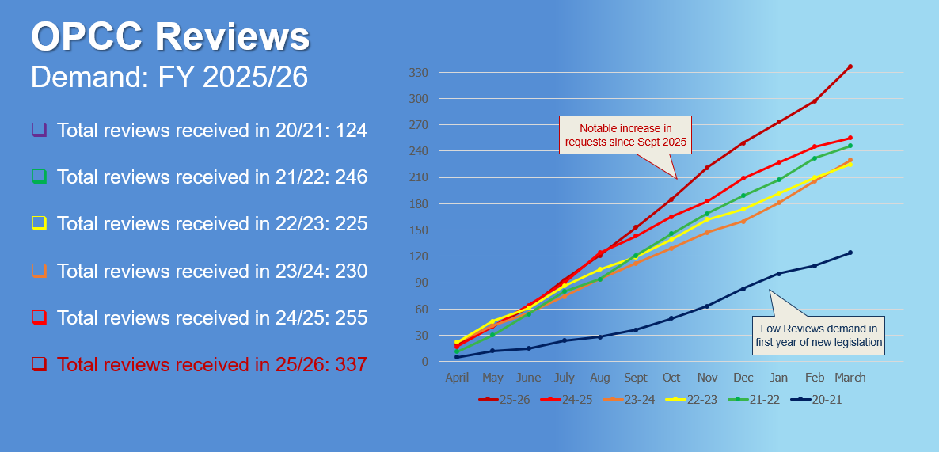

NB: ‘2024’ above represents only a three-month period from Jan to March 2024.

- Forecast for reviews work, Financial Year April 2026 - March 2027

With the exception of 2023, which saw a reduction of 8.3% compared with 2022 figures, the Kent OPCC has, until the financial year 2025-2026 seen a steady increase in the total number of review requests received. The financial year 2025-2026 has seen a sharp increase in the total number of received which mirrors similar increases seen in Kent PSD in relation to complaints in general.

Over the financial year 2025-2026 Kent OPCC have noted that there has been, on average, approximately 28 reviews per month. Whilst this figure has fluctuated on a month by month basis, it is notable that Q1 of the financial year 2025-2026 saw a slightly lower amount of review requests being received in comparison to the remainder of the year.

NB: ‘2024’ above represents only a three-month period from Jan to March 2024.

Taking into account the above, together with other factors, such as the increase in repeat complainants and the fact that no anticipated increase in relation to Schedule 3 complaints is anticipated in the financial year 2026-2027, the OPCC is anticipating that there will be a growth of approximately 20% for the financial year giving an anticipated annual total of 404 reviews.

In terms of timeliness of responses to reviews, Kent OPCC, in accordance with IOPC data, have consistently been performing above the national average, albeit that it is acknowledged that the timeliness of response is not at the same level as previous years due to the increases seen, and some unplanned staff absence.

For the financial year 2024-2025, the IOPC reported that the national average number of working days to complete a review undertaken by a Local Policing Body (LPB) was 48 days. Kent OPCC’s average completion time for reviews was 30 days.

For the financial year 2025-2026 the national average number of working days to complete a review undertaken by a Local Policing Body (LPB) reduced to 41 days. Kent OPCC’s average completion time for reviews increased by 7 days to 37 days. This is still below the most similar force whose average completion time for reviews is approximately 45 days.

Whilst Kent OPCC has seen an increase in the average completion time for reviews by 7 days – it is notable that Q3 – Q4 saw the largest increase which is as a result of increased demand and staff absence through unplanned leave - the Kent OPCC continues to perform well in relation to timeliness of review response in comparison to the national average and also in direct comparison to the LPBs in Most Similar Forces (MSF) over the last two financial years as detailed in the below.

It is anticipated that Kent OPCC’s average completion time for reviews in the coming year will continue to remain below the national average and it is anticipated that the average completion will reduce from 37 days back to an anticipated 30 days.

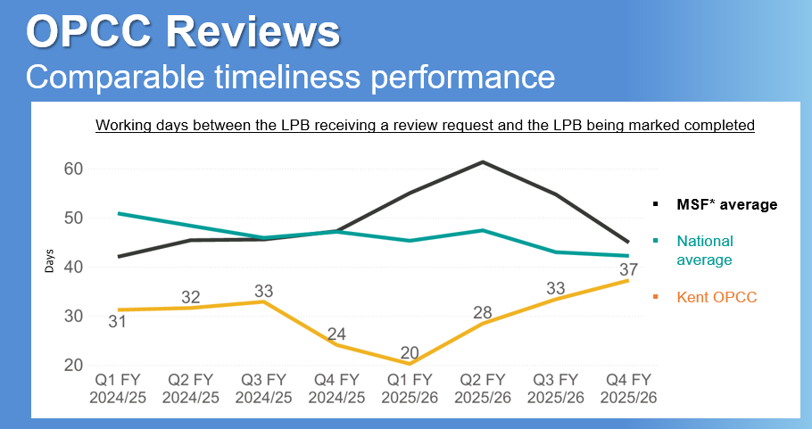

*Historically, up to and including FY 2025-26, Kent’s Most Similar Forces’ (MSF) have been deemed to be Avon & Somerset, Derbyshire, Essex, Hertfordshire, Northamptonshire, Nottinghamshire, and Staffordshire. The forces contained within that MSF are due to be revised in 2025/26.

It should also be noted that despite the government’s announcement to abolish PCCs, the complaint and review functions carried out by OPCCs is unlikely to change and will need to be moved to a new body.

Some OPCCs have reported that the announcement has seen a negative impact on the working relationship with their associated force. Kent OPCC is encouraged to note that there has been no impact on the working relationship between Kent OPCC and Kent Police following the announcement and it is anticipated that the working relationship will remain strong in the financial year 2026-2027.

20th May 2026

For example, where a person lists a number of issues that they were unhappy with, such as use of handcuffs, officer’s impolite tone, and necessity for arrest, but these are ‘bundled’ into one complaint of general dissatisfaction.

