


ANNUAL REPORT

Independent Custody Visiting Scheme

2025 -2026

www.kent-pcc.gov.uk/icv icv.scheme@kent.police.uk

ACKNOWLEDGEMENTS
13

CONTENTS
FOREWORD FROM PCC MATTHEW SCOTT ₀₃
ABOUT INDEPENDENT CUSTODY VISITING ₀₄
ABOUT OUR VOLUNTEERS ₀₅
OVERVIEW OF KENT CUSTODY SUITES ₀₆
OVERVIEW OF ICV VISITS ₀₇
AREAS OF GOOD PRACTICE ₀₈
AREAS REQUIRING FOCUS ₀₉
HEALTHCARE AND MENTAL HEALTH SUPPORT ₁₀
APPROPRIATE ADULT SERVICES ₁₁
ADDITIONAL SCRUTINY AND OVERSIGHT 12

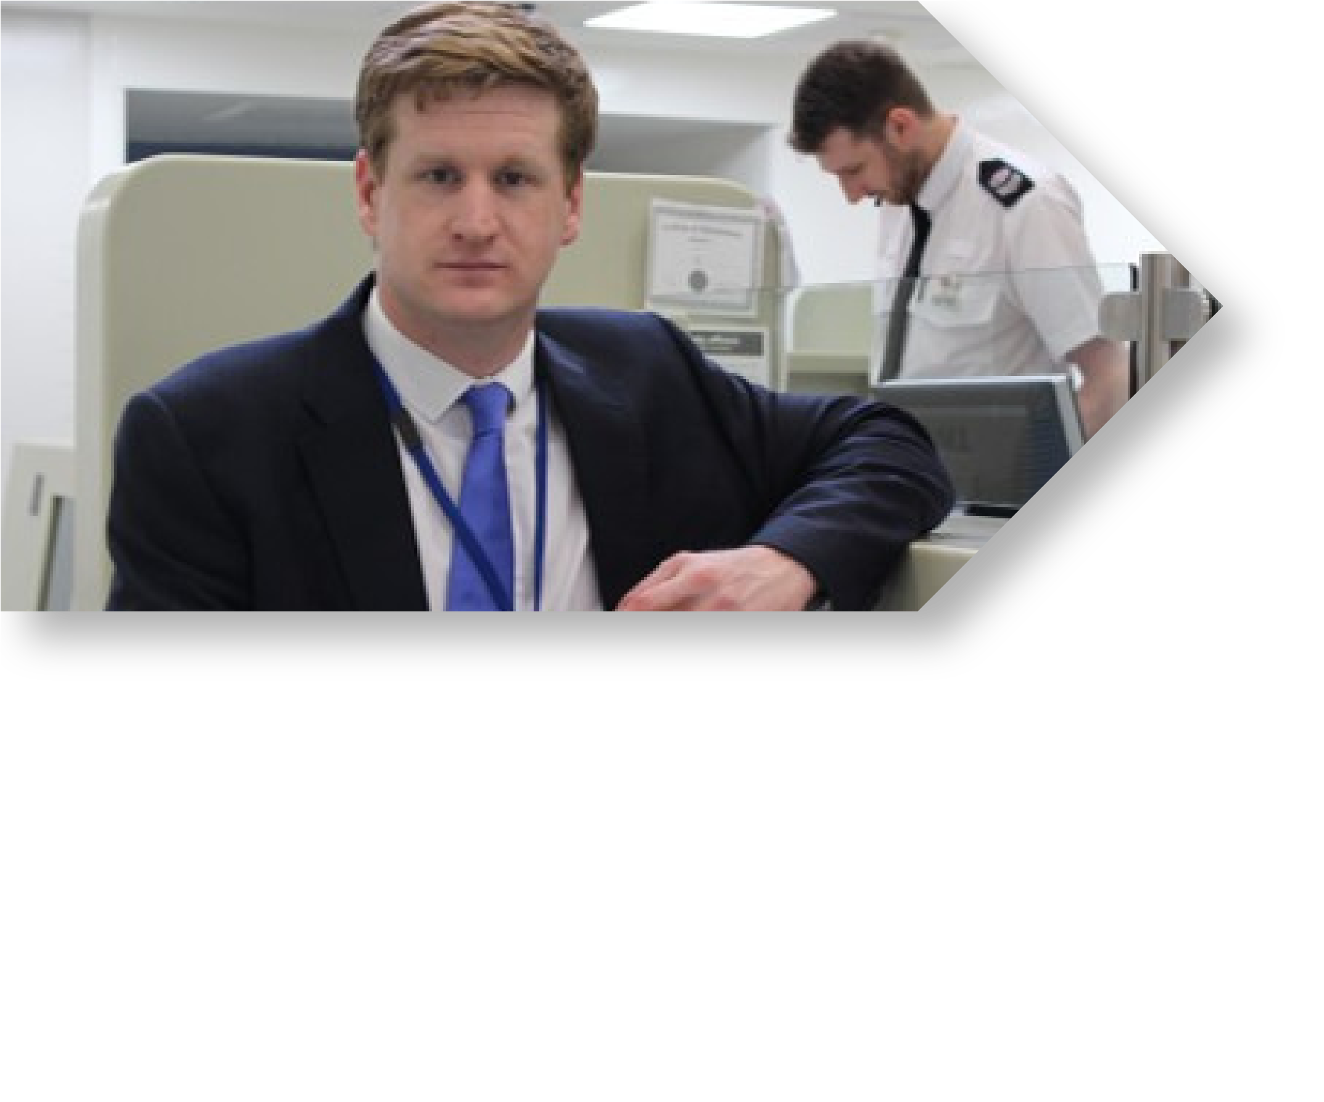


FOREWORD
It is my pleasure to introduce the ICV Annual Report for 25-26.

This year’s report continues to provide me with the reassurance that people detained in police custody are treated with dignity and respect and demonstrates that ICV feedback is actively being used to further improve conditions in custody. I am especially encouraged by the continued focus on welfare of vulnerable people, including children and those with additional needs.

I am delighted to share that the Kent ICV Scheme has recently achieved the ICVA Gold Standard Award. This is a national accreditation that recognises the professionalism, consistency and impact of ICV schemes, and reflects the hard work of our volunteers, coordinators and ICV Scheme Managers in Kent.

The Custody and Detention Scrutiny Panel has also continued to develop and strengthen its role. This year’s thematic review examining the detention of children from ethnic minority backgrounds, was supported by the work of ICVs during their visits. The findings provide important reassurance in how children from ethnic minority backgrounds are treated in Kent Police custody, highlighting good practice throughout with suggestions to help improve custody record keeping.

We are approaching a period of wider change and uncertainty in policing governance. The proposed abolition of Police and Crime Commissioners in 2028, along with uncertainty around future funding for the national Independent Custody Visiting Association beyond 2027, presents questions around what the future of custody oversight will look like. However, I want to provide clear reassurance that Independent Custody Visiting is a statutory function. The role of ICVs will continue, and independent scrutiny of custody will remain an essential safeguard for detainees and for public confidence. I have also written directly to the Home Secretary to outline my concerns about the funding position for ICVA and re-iterate my support for custody visiting.

Finally, I would like to thank all of our volunteers for their commitment to the ICV scheme. The dedication helps me maintain oversight, transparency and public trust in policing and for that I am incredibly grateful. I warmly welcome our newly recruited members and look forward to the year ahead.

MATTHEW SCOTT
Kent Police and Crime Commissioner


About Independent Custody Visiting

All Police and Crime Commissioners (PCCs) are required to run an Independent Custody Visiting Scheme, whereby members of the public check on the welfare of people detained in police custody. The scheme aims to enhance public trust in the police and assists PCCs in holding local police forces to account.

In Kent, Independent Custody Visitors (ICVs) make unannounced visits to seven police custody suites around the county to check on the welfare of detained persons, ensure they have received their rights and make sure they are being held in conditions that are up to standard. Each custody suite is visited at a minimum once a month, and at maximum, once a week.

ICVs also visit a non-designated suite at Bluewater Shopping Centre. This custody suite is not staffed 24/7 and operates around the hours of Bluewater Shopping Centre. Detainees at this suite are usually taken to North Kent Police Station promptly for detention. The suite is only opened when a detainee is taken there and as a result, it is not always possible for ICVs to undertake a visit. Visits are scheduled twice a month and paired with a visit to North Kent. ICVs will only record a visit to Bluewater if entry has been successful. On occasion, the suite is open with a member of staff but no detainees, and in this scenario ICVs will conduct a check of the suite’s infrastructure, stock levels and general maintenance.

In addition, ICVs visit the UK Border Force (UKBF) detention centre in Dover once a month. This data is fed back directly to UKBF. The ICVs and ICV Manager meet with the UKBF team annually to discuss their findings.

Each visit to a police station cell is undertaken by two volunteers who then highlight their findings to the custody staff and then submit a report to the Office of the Police and Crime Commissioner (OPCC). The information is monitored regularly by the PCC's staff and Kent Police to ensure any important issues are dealt with swiftly.

Each ICV is expected to visit custody at least once a month and attend training sessions, two panel meetings per year, and an Annual General Meeting.

Although Independent Custody Visitors are volunteers (unpaid members of the local community) they do receive traveling expenses (mileage/parking) when undertaking visits.

About Our Volunteers

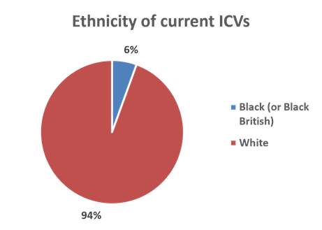
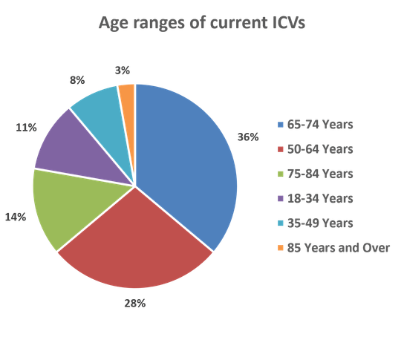
At present, Kent’s ICV Scheme has 36 volunteers, with 16 on the East panel and 20 on the North & West panel.

Each panel is headed by an ICV Coordinator who creates the rota, assists with the recruitment and retention of each team, chairs local panel meetings and attends the Custody and Detention Scrutiny Panel. Each ICV Coordinator is a volunteer and carries out the duties of an ICV in addition to the coordinator role. They sit on the interview panel and assist with selection of applicants to maintain transparency and independence.

The scheme has recently offered appointments to 22 more volunteers, subject to successful vetting. This will bring the scheme up to establishment, allowing better allocation of visits and increasing diversity.

Please note that the tables provided do not include the demographic data of new ICVs awaiting vetting.

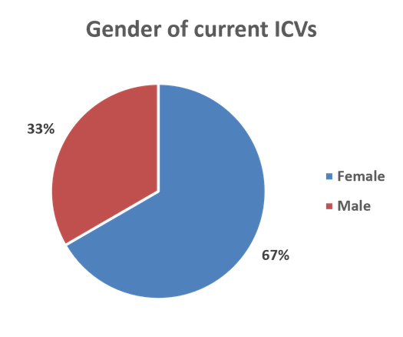

The OPCC strives to have a diverse team of volunteers that represents the people of Kent. We actively reach out to people from as many different backgrounds and communities, specifically those who are under-represented within the scheme. Our recent recruitment process has been successful in this respect.

To be eligible to join the Kent ICV Scheme, volunteers must be 18 or older, have no direct involvement in the criminal justice system, and successfully pass security vetting at Non-Police Personnel Level 2.
.
The scheme will continue to recruit ICVs as and when required, with input from each ICV Coordinator to ensure each suite is visited regularly.


Overview of Kent Custody Suites

Total Cell Capacity
Maidstone custody suite closed in October 2025, leaving six fully operational custody suites within the county with a total of 142 cells. Prior to this, there were seven custody suites, with a total of 159 cells across Kent.
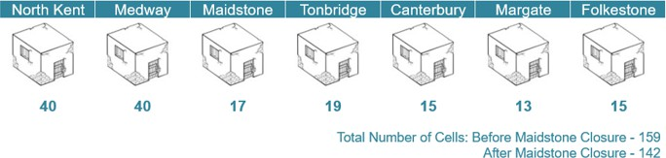

Detainee Throughput
There was a total of 29,721 detainees in Kent Police custody between 1st April 2025 and 31st March 2026. Medway Custody is normally much busier than other custody suites and had a significantly higher number of detainees this year. The low numbers at Maidstone reflect its closure part-way through the year.
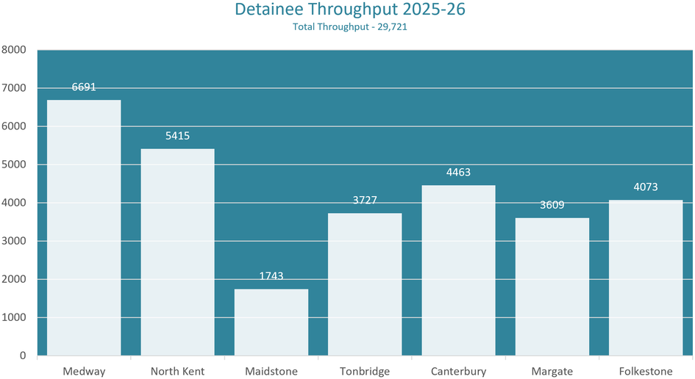

Overview of ICV Visits

Between April 2025 and March 2026 ICVs made 218 visits to custody and spoke with 724 detainees They were unable to speak with 935 detainees, which can be attributed to detainees being asleep, out of their cell in interview or ICVs’ time constraints. ICVs will prioritise the most vulnerable detainees which includes children, those with mental health issues, foreign nationals and female detainees. ICVs introduce themselves to the detainee, highlighting that they are independent from the Police, to increase the chance of detainee engagement. As a result, only 36 detainees refused to speak with ICVs. Additionally, ICVs were able to conduct a visit to Bluewater 5 times during this period, but there were no detainees on site.

Maidstone custody suite closed in October 2025 and this is reflected in the data below.

Panel | North Kent |  | West Kent |  | East Kent |  |  | Total
Station | North Kent | Medway | Maidstone | Tonbridge | Canterbury | Margate | Folkestone | Total
No of Visits | 38 | 29 | 12 | 35 | 33 | 38 | 33 | 218
No. of DPs at time of visit | 378 | 339 | 64 | 271 | 217 | 216 | 210 | 1695
DPs Visited | 157 | 134 | 30 | 126 | 81 | 87 | 109 | 724
DPs Not Visited | 210 | 193 | 31 | 143 | 135 | 124 | 99 | 935
DPs Refused Visit | 11 | 12 | 3 | 2 | 1 | 5 | 2 | 36

It is important to note that each custody suite closed (either partially or fully) for essential maintenance during the year. The other custody suites accepted additional detainees if another suite was closed or at capacity.

The following commentary covers all recurring themes ICVs have recognised this year. Where ICVs have highlighted one-off, non-recurring concerns, these have been addressed with the custody managers to get an understanding of the issue, and ICVs provided with reassurance where necessary. When required, the OPCC will view the custody record or CCTV to provide reassurance to the ICVs and take further action when necessary.


Areas of
Good Practice

The majority of ICV reports highlighted generally good care of detainees from their observations, and received mostly positive feedback from detainees regarding their care. Overarching themes include:

Significant improvements to feminine hygiene care, including feminine hygiene packs being routinely offered to female detainees, with a wider range of hygiene items available. The addition of menopause items soon to be launched is welcomed, which will support detainees who enter custody experiencing menopause symptoms.

Named carers being routinely assigned to those who require additional support, including all children and all female detainees, as standard practice. This provides the detainee with a single point of contact for more sensitive matters.

The introduction of salt and vinegar crisps, with the strong sharp flavour being identified as having a soothing effect for menopausal and neurodivergent detainees.

Detainees being routinely offered distraction items such as books, puzzles and fidget toys, with a good range of items available to support different needs, preferences, languages and age groups.

Custody staff following alcohol and intoxication protocols well, including appropriate monitoring and risk management of detainees under the influence.

Staff responding proactively to healthcare needs, including following medical advice, arranging hospital treatment or placing detainees under constant observation, when required.

Religious needs and dietary requirements being recognised and accommodated, including provision of appropriate meals and access to religious texts or items.

Staff being welcoming, transparent and accommodating towards ICVs during visits, particular during busy periods. ICVs noted staff often approached them with concerns, so that feedback could be made via the OPCC. This demonstrates a good level of trust between ICVs, custody staff and the OPCC.


Areas
Requiring Focus

Several themes were identified by ICVs and require focus for improvement. These include;

Delays securing Appropriate Adults (AAs) for both children and vulnerable adults, particularly out of hours. In some cases, this extended detention times and prevented detainees from being processed. In rare instances, detainees were bailed due to a lack of
AA. This was occasionally identified as an issue with inconsistent record keeping (see point below), with most occasions being a lack of availability from either of the AA Schemes.

Inconsistent record keeping of actions, including those taken to obtain an AA. On a few occasions, this has led to confusion, delays in obtaining an AA and extended lengths of detention. ICVs suggest that custody invest in tablets to aid custody staff in completing custody records entries as they move around the suite. This recommendation has also been made at the CDSP, through their Thematic Reviews. At present, custody staff take notes on paper to type up when they find the time, contributing to inconsistent record keeping.

In addition, issues with the recording of Inspector reviews continues to be identified. ICVs note that it is not always clear whether a review has taken place within the required timescales, or whether sleeping detainees have been informed of their review once awake.

Continued concerns around staffing levels across the county, particularly during busy periods. On occasions, this has delayed booking-in and processing detainees. This also impacted the ability to facilitate several custody visits, with some visits being delayed, abbreviated or aborted due to limited staff availability.

Occasions during the first half of the year where access to a custody healthcare professional was delayed, particularly where provision is shared across multiple custody suites. However, it should be noted that improvements have been noted over time.

Stock management being a concern across custody suites, including shortages of clothing and footwear in some sizes, and some food items. It should be noted that a volunteer has been sought to support stock management, allowing custody staff to focus on detainee processing and care.

Instances of detainees remaining in custody for extended periods due to external factors such as prison lockouts, particularly over weekends.

Healthcare and Mental Health Support

Healthcare in Custody
The Kent Police Custody Healthcare Team has a Head of department, two Managers and one part time admin Assistant. Kent Police currently has two Forensic Healthcare Practitioner teams comprising of nurses and paramedics. The areas covered:

Canterbury, Margate and Folkestone
Medway, North Kent and Tonbridge

Kent Police’s Custody Healthcare Team establishment is 23 Whole Time Equivalent (WTE) but this excludes the two Managers and one Admin Assistant.

The service covers from 0730-0500hrs each day; therefore between 0500 – 0730hrs each morning there is no cover in the county.

Total number of detainees in custody = 29,721. Total number of detainees seen by an FHP =12,018. This represents 40% of detainees who are seen by an FHP. The below table outlines the number of detainees per suite, per month, that were seen by an FNP.
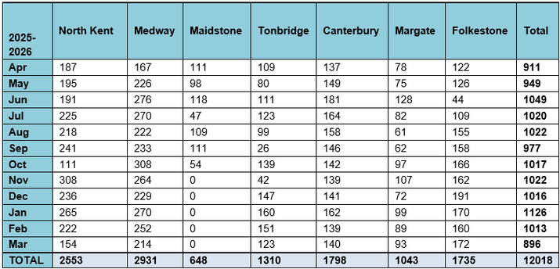

Mental Health Team
The Kent Police Mental Health Team are locally based and embedded within mental health establishments across the county. In addition to reducing the incidents of violence/aggression and absconding from establishments, the team engages with those who have mental health issues and regularly go missing or are ‘repeat presenters’; manage an investigative caseload providing continuity across NHS sites; and provide advice and guidance to their colleagues including within the Force Control Room and the OPCC.

The aim of the team is to apply a consistent approach across the county, and to reduce demand by more effectively managing service users either through the involvement of partner agencies or effective application of legislation.

Appropriate Adult Services

The Police & Crime Commissioner commissioned a 24/7 AA service for vulnerable adults in Kent and out of hours coverage for Medway children and adults. This is delivered by The Appropriate Adult Services Ltd (TAAS) and commenced in October 2022. Kent County Council and Medway Council separately commission Young Lives Foundation (YLF) to provide AAs for children during the daytime and vulnerable adults during the daytime in Medway. TAAS provide AAs where the out of hours service cannot meet the need in Kent.

The new contract for the OPCC’s AA Scheme will be awarded later in the year and will commence on 1st December. The service specification has been enhanced to ensure that the booking of AAs and the communication lines regarding AA attendances can utilise different methods and allow the development of the use of IT in line with Kent Police policies.

Kent County Council’s Duty Social Service team are required to source AAs for children behind held in custody between 2300hrs and 0800hrs, for all custody suites except Medway.

The time of day, and which station the AA is required to attend, will determine which of the two services are contacted. Custody have set up a central number which directs staff to the right service depending on operating hours.

Staff will generally seek family and friends to act as AAs first, as per the approved process. ICVs reported that there were occasional delays in obtaining an AA from the scheduled service provider at the time.



Additional Scrutiny and Oversight

Custody and Detention Scrutiny Panels
In 2023, guidance was issued to all Forces and OPCCs by the Association of Police and Crime Commissioners, and the National Police Chiefs’ Council, regarding the establishment of Custody and Detention Scrutiny Panels (CDSPs). There was an awareness that scrutiny of custody was currently limited to HMICFRS, which is in-depth but infrequent, and the work of ICVs. Nationally, there is a desire to both improve the collection and assessment of data, and the independent oversight of custody.

A CDSP has been established in Kent now for over two years and ICVs play a key role. Both coordinators also attend as representatives of their respective panel of ICVs, and the North & West Kent ICV Panel Coordinator is currently the co-Chair.

The CDSP examine the data collected about Kent’s custody, and consider a full data pack created by the OPCC's analyst, which covers numbers of detainees broken down by age, sex and lengthy of detention, and a wide range of other measure such as strip searches, delays in collection from custody, and so on; examine case studies, and areas of interest such as the detention of children; look at information collected by ICVs; and consider disproportionality, amongst other things. Complaints about custody are also examined, both in terms of number, distribution and outcome.

The panel produces an annual report as well as a thematic review on a topic of interest. This year, the review focused on the detention of children from an ethnic minority background. This can be found on our website here.

Quality Assurance Framework Gold Award
The Independent Custody Visiting Association (ICVA), a
national membership organisation that supports, leads and represents ICV schemes, has developed a quality assurance framework to assess how well schemes comply with the code of practice that governs custody visiting.

The Kent ICV scheme has been awarded the Gold Award, recognising that the scheme provides an excellent standard of custody visiting and volunteer management.

This is the third year that schemes have been assessed under the framework and have been able to gain quality assurance awards to recognise the value of their work.


Acknowledgements

The OPCC wishes to thank the custody management team for being receptive to ICV feedback and making positive changes in response to ICVs’ concerns.

The OPCC extends thanks to the wider custody team for accommodating ICVs on their visits, being receptive to feedback and taking immediate action at any matters that need resolution during a visit.

The OPCC wishes to thank all volunteers on the Independent Custody Visiting Scheme for their dedication to the role and providing a vital service for the care of detained persons.

