

Custody Detention Scrutiny Panel
Data pack
Tuesday 13th October 2026

Table of Contents

- Overall Volume – Authorised Child Detentions page 3 & 4

- Child Detentions Refused page 5

- Reason for Arrest page 6

- Comparative data – Child Detentions in the 9 Athena forces page 7

- Child Detainees by Ethnic Appearance page 8

- Average Detention Time per Custody Suite page 9 & 10

- Appropriate Adults for Children page 11

- Child Strip Searches page 12, 13 & 14

- Children in Custody - Bail Denied and Court Outcome page 15 & 16

- Late Collections page 17

- Successful Interventions page 18 & 19

- Section 136 page 20

- Custody Closures page 21 & 22

- Overall Volume – Authorised Child Detentions
(Data supplied by Central Analytical Team, Kent Police)

Child detentions are those detainees, aged between 10 –17 years of age, who have been arrested and brought into custody. Their detention (stay in custody) has been authorised by a custody officer.

There have been 1,255 authorised child detentions so far in 2026 (end of August 2026).

By comparison, the previous ‘full year’ volumes were:

- 2019: 1,769 child detentions
- 2020: 1,654 child detentions
- 2021: 1,202 child detentions
- 2022: 1,444 child detentions
- 2023: 1,535 child detentions
- 2024: 1,718 child detentions
- 2025: 1,588 child detentions

The proportion of adult/child Authorised Detainees for 2026 is as follows: -

- 93.7% adults (18,633)
- 6.3% children (1,255)

The below table and chart show the number of authorised child detentions in 2023, 2024, 2025 and so far in 2026:-

 | Year
Month | 2023 | 2024 | 2025 | 2026
January | 126 | 137 | 121 | 127
February | 93 | 122 | 139 | 136
March | 159 | 158 | 152 | 156
April | 115 | 163 | 130 | 139
May | 129 | 132 | 175 | 176
June | 153 | 136 | 146 | 197
July | 131 | 165 | 145 | 151
August | 116 | 133 | 108 | 173
September | 128 | 141 | 131
October | 135 | 149 | 131
November | 135 | 144 | 102
December | 115 | 138 | 108
Total | 1,535 | 1,718 | 1,588 | *1,255
*To date

So far this year 2026 (1,255) has seen slightly higher numbers of authorized child Detentions to the same period in 2025 (1,116) and 2024 (1,146).

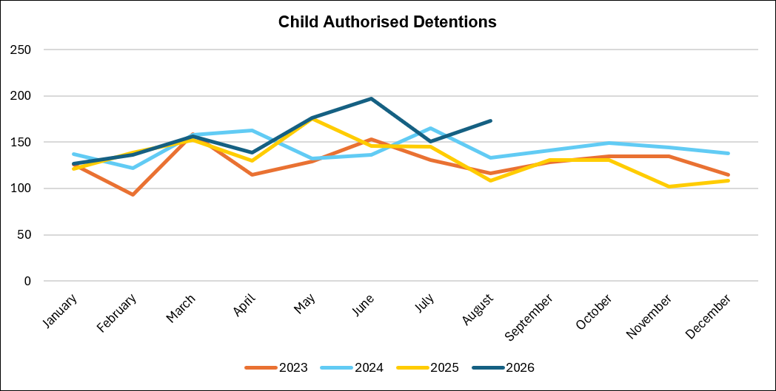

- Child Detentions Refused
(Data supplied by Central Analytical Team, Kent Police)

The below table looks at the number of detentions refused and those authorised between June and August 2026, broken down by custody suite, with a proportion of the number of refused detentions out of the total number of children arrested and brought into custody (authorised + refused).

Custody Suite | Authorised | Refused | % Refused
Medway | 121 | 12 | 9.0%
North Kent | 67 | 6 | 8.2%
*Maidstone | - | - | -
Tonbridge | 83 | 7 | 7.8%
Margate | 65 | 4 | 5.8%
Folkestone | 90 | 4 | 4.3%
Canterbury | 95 | 6 | 5.9%
Total | 521 | 39 | 7.0%
*Maidstone Custody closed on 15th October 2025

- 39 child detentions have been refused during June and August 2026.
- Medway had the highest proportion of refused detentions with 9.0% (12), North Kent is the 2nd highest proportion with 8.2% (6).
- Folkestone had the lowest proportion of child detentions refused with 4.3% (4).

Whilst it has not been possible to review every refused detention, of those that have been refused, the underlying reason for refusal is that detention would be disproportionate as the offences under consideration could be investigated via voluntary attendance interview.

- Reasons for Arrest
(Data supplied by Children in Custody Concordat, Kent Police)

This data looks at all reasons for arrests where a detainee has been secured within a Kent custody suite at some point. Please note that an individual can be arrested for more than 1 offence and thus result in multiple arrests and these arrests may not all belong to Kent Police. The volume of arrests will always be higher than the volume of detainees.

There were 1,163 arrests across April – June, broken down into the following arrest reasons:
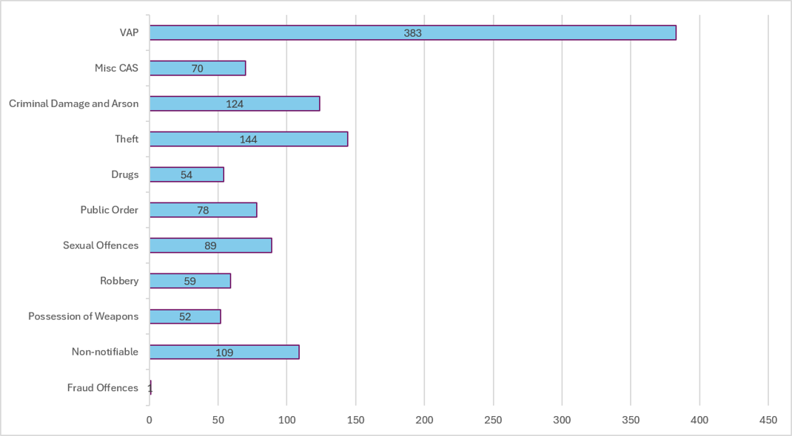

- Violence against the Person (VAP) accounts for the highest volume of arrests (32.9%). This is very similar to the 32.8% in the previous quarter.
- Theft accounts for the largest proportional increase in arrests, from 159 to 231, proportionally increasing from 15.0% to 21.8%.
- Criminal Damage and Arson accounts for the largest proportional decrease in arrests, from 132 to 101, proportionally decreasing from 12.7% to 9.5%.

- Comparative data – Child Detentions in the 9 Athena forces
(Data supplied by Kent Police Criminal Justice - Command not to be shared wider)

The below chart shows a comparison of how many child custody detentions have occurred between May to July 2026 in the 9 Athena forces. The percentages show the percentage of child custody detentions, compared to the number of detentions overall: -

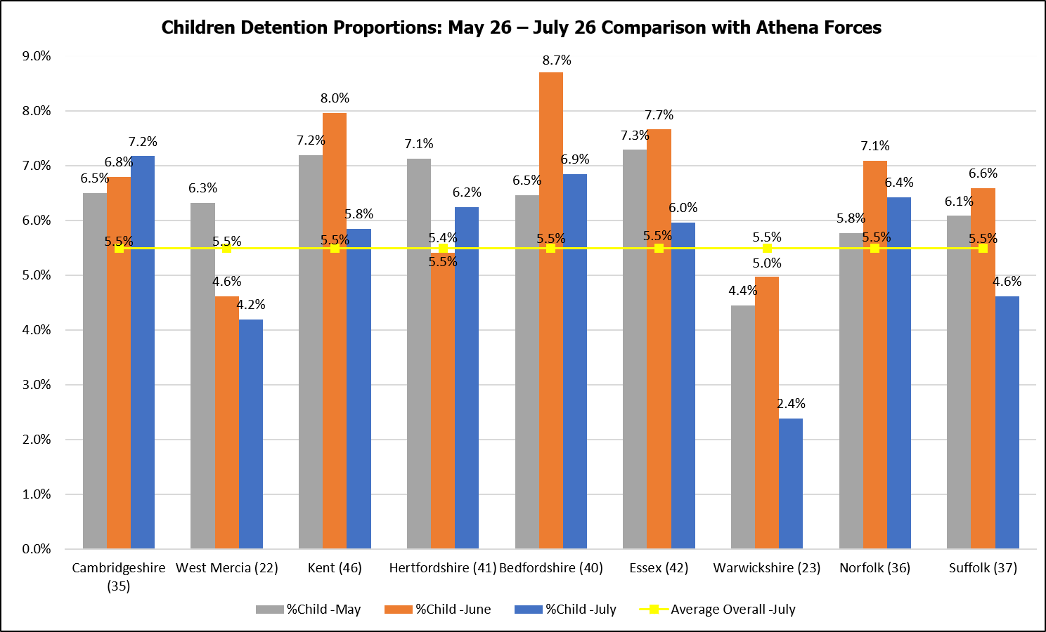

*The above data belongs to other police forces; consent must be cleared before sharing wider

The below table shows a comparison of the total population per Athena force: -

Athena Force | Population per Square Kilometre | Population Total
Cambridgeshire (35) | 253.67 | 859,830
West Mercia (22) | 175.28 | 1,298,422
Kent (46) | 500.11 | 1,868,199
Hertfordshire (41) | 727.71 | 1,195,672
Bedfordshire (40) | 552.29 | 682,311
Essex (42) | 505.81 | 1,856,063
Warwickshire (23) | 295.58 | 583,786
Norfolk (36) | 170.19 | 914,039
Suffolk (37) | 200.32 | 761,246
*Data taken from HMICFRS on 20/09/2024

The above data shows Kent currently has the highest population of the 9 Athena forces with Essex having a similar number.

- Child Detainees by Ethnic Appearance
(Data supplied by Central Analytical Team, Kent Police)

Due to a change in the way Kent Police uploads data to the force Data Hub, below is the available data for Detainees by Ethnicity child only.

Ethnic Appearance is not a mandatory field and is based on officer judgement.

The below table shows the ethnic appearance of detainees between August 2025 – August 2026, who had a known and unknown ethnic appearance: -

- Average Detention Time per Custody Suite

(Data supplied by Central Analytical Team, Kent Police)

The below charts show the Overall average dwelling time, Adult average dwelling time and Child average dwelling time per custody suite, between September 2025 and August 2026: -

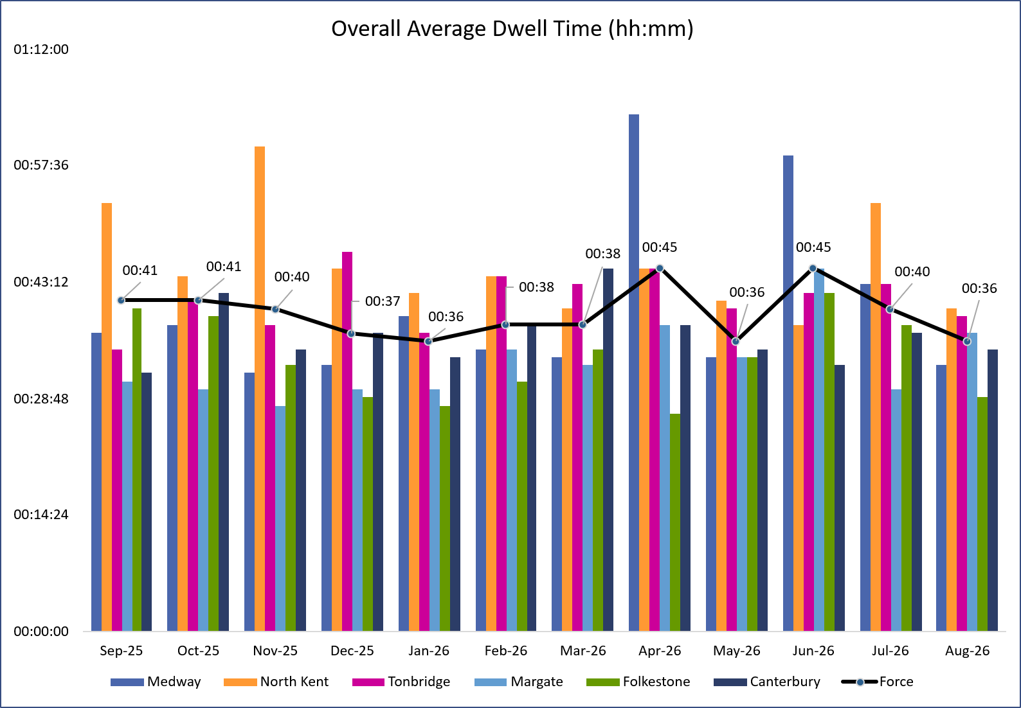
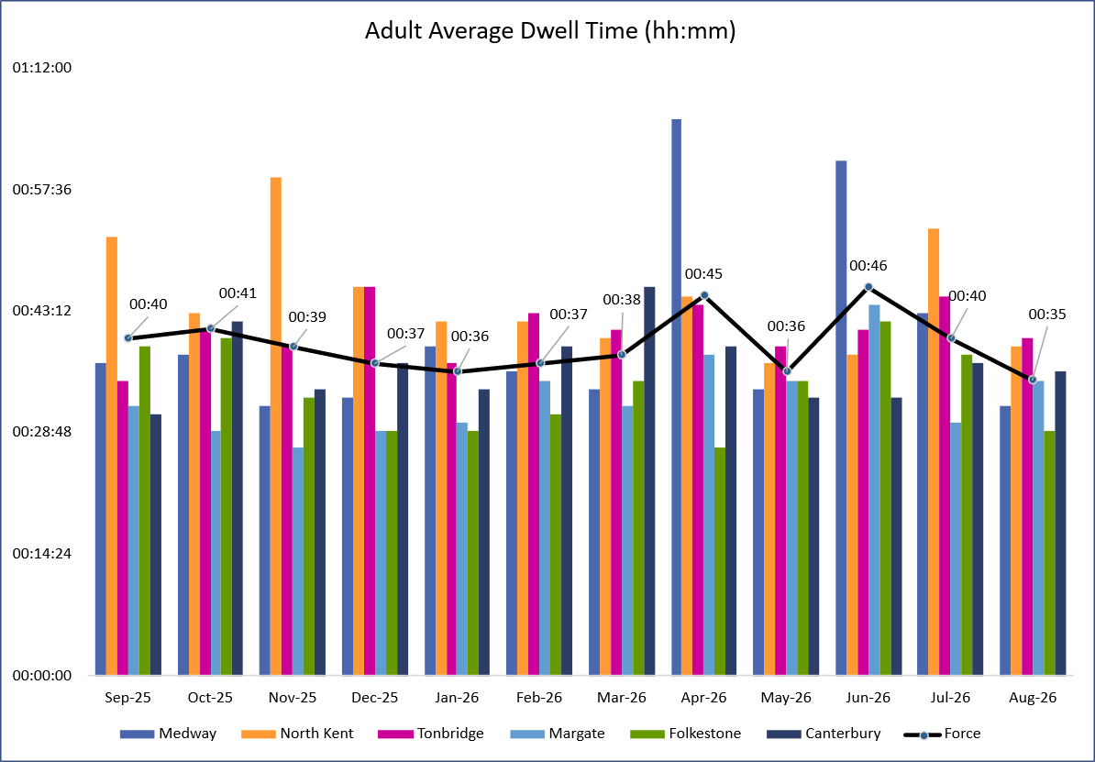

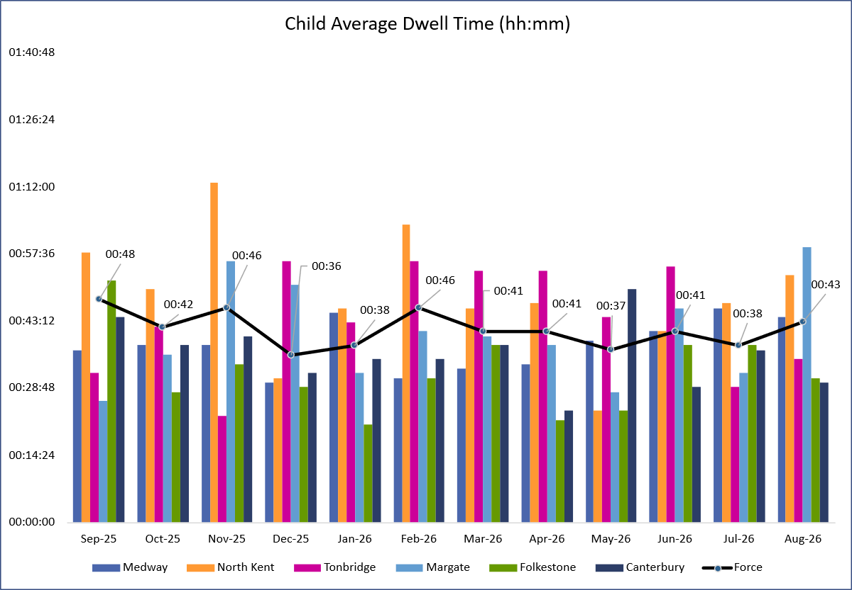

- Appropriate Adults for Children
(Data supplied by Central Analytical Team, Kent Police)

All children require an Appropriate Adult (AA) be present at certain stages of the custody process. This data looks at whether an AA was present during the child’s detention.

The below chart and table show the number of Appropriate Adults present or not present for children between August 2025 and August 2026: -

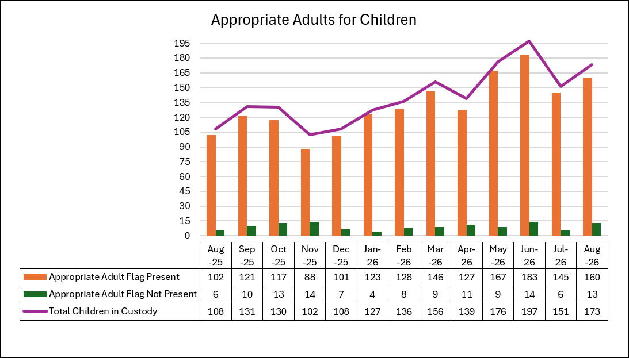

- Child Strip Searches
(Data supplied by Custody Department, Kent Police)

Between June and August 2026, there was a total of 13 child strip searches in custody.
The below table shows the age, gender, ethnicity, reason for strip search and further details: -

 | Record Number | Age & Gender | Ethnicity | Reason For Arrest | Looked after Child | Intimate exposure | Details
1 | E/1780/26 Kent address | 17M | Black Spanish | Drug supply, County Lines | No | Yes | Inspector authority recorded. AA aware/nearby. Two same-sex officers. Further wraps recovered from groin/genital area.
2 | E/1849/26 Kent address | 14F | Black British | Criminal damage Common Assault | Yes | Yes | Inspector authority recorded. AA aware/nearby. Two same-sex officers. Search negative.
3 | E/1979/26  Kent address | 14F | Black British | Arson endangering life | Yes | Yes | Inspector authority recorded. AA present/nearby. Two same-sex officers. Search negative.
4 | E/1984/26 Kent address | 14F | Black British | Common assault | Yes | Yes | Inspector authority recorded. AA aware/nearby. Two same-sex officers. Search negative.
5 | E/2074/26 Kent address | 14F | Black British | Assault | Yes | Yes | Inspector authority recorded. AA aware but declined to attend.  Two same-sex officers. Search negative.
6 | E/2125/26 Kent address | 16M | White British | Assault GBH | Yes | Yes | Inspector authority not recorded. AA aware/nearby. Two same-sex officers.  Search negative. Feedback provided.
7 | A/4184/26 Medway address | 16M | Black British | Robbery | No | No | Forensic clothing seizure only.  No intimate parts exposed.
8 | A/4185/26 Medway address | 15M | Black Nigerian | Robbery | No | No | Forensic clothing seizure only.  No intimate parts exposed.
9 | A/4186/26 Medway address | 14M | Black British | Robbery | No | No | Forensic clothing seizure only.  No intimate parts exposed.
10 | B/2820/26 Kent address | 16M | White British | Rape | No | No | Forensic clothing seizure only.  No intimate parts exposed.
11 | M/2404/26 Kent address | 16M | White British | Drug supply | Yes | Yes | Inspector authority recorded. AA present/nearby. Same-sex officers. Search negative
12 | A/4991/26 Kent address | 14M | White British | Rape | No | No | Forensic clothing seizure only.  No intimate parts exposed.
13 | C/3269/26 Kent address | 16M | Black British | Drug possession and supply | Yes | Yes | Inspector authority not recorded.  AA present/nearby. Two same-sex officers.  Cannabis recovered from boxer shorts.

46ZE/2125/26 – 16-year-old has been arrested after handing himself in at Front Counter. Allegation of GBH with two adult co-defendants in custody. Strip search was not authorised by an Inspector, and this has been dealt with by way of feedback to a new in post officer.
46XC/3269/26 - 16-year-old male detained for drug offences while on bail for similar matters. A strip search was authorised by the custody officer due to suspected bail breaches involving mobile phones; however, the record does not evidence Inspector authority. The search was conducted by two same-sex officers in a controlled area and located a small quantity of cannabis concealed in the detainee’s boxer shorts.
Summary of Strip Searches Involving Children
(Breakdowns do not include removal of clothing and admin error records)

Between June and August 2026, there was a total of 13 children were recorded on Athena as having been subject to strip searches.

Age breakdown
- 17 years: 1
- 16 years: 5
- 15 years: 1
- 14 years: 6

Gender breakdown
- Male: 9
- Female: 4

Ethnicity breakdown
- White British: 4
- Black British: 7
- Black Spanish: 1
- Black Nigerian: 1

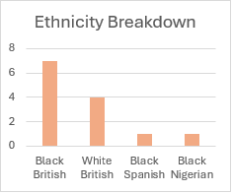

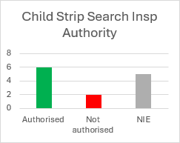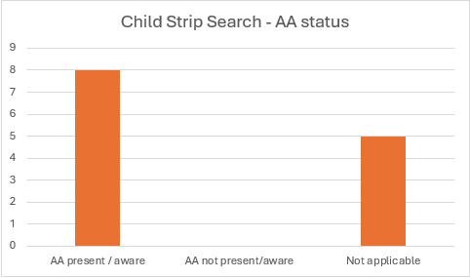

- Children in Custody - Bail Denied and Court Outcome
(Data supplied by Custody Department, Kent Police)

Between June and August 2026, a total of 11 children had their bail denied. The below table shows the age, gender, ethnicity, reason for arrest, and further details: -

 | Record Number | Age | Ethnicity | Reason For Arrest | Looked after Child | Accommodation position | Court Outcome
1 | A/3136/26  Kent address | 16M | Black British | Robbery x3  Offensive weapon | Yes | Secure accommodation agreed, but not provided | Remanded into youth detention
2 | A/3138/26 Kent address | 15M | Black British | Robbery x3  Offensive weapon | Yes | Secure accommodation agreed, but not provided | Sentenced following a guilty plea; full details were not recorded as this was an out-of-county case
3 | B/2500/26 Kent address | 17M | White British | Assault, ABH | Yes | Suitable accommodation agreed but not provided. The existing care placement was considered unsuitable by the custody officer | Remanded into the care of the Local Authority with strict reporting conditions
4 | E/2125/26 Kent address | 16M | White British | Assault, GBH | Yes | Secure accommodation requested but not agreed or provided | Court outcome awaiting confirmation at the time of reporting
5 | A/4302/26 Medway address | 17M | Black British | Possession of firearm with intent  Drug possession | Yes | Charged at 02:30 and it was considered impractical to move the child | Remanded into Local Authority accommodation
6 | M/2404/26 Kent address | 16M | White British | Drug supply | Yes | Secure accommodation agreed but unavailable at short notice | Conditional bail with tagging conditions that the police could not administer
7 | A/3959/26 Out of County | 16M | Romanian | Rape | Yes | Secure accommodation requested but not provided. Responsibility rested with Greenwich | Remanded into youth detention until trial
8 | A/4196/26 Medway address | 16M | White British | Att Murder  (Bleach in carers drink) | Yes | Accommodation request was unclear because the form had not been completed correctly | Conditional bail
9 | M/2639/26 Kent address | 17M | White British | GBH | Yes | Suitable accommodation requested but not provided. The Local Authority agreed the child would remain in police custody | Remanded into youth detention until hearing
10 | A/5031/26 Out of County | 17F | Romanian | Theft | Yes | Secure accommodation was not agreed or provided. Havering Local Authority was identified after it had become impractical to move the child | Conditional bail
11 | C/3394/26 Out of County | 16F | White British | Theft  Outstanding warrant | No | Movement not practical | Court outcome awaiting confirmation at the time of reporting

Child bail denied March, April and May 2026

Between June and July 2026, a total of 11 children were denied bail.

Age Breakdown
- 17 yrs: 4
- 16 yrs: 6
- 15 yrs: 1

Sex Breakdown
- Male: 9
- Female: 2

Ethnicity Breakdown
- White British: 6
- White Romanian: 3
- Black British: 2

10.Late Collections
(Data supplied by Kent Police Criminal Justice Command)

The below chart shows Late Collections (after 09:30 hours) by suite between April and July 2026:-

The below chart shows Late Collections Total between August 2025 and July 2026:-

11.Successful Interventions
(Data supplied by Custody Department, Kent Police, Kent Police).

The below chart shows Custody Suite Submissions by suite between June and August 2026:-

The below chart shows Suite breakdown by incident type for August 2026:-

The below chart shows Types of Incidents by Suite between 2024 and 2026:-

The below chart shows Successful Interventions by categories between 2024 and 2026:-

The below chart shows Successful Intervention Submissions September 2025 and August 2026:-

12.Section 136
(Data supplied by Strategic Prevention Command, Kent Police)

July 2026
Total S136 = 69
Total from Custody = 1 (as outlined below, detained at Canterbury Custody)

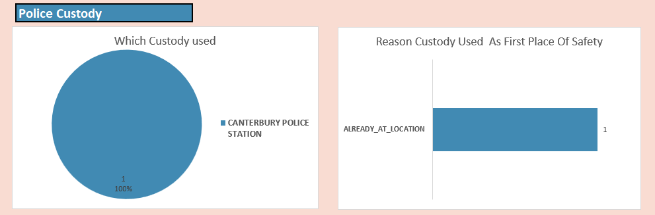

August 2026
Total S136 = 61
Total from Custody = 0

September 2026
Total S136 = 57
Total from Custody = 2

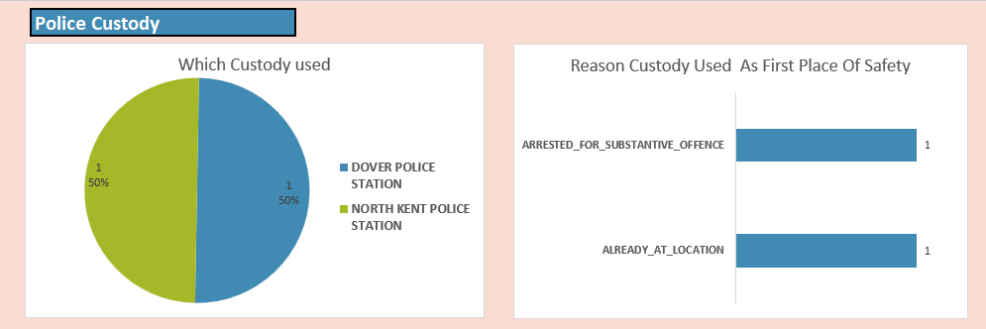

13.Custody Closures
(Data supplied by Estate and Facilities Services Department, Kent Police)

Below are the planned closures for 2026:-

Programme rev3
Task Name | Duration | Start | Finish
Folkestone – Full closure | 15 days | Mon 30/03/26 | Fri 17/04/26
Decorations to fabric | 15 days | Mon 30/03/26 | Fri 17/04/26
Ligature risk reduction | 5 days | Mon 30/03/26 | Fri 03/04/26
Cell door tolerance checks | 2 days | Mon 30/03/26 | Tue 31/03/26
ITS to replace all external microphones | 3 days | Mon 30/03/26 | Wed 01/04/26
Drainage survey | 1 day | Mon 30/03/26 | Mon 30/03/26
Air handling ductwork cleaning | 3 days | Mon 30/03/26 | Wed 01/04/26
Asbestos surveys | 1 day | Mon 30/03/26 | Mon 30/03/26
Medway – Full Closure | 10 days | Mon 20/04/26 | Fri 01/05/26
Front Counter refurb | 10 days | Mon 20/04/26 | Fri 01/05/26
Flooring around custody desks | 5 days | Mon 20/04/26 | Fri 24/04/26
Lifts circuit boards, software | 2 days | Mon 20/04/26 | Tue 21/04/26
CCTV replacements, inc cells | 10 days | Mon 20/04/26 | Fri 01/05/26
Minor décor and finish defects inc cell flooring where required | 3 days | Mon 20/04/26 | Wed 22/04/26
Canterbury - Full closure | 14 days | Weds 06/05/26 | Fri 22/05/26
Decorations to fabric | 14 days | Weds 06/05/26 | Fri 22/05/26
Ligature risk reduction | 5 days | Mon 11/05/26 | Fri 15/05/26
Cell door tolerance checks | 2 days | Mon 11/05/26 | Tue 12/05/26
Drainage survey | 1 day | Mon 11/05/26 | Mon 11/05/26
CCTV replacements, inc cells | 14 days | Weds 06/05/26 | Fri 22/05/26
Air handling ductwork cleaning | 3 days | Mon 11/05/26 | Wed 13/05/26
Asbestos surveys | 1 day | Mon 11/05/26 | Mon 11/05/26
Margate – Full closure | 15 days | Weds 27/05/26 | Fri 12/06/26
Decorations to fabric | 15 days | Weds 27/05/26 | Fri 12/06/26
Ligature risk reduction | 5 days | Mon 01/06/26 | Fri 05/06/26
Cell door tolerance checks | 2 days | Mon 01/06/26 | Tue 02/06/26
CCTV replacements, inc cells | 15 days | Weds 27/05/26 | Fri 12/06/26
Drainage survey | 1 day | Mon 01/06/26 | Mon 01/06/26
Air handling ductwork cleaning | 3 days | Mon 01/06/26 | Wed 03/06/26
Asbestos surveys | 1 day | Mon 01/06/26 | Mon 01/06/26
North Kent – Full Closure | 30 days | Mon 15/06/26 | Fri 24/07/26
Drainage works | 15 days | Mon 15/06/26 | Fri 03/07/26
Toilet Controllers replaced | 5 days | Mon 22/06/26 | Fri 26/06/26
Minor Décor works | 2 days | Mon 22/06/26 | Tue 23/06/26
CCTV replacements, inc cells (hold) | 30 days | Mon 15/06/26 | Fri 24/07/26
Flooring replacements | 1 day | Mon 22/06/26 | Mon 22/06/26
Custody break | 28 days | Wed 22/07/26 | Fri 28/08/26
Maidstone – Closed until further notice | 5 days | Mon 31/08/26 | Fri 04/09/26
Maintenance | 5 days | Mon 31/08/26 | Fri 04/09/26
Drainage survey | 1 day | Mon 31/08/26 | Mon 31/08/26
Air handling ductwork cleaning | 3 days | Mon 31/08/26 | Wed 02/09/26
Asbestos surveys | 1 day | Mon 31/08/26 | Mon 31/08/26
Tonbridge – Part closure | 20 days | Mon 07/09/26 | Fri 02/10/26
Decorations to fabric | 15 days | Mon 07/09/26 | Fri 25/09/26
Ligature risk reduction | 5 days | Mon 07/09/26 | Fri 11/09/26
Cell door tolerance checks | 2 days | Mon 07/09/26 | Tue 08/09/26
Drainage survey | 1 day | Mon 07/09/26 | Mon 07/09/26
Air handling ductwork cleaning | 3 days | Mon 07/09/26 | Wed 09/09/26
Asbestos surveys | 1 day | Mon 07/09/26 | Mon 07/09/26
Bluewater – Full Closure | 5 days | Mon 28/09/26 | Fri 02/10/26
Decorations to fabric | 5 days | Mon 28/09/26 | Fri 02/10/26
Ligature risk reduction | 5 days | Mon 28/09/26 | Fri 02/10/26
Cell door tolerance checks | 2 days | Mon 28/09/26 | Tue 29/09/26
Drainage survey | 1 day | Mon 28/09/26 | Mon 28/09/26
Air handling ductwork cleaning | 3 days | Mon 28/09/26 | Wed 30/09/26
Asbestos surveys | 1 day | Mon 28/09/26 | Mon 28/09/26
Half term / Bonfire break | 5 days | Mon 19/10/26 | Fri 23/10/26
Coquelle – Not closing | 1 day | Mon 26/10/26 | Mon 26/10/26
Ballistic door maintenance | 1 day | Mon 26/10/26 | Mon 26/10/26

