

Custody Detention Scrutiny Panel
Data pack
Tuesday 14th July 2026

Table of Contents

- Overall Volume – Authorised Child Detentions page 3 & 4

- Child Detentions Refused page 5

- Comparative data – Child Detentions in the 9 Athena forces page 6

- Child Detainees by Ethnic Appearance page 7

- Average Detention Time per Custody Suite page 8 & 9

- Appropriate Adults for Children page 10

- Child Strip Searches page 11, 12 & 13

- Children in Custody - Bail Denied and Court Outcome page 14 & 15

- Late Collections page 16

- Successful Interventions page 17, 18 & 19

- Custody Closures page 20 & 21

- Overall Volume – Authorised Child Detentions
(Data supplied by Central Analytical Team, Kent Police)

Child detentions are those detainees, aged between 10 –17 years of age, who have been arrested and brought into custody. Their detention (stay in custody) has been authorised by a custody officer.

There have been 734 authorised child detentions so far in 2026 (end of May 2026).

By comparison, the previous ‘full year’ volumes were:

- 2019: 1,769 child detentions
- 2020: 1,654 child detentions
- 2021: 1,202 child detentions
- 2022: 1,444 child detentions
- 2023: 1,535 child detentions
- 2024: 1,718 child detentions
- 2025: 1,588 child detentions

The proportion of adult/child Authorised Detainees for 2026 is as follows: -

- 93.9% adults (11,360)
- 6.1% children (734)

The below table and chart show the number of authorised child detentions in 2023, 2024, 2025 and so far in 2026:-

 | Year
Month | 2023 | 2024 | 2025 | 2026
January | 126 | 137 | 121 | 127
February | 93 | 122 | 139 | 136
March | 159 | 158 | 152 | 156
April | 115 | 163 | 130 | 139
May | 129 | 132 | 175 | 176
June | 153 | 136 | 146
July | 131 | 165 | 145
August | 116 | 133 | 108
September | 128 | 141 | 131
October | 135 | 149 | 131
November | 135 | 144 | 102
December | 115 | 138 | 108
Total | 1,535 | 1,718 | 1,588 | *734
*To date

So far this year 2026 (734) has seen similar numbers of authorized child Detentions to the same period in 2025 (717) and 2024 (712).

- Child Detentions Refused
(Data supplied by Central Analytical Team, Kent Police)

The below table looks at the number of detentions refused and those authorised between March and May 2026, broken down by custody suite, with a proportion of the number of refused detentions out of the total number of children arrested and brought into custody (authorised + refused).

Custody Suite | Authorised | Refused | % Refused
Medway | 94 | 7 | 6.9%
North Kent | 98 | 3 | 3.0%
*Maidstone | - | - | -
Tonbridge | 90 | 9 | 9.1%
Margate | 60 | 3 | 4.8%
Folkestone | 78 | 2 | 2.5%
Canterbury | 66 | 0 | 0.0%
Total | 486 | 24 | 4.7%
*Maidstone Custody closed on 15th October 2025

- 24 child detentions have been refused during March and May 2026.
- Tonbridge (last quarters lowest suite) had the highest proportion of refused detentions with 9.1% (9), Medway (last quarters highest suite), is the 2nd highest proportion with 6.9% (7).
- Canterbury (last quarters 2nd highest suite) is the lowest proportion of child detentions refused with 0% (0).

Whilst it has not been possible to review every refused detention, of those that have been refused, the underlying reason for refusal is that detention would be disproportionate as the offences under consideration could be investigated via voluntary attendance interview.

- Comparative data – Child Detentions in the 9 Athena forces
(Data supplied by Kent Police Criminal Justice - Command not to be shared wider)

The below chart shows a comparison of how many child custody detentions have occurred between January to March 2026 in the 9 Athena forces. The percentages show the percentage of child custody detentions, compared to the number of detentions overall: -

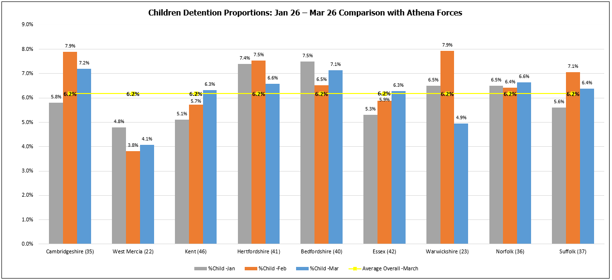
*The above data belongs to other police forces; consent must be cleared before sharing wider

The below table shows a comparison of the total population per Athena force: -

Athena Force | Population per Square Kilometre | Population Total
Cambridgeshire (35) | 253.67 | 859,830
West Mercia (22) | 175.28 | 1,298,422
Kent (46) | 500.11 | 1,868,199
Hertfordshire (41) | 727.71 | 1,195,672
Bedfordshire (40) | 552.29 | 682,311
Essex (42) | 505.81 | 1,856,063
Warwickshire (23) | 295.58 | 583,786
Norfolk (36) | 170.19 | 914,039
Suffolk (37) | 200.32 | 761,246
*Data taken from HMICFRS on 20/09/2024

The above data shows Kent currently has the highest population of the 9 Athena forces with Essex having a similar number.

- Child Detainees by Ethnic Appearance
(Data supplied by Central Analytical Team, Kent Police)

Due to a change in the way Kent Police uploads data to the force Data Hub, below is the available data for Detainees by Ethnicity child only.

Ethnic Appearance is not a mandatory field and is based on officer judgement.

The below table shows the ethnic appearance of detainees between May 2025 – May 2026, who had a known and unknown ethnic appearance: -

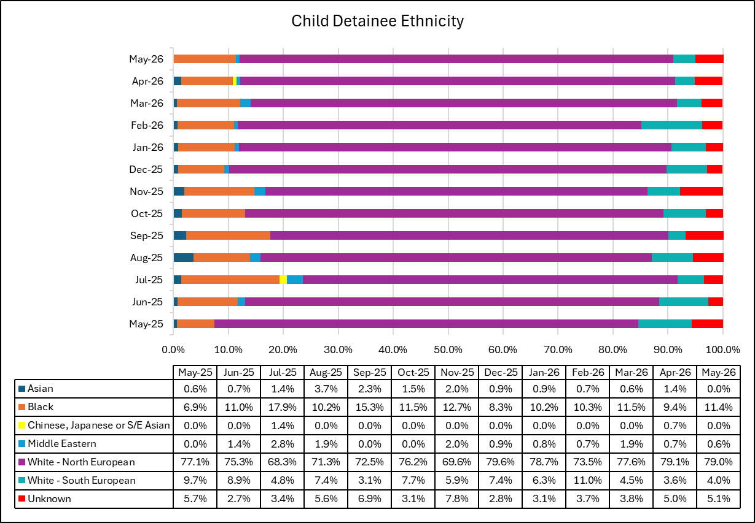

*Please see attachment 5a for Kent demographic data from census dated 2021.

- Average Detention Time per Custody Suite

(Data supplied by Central Analytical Team, Kent Police)

The below charts show the Overall average dwelling time, Adult average dwelling time and Child average dwelling time per custody suite, between May 2025 and April 2026: -

- Appropriate Adults for Children
(Data supplied by Central Analytical Team, Kent Police)

All children require an Appropriate Adult (AA) be present at certain stages of the custody process. This data looks at whether an AA was present during the child’s detention.

The below chart and table show the number of Appropriate Adults present or not present for children between May 2025 and May 2026: -

- Child Strip Searches
(Data supplied by Custody Department, Kent Police)

Between March and May 2026, there was a total of 19 child strip searches in custody.
The below table shows the age, gender, ethnicity, reason for strip search and further details: -

 | Record Number | Age & Gender | Ethnicity | Reason For Arrest | Looked after Child | Details
1 | 1243/26  Medway address | 17M | White British | Drug offences | Yes | Inspectors authority / AA present – nearby Same sex officers x 2. Nature of arrest and mannerisms displayed – NEGATIVE. DP was sent to hospital as suspected of conceal/ingest prior to strip search
2 | 1015/26  Out of county | 17M | White British | Criminal Damage | Yes | Inspectors authority / AA present – nearby Same sex officers x 2. Previous self-harm intelligence – POSITIVE. Good rationale – Not a full intimate search – removal of bra only – Item located
3 | 855/26  Medway address | 15M | Black British | Offensive Weapon  Drugs | No | Inspectors authority/ AA present – nearby – Same sex officers x 2. Nature of arrest and opportunity to conceal – NEGATIVE
4 | 1670/26  Medway address | 14M | White British | Going Equipped  Bladed Article | No | No Inspectors Authority/ AA present/Nearby – Same sex officers x 2. Child advised officers of the concealment of drugs – POSITIVE
5 | 1858/26  Kent address | 17M | White British | Theft | No | Inspectors Authority / AA present – Nearby – Same sex officers x 2. Antecedents and recent intelligence – NEGATIVE
6 | 1319/26  Out of County | 17M | Black British | PWiTS | No | Inspectors Authority / AA aware but not present – Same sex officers x 2. Nature of Arrest, Antecedents and opportunity - NEGATIVE
7 | 1323/26  Kent address | 17M | Black British | PWiTS | No | Inspectors Authority / AA present – Nearby – Same sex officers x 2. Nature of arrest and opportunity - NEGATIVE
8 | 1349/26  Kent address | 16M | White British | Theft | Yes | Inspectors Authority / AA present – Nearby – Same sex officers x 2. Intelligence regarding recent self-harm – NEGATIVE
9 | 1965/26  Out of County | 15M | Black British | Drug Offences (County Lines) | Yes | Inspectors Authority – AA present/nearby – same sex officers x 2. Nature of arrest and opportunity - NEGATIVE
10 | 2188/26  Medway address | 14M | Black British | Drug Offences (County Lines) | No | Inspectors Authority – AA present/nearby – same sex officers x 2. Nature of arrest and opportunity - NEGATIVE
11 | 1509/26  Kent address | 16M | White British | Criminal Damage | No | Inspectors Authority – AA present/nearby – same sex officers x 2. Nature of arrest and recent intelligence to protect detainee and officers - NEGATIVE
12 | 1528/26  Kent address | 14F | Black British | Assault, Criminal Damage, Offensive Weapon | Yes  (Surrey) | Inspectors Authority – AA present/nearby – same sex officers x 2. Nature of arrest and current intelligence – self harm - NEGATIVE
13 | 1989/26  Out of County | 13M | White British | Robbery  Sexual Assault | No | Clothing removal for forensics – No intimate parts exposed
14 | 2097/26  Kent address | 16M | White British | Rape | No | Clothing removal for forensics – No intimate parts exposed.
15 | 1627/26  Kent address | 14M | Black British | Drug Offences (County Lines) | Yes | Inspectors Authority – AA present/nearby – same sex officers x 2. Nature of arrest and opportunity – POSITIVE. 48 wraps of crack cocaine and heroin
16 | 1658/26a  Kent address | 17M | White British | Theft | No | Entry made in error – ADMIN
17 | 1676/26  Kent address | 17M | White British | Theft, Assault,  Criminal Damage | No | Inspectors Authority – AA present/nearby – same sex officers x 2. Concealment found on initial search - NEGATIVE
18 | 1658/26b  Out of County | 17M | Black British | Public Order  Offensive weapon | No | Inspectors Authority – No AA present/nearby – same sex officers x 2. Nature of offence and opportunity to conceal - POSITIVE. Knife located between buttocks.
19 | 1690/26  Kent address | 15M | White British | Drug Offences (County Lines) | No | Inspectors Authority – AA present/nearby – same sex officers x 2. Nature of arrest and opportunity - NEGATIVE.

1658/26 – 17-year-old male arrested for Public Order
Circumstances recorded as a group of males reportedly using a machete to threaten members of the public.
Upon arrival, shortly after midnight, the Appropriate Adult (AA) scheme was contacted as family members were unavailable/unsuitable. TAAS were unable to provide an AA. The authorising Inspector recorded that two options were available:

- retain the child in handcuffs until an AA became available later in the morning, or
- proceed with the search without an AA present.

A decision was made to proceed with the search in the absence of an AA (not present or nearby), on the basis that this would mitigate the risk of harm to the child.
Result of the strip search was that a knife was found between the child’s buttocks.

1319/26 relates to a 17-year-old child who had travelled from London to Kent for the purpose of selling drugs. The child’s parent was contacted immediately but was unwilling to attend custody. The Appropriate Adult (AA) service was contacted; however, they were unable to attend within an hour. Given concerns that delaying the search would present an undue risk to the child, specifically in relation to the potential ingestion of drugs, and noting that the child repeatedly requested to use the toilet, the Inspector authorised the search to proceed in the absence of an AA. Full rationale and justification for this decision were clearly recorded on the custody record.

1670/26 – Newly promoted officer in training – feedback provided and accepted

Summary of Strip Searches Involving Children
(Breakdowns do not include removal of clothing and admin error records)

Between March and May 2026, there was a total of 16 children were recorded on Athena as having been subject to strip searches.

6 (37.5%) detainees had been arrested for Drug related offences.

Age breakdown
- 17 years: 8
- 16 years: 2
- 15 years: 3
- 14 years: 3

Gender breakdown
- Male: 15
- Female: 1

Ethnicity breakdown
- White British: 8
- Black British: 8

- Children in Custody - Bail Denied and Court Outcome
(Data supplied by Custody Department, Kent Police)

Between March and May 2026,16 children had their bail denied. The below table shows the age, gender, ethnicity, reason for arrest, and further details: -

 | Record Number | Age | Ethnicity | Reason For Arrest | Looked after Child | Accom requested | Accom provided | Court Outcome / Notes
1 | 1058/26  Kent address | 17M | White British | Breach of non-Molestation order - DV | No | No | N/A | Not practical – time of charge 04:30
2 | 1031/26  Kent address | 17M | White British | Assault – ABH  Robbery  BOCB | No | N/A | N/A | BOCB
3 | 845/26*  Kent address | 17M | White British | Assault, Crim Dam, Public Order, Poss of Firearm, Poss Off Weapon, Drug Poss, Burglary | No | Secure – No rationale recorded on the form | No | SS replied advising no secure accommodation available and did not suggest any alternative. But did have concerns about this child’s offending
4 | 896/26*  Kent address | 17M | White British | GBH | No | Secure – No rationale recorded on the form | No | *Same child as above – arrested 2 days after above record. Social Services had not made contact with the family since previous referral. Social Services responded with a message advising Police to refer to the previous details from 2 days before. No secure accommodation available and no alternatives were suggested.
5 | 980/26  Kent address | 14F | White British | AOEW  Criminal Damage | Yes | Suitable | Yes | Social Services suggested child returns to care home. Police transport to care home and child placed into care of staff for presenting at court the following day
6 | 1410/26  Medway address | 17M | White British | Burglary  Going Equipped  Driving Offences | No | Suitable | No | From SS: Non-secure accommodation is not considered suitable due to child’s continued offending behaviour, lack of engagement with the Local Authority, and the risk of absconding, therefore continued detention until court is assessed as the most appropriate safeguarding measure.
7 | 1664/26  Out of County | 16M | White Romania | Theft  (High value) | Yes  Immigration | Suitable | No | From SS: Child is a Looked After Child under the responsibility of London Borough of Havering, who have confirmed they will not be providing accommodation at this time. Kent Out of Hours will not assist.
8 | 1776/26  Kent address | 16M | White Romania | Rape  Conspire to rape | No | N/A | N/A | Charged at 09:10 and attended court the same day.
9 | 1784/26  Kent address | 15M | White Romania | Rape  Conspire to rape | No | N/A | N/A | Charged at 09:27 and attended court on the same day
10 | 1323/26  Kent address | 17M | Black British | Drug offences | No | Suitable | No | OOHSS advised nothing available
11 | 1810/26  Kent address | 16M | White British | Rape  Conspire to rape | No | N/A | N/A | Charged at 09:34 and attended court on the same day
12 | 2285/26  Medway address | 15F | White British | GBH | No | Suitable | Yes | Suitable accommodation was requested; however, CPS did not agree to overnight detention and the child was returned to parental care. PACE s.38 requirements were not fully met, as there was no record of instructions provided regarding the child’s remand status or Local Authority responsibility.
13 | 1780/26  Kent address | 17M | White British | Theft  Breach of Crown Court bail | No | Suitable | No | Suitable requested however SS replied saying secure was requested and they don’t have any available. Full review of the request has taken place and suitable was requested.
14 | 1965/26  Out of County address | 15M | Black British | Drug supply  Drug possession | Yes | Suitable | No | Kent SS were asked for suitable however declined. Advising that a strategy meeting would be held the following day with Bristol SS.
15 | 2071/26  Kent address | 17M | White British | Robbery  Knife | Yes | No | N/A | No accommodation requested – email sent to officer to clarify details
16 | 1475/26  Kent address | 16M | White British | Rape | Yes | Secure  (justified) | No | Social Services were contacted via S38 form and Police requested Secure however no reply was received.

Children bail denied March, April and May 2026

Between March and May 2026, a total of 16 children were denied bail.

Age Breakdown
- 17 yrs: 8
- 16 yrs: 4
- 15 yrs: 3
- 14 yrs: 1

Sex Breakdown
- Male: 14
- Female: 2

Ethnicity Breakdown
- White British: 11
- White Romanian: 3
- Black British: 2
- Late Collections
(Data supplied by Kent Police Criminal Justice Command)

The below chart shows Late Collections (after 09:30 hours) by suite between February and May 2026:-

The below chart shows Late Collections Total between February and May 2026:-

10.Successful Interventions
(Data supplied by Custody Department, Kent Police, Kent Police).

11.Custody Closures
(Data supplied by Estate and Facilities Services Department, Kent Police)

Below are the planned closures for 2026:-

Programme rev3
Task Name | Duration | Start | Finish
Folkestone – Full closure | 15 days | Mon 30/03/26 | Fri 17/04/26
Decorations to fabric | 15 days | Mon 30/03/26 | Fri 17/04/26
Ligature risk reduction | 5 days | Mon 30/03/26 | Fri 03/04/26
Cell door tolerance checks | 2 days | Mon 30/03/26 | Tue 31/03/26
ITS to replace all external microphones | 3 days | Mon 30/03/26 | Wed 01/04/26
Drainage survey | 1 day | Mon 30/03/26 | Mon 30/03/26
Air handling ductwork cleaning | 3 days | Mon 30/03/26 | Wed 01/04/26
Asbestos surveys | 1 day | Mon 30/03/26 | Mon 30/03/26
Medway – Full Closure | 10 days | Mon 20/04/26 | Fri 01/05/26
Front Counter refurb | 10 days | Mon 20/04/26 | Fri 01/05/26
Flooring around custody desks | 5 days | Mon 20/04/26 | Fri 24/04/26
Lifts circuit boards, software | 2 days | Mon 20/04/26 | Tue 21/04/26
CCTV replacements, inc cells | 10 days | Mon 20/04/26 | Fri 01/05/26
Minor décor and finish defects inc cell flooring where required | 3 days | Mon 20/04/26 | Wed 22/04/26
Canterbury - Full closure | 14 days | Weds 06/05/26 | Fri 22/05/26
Decorations to fabric | 14 days | Weds 06/05/26 | Fri 22/05/26
Ligature risk reduction | 5 days | Mon 11/05/26 | Fri 15/05/26
Cell door tolerance checks | 2 days | Mon 11/05/26 | Tue 12/05/26
Drainage survey | 1 day | Mon 11/05/26 | Mon 11/05/26
CCTV replacements, inc cells | 14 days | Weds 06/05/26 | Fri 22/05/26
Air handling ductwork cleaning | 3 days | Mon 11/05/26 | Wed 13/05/26
Asbestos surveys | 1 day | Mon 11/05/26 | Mon 11/05/26
Margate – Full closure | 15 days | Weds 27/05/26 | Fri 12/06/26
Decorations to fabric | 15 days | Weds 27/05/26 | Fri 12/06/26
Ligature risk reduction | 5 days | Mon 01/06/26 | Fri 05/06/26
Cell door tolerance checks | 2 days | Mon 01/06/26 | Tue 02/06/26
CCTV replacements, inc cells | 15 days | Weds 27/05/26 | Fri 12/06/26
Drainage survey | 1 day | Mon 01/06/26 | Mon 01/06/26
Air handling ductwork cleaning | 3 days | Mon 01/06/26 | Wed 03/06/26
Asbestos surveys | 1 day | Mon 01/06/26 | Mon 01/06/26
North Kent – Full Closure | 30 days | Mon 15/06/26 | Fri 24/07/26
Drainage works | 15 days | Mon 15/06/26 | Fri 03/07/26
Toilet Controllers replaced | 5 days | Mon 22/06/26 | Fri 26/06/26
Minor Décor works | 2 days | Mon 22/06/26 | Tue 23/06/26
CCTV replacements, inc cells (hold) | 30 days | Mon 15/06/26 | Fri 24/07/26
Flooring replacements | 1 day | Mon 22/06/26 | Mon 22/06/26
Custody break | 28 days | Wed 22/07/26 | Fri 28/08/26
Maidstone – Closed until further notice | 5 days | Mon 31/08/26 | Fri 04/09/26
Maintenance | 5 days | Mon 31/08/26 | Fri 04/09/26
Drainage survey | 1 day | Mon 31/08/26 | Mon 31/08/26
Air handling ductwork cleaning | 3 days | Mon 31/08/26 | Wed 02/09/26
Asbestos surveys | 1 day | Mon 31/08/26 | Mon 31/08/26
Tonbridge – Part closure | 20 days | Mon 07/09/26 | Fri 02/10/26
Decorations to fabric | 15 days | Mon 07/09/26 | Fri 25/09/26
Ligature risk reduction | 5 days | Mon 07/09/26 | Fri 11/09/26
Cell door tolerance checks | 2 days | Mon 07/09/26 | Tue 08/09/26
Drainage survey | 1 day | Mon 07/09/26 | Mon 07/09/26
Air handling ductwork cleaning | 3 days | Mon 07/09/26 | Wed 09/09/26
Asbestos surveys | 1 day | Mon 07/09/26 | Mon 07/09/26
Bluewater – Full Closure | 5 days | Mon 28/09/26 | Fri 02/10/26
Decorations to fabric | 5 days | Mon 28/09/26 | Fri 02/10/26
Ligature risk reduction | 5 days | Mon 28/09/26 | Fri 02/10/26
Cell door tolerance checks | 2 days | Mon 28/09/26 | Tue 29/09/26
Drainage survey | 1 day | Mon 28/09/26 | Mon 28/09/26
Air handling ductwork cleaning | 3 days | Mon 28/09/26 | Wed 30/09/26
Asbestos surveys | 1 day | Mon 28/09/26 | Mon 28/09/26
Half term / Bonfire break | 5 days | Mon 19/10/26 | Fri 23/10/26
Coquelle – Not closing | 1 day | Mon 26/10/26 | Mon 26/10/26
Ballistic door maintenance | 1 day | Mon 26/10/26 | Mon 26/10/26

