Police Forces Merger Consultation
Kent Police and Crime Commissioner, Matthew Scott, asked local residents to share their views regarding the Government’s proposals to merge police forces across England and Wales.
In January, the Government confirmed its intention to merge police forces, which will see the existing 43 forces combined into larger, regional forces.
An Independent Review is being carried out to advise the Government on how to take the force merger plans forward. However, the review is not asking for the views of members of the public - meaning that it is unclear how much support there is for these changes.
In response to this lack of engagement the PCC launched a consultation to give the people of Kent the opportunity to have their say. The survey received 2,647 responses.
For further information about the proposals, you can read the Government’s white paper ‘From local to national: a new model for policing’ - https://www.gov.uk/government/publications/from-local-to-national-a-new-model-for-policing.

- Before today, were you aware that the Government has proposed merging police forces across England and Wales?
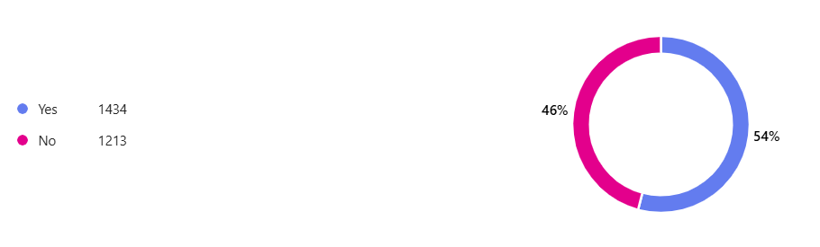
- Do you believe that Kent Police should be merged with other Forces to create a larger Force?
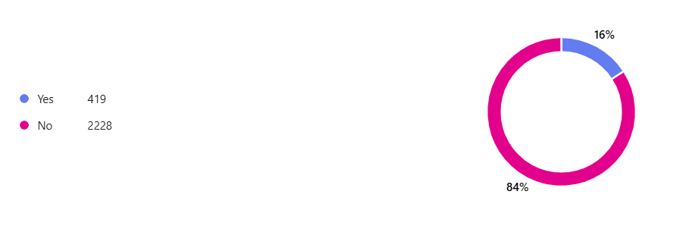
- Please rank your support for the following mergers. Ranking the merger you support most at the top. (Please note, Kent and Essex already share some services, and Kent works with Forces in the Eastern Region.)
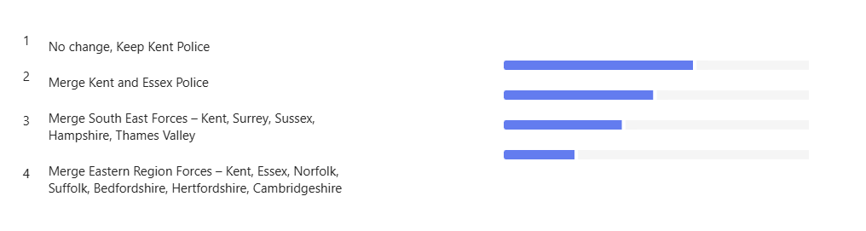
77% selected no change as their first choice, 66% selected merge Kent and Essex as their second choice, 62% selected merge SE forces as their third choice and 77% selected merge eastern region as their fourth choice.

- What do you think are the benefits of merging police forces?
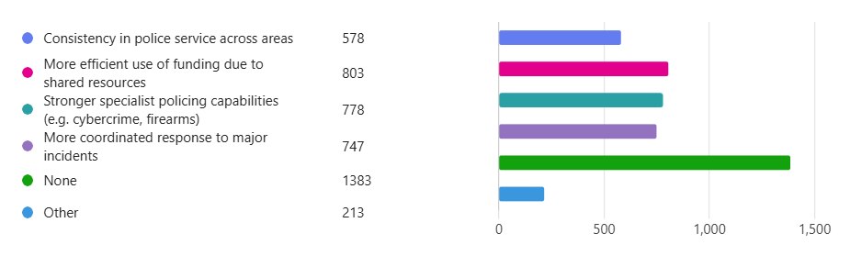
The ‘Other’ responses mentioned improvement to organisational efficiencies, shared capabilities and improved information exchange. However, these benefits are frequently qualified by concern that savings could come at the expense of local knowledge, visible policing and community responsiveness. A notable group did not consider a merger necessary, arguing that collaboration and shared systems could be improved without changing force structures.

- What do you think are the risks of merging police forces? (select as many as appropriate.)
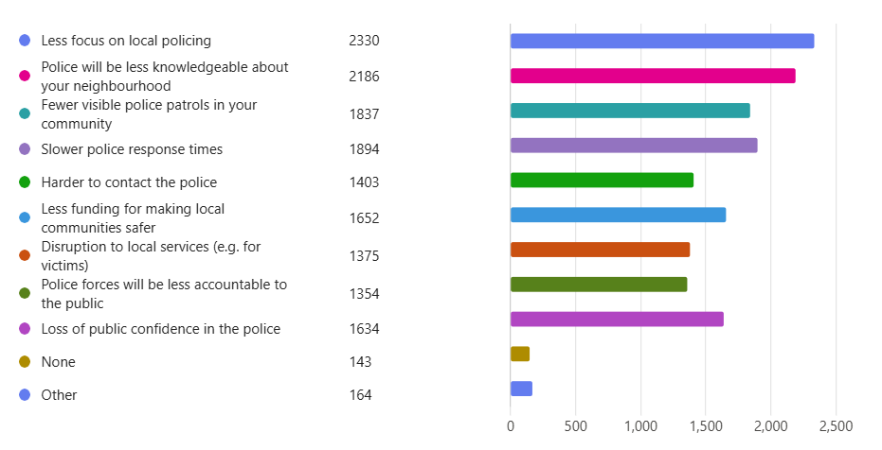
The ‘Other’ responses mentioned concern that a merger would become a cost-cutting exercise. Many feared centralisation would weaken neighbourhood policing and longer travel distances and the diversion of resources to higher-demand areas could slow responses. Others anticipated larger management structures and bureaucracy. A smaller group argued that local partnerships could be negatively affected.

- Why did you give this answer?
The responses to question 6 showed widespread concern that a merger would worsen policing services. Respondants expected visible policing and response policing to deteriorate, while others anticipated reduced accountability. Majorities also predicted worse call handling, crime investigation and partnership working. Partnership working attracted optimism, although only a minority expected improvement. Overall, respondents believed a merger was substantially more likely to weaken than improve policing.
- To what extent do you think that visible policing will get better or worse if Kent Police merges?
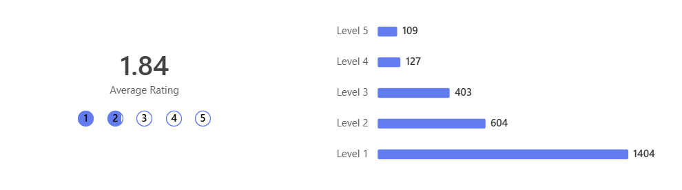
- To what extent do you think that crime investigation will get better or worse if Kent Police merges?
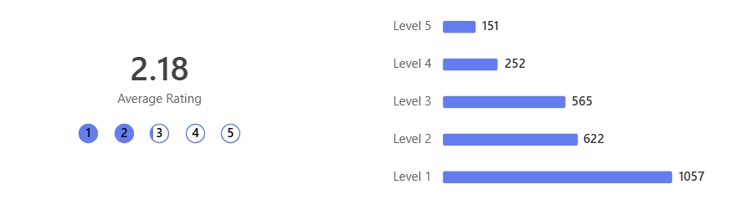
- To what extent do you think that call handling will get better or worse if Kent Police merges?
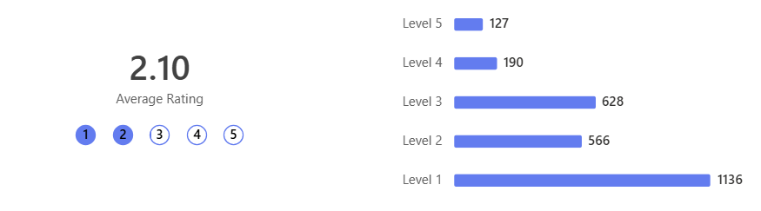
- To what extent do you think that response policing will get better or worse if Kent Police merges?
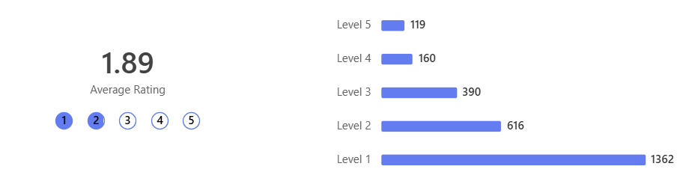
- To what extent do you think that partnership working with other agencies will get better or worse if Kent Police merges?
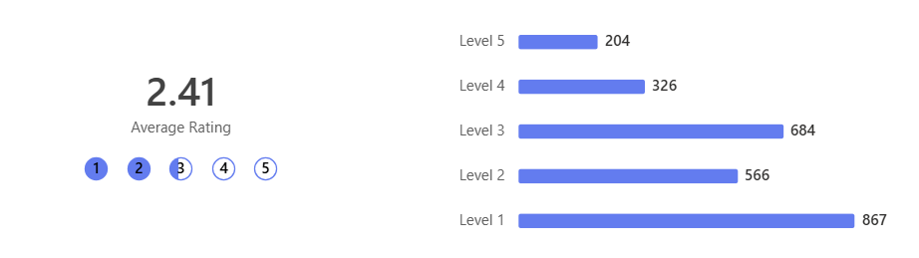
- To what extent do you think that accountability will get better or worse if Kent Police merges?
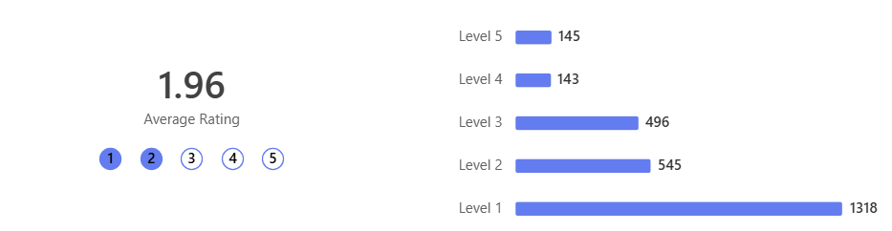

Section 2 – Use of AI and Live Facial Recongition
The PCC also took the opportunity to consult with the public on the use of Live Facial Recognition. Live Facial Recognition (LFR) technology uses live video footage of people passing an LFR camera in a public place and compares their images to a specific list of people wanted by the police (known as a watchlist). It means the police can quickly locate wanted people and take them off the streets.

- Would you support the use of facial recognition technology by Kent Police?
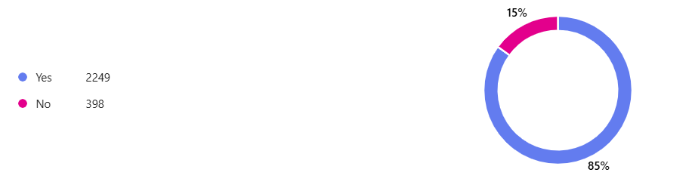
- If so, what for?
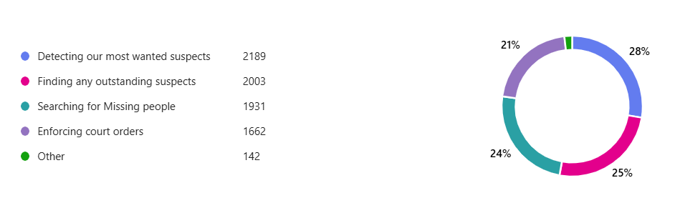

The ‘Other’ responses mentioned broader use for crime prevention and detection, particularly shoplifting, antisocial behaviour, repeat offending, terrorism and organised crime. A smaller number qualified their support by calling for strong oversight and reliable and unbiased technology.

- Do you support the use of artificial intelligence technology in policing?
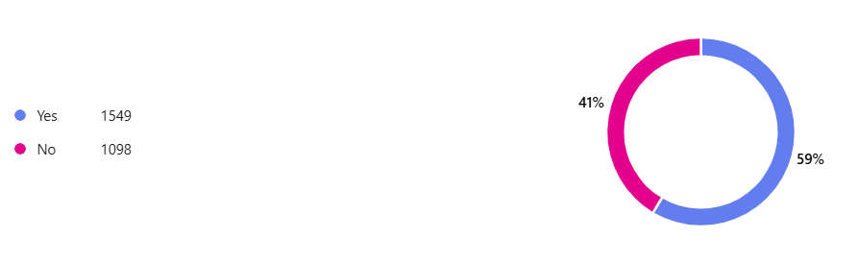
- If so, what for?
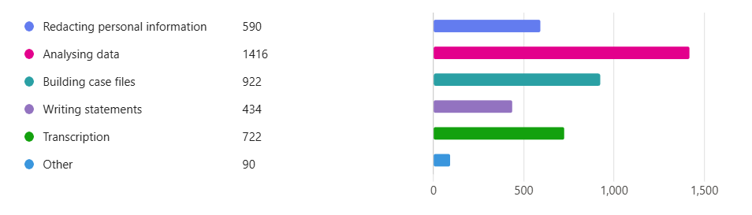
The ‘Other’ responses mentioned focussing on identifying crime patterns, reviewing CCTV and digital evidence, predicting hotspots and reducing administrative workloads. Many respondents stressed that AI should be used to assist (not replace), have rigorous testing and human oversight.
- What safeguards do you think should be put in place?
Among the 1,545 respondents who suggested safeguards, the dominant theme was that AI should support, not replace, human judgement. Outputs should be checked by trained staff and final decisions remaining with accountable officers. Respondents also called for rigorous accuracy and bias testing, strong data-protection and cybersecurity controls, transparent auditing, clear legal limits on how the technology may be used and independent oversight. Further suggestions included staff training, public notification or consent where appropriate, and strict controls over access, data sharing, retention and deletion.

Section 3 – Questions about the person

- What district do you live in?
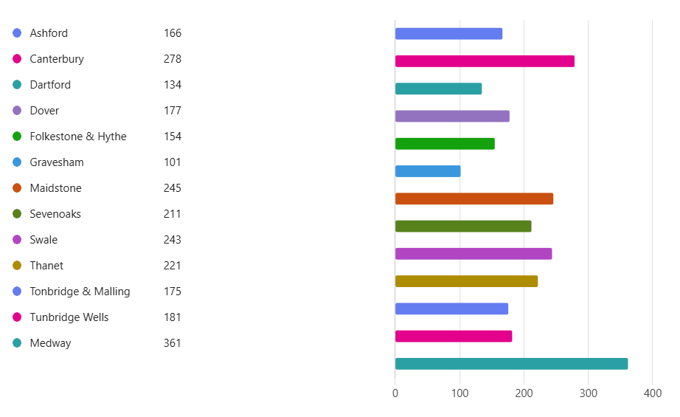

- Your age
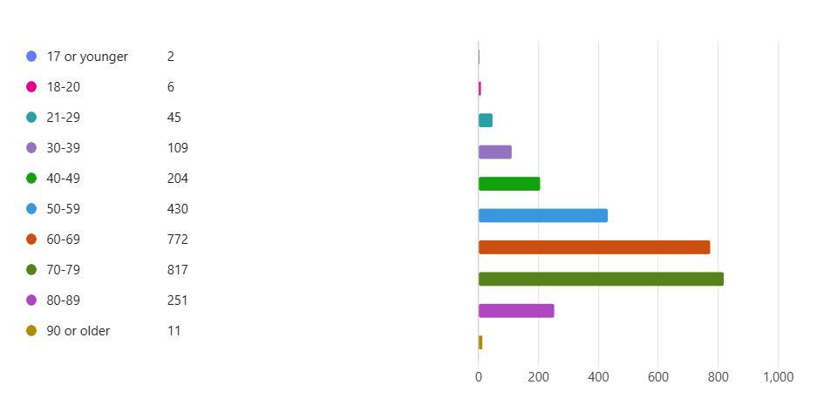

Summary:
This survey received 2,647 responses, with all 13 Kent districts represented. Awareness of the proposed police-force mergers are relatively evenly divided: 54% were aware and 46% were not. Opposition to merging Kent Police is substantial, with 84% opposed and 16% supportive. When ranking structural options, 77% placed “No change, Keep Kent Police” first.
Respondents identified fewer benefits than risks. 52% selected no benefits. The most frequently selected potential benefits were more efficient use of funding (30%), stronger specialist capabilities (29%) and better coordination during major incidents (28%). The leading perceived risks were reduced focus on local policing (88%), poorer neighbourhood knowledge (83%), slower response times (72%) and fewer visible patrols (69%). Most respondents expected a merger to worsen visible policing (76%), response policing (75%), accountability (70%), call handling (64%), crime investigation (63%) and partnership working (54%).
Support was stronger for policing technology. 85% supported facial recognition, principally for detecting wanted suspects, finding outstanding suspects, locating missing people and enforcing court orders. 59% supported artificial intelligence, most commonly for analysing data, building case files, transcription, redaction and drafting statements. Safeguard comments repeatedly called for human review and accountable decision-making, alongside accuracy testing, data protection, transparency, clear legal limits and independent oversight.
Overall, the results show strong opposition to restructuring Kent Police alongside broad, but more conditional, support for technology that assists policing under appropriate safeguards.

