Criminals are increasingly spoofing Police and bank telephone numbers to make their calls appear genuine, in other words, the number will be the official Police or bank telephone number and is copied to defeat caller ID, so never trust Caller Display alone.
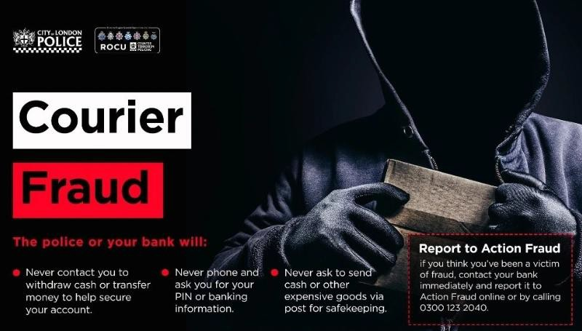
If you receive an unexpected call claiming to be from the Police, your bank, or a fraud team:
- Obtain the caller's name, collar number (if claiming to be Police), and department.
- End the call immediately.
- Wait several minutes, or use a different telephone if possible.
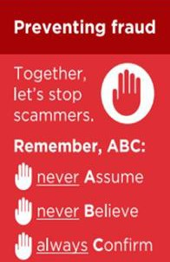
- Contact the Police on 101 or your bank by calling 159. Remember:
- The Police will NEVER ask for your bank account details or PIN.
- The Police will NEVER ask you to withdraw cash, purchase gold, jewellery, gift cards, cryptocurrency, or other valuables as part of an investigation.
- The Police will NEVER ask you to take part in a covert operation involving your own money.
- Your bank will NEVER ask you to transfer money to a "safe account" or "secure account".
- Your bank will NEVER send a courier to collect cash, bank cards, PINs, passwords, jewellery, or other valuables.
- Neither the Police nor your bank will ask you to post cash, bank cards, valuables, or precious metals to an address for safekeeping.
- Fraudsters may try to keep you on the line while pretending to transfer your call to the Police or your bank. Always end the call and independently verify who you are speaking to.
If you have been a victim of any type of scam, then contact your Bank immediately, which you can do by calling 159 and reporting to Report Fraud at Reporting cyber crime and fraud or phishing attempts or call 0300 123 2040.
Find out more by visiting our website at Advice about fraud | Kent Police and from the Home Office at Stop! Think Fraud - How to stay safe from scams

Suspected rogue traders have been arrested following prompt work by neighbourhood officers in Dover.
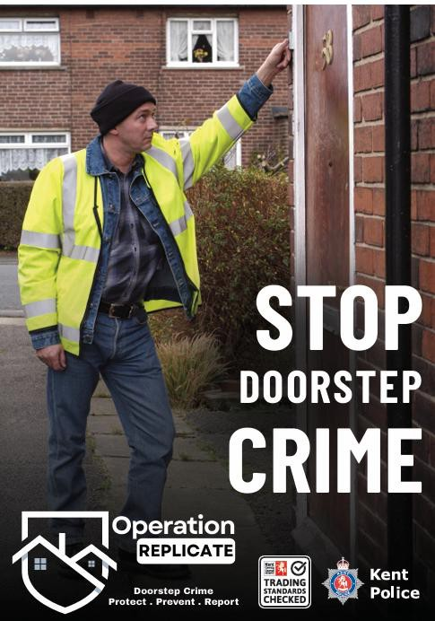
Kent Police was alerted just before 2.30pm on Wednesday 16 September 2026 to suspicious behaviour in Castle Drive, Whitfield.
Residents approached - A group of people had arrived in the area in a van. Local residents were approached by the occupants and reportedly told that repairs were needed to their homes. It is alleged that a demand for payment was made after a roof was accessed and damage reported.
Arrests made - Officers attended and carried out enquiries at the scene. Shortly afterwards, two 18 year old men and a 16 year old boy were arrested in connection with the incident and taken into custody. They were later bailed with conditions while enquiries are completed.
An investigation is ongoing and anyone with relevant information to assist should contact Kent Police on 01843 222289 quoting 46/154021/26.

Remember:
- Consider using Trading Standards Checked traders.
- Get three quotes.
- Take time to decide.
- Discuss major work with somebody you trust.

Never:
- Agree to work from an uninvited caller.
- Pay cash or large upfront deposits.
- Be rushed into a decision.
- Go to the bank with a trader.
- Seek recommendations from family and friends.
If you feel threatened, call 999. If you suspect rogue trading activity, call Kent Police on 101.
If you have been a victim of any type of scam, then contact your Bank immediately, which you can do by calling 159 and reporting to Report Fraud at Reporting cyber crime and fraud or phishing attempts or call 0300 123 2040.
Find out more by visiting our website at Advice about fraud | Kent Police and from the Home Office at Stop! Think Fraud - How to stay safe from scams

Impersonation Scams - Surveys

Criminals are impersonating well known retailers, delivery companies and other trusted organisations to steal personal and financial information.
Fraudulent emails, text messages and social media adverts may offer:
- Gift cards or vouchers
- Free products or prizes
- Exclusive Christmas discounts
- Rewards for completing a survey
The message will often encourage you to click a link, provide personal details, or pay a small fee to claim the reward. These are common tactics used to commit fraud.
Protect Yourself -
- Be cautious of unexpected offers, prizes or rewards.
- Do not click links in unsolicited emails or messages.
- Visit organisations using their official website.
- Never provide bank or card details to claim a prize.
- Take time to verify offers before responding. Remember -
- If it sounds too good to be true, it probably is.
- Criminals rely on excitement, urgency and the promise of a bargain to encourage quick decisions.
- Stop and never assume or believe but always confirm by telephoning the company on a trusted number that you have researched yourself.
If you have been a victim of any type of scam, then contact your Bank immediately, which you can do by calling 159 and reporting to Report Fraud at Reporting cyber crime and fraud or phishing attempts or call 0300 123 2040.
Find out more by visiting our website at Advice about fraud | Kent Police and from the Home Office at Stop! Think Fraud - How to stay safe from scams

Investment Fraud
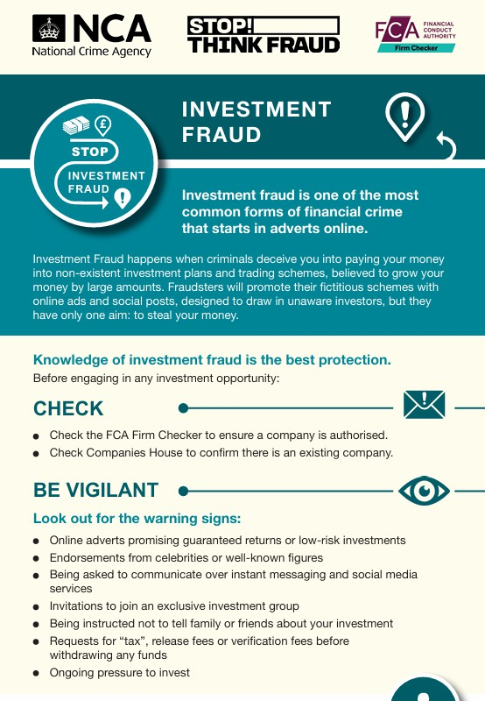
A new video has been released focusing on investment fraud as part of the National Crime Agency's Fraud Explained campaign.
Investment fraud occurs when criminals promote fake investment opportunities and promise high returns with little or no risk.
Fraudsters often use convincing websites, social media adverts and persuasive sales tactics to gain trust and steal money.
The video highlights the warning signs to look out for and practical steps people can take to protect themselves before investing - Watch the Investment Fraud video
Knowledge of investment fraud is the best protection. Before engaging in any investment opportunity:
- Check the FCA Firm Checker to ensure a company is authorised.
- Check Companies House to confirm there is an existing company.
- Look to obtain independent financial advice. Look out for the warning signs:
- Online adverts promising guaranteed returns or low-risk investments.
- Endorsements from celebrities or well-known figures.
- Being asked to communicate over instant messaging and social media services.
- Invitations to join an exclusive investment group.
- Being instructed not to tell family or friends about your investment.
- Requests for “tax,” release fees or verification fees before withdrawing any funds.
- Ongoing pressure to invest.

If you have been a victim of any type of scam, then contact your Bank immediately, which you can do by calling 159 and reporting to Report Fraud at Reporting cyber crime and fraud or phishing attempts or call 0300 123 2040.
Find out more by visiting our website at Advice about fraud | Kent Police and from the Home Office at Stop! Think Fraud - How to stay safe from scams


Kent Fraud Alert System
Celebrity Romance Fraud

Police Forces across the UK continue to receive reports of celebrity romance scams that often start through unofficial fan pages on Facebook, Instagram and TikTok.
Fraudsters again target both men and women equally and will often encourage conversations to move onto private messaging apps such as Telegram, Zangi, WhatsApp and Signal.
Victims are often vulnerable and may receive a large number of kind and affectionate messages designed to build trust and create an emotional connection. The fraudster will then ask for money, typically Apple or Amazon gift voucher codes. Celebrities most impersonated include Prince William, Kevin Costner, Tom Jones, Tom Hanks and George Clooney.
We also believe that Artificial Intelligence is increasingly being used to create convincing fake videos, images and messages, making it harder for victims to recognise that they are communicating with a fraudster rather than the genuine celebrity.
In one recent example a lady in her seventies from Surrey, sent £25,000 to fraudsters believing herself to be in a relationship with the actor George Clooney.
This convincing fraud caused devastation and heartache for both her and her family.
Keep yourself and loved ones safe from romance fraudsters:
- Do not rush into online relationships
- Analyse profiles for inconsistencies
- Talk to trusted friends and family
- Evade scammers—never send money or share financial details
- Stay on secure dating platforms and their messenger service.
For more good advice from DC Mark Newman of Kent Police, view the following short video - Bing Videos
If you have been a victim of any type of scam, then contact your Bank immediately, which you can do by calling 159 and reporting to Report Fraud at Reporting cyber crime and fraud or phishing attempts or call 0300 123 2040. Find out more by visiting our website at Advice about fraud | Kent Police and from the Home Office at Stop! Think Fraud - How to stay safe from scams

