
Kent Fraud Alert System

KFAS Alert: Unexpected Mobile Phone Delivery Scam
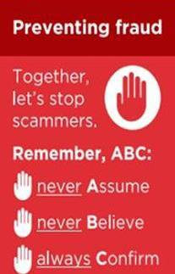
Kent residents are being warned about a scam where a mobile phone is delivered to their address despite them never ordering one. Fraudsters have often used stolen personal details to open a mobile phone contract in the victim's name. Shortly afterwards, the victim receives a call or visit from someone claiming the phone was delivered by mistake and needs to be collected.
If you receive a mobile phone you did not order:
- Do not hand it to anyone who arrives to collect it.
- Do not post it to an address provided over the phone.
- Contact the mobile network or retailer directly using official contact details.
- Check your bank accounts and credit records for any suspicious activity.
Remember: Genuine mobile phone companies do not send couriers to collect handsets following an unexpected delivery.

If you have been a victim of any type of scam, then contact your Bank immediately, which you can do by calling 159 and reporting to Report Fraud at Reporting cyber crime and fraud or phishing attempts or call 0300 123 2040.
Find out more by visiting our website at Advice about fraud | Kent Police and from the Home Office at Stop! Think Fraud - How to stay safe from scams

Kent Fraud Alert System
KFAS Fraud Alert - Fake Council Credit Email Scam
Kent residents are being warned to be on their guard after reports of emails claiming to be from a 'Civic Finance Section' or Revenues & Benefits Officer, advising that a
credit or refund is available on their account.
The email encourages recipients to click a link to view or claim the money. These messages may appear genuine and can use official-sounding job titles and department names to gain trust. Ultimately by clicking the link, you are taken to a realistic looking website under the control of the criminals, where they steal your financial and personal data.

Protect yourself:
- Be suspicious of unexpected emails claiming you are owed money.
- Do not click links or download attachments from unsolicited emails.
- Contact your local council directly using contact details from their official website if you are unsure.
- Never provide personal, banking or login details after following a link in an email.
Remember: Fraudsters often create emails that look convincing and use financial incentives, such as refunds, credits or rebates, to encourage victims to act quickly.
If you receive a suspicious email, do not engage with it. Report phishing emails by forwarding them to report@phishing.gov.uk and delete the message.
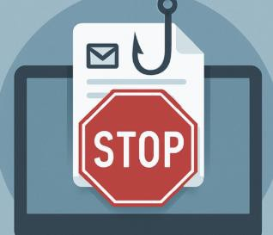
If you have been a victim of any type of scam, then contact your Bank immediately, which you can do by calling 159 and reporting to Report Fraud at Reporting cyber crime and fraud or phishing attempts or call 0300 123 2040.
Find out more by visiting our website at Advice about fraud | Kent Police and from the Home Office at Stop! Think Fraud - How to stay safe from scams

Kent Fraud Alert System

KFAS Fraud Alert - Investment Fraud
Kent residents are being reminded to stay vigilant against investment fraud, which continues to cost victims thousands of pounds every year.
Fraudsters often contact people through social media, messaging apps, email, or professional-looking websites, offering investment opportunities that promise high returns with little or no risk. Common scams involve cryptocurrency, foreign exchange trading, shares, bonds, or property investments.

Protect yourself:
- Be wary of investment opportunities that promise guaranteed or unusually high returns.
- Never feel pressured into making a quick decision.
- Check that the company is authorised by the Financial Conduct Authority (FCA).
- Seek independent financial advice before investing.
- Be suspicious if you are asked to move conversations to WhatsApp, Telegram, or other messaging platforms.
Remember: If an investment opportunity sounds too good to be true, it usually is. Fraudsters are skilled at creating convincing websites, testimonials, and paperwork to make scams appear legitimate
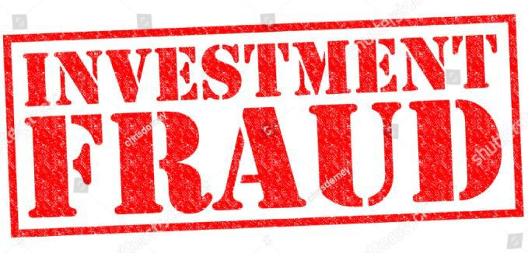
If you have been a victim of any type of scam, then contact your Bank immediately, which you can do by calling 159 and reporting to Report Fraud at Reporting cyber crime and fraud or phishing attempts or call 0300 123 2040.

Find out more by visiting our website at Advice about fraud | Kent Police and from the Home Office at Stop! Think Fraud - How to stay safe from scams

