
Kent Fraud Alert System

Book your free Fraud Talk now
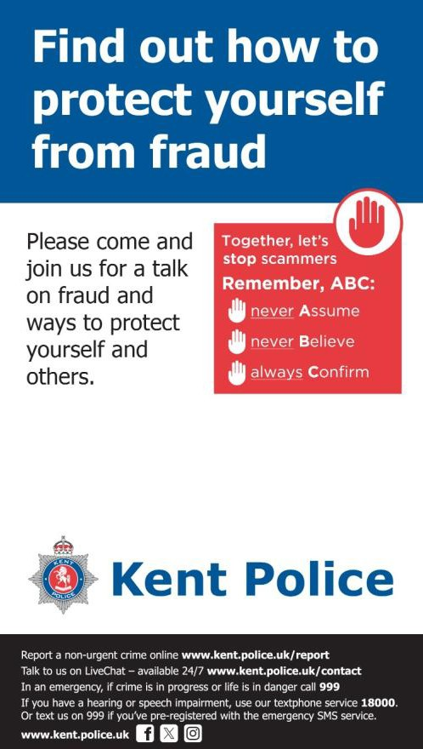
We are busy preparing our Autumn/Winter calendar for 2026/27 and if you would like a free talk/presentation on the latest scams and how to avoid becoming a victim of
fraud then please email me at -Stephen.kelly@kent.police.uk or KFAS@ecis.police.uk
The talks are open to community groups, charities, schools, local businesses etc.
Some of the areas that we cover are –
- Phishing
- Courier Fraud
- Rogue Traders
- Romance Scams
- Investment Fraud
- Online Shopping Scams
- QR Codes
- Smishing
- And many other various scams, including the impact of Artificial Intelligence
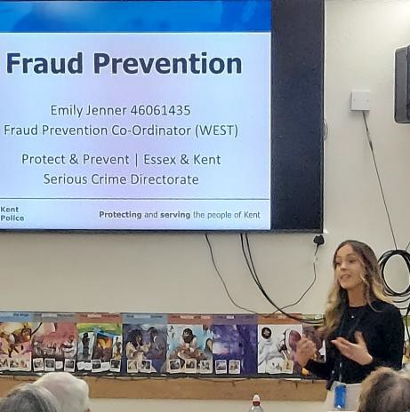
Not many things are free now days, so why not take advantage of this offer which may result in you stopping fraudsters getting your are hard earnt money.

You can find out more about fraud by visiting our website at Advice about fraud | Kent Police and you can also visit Home Office at Stop! Think Fraud - How to stay safe from scams

Kent Fraud Alert System
Rogue Trader Arrests
Fast-responding officers arrested two suspected rogue traders at a pensioner's property in Kemsing.
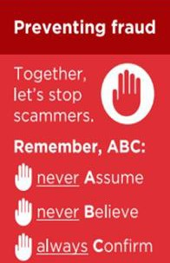
Kent Police was called at 12.20pm on Thursday 6 August 2026 to a report of fraud at an address near Pilgrims' Way.
It is alleged two men approached an elderly man at his home on Wednesday 5 August and offered to carry out repair works. Reportedly, they did not carry out the work agreed before demanding more money from the victim.
The next day, the suspects returned and officers swiftly attended the scene. Arrested
They arrested a 25 year old man from West Malling and a 19 year old, of no fixed address, on suspicion of fraud by false representation.
They have since been bailed pending further enquiries.
An investigation to establish the full circumstances surrounding the incident is ongoing.
Appeal
Anyone with information is urged to call the west Kent appeals line on 01622 604100, quoting reference 46/128762/26.
Protect advice -
- Always insist on a written agreement detailing the work, cost, and timescales.
- Never pay the full amount upfront.
- Avoid paying in cash where possible. Use a payment method that creates a record.
- Be suspicious of requests for immediate payment or claims that "extra work" is suddenly needed.
If you have been a victim of any type of scam, then contact your Bank immediately, which you can do by calling 159 and reporting to Report Fraud at Reporting cyber crime and fraud or phishing attempts or call 0300 123 2040.
Find out more by visiting our website at Advice about fraud | Kent Police and from the Home Office at Stop! Think Fraud - How to stay safe from scams

Kent Fraud Alert System
Romance Fraud
- Do you know the signs of Romance Fraud?
- Would you recognise the signs if a family member or friend is an unknowing victim?
- Criminals perpetrating romance fraud stole over £102M last year from victims across the UK. See the following video for expert advice from DC Mark Newman of Kent Police -Bing Videos
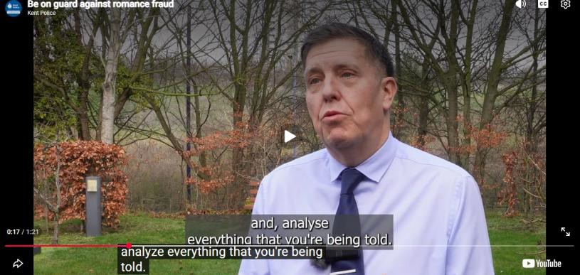
To see the devasting effect that these crimes have on their victims, then see “a victim’s tale” - Bing Videos
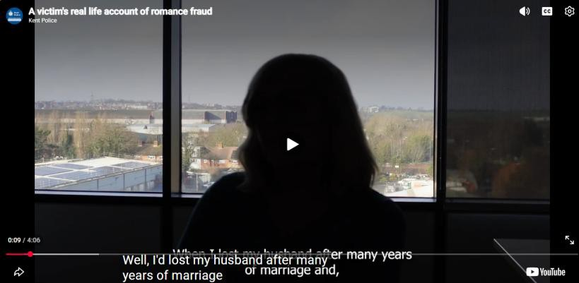
If you have been a victim of any type of scam, then contact your Bank immediately, which you can do by calling 159 and reporting to Report Fraud at Reporting cyber crime and fraud or phishing attempts or call 0300 123 2040.
Find out more by visiting our website at Advice about fraud | Kent Police and from the Home Office at Stop! Think Fraud - How to stay safe from scams

Kent Fraud Alert System

FRAUD ALERT: Smishing (Text Message Scams)
Residents are being warned about an increase in smishing attacks, where fraudsters send fake text messages pretending to be trusted organisations such as banks, delivery companies, HMRC, TV Licensing and mobile phone providers.
Common messages claim:
- A parcel cannot be delivered until a fee is paid.
- Suspicious activity has been detected on your bank account.
- You are due a tax refund.
- A payment has failed and urgent action is required. Protect Yourself
- Do not click links in unexpected text messages.
- Never provide personal or banking details via text.
- Contact organisations using a trusted phone number or website.
- Forward suspicious texts to 7726 (SPAM).
Remember the ABC of fraud awareness and Never Assume, Never Believe, Always Confirm.

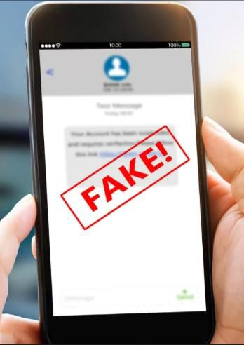
If you receive an unexpected text asking you to click on a link, make a payment or provide personal information, do not click. Independently verify the request by contacting the organisation using a trusted phone number or website that you have sourced yourself and not any contact details provided within the message.
If you have been a victim of any type of scam, then contact your Bank immediately, which you can do by calling 159 and reporting to Report Fraud at Reporting cyber crime and fraud or phishing attempts or call 0300 123 2040.
Find out more by visiting our website at Advice about fraud | Kent Police and from the Home Office at Stop! Think Fraud - How to stay safe from scams

Kent Fraud Alert System
FRAUD PREVENTION ALERT: Check if Your Data Has Been Exposed
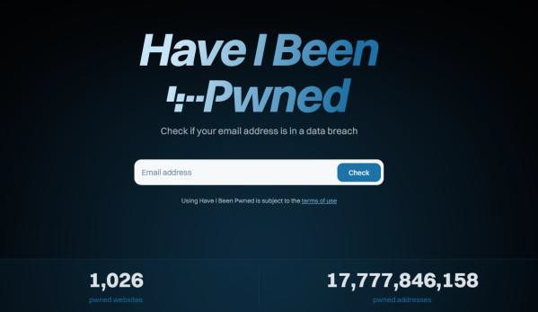
Data breaches affecting major organisations happen regularly, often exposing email addresses, passwords and other personal information that can later be used by fraudsters.
A useful free tool to help protect yourself is Have I Been Pwned, a trusted website that allows you to check whether your email address has appeared in known data breaches. The service can also notify you if your details are exposed in future breaches.

Protect Yourself
- Visit Have I Been Pwned: Check if your email address has been exposed in a data breach and check your email address.
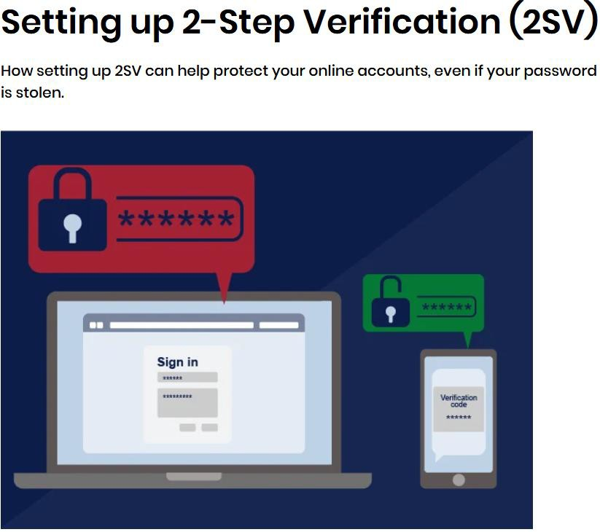
- If your details have been exposed, change your password immediately.
- Use a strong, unique password for each account.
- Enable two-factor authentication (2FA) wherever available - Setting up 2-Step Verification (2SV) | National Cyber Security Centre
- Consider signing up for breach notifications to receive alerts if your email appears in future data breaches.
Remember the ABC of fraud awareness and Never Assume, Never Believe, Always Confirm.
If criminals have access to your personal information, they may use it to make scams appear genuine. Taking a few minutes to check whether your data has been exposed could help prevent fraud and identity theft.
If you would like a presentation by our Cyber expert for your business, community group or school
etc…..Then please email - ArranJohnAnthony.Ostridge@kent.police.uk
If you have been a victim of any type of scam, then contact your Bank immediately, which you can do by calling 159 and reporting to Report Fraud at Reporting cyber crime and fraud or phishing attempts or call 0300 123 2040.
Find out more by visiting our website at Advice about fraud | Kent Police and from the Home Office at Stop! Think Fraud - How to stay safe from scams

