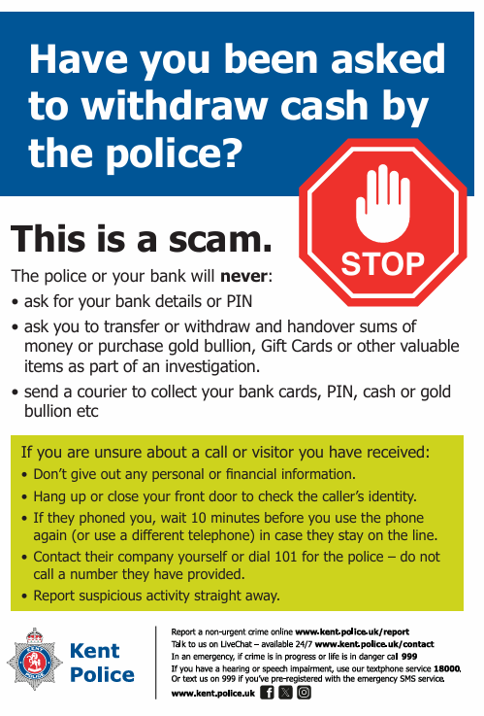
Telephone scammers posing as police officers or bank staff stole more than £766,000 from 86 Kent victims in 2025 through courier fraud. The scam typically involves fraudsters convincing victims their bank account is at risk or that they are helping with an investigation, before arranging for cash, bank cards, jewellery or other valuables to be collected by a courier. Kent Police is supporting a national City of London Police campaign to raise awareness of this crime.
Detective Inspector Ian Sanderson of Kent Police said:
‘Fraudsters frequently target people who are elderly or vulnerable and may pretend to be from a trusted organisation before persuading them to hand over their valuables. They can also make contact by WhatsApp and pretend to be a relative in need of urgent cash.
‘Between 1 and 10 June this year, we received 30 reports of this type of offence of which 18 were to residents in the east of the county. The criminals were successful in only three of the incidents managing to steal more than £9,300.
‘We investigate reported frauds based on the evidence that is available and will always seek to track down those responsible and bring them to justice. We also have specialist staff who pay regular visits to banks and community groups to educate people on the warning signs. In this way, we hope victims will feel confident to stop, question and deter suspicious callers.'
Protect yourself from courier fraud:
- Your bank or the police will never ask for your PIN, passwords or personal details over the phone, or send a courier to collect cash, bank cards or valuables.
- Treat any unexpected call claiming your account is at risk or asking you to assist an investigation with caution.
- Do not trust caller ID – it can be spoofed.
- If in doubt, hang up and contact your bank calling 159 and the Police on 101.
Take time to verify requests, seek advice from someone you trust, and never feel pressured into making financial decisions.
If you have been a victim of any type of scam, then contact your Bank immediately, which you can do by calling 159 and reporting to Report Fraud at Reporting cyber crime and fraud or phishing attempts - Report Fraud or call 0300 123 2040. Find out more by visiting our website at Advice about fraud | Kent Police and from the Home Office at Stop! Think Fraud - How to stay safe from scams

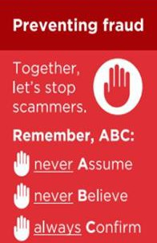
Tonbridge and Malling Council are warning residents about a parking payment scam targeting motorists shortly after they have paid for parking.
A local resident recently received a text message claiming further payment was required. The message linked to a fake website designed to look like a genuine parking provider in an attempt to steal personal and financial information.
These scam texts can appear convincing and often create a sense of urgency, suggesting money is still owed. In some cases, messages are timed to arrive shortly after a legitimate parking session, making them seem genuine.
However, this is not just a scam local to Tonbridge and Malling and has been an ongoing problem for several months now, so all residents of Kent need to stay alert to these types of scams.

How to protect yourself:
- Be wary of unexpected text messages about parking charges or payments.
- Do not click on links in unsolicited messages.
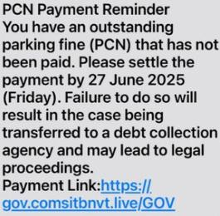
- If you need to check or pay for parking, use a trusted parking app or website directly.
- Remember that councils do not typically contact drivers about parking payments by text message.
- You can report suspicious texts by forwarding to 7726.
If you have been a victim of any type of scam, then contact your Bank immediately, which you can do by calling 159 and reporting to Report Fraud at Reporting cyber crime and fraud or phishing attempts - Report Fraud or call 0300 123 2040.
Find out more by visiting our website at Advice about fraud | Kent Police and from the Home Office at Stop! Think Fraud - How to stay safe from scams

Netflix Phishing Email Warning
Criminals are sending fake emails claiming Netflix payments have failed and accounts will be suspended. The emails encourage recipients to click a link and update payment details via a fraudulent website.

Protect yourself:
  - Do not click links in unexpected emails.
  - Log in to Netflix directly through the app or official website to check your account.
  - Never share passwords or payment details via links received in messages.
  - You can report suspicious emails by forwarding to report@phishing.gov.uk
If you have been a victim of any type of scam, then contact your Bank immediately, which
you can do by calling 159 and reporting to Report Fraud at Reporting cyber crime and fraud or phishing attempts - Report Fraud or call 0300 123 2040.
Find out more by visiting our website at Advice about fraud | Kent Police and from the Home Office at Stop! Think Fraud - How to stay safe from scams

Microsoft 365 Phishing Warning
Cyber security experts continue to warn about phishing emails impersonating Microsoft 365. Common themes include password expiry notifications, suspicious login alerts and account verification requests. Criminals use fake login pages to steal usernames, passwords and multi-factor authentication codes.

Protect yourself:
  - Access Microsoft 365 directly through your browser or app and do not click on email links.
  - Be cautious of unexpected password expiry or security alerts.
  - Verify sender email addresses carefully.
  - Never enter login details after clicking a link in an unsolicited email.
  - You can report suspicious emails by forwarding to report@phishing.gov.uk
If you have been a victim of any type of scam, then contact your Bank immediately, which you can do by calling 159 and reporting to Report Fraud at Reporting cyber crime and fraud or phishing attempts - Report Fraud or call 0300 123 2040.
Find out more by visiting our website at Advice about fraud | Kent Police and from the Home Office at Stop! Think Fraud - How to stay safe from scams

Fraud Alert: Fake Royal Mail Delivery Messages
Residents are being warned about scam emails and texts claiming a parcel cannot be delivered until a small fee is paid. The messages include links to fake websites designed to steal personal and banking details.

Protect yourself:
  - Do not click links in unexpected delivery messages.
  - Check parcel deliveries directly through the official Royal Mail website or app.
  - Never provide payment details unless you are certain a request is genuine.

Report suspicious messages:
  - Texts: You can report suspicious text messages by forwarding to 7726
  - Emails: You can report suspicious emails by forwarding to report@phishing.gov.uk
If you have been a victim of any type of scam, then contact your Bank immediately, which you can do by calling 159 and reporting to Report Fraud at Reporting cyber crime and fraud or phishing attempts - Report Fraud or call 0300 123 2040.
Find out more by visiting our website at Advice about fraud | Kent Police and from the Home Office at Stop! Think Fraud - How to stay safe from scams
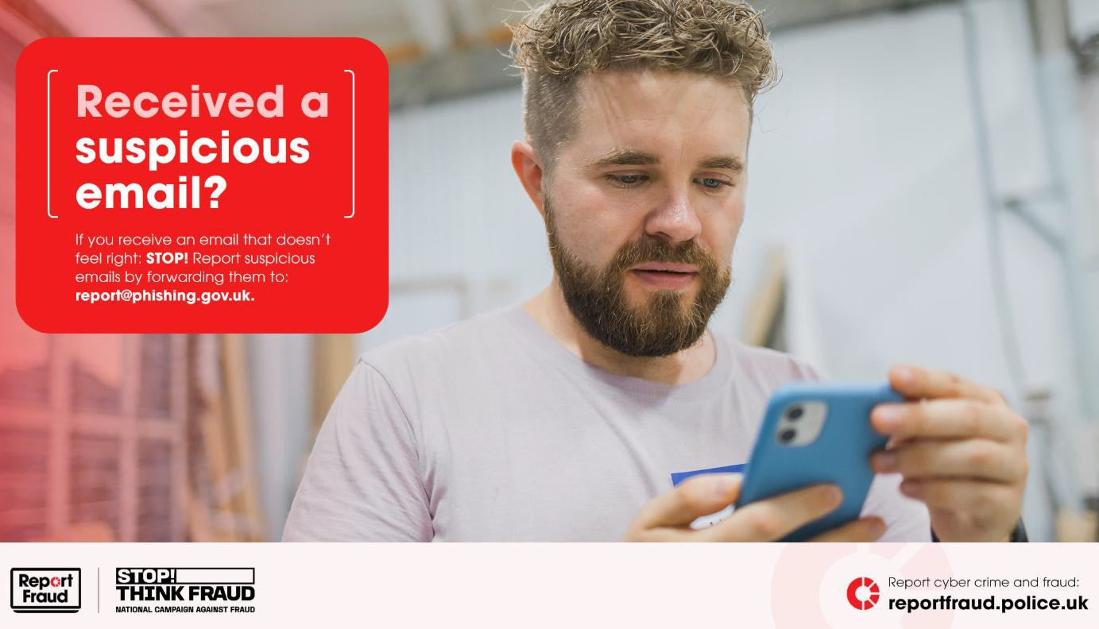

Rogue Trader Warning Across Kent
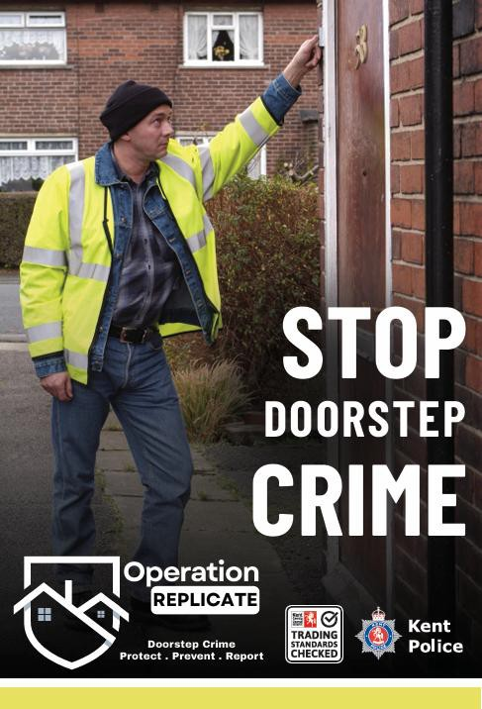
Kent residents are being urged to remain vigilant following reports of rogue traders and doorstep criminals targeting homes across the county. Offenders are cold calling at properties offering roofing, driveway, gardening and other home maintenance services, often claiming urgent repairs are required and pressuring residents into making quick decisions.

Protect Yourself – Remember the ABC Message
Never assume that someone at your door is a legitimate trader simply because they appear professional or claim to be working in the area.
  - Rogue traders can be very convincing.
  - Be cautious of anyone offering unsolicited repairs or maintenance.
  - Genuine traders rarely cold call without an appointment.
  - Do not be pressured into making an immediate decision.
Never believe claims that urgent work is needed without seeking independent advice.
  - Don't accept verbal claims about damage to your property.
  - Be wary of scare tactics designed to create panic.
  - Never hand over cash or make payments on the doorstep.
  - Do not accompany traders to the bank or cashpoint. Always confirm who you are dealing with before agreeing to any work.
  - Obtain at least three independent quotes.
  - Verify company details and check reviews.
  - Seek recommendations from family and friends.
  - Speak to a trusted friend, family member or neighbour before making a decision.
  - Take your time – legitimate businesses will respect this.
If you have been a victim of any type of scam, then contact your Bank
immediately, which you can do by calling 159 and reporting to Report Fraud at Reporting cyber crime and fraud or phishing attempts - Report Fraud or call 0300 123 2040.
Find out more by visiting our website at Advice about fraud | Kent Police and from the Home Office at Stop! Think Fraud - How to stay safe from scams

