KFAS ALERT: TV Licence Phishing Email

Kent residents are being warned about phishing emails claiming that a TV Licence payment has failed or that account details need to be updated.
The email often creates a sense of urgency and asks you to click on a link to confirm payment details, update your information or avoid losing your TV Licence.
However, the link will take you to a fake website designed to steal personal and financial information.
Protect Yourself:
- Be suspicious of unexpected emails about missed payments or account problems.
- Do not click on links within unsolicited emails.
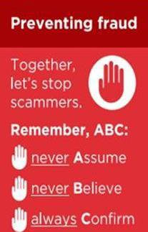
- Never provide bank details or passwords through links sent in emails or text messages.
- Visit the official TV Licensing website by typing the address into your browser yourself.
- Check the sender's email address carefully, as scammers often use addresses that appear genuine at first glance.
If you have clicked the link or provided your bank details:
- Contact your bank immediately.
- Change any passwords that may have been compromised.
- Report the phishing email by forwarding it to: report@phishing.gov.uk
Remember: Criminals routinely recycle well-known scams because they continue to catch out unsuspecting victims. Always take a moment to stop, think, and check before responding to unexpected requests for personal or financial information.
If you have been a victim of any type of scam, then contact your Bank
immediately, which you can do by calling 159 and reporting to Report Fraud at Reporting cyber crime and fraud or phishing attempts or call 0300 123 2040.
Find out more by visiting our website at Advice about fraud | Kent Police and from the Home Office at Stop! Think Fraud - How to stay safe from scams

KFAS ALERT: PHP Cyber Security Vulnerability
I have had several people ask me about this, so wanted to share some information with you.
What the PHP Hack Means for You?
You may have seen reports about a serious security flaw affecting PHP software used by millions of websites worldwide.
While the vulnerability mainly affects businesses and website owners, there could be an impact on the public if a website you use suffers a data breach.
What are the risks?
- Personal information being exposed.
- Increased phishing emails and scam messages.
- Fake websites being used to target customers. How can you protect yourself?
- Be cautious of unexpected emails, texts or calls.
- Don't click links asking you to verify account details.
- Use strong, unique passwords.
- Monitor your accounts for unusual activity.
At present, there is no evidence that simply visiting websites puts members of the public at risk, but criminals often use stolen data from cyber attacks to launch convincing scams.
Remember: If a message creates urgency and asks for personal or financial information, stop, think and check before responding.
If you have been a victim of any type of scam, then contact your Bank immediately, which you can do by calling 159 and reporting to Report Fraud at Reporting cyber crime and fraud or phishing attempts or call 0300 123 2040.
Find out more by visiting our website at Advice about fraud | Kent Police and from the Home Office at Stop! Think Fraud - How to stay safe from scams

KFAS ALERT: Rogue Trader Jailed After Conning Kent Victims Out of £40,000
A rogue trader from Maidstone, Billy Beaney, has been jailed after fraudulently obtaining more than
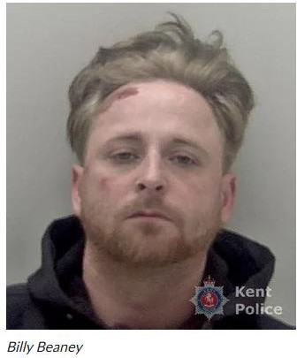
£40,000 from two vulnerable victims in Medway and Swale.
Beaney cold called at victims homes and claimed urgent roofing and building repairs were needed. As work progressed, he repeatedly reported further supposed problems, causing the costs to escalate into tens of thousands of pounds. In some cases, work was left incomplete or in a worse condition than before.
The victims became suspicious and contacted police, leading to an investigation and Beaney's arrest. Beaney, of Stilebridge Lane, Maidstone, later admitted two fraud offences and has now been sentenced to 28 months imprisonment.
Protect Yourself from Rogue Traders -
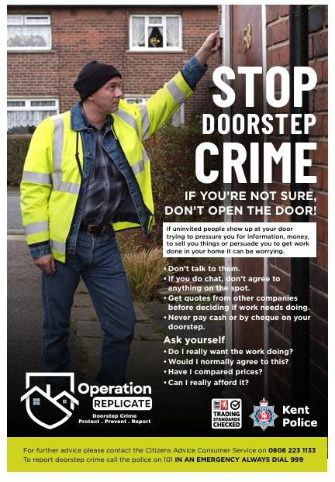
Be wary of anyone who cold calls offering home repairs.
Never agree to work on the doorstep.
Obtain at least three independent quotes.
Check traders through trusted sources and seek recommendations.
Never feel pressured into making immediate payments.
Speak to family, friends or neighbours before agreeing to costly work.
Remember: Rogue traders often create a sense of urgency and claim further problems have been discovered in order to obtain more money. Genuine tradespeople will not pressure you into making quick decisions.
If you have been a victim of any type of scam, then contact your Bank immediately, which you can do by calling 159 and reporting to Report Fraud at Reporting cyber crime and fraud or phishing attempts or call 0300 123 2040.
Find out more by visiting our website at Advice about fraud | Kent Police and from the Home Office at Stop! Think Fraud - How to stay safe from scams

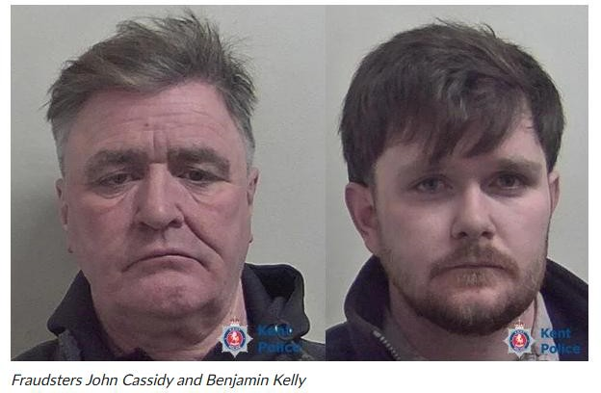
Two rogue traders from Maidstone, Benjamin Kelly and John Cassidy, have been jailed after targeting an elderly Kent couple and convincing them to pay around
£55,000 for unnecessary roofing and building work. Kelly and Cassidy initially secured a small repair job before repeatedly returning and claiming they had discovered further serious problems with the property. Over several weeks, they persuaded the couple to pay for extensive roof and building work that was not required, causing significant financial loss and distress.
The fraud was uncovered after concerns were raised with police, leading to an investigation and the conviction of both men. Kelly, aged 24, and Cassidy, aged 53, both of Plains Avenue, Maidstone, have now been sentenced to
prison. Kelly received a three-year custodial sentence. Cassidy was given a custodial sentence of three years and four months.
How to Protect Yourself
- Be cautious of unexpected callers offering home repairs.
- Never agree to costly work on the spot.
- Obtain independent quotes before committing to any major repairs.
- Ask a trusted family member, friend or neighbour for advice.
- Be suspicious if a trader continually identifies "new" problems that require additional payment.
- Contact Trading Standards or the police if you feel pressured or concerned.
Remember: Rogue traders often start with a small repair before claiming to find further defects requiring urgent and expensive work. Genuine tradespeople will not pressure you into making immediate decisions or payments.
Investigating officer Detective Constable Jessica Grigson said: “The tactics employed by Benjamin Kelly and John Cassidy were aimed at scaring residents into paying overinflated prices for work that was not needed. They were ruthless in their behaviour. These victims trusted the advice which sounded so convincing by supposedly legitimate builders. Fortunately, their very visible antics attracted suspicions and they were quickly arrested following the report made to police.”
If you have been a victim of any type of scam, then contact your Bank immediately, which you can do by calling 159 and reporting to Report Fraud at Reporting cyber crime and fraud or phishing attempts or call 0300 123 2040.


In Dorset, residents are being warned about fraudulent emails claiming to be from UK police forces, including the Metropolitan Police. Criminals are sending convincing emails stating that a police investigation has been opened against the recipient and urging them to respond
urgently.
These emails may include police logos, reference numbers and the name of a supposed investigating officer to make them appear genuine. The aim is to create fear and pressure victims into providing personal information or engaging with the sender.
Therefore, it is very likely, that we will, if not already see similar emails targeting Kent residents.

Protect Yourself
- Do not reply to the email.
- Do not click on links or open attachments.
- Never provide personal, financial or banking information.
- Verify any police contact independently using official contact details (ringing 101).
- Be wary of messages designed to create urgency, fear or panic.
Remember: Police will not ask you to provide banking details, passwords or transfer money in response to an email. If you receive a suspicious message, report it and verify any contact directly with the relevant police force.
Suspicious emails can be forwarded to report@phishing.gov.uk
If you have been a victim of any type of scam, then contact your Bank immediately, which you can do by calling 159 and reporting to Report Fraud at Reporting cyber crime and fraud or phishing attempts or call 0300 123 2040.
Find out more by visiting our website at Advice about fraud | Kent Police and from the Home Office at Stop! Think Fraud - How to stay safe from scams

