
Kent Fraud Alert System
Another Rogue Trader locked up
A rogue trader from Gillingham has been jailed after stealing almost £15,000 from a pensioner.
Amos Smith, 47, gave a false name to his victim as he completed ground clearance in the
man’s Twydall garden throughout May and June of 2025. Initially he charged the homeowner, in his 70s,
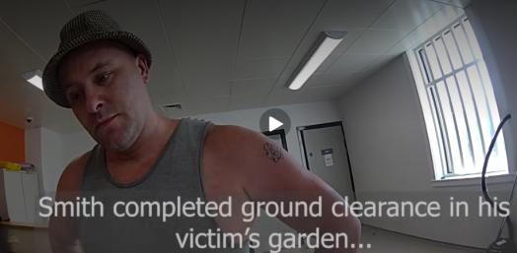
£11,000 for the work, which included removing trees and rubbish.
A month after groundwork was completed, Smith reattended the victim’s address telling him he owed more money. He told the man to walk with him to a local shop to withdraw cash, which he complied with on 5,6, 7, 9, and 13 August while Smith watched. In total, around £15,000 was handed over by his victim.
Watch the footage of his arrest - Bing Videos
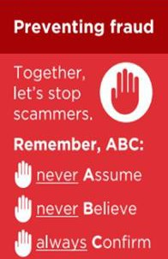
Smith was arrested on 14 April 2026 as he left prison, having finished serving a sentence for similar offences. The Gillingham Road resident was subsequently charged with 2 counts of fraud by false representation, which he admitted to at Maidstone Magistrates Court on 29 June 2026.
At the same hearing, he was jailed for 2 years and 8 months. Investigating officer Detective Constable James Finch said:
‘Smith took advantage of a vulnerable member of our community and arrogantly thought he could get away with it. ‘ The persistence with which he approached his victim shows he had a lack of remorse or reflection regarding his actions, which have left the man more anxious and hugely out of pocket.‘ We are satisfied he is behind bars and we hope that by getting his name and image out in public, others will avoid falling victim to this
conman.’
If you have been a victim of any type of scam, then contact your Bank immediately, which you can do by calling 159 and reporting to Report Fraud at Reporting cyber crime and fraud or phishing attempts - Report Fraud or call 0300 123 2040.
Find out more by visiting our website at Advice about fraud | Kent Police and from the Home Office at Stop! Think Fraud - How to stay safe from scams

Kent Fraud Alert System

Amazon Scam Warning
Avon and Somerset Police are witnessing an increase in cases where fraudsters are purporting to be from Amazon.
They will claim that someone is purchasing expensive items on their Amazon account, such as a phone and that they wanted to check it was actually them. The panicking victim states that it is not them making the purchase, and the fraudster says that this means that their account has been hacked. The fraudster will then take the victim through steps to “rectify” this, which usually involves them gaining remote access to their device. Once they have remote access, they can access the victim’s online banking and make
transfers, often claiming that are helping to move their money to a “safe account” which is actually just an account belonging to the fraudster. They may also access the victim’s Amazon account and place orders to themselves. This will often include the victim receiving a one-time passcode (OTP) to their phone and being requested to read this out to the fraudster so that they can gain access to their Amazon account.
Advice:
- If you receive an unexpected phone call and they ask you to download a remote access app, it will be a scam.
- Hang up and check your purchase history on your Amazon account for reassurance.
- If you are still unsure, contact Amazon through the genuine website or app.
- Never provide anyone with your one-time passcode (OTP)
- Do not be pressured – fraudsters will create a sense of urgency to convince victims to do what they are asking.
- Hang up the phone, give yourself time to think, and speak to a friend or family member about it.
If you have been a victim of any type of scam, then contact your Bank immediately, which you can do by calling 159 and reporting to Report Fraud at Reporting cyber crime and fraud or phishing attempts - Report Fraud or call 0300 123 2040.
Find out more by visiting our website at Advice about fraud | Kent Police and from the Home Office at Stop! Think Fraud - How to stay safe from scams

Kent Fraud Alert System

FRAUD ALERT: Parking Charge Scam Text Messages
Parking-related scams remain highly prolific, with fraudsters sending text messages claiming you have an unpaid parking charge and directing you to click a link to make payment.
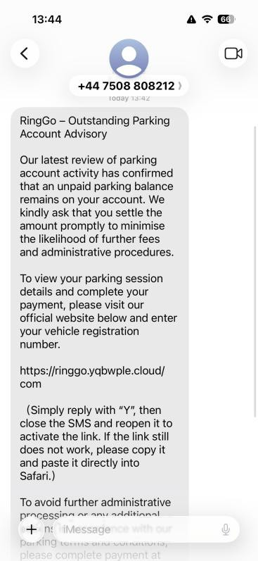
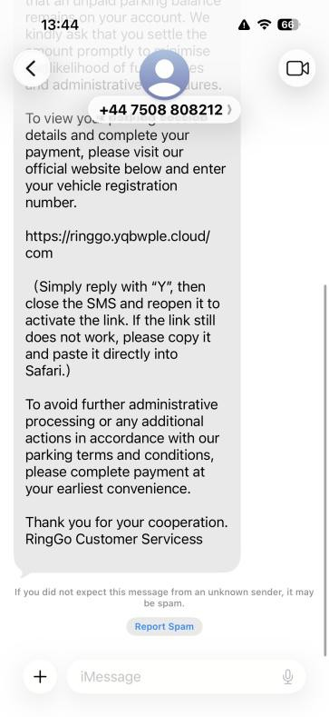
If you receive a message like the example shown, do not respond and click any links – it is likely to be a scam.

Warning Signs -
  - The message does not include your vehicle registration.
  - There is no date or time of the alleged offence.
  - No location is provided of the offence.
  - The message creates urgency and directs you to click a link to pay.
Remember, legitimate parking companies will not usually ask you to click a link in an unsolicited text message to pay a parking charge.

What To Do -
- Do not click any links.
- Do not make any payment.
- Forward the message to 7726 (SPAM) to report it.
- Delete the message.
If you are concerned about a genuine parking charge, contact the parking
company directly using trusted contact details obtained from their official website or correspondence.
If you have been a victim of any type of scam, then contact your Bank immediately, which you can do by calling 159 and reporting to Report Fraud at Reporting cyber crime and fraud or phishing attempts - Report Fraud or call 0300 123 2040.
Find out more by visiting our website at Advice about fraud | Kent Police and from the Home Office at Stop! Think Fraud - How to stay safe from scams

Kent Fraud Alert System
FRAUD ALERT: Fake Water Company Messages
Fraudsters are sending convincing text messages, emails and making phone calls pretending to be water companies. The messages often use official logos and professional language to appear genuine.

Examples include -
  - "There is now a hosepipe ban. Click here to see if your area is affected."
  - "You are eligible for a free water-saving kit. Click here to claim it."
  - "Your water bill is changing due to restrictions. Update your payment details."
The links lead to fake websites designed to steal personal information, passwords, banking details and payment card information.

Protect Yourself -
  - Do not click links in unexpected texts or emails.
  - Check information directly on your water supplier's official website.
  - Never provide banking details, passwords or card information after following a link.
  - Contact your water company using trusted contact details if you are unsure.

Remember –
Genuine water companies will not ask you to update payment details or provide sensitive information through links sent in unsolicited text messages or emails. If in doubt, contact the company directly using official contact details.

Report It -

- Forward suspicious texts to 7726 (SPAM).
- Forward suspicious emails to report@phishing.gov.uk.

If you have been a victim of any type of scam, then contact your Bank immediately, which you can do by calling 159 and reporting to Report Fraud at Reporting cyber crime and fraud or phishing attempts - Report Fraud or call 0300 123 2040.
Find out more by visiting our website at Advice about fraud | Kent Police and from the Home Office at Stop! Think Fraud - How to stay safe from scams

Kent Fraud Alert System

FRAUD ALERT: Fake Mobile Phone Upgrade & Account Update Calls
Fraudsters are impersonating mobile network providers such as EE, O2, Vodafone and Three, claiming you are due a discounted handset upgrade, contract renewal or account update.
The caller may ask for personal details, account logins, security codes or banking information. In some cases, criminals use this information to order a new phone in the victim's name.
Victims may then receive a handset they did not request and are told it was sent in error. The fraudster instructs them to return it to an address they provide or may knock on their door after delivery claiming it was sent in error and they are there to collect it. Subsequently, the victim is left liable for the contract.

Protect Yourself -
- Be wary of unexpected calls offering upgrades or significant discounts.
- Never share passwords, PINs, one-time passcodes or account login details over the phone.
- If contacted unexpectedly, hang up and call your provider using a trusted number or official app.
- If you receive a phone, you did not order, contact your network provider immediately.
- Never return a handset to an address provided during an unsolicited call. Genuine providers use official return procedures.

Remember -
If a phone arrives unexpectedly, keep hold of it and contact your mobile network provider directly using official contact details. Do not return it, hand it over, or arrange collection until you have verified the request independently.

If you have been a victim of any type of scam, then contact your Bank immediately, which you can do by calling 159 and reporting to Report Fraud at Reporting cyber crime and fraud or phishing attempts - Report Fraud or call 0300 123 2040.
Find out more by visiting our website at Advice about fraud | Kent Police and from the Home Office at Stop! Think Fraud - How to stay safe from scams

