We have received reports of a common scam targeting the public through text messages.

What is happening?
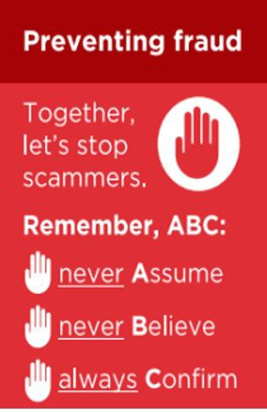
Fraudsters are sending text messages pretending to be a family member—often starting with a simple message such as: “Hi Mum.”
The scammer then claims they have a new phone number or an urgent issue and asks for money to be transferred.

Example Incident
A victim received a message believed to be from their daughter requesting financial help.
Trusting the request, a payment of £1800 was made. The victim was unable to verify the request immediately due to being at work. Upon checking later, it became clear that the message was fraudulent.

Key Warning Signs
- Messages from unknown or new numbers claiming to be a family member
- Requests for urgent financial help
- Pressure to act quickly without verifying
- Claims such as lost/broken phone or new number How to Protect Yourself
- Always verify: Contact the person directly using a known, trusted number
- Do not send money until you are certain the request is genuine
- Be cautious of urgent or emotional appeals
- Report suspicious messages to your bank and mobile provider immediately
Legitimate family members will understand if you take a moment to verify. Fraudsters rely on urgency and trust—take a step back before acting.
If you have been a victim of any type of scam, then contact your Bank immediately, which you can do by calling 159 and reporting to Report Fraud at Reporting cyber crime and fraud or phishing attempts - Report Fraud or call 0300 123 2040.
Find out more by visiting our website at Advice about fraud | Kent Police and also from the Home Office at Stop! Think Fraud - How to stay safe from scams

Which are warning the public about scam text messages impersonating Barclays. Fraudsters are sending text messages from spoofed mobile numbers claiming to be Barclays. The message typically states that:
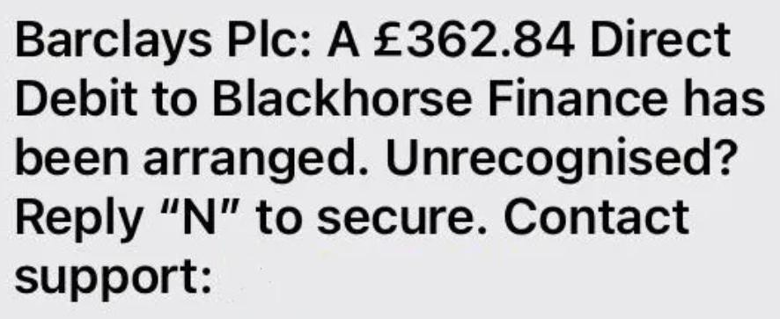
A new direct debit has been set up on your account. The text then provides a phone number to call if you do not recognise the transaction.
However, if you call the number provided, you are likely to be connected to a fraudster posing as bank staff.

They will attempt to:
- Gain your trust
- Create urgency or panic

Trick you into revealing personal and financial information
- Potentially persuade you to move money or share security details

Key Warning Signs
- Messages from unexpected or unknown mobile numbers claiming to be your bank
- Alerts about transactions or direct debits you do not recognise
- Being asked to call a number provided in the message
- Requests for PINs, passwords, or security codes

How to Protect Yourself
- Do not call numbers provided in unsolicited texts
- Contact your bank using the official number on their website or card
- Do not share personal or banking information over the phone unless you are certain who you are speaking to
- Treat unexpected financial alerts with caution and verify independently
Banks like Barclays will never ask for sensitive information such as your PIN or full password over the phone or via text. You can report suspicious text messages by forwarding to 7726.
If you have been a victim of any type of scam, then contact your Bank immediately, which you can do by calling 159 and reporting to Report Fraud at Reporting cyber crime and fraud or phishing attempts - Report Fraud or call 0300 123 2040. Find out more by visiting our website at Advice about fraud | Kent Police and also from the Home Office at Stop! Think Fraud - How to stay safe from scams

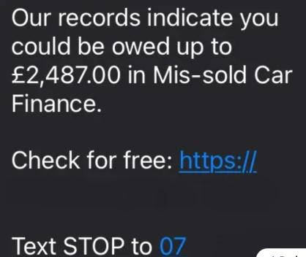
We have been alerted to scam texts claiming you may be owed compensation for mis-sold car finance, often quoting figures like: “You could be owed up to £2,487.”
These messages usually include a link to “check” your entitlement and a number to opt out. They are often sent by rogue or unregulated claims firms and may:
- Encourage you to click a link and enter personal details
- Attempt to collect sensitive information
- Charge hidden fees
- Target individuals who are not eligible for any compensation Reports show many recipients have no valid claim.
Key Warning Signs -
- Unexpected compensation offers
- Promises of large payouts with little effort
- Links requesting personal or financial information
- Messages from unknown or suspicious numbers
- Pressure to act quickly or “check now”
How to Protect Yourself –
- Do not click links in unsolicited messages
- Be cautious of cold contact about compensation
- Check firms on the FCA register
- Never share personal or financial details unless you are sure the company is legitimate
Seek advice from trusted, regulated sources
If you have been a victim of any type of scam, then contact your Bank immediately, which you can do by calling 159 and reporting to Report Fraud at Reporting cyber crime and fraud or phishing attempts - Report Fraud or call 0300 123 2040.
Find out more by visiting our website at Advice about fraud | Kent Police and also from the Home Office at Stop! Think Fraud - How to stay safe from scams

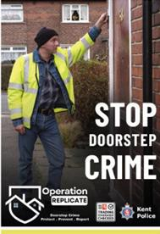
Residents are warned to be vigilant following an arrest in connection with suspected rogue trading in Ashford.
Kent Police was called to Lloyds Bank in High Street at 10.30am on Friday 15 May 2026, where a request to withdraw a large amount of money aroused the suspicion of staff. Officers attended and carried out enquiries. A couple in their 70s had been approached at home by a man who spoke to them about their roof.
It is reported that the couple were told that previous work completed on their roof was inadequate, and that remedial work was needed. The quote for the additional work was reportedly several thousands of pounds, which one of the victims attempted to draw out in cash at the bank.
Patrols attended the residential address and a 19 year old man was arrested on suspicion of fraud. He has since been bailed with conditions while an investigation is ongoing.
Anyone with relevant information that may assist officers’ enquiries should
contact Kent Police on 01843 222289 quoting 46/77146/26.
Inspector Sarah Williams said, ‘While this incident is being investigated, I would remind homeowners to remain vigilant about who they allow to complete work at their homes. ‘Always be cautious if somebody knocks at your door unexpectedly and offers to carry out repairs, and only agree to any work if you are confident it is needed and that you can trust the person who is carrying it out. It is also good practice to get several written quotes first. ‘Do not allow anyone to pressure you into agreeing to have work carried out. If you ask them to leave and they do not, contact the police.’ Do not ever go to a bank or cash machine with a trader; legitimate traders would never do this. ‘If you believe you, a member of your family or a neighbour has been targeted by a rogue trader then please report it to us as soon as possible so we can take action to protect
other people from financial harm.’
If you have been a victim of any type of scam, then contact your Bank immediately, which you can do by calling 159 and reporting to Report Fraud at Reporting cyber crime and fraud or phishing attempts - Report Fraud or call 0300 123 2040.
Find out more by visiting our website at Advice about fraud | Kent Police and also from the Home Office at Stop! Think Fraud - How to stay safe from scams

Fraud Alert: Social Media Scam
We have had several reports where people’s social media accounts are taken over by fraudsters and sending messages to contacts asking for money or urgent help.
Messages may appear genuine and come from someone you know
Requests often involve urgent payments, vouchers, or bank transfers

Advice:
- Do not send money without verifying the request directly (call the person a number you know)
- Be cautious of urgent or unusual messages
- Enable two-step verification on WhatsApp
- Ensure that you always use a strong password on all your accounts –
See below.

- Report suspicious messages and block the sender Stay vigilant and help protect friends and family from fraud. How to make a strong password
- Make it long
  - Aim for at least 12–16 characters
  - Longer = harder to crack
Example: BlueRiver!Coffee92#
If you have been a victim of any type of scam, then contact your Bank immediately, which you can do by calling 159 and reporting to Report Fraud at Reporting cyber crime and fraud or phishing attempts - Report Fraud or call 0300 123 2040.
Find out more by visiting our website at Advice about fraud | Kent Police and also from the Home Office at Stop! Think Fraud - How to stay safe from scams

