Learn how to spot the warning signs of scams, safeguard your personal information, understand the latest fraud trends, and know what to do if you or someone you care about becomes a victim.
- Wednesday 11th November
- 10:00am to 2:00pm
- Age UK Millmead Community Centre, Dane Valley Road, Margate, CT9 1RU
Meet fraud prevention specialists and partner agencies, ask questions, receive tailored advice, and find out about the support available to help keep you, your family and your finances safe.
Would YOU spot a scam? Come along and find out.
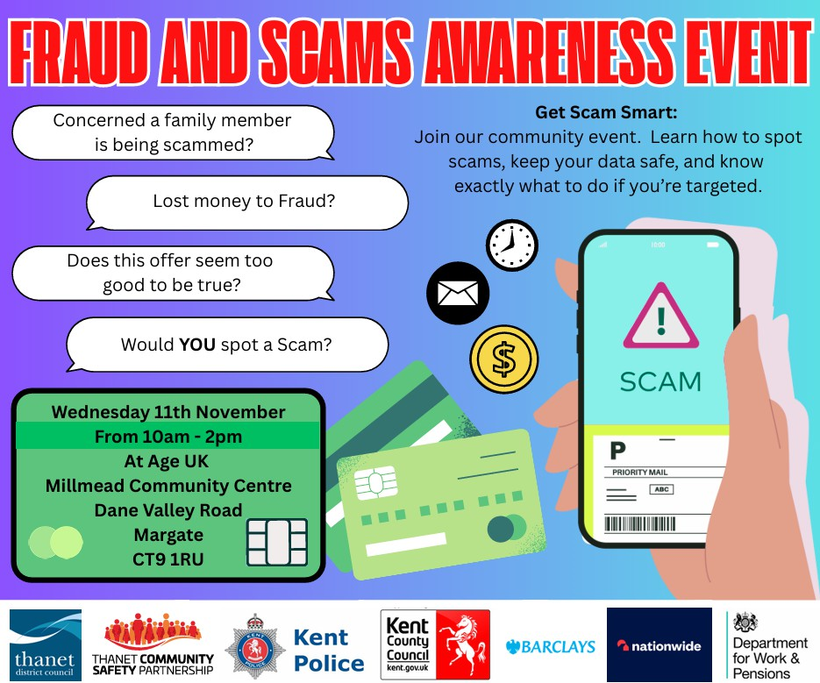

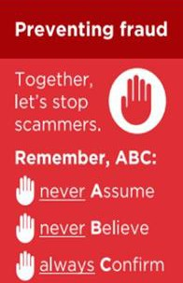
Fraudsters are increasingly exploiting people's generosity by posing as charity collectors, creating fake fundraising appeals, and impersonating legitimate charities. Criminals use emotional stories, urgent requests and convincing branding to persuade people to hand over money that never reaches those in need.
Common Charity Scams
- Doorstep collectors Criminals may knock on doors claiming to be collecting for a charity. They may be unable to provide valid identification, a registered charity number, or evidence of who they represent.
- Street collections Fraudsters may use collection buckets or tins that appear genuine. Legitimate collectors should be able to provide identification and details of the charity they are fundraising for.
- Disaster and emergency appeals Following natural disasters, conflicts, or high-profile incidents, criminals often create fake appeals within hours, knowing people want to help.
- Clothing and household collections Bags posted through letterboxes may suggest donations are supporting worthy causes. In some cases, items are collected and sold for private profit, with little or no benefit reaching charities.
How to Protect Yourself
- Check the charity's name and registration number independently through the Charity Commission Register: https://www.gov.uk/check-charity
- Ask collectors for official identification and details of the organisation they represent.
- Never feel pressured to donate immediately. Genuine charities will allow you time to check their credentials.
- Donate directly through the charity's official website or recognised fundraising channels rather than handing over cash to an unsolicited collector.
- Be suspicious of requests to pay via bank transfer, cryptocurrency, gift cards or to a personal account.
- If a collector cannot provide a registered charity number, refuse the donation and report any concerns.
Remember
Most charity fundraising is genuine, and legitimate charities rely on public support. However, a few simple checks can help ensure your hard-earned money reaches those who genuinely need it rather than ending up in the pockets of criminals.

Criminals are continuing to target Kent residents by impersonating Police Officers and Bank Fraud Department staff. They may contact you by telephone claiming:
- Your bank account has been compromised.
- Fraudulent transactions have been identified on your account.
- Your bank card needs replacing.
- A family member has been arrested.
- You need to assist with a Police or bank investigation.
- You must withdraw cash, buy gold or valuables, or transfer your money to a "safe account" that they have opened for you.
- You need to post cash, bank cards, jewellery, gold or other valuables to an address they provide as part of an investigation.
A courier may then be sent to your address to collect cash, bank cards, jewellery, gold or other valuables.

THIS IS A SCAM.
- The Police will NEVER ask for your bank details.
- The Police will NEVER ask you to withdraw cash, purchase gold or valuables, or take part in a covert operation.
- Your bank will NEVER ask you to transfer money to a "safe account".
- Your bank will NEVER send a courier to collect your bank card, cash, PIN, passwords or valuables.
- Neither the Police nor your bank will ask you to post cash, bank cards, jewellery or valuables to an address for safekeeping.
Protect Yourself -
- STOP and think before acting.
- HANG UP on unexpected calls claiming to be from the Police or your bank.
- VERIFY by calling your bank on a trusted number or by using 159.
If you have been a victim of any type of scam, then contact your Bank immediately, which you can do by calling 159 and reporting to Report Fraud at Reporting cyber crime and fraud or phishing attempts or call 0300 123 2040.
Find out more by visiting our website at Advice about fraud | Kent Police and from the Home Office at Stop! Think Fraud - How to stay safe from scams

Kent residents are being warned after reports of individuals receiving unsolicited telephone calls claiming to be conducting a Government heating survey. In a recent report, the caller asked questions about the resident, whether a Power of Attorney (POA) was in place, and attempted to
arrange a visit to the property.
Criminals and rogue traders often use claims about heating systems, insulation, energy grants, boiler upgrades or government-backed schemes to gather personal information, identify vulnerable individuals, and gain access to homes. They may falsely claim to represent government departments, councils, energy companies or official schemes.

Warning Signs
- Unexpected calls about heating, insulation, energy efficiency or government grants.
- Questions about who lives at the property, age, health, finances, carers or Power of Attorney arrangements.
- Pressure to arrange a home visit or survey.
- Claims that urgent inspections are required or that funding is about to expire.
- Callers claiming to be from a government agency, local authority or energy organisation without providing verifiable credentials.

Protect Yourself
- Be cautious of any unsolicited call offering surveys, grants, insulation or heating upgrades.
- Never disclose personal, financial or legal information, including details of any Power of Attorney arrangements.
- Do not agree to a home visit from an unexpected caller.
- Verify any claims independently using official contact details from GOV.UK or your local authority. Discuss unexpected calls with family members, friends or carers before taking any action.
Remember - Legitimate organisations will not object if you take time to verify who they are before engaging with them. Scammers rely on creating trust, urgency and confusion to obtain information or gain access to your home.
If you have been a victim of any type of scam, then contact your Bank immediately, which you can do by calling 159 and reporting to Report Fraud at Reporting cyber crime and fraud or phishing attempts or call 0300 123 2040. Find out more by visiting our website at Advice about fraud | Kent Police and from the Home Office at Stop! Think Fraud - How to stay safe from scams

MOBILE PHONE DELIVERY SCAM
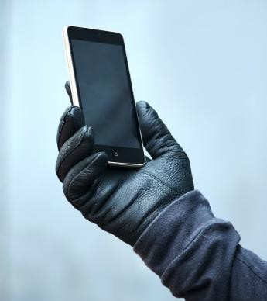
Kent residents are being warned after reports of criminals ordering mobile phones in their name and having them delivered to the victim's address. Victims are then contacted and told the phones were delivered in error and need to be collected or returned.
How the Scam Works -
- Fraudsters use stolen personal details to obtain a mobile phone contract.
- The phone is delivered to the victim's address.
- The victim is then contacted by someone claiming to be from the retailer, courier company or mobile network and asked to hand the phone over.
- If the phone is handed over, the criminals keep the handset while the victim may be left dealing with fraudulent accounts opened in their name.
Protect Yourself -
- Never hand over a phone or parcel to an unexpected visitor.
- Contact the retailer or mobile network directly using trusted contact details.
- Arrange collection only on an agreed date with an agreed delivery company.
- Do not rely on phone numbers, WhatsApp messages, emails or collection arrangements provided by the person contacting you.
- Check your accounts and credit file for signs of identity fraud.
If you have been a victim of any type of scam, then contact your Bank immediately, which you can do by calling 159 and reporting to Report Fraud at Reporting cyber crime and fraud or phishing attempts or call 0300 123 2040.
Find out more by visiting our website at Advice about fraud | Kent Police and from the Home Office at Stop! Think Fraud - How to stay safe from scams

