
Kent Fraud Alert System
Rogue Traders locked up
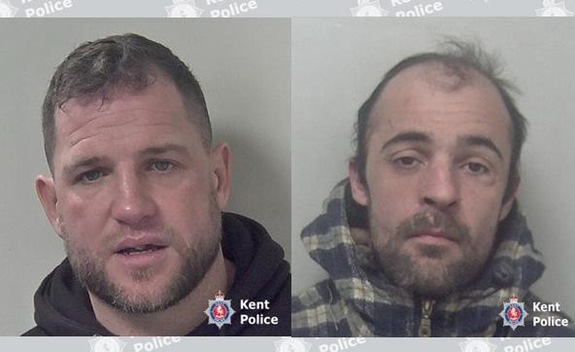
Two criminals have been jailed after admitting their involvement in a roofing scam which conned elderly residents into paying thousands of pounds for unnecessary repairs. Nelson Cooper and Scott Smith targeted homes in Dover, Canterbury, Ramsgate and Swanley between 20 September 2024 and 10 January 2025, convincing homeowners that chimney and roof repairs were needed, starting with smaller quotes but then inflating the costs into hundreds and sometimes thousands of pounds.
Escorting victims to banks
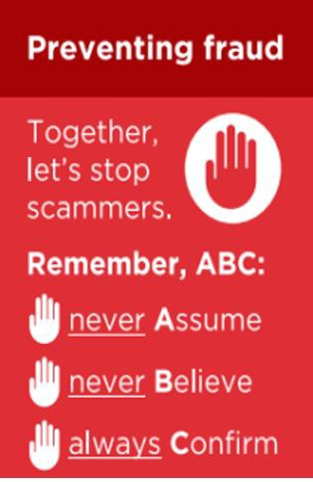
An investigation by Kent Police into Cooper’s company, which Smith worked for, found that the repairs recommended by them had been fraudulent. In several cases, 39 year old Cooper even escorted his victims to banks and cash machines if they tried to suggest they did not have the cash at home. A victim who had been visited by the rogue traders in December 2024 reported that he was advised by Cooper to tell the bank that he was withdrawing the money for Christmas presents.
When Cooper was arrested on 18 December 2024, his mobile phones were seized and found to contain contact details for Smith, as well as evidence he was knowingly preying on elderly residents. Officers recovered media messages containing video clips of elderly people, unaware they were being filmed and voice notes which discussed how promising particular areas were for fraud.
Cooper stated in one message to a contact that all of the jobs he had done in Ramsgate were over £2,700, while a second message revealed that in Dover ‘Ladders are going up left right and centre’. He also sent a voice note singing 'Christmas money' in reference to the cash he was making.
On 10 January 2025, Kent Police attended a property in Ramsgate following reports of cold callers in the area. Checking a property which had building work taking place, officers found Smith working there and enquiries revealed the elderly resident had already paid more than £25,000 for unnecessary work.
Smith was arrested while Cooper, who had also been there that day but fled at the sight of police cars, was arrested a short time later. They were both charged with a number of fraud offences.
Watch on YouTube - Two rogue traders jailed for roof scam which targeted elderly residents in Kent - YouTube

Kent Fraud Alert System
Investigating officer DC Mark Collins said:
‘Our investigation into Cooper and Smith’s criminal activities was able to show how far reaching they had
been and many elderly victims there were, as they destroyed homes with unnecessary work, took life
savings and then didn’t look back.‘ When Cooper was arrested and his phones were seized, it was distressing to see how little respect he had shown people, from filming them unaware, even when they were upset about the costly repairs, to singing and joking about the money he was making from his fraud.‘ Through determination to uncover the evidence needed, officers were able to bring them before the courts to stop them taking advantage of any more people. ‘Rogue traders like Cooper and Smith are often well practiced in their scams and the advice they provide can often sound very convincing. Anyone can become a victim of such frauds so if you are approached out of the blue about repairs needed, do not be rushed into agreeing the work. Do not be afraid to seek a second opinion.’
Advice for residents:
•If someone knocks at your door, always refuse on the spot repairs or maintenance.
•Don't allow anyone to pressure you into agreeing to have work carried out. If you ask them to
leave and they don't, contact the police on 999.
•Don't ever go to a bank or cashpoint with a trader; legitimate traders would never do this.
•Use reputable traders who are members of the KCC Trading Standards approved trader scheme
Trading Standards Checked.
•Ask for quotes in writing and check that the tradesperson is from the company they say they are from.

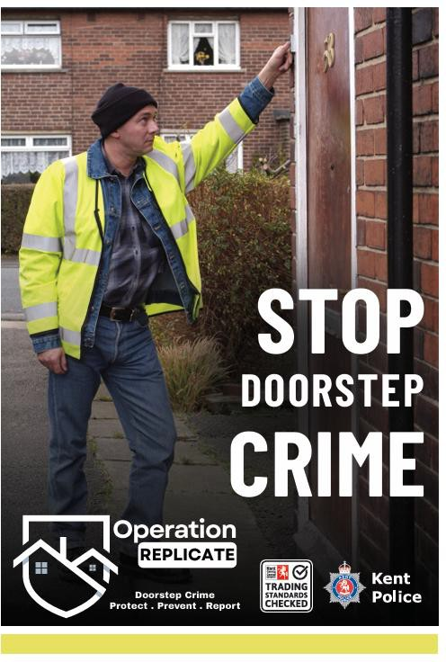
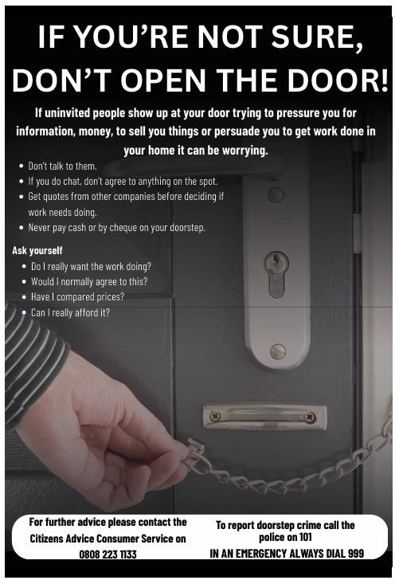
If you have been a victim of any type of scam, then contact your Bank immediately, which you can do by calling 159 and reporting to Report Fraud at Reporting cyber crime and fraud or phishing attempts - Report Fraud or call 0300 123
2040.
Find out more by visiting our website at Advice about fraud | Kent Police and also from the Home Office at Stop! Think Fraud - How to stay safe from scams

Kent Fraud Alert System
Romance Fraud
Victims of romance fraud lost more than £102 million in the UK last year, as criminals continue to exploit online relationships to manipulate people into transferring money.

Analysis shows people aged 55 to 74 experienced the greatest financial losses, accounting for almost half of the total amount stolen. Although men submitted a higher number of reports overall, women experienced higher individual losses, making up just over 40 per cent of the total value reported.
Romance fraud remains closely linked to online platforms, particularly social media and dating sites, where offenders can create convincing false identities. Investigators are also seeing increased use of
AI-generated images and messages to support these profiles. In many cases, it is also linked to fake investment opportunities, including cryptocurrency, increasing the financial risk to victims.
We are urging the public to stay cautious when forming relationships online and to recognise the warning signs:
Be cautious of individuals who develop relationships very quickly or express strong feelings early on
- Be wary of excuses not to meet in person or to avoid live video calls
- Never send money, cryptocurrency or gift cards to someone you have not met face to face
- Be alert to requests linked to investments, medical emergencies or travel costs
- Speak to a trusted friend or family member if something feels unusual or pressured
For further information view our videos, an interview with a victim and some expert advice from Mark Newman from our Fraud team.
A victim's real life account of romance fraud - YouTube
Be on guard against romance fraud - YouTube
If you have been a victim of any type of scam, then contact your Bank immediately, which you can do by calling 159 and reporting to Report Fraud at Reporting cyber crime and fraud or phishing attempts - Report Fraud or call 0300 123 2040.
Find out more by visiting our website at Advice about fraud | Kent Police and also from the Home Office at Stop! Think Fraud - How to stay safe from scams

Kent Fraud Alert System

Impersonation Scam
Kent county council are warning that Kent residents are being targeted by scam calls claiming to be citizens advice.
The calls are coming from withheld numbers and the criminals are claiming that the recipients have outstanding debts that must be dealt with urgently.
If you get a call like this –
- Do not share personal or financial information
- Do not engage with the caller and hang up
- Remember that Citizens Advice will never call you out of the blue about debts.
If you have been a victim of any type of scam, then contact your Bank immediately, which you can do by calling 159 and reporting to Report Fraud at Reporting cyber crime and fraud or phishing attempts - Report Fraud or call 0300 123 2040.
Find out more by visiting our website at Advice about fraud | Kent Police and also from the Home Office at Stop! Think Fraud - How to stay safe from scams

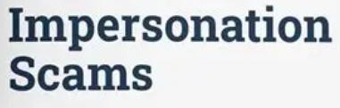

Kent Fraud Alert System
Unexpected Mobile Phone Delivery Scam
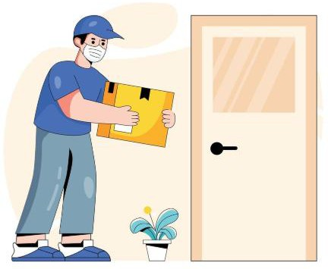
Criminals are targeting people across Kent by ordering expensive mobile phones in their name, having them delivered to their home address, and then tricking them into handing the phone back.
How the scam works -
  - Fraudsters use stolen personal details to take out a mobile phone
contract in someone else’s name.
  - A new phone is delivered to the victim’s home address, even
though they did not order it.
  - Shortly after delivery, someone turns up claiming to be a courier, saying the phone was delivered in error and needs to be collected.
  - Once the phone is handed over, the criminal keeps it — but the victim is left liable for the contract, bills and possible credit damage.
Warning signs -
  - You receive a mobile phone or parcel you did not order
  - Someone arrives unexpectedly asking to collect it
  - They pressure you to act quickly or say it is an admin or scanning mistake
  - They refuse to let you verify the request with the retailer Protect yourself -
  - Do not hand over parcels to anyone who turns up at your door unannounced
  - Legitimate retailers and couriers will not ask for goods back at the doorstep
  - Contact the mobile provider or retailer directly using official contact details
  - Keep the parcel until the retailer confirms safe return arrangements
  - Regularly check your credit report for unknown accounts
If you have been a victim of any type of scam, then contact your Bank immediately, which you can do by calling 159 and reporting to Report Fraud at Reporting cyber crime and fraud or phishing attempts - Report Fraud or call 0300 123 2040.
Find out more by visiting our website at Advice about fraud | Kent Police and also from the Home Office at Stop! Think Fraud - How to stay safe from scams

Kent Fraud Alert System

Football Ticket Scams – The World Cup is coming.
Fraudsters are targeting football fans with fake ticket offers, including for Premier League matches and the World Cup.

UK banks and the Government confirmed that football ticket scams have risen by 36% during the current Premier League season, compared with the same period last year. This was highlighted in warnings issued on 11 May 2026, ahead of the World Cup, based on Lloyds Banking Group fraud data.
Scammers often advertise tickets on social media, move the conversation to private messages, and pressure people to pay quickly by bank transfer. After payment, the seller disappears and no tickets are received.
Some scams also involve -
- Fake waiting lists
- Counterfeit QR codes or screenshots
- Fake resale websites made to look official Warning signs –
- Tickets are cheaper than everywhere else
- You are told to act quickly or miss out
- The seller avoids official platforms
- You are asked to pay by bank transfer or cryptocurrency
- Tickets are sent only as screenshots or PDFs Protect yourself -
- Only buy tickets from official sellers or authorised resale platforms
- Avoid buying tickets through social media or private messages
- Never pay by bank transfer to someone you don’t know
- Use a credit card where possible for extra protection
- Be cautious of “last-minute,” “spare” or “too good to be true” offers
If you have been a victim of any type of scam, then contact your Bank immediately, which you can do by calling 159 and reporting to Report Fraud at Reporting cyber crime and fraud or phishing attempts - Report Fraud or call 0300 123 2040.
Find out more by visiting our website at Advice about fraud | Kent Police and also from the Home Office at Stop! Think Fraud - How to stay safe from scams

