
Kent Fraud Alert System

Fake Police Calls (Courier Fraud)
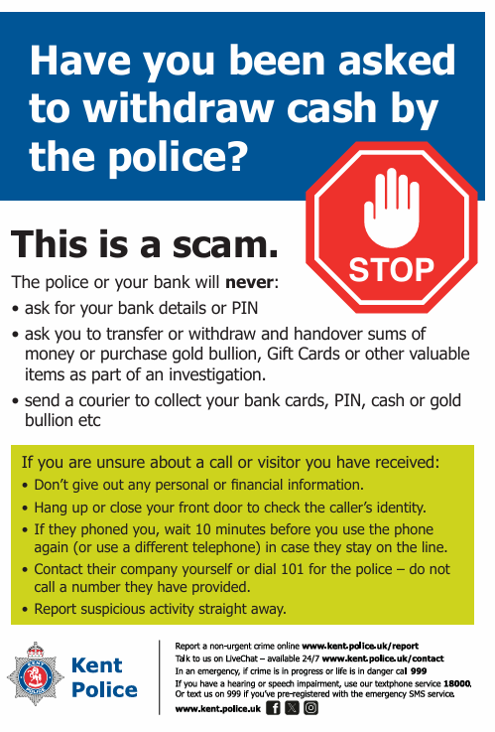
Kent residents are being warned about criminals pretending to be police officers on the telephone. This week, we have received reports from all over Kent, including, Tonbridge, Romney Marsh, Dartford, Ashford, Maidstone, Rochester and Gillingham.
How the scam works:
- You receive a call from someone claiming to be a police officer.
- They say your bank account has been hacked or a family member has been arrested.
- They ask you to withdraw cash or buy gold/jewellery to
“help an investigation.”
- A courier is then sent to your home to collect the money or valuables.
This is a scam. Remember:
- Police will NEVER ask you to withdraw cash.
- Police will NEVER ask for your PIN or bank details.
- Police will NEVER send someone to collect money or valuables.
How to stay safe:
- Hang up immediately if you feel unsure.
- Call your bank using 159.
- Speak to a trusted friend or family member.
Please share this warning with family, friends, and neighbours, especially those who may be more vulnerable.
If you have been a victim of any type of scam, then contact your Bank immediately, which you can do by calling 159 and reporting to Report Fraud at Reporting cyber crime and fraud or phishing attempts - Report Fraud or call 0300 123 2040.
Find out more by visiting our website at Advice about fraud | Kent Police and also from the Home Office at Stop! Think Fraud - How to stay safe from scams

Kent Fraud Alert System
55 million suspicious emails reported by the public across the UK
Members of the public have reported 55.7 million suspicious emails to the Suspicious Email Reporting
Service (SERS). The free service was created by the UK’s National Cyber Security Centre (NCSC) in 2020 and
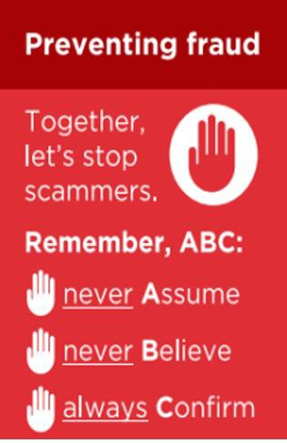
since its launch has resulted in the removal of 250,000 scams across 443,000 malicious websites.
Phishing is when criminals use scam emails, text messages or phone calls to trick their victims. The aim is often to make you visit a website, which may download a virus onto your computer, or steal bank details or other personal information.
The NCSC is a UK government organisation that has the power to investigate and take down scam email addresses and websites. Reporting a scam is free and only takes a minute. By reporting suspicious emails, messages and calls, you can:
- Reduce the amount of scam communications you receive.
- Make yourself a harder target for scammers.
- Protect others from cybercrime online.
If you have received an email or text message that does not feel right, STOP!
- Break the contact – do not reply, click on any links, call any phone numbers or make any payments.
- Check if it is genuine: contact the organisation directly using an email address or phone number you know is correct, e.g. from your utility bills, via a search engine, on the back of your card or by calling 159 for banks.
- Report suspicious emails by forwarding them to: report@phishing.gov.uk
- Report suspicious text messages by forwarding them to: 7726 (it is free of charge).
How to report suspicious phone calls:
- If you have received a phone call that does not feel right, STOP!
- hang up.
- check if it is genuine: contact the organisation directly using contact details you know are correct, such as those on a utility bill, official website, the back of your card or by calling 159 for your bank.
- do not trust the Caller ID display on your phone – it is not proof of ID.
- report it by sending a text to 7726 with the word ‘Call’ followed by the scam caller’s number.
If you have been a victim of any type of scam, then contact your Bank immediately, which you can do by calling 159 and reporting to Report Fraud at Reporting cyber crime and fraud or phishing attempts - Report Fraud or call 0300 123 2040.
Find out more by visiting our website at Advice about fraud | Kent Police and also from the Home Office at Stop! Think Fraud - How to stay safe from scams

Kent Fraud Alert System

Fraud Alert – Distraction Theft Targeting Bank Customers
We are warning of incidents where offenders are targeting people shortly after they withdraw cash from banks.

What is happening:
- Offenders monitor bank customers who have made large cash withdrawals.
- They follow victims to car parks or nearby locations.
- A distraction is used (e.g. dropping a note on the ground and pointing it out).
- While the victim is distracted, a second person attempts to steal a purse, wallet, or cash.
This type of offence has been seen before and appears to be organised, with offenders working together.

How to protect yourself:
- Stay alert after withdrawing cash and be aware of people nearby.
- Do not accept help or engage with strangers who try to distract you.
- Keep bags, purses, and cash secure and out of sight at all times.
- Lock vehicle doors immediately when entering your car.
- If you feel you are being followed, go to a safe place and seek assistance.

If you are targeted:
- Report immediately to Police via 101 (or 999 in an emergency).
If you have been a victim of any type of scam, then contact your Bank immediately, which you can do by calling 159 and reporting to Report Fraud at Reporting cyber crime and fraud or phishing attempts - Report Fraud or call 0300 123 2040.
Find out more by visiting our website at Advice about fraud | Kent Police and also from the Home Office at Stop! Think Fraud - How to stay safe from scams

Kent Fraud Alert System

Fraud Alert – “Ghost Broking” Car Insurance Scam
Young drivers (aged 17–25) are being warned about a scam known as “ghost broking”, where fraudsters sell fake or invalid car insurance online.
What is happening:
- Fraudsters pose as insurance brokers on social media and messaging apps.
- They offer cheap insurance deals that seem too good to be true.
The policy may be:
- Completely fake
- Set up using false details to lower the cost.
- Cancelled shortly after purchase The risk:
- Victims are left uninsured without realising it.
- This can lead to:
- Fines and penalty points
- Vehicle seizure
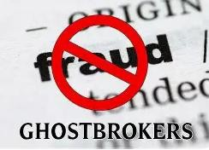
- Possible criminal charges How to protect yourself:
- Only buy insurance from trusted companies or official comparison websites
- Be cautious of deals offered via social media or direct messages.
- Check that the provider is authorised on the FCA register.
- Never share personal details with unknown individuals Remember:
If a deal seems too cheap, it is likely a scam.
If you have been a victim of any type of scam, then contact your Bank immediately, which you can do by calling 159 and reporting to Report Fraud at Reporting cyber crime and fraud or phishing attempts - Report Fraud or call 0300 123 2040.
Find out more by visiting our website at Advice about fraud | Kent Police and also from the Home Office at Stop! Think Fraud - How to stay safe from scams

Kent Fraud Alert System
Fraud Alert – Fake Ticket Scams
People across the UK are being warned about a rise in ticket scams for concerts, festivals and sporting events.
What is happening:
- Criminals are selling fake or non-existent tickets online.
- Most scams start on social media, resale sites, or messaging apps.
Victims pay for tickets that:
- Never arrive.
- Are fake or copied.
- Have already been sold to someone else.
Recent data shows thousands of cases reported, with millions of pounds lost each year, often linked to tickets advertised on social media.
Common warning signs:
- Tickets being sold cheaply for sold-out events.
- Sellers asking for bank transfer or “friends & family” payments.
- Pressure to pay quickly.
- New or unverified social media accounts

Fraudsters exploit high demand for popular events and target fans who are worried about missing out. How to stay safe:
Only buy tickets from:
- Official box offices
- Trusted, authorised resale sites
- Avoid paying by bank transfer.
- Use a credit card or secure payment method.
- Check the seller carefully before buying.

If you have been a victim of any type of scam, then contact your Bank immediately, which you can do by calling 159 and reporting to Report Fraud at Reporting cyber crime and fraud or phishing attempts - Report Fraud or call 0300 123 2040.
Find out more by visiting our website at Advice about fraud | Kent Police and also from the Home Office at Stop! Think Fraud - How to stay safe from scams

Kent Fraud Alert System
Fraud Alert – Fake World Cup Merchandise

Football fans are being warned about scams selling fake World Cup merchandise online.
What’s happening:
- Criminals are creating fake websites and social media shops posing as official sellers.
- They advertise cheap kits, shirts, and “limited edition” items.
- After payment, goods either never arrive or are poor-quality fakes. Warning signs:
- Prices that seem too good to be true
- Fake websites using FIFA branding.
- Pressure to buy quickly.
- Requests to pay by bank transfer. Protect yourself:
- Only buy from official or trusted retailers
- Check the website carefully.
- Use secure payment methods (e.g. credit card) If it looks too cheap or rushed, it is likely a scam.
If you have been a victim of any type of scam, then contact your Bank
immediately, which you can do by calling 159 and reporting to Report Fraud at Reporting cyber crime and fraud or phishing attempts - Report Fraud or call 0300 123 2040.
Find out more by visiting our website at Advice about fraud | Kent Police and also from the Home Office at Stop! Think Fraud - How to stay safe from scams

