
Kent Fraud Alert System
East Kent builder jailed after conning thousands from victims
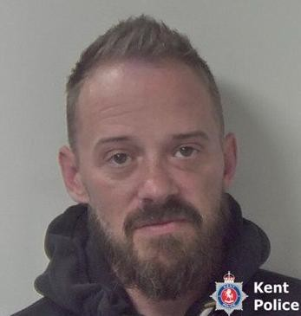
A rogue builder who conned victims out of thousands of pounds has been jailed following an investigation by Kent Police. Michael Rylands, from Sandwich, took advance payments for building work and goods that were never delivered or completed, leaving a number of victims out of pocket.
His offences included taking £6,000 from a pre-school for a climbing frame project that was never completed, accepting payment for windows that were never supplied, carrying out incomplete renovation work, and running up debts with building suppliers. He also defrauded individuals through online sales and made false claims to victims when challenged about missing money and unfinished work.
During court proceedings, Rylands even attempted to avoid justice by falsely claiming he was receiving cancer treatment. Checks later confirmed this was untrue, leading to an additional offence of perverting the course of justice.
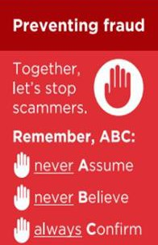
At Canterbury Crown Court, the 44-year-old admitted seven fraud offences as well as perverting the course of justice. He was sentenced to a total of 22 months' imprisonment.
Investigating officer Detective Constable Benjamin Deegan said:
“Our investigation uncovered a trail of unhappy people who had put their trust in Rylands and ended up out of pocket. He showed little remorse for his actions and thought that claiming he had cancer would provide him with a get-out-of-jail-free card. He had a flagrant disregard for people and property and I am pleased we were able to bring him to court to face justice.”
If you have been a victim of any type of scam, then contact your Bank immediately, which you can do by calling 159 and reporting to Report Fraud at Reporting cyber crime and fraud or phishing attempts - Report Fraud or call 0300 123 2040.
Find out more by visiting our website at Advice about fraud | Kent Police and from the Home Office at Stop! Think Fraud - How to stay safe from scams

Fraud Alert – Amazon Impersonation Scam
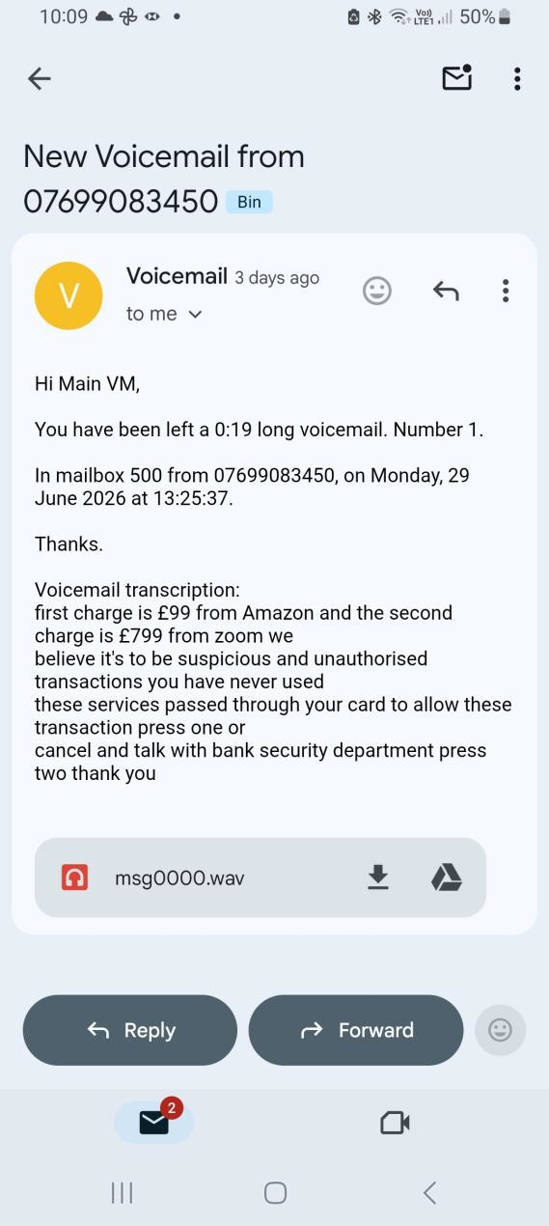
Residents are being warned about scam voicemails and phone calls claiming that suspicious payments have been made to companies such as Amazon or Zoom. Victims are told to "press 1" to cancel the transaction or speak to a security team.
These calls are scam phone calls designed to steal your money or personal details and designed to create panic and encourage victims to engage with fraudsters. The scammer's objective is typically to obtain banking details, card information, security codes, online banking credentials, or remote access to a victim's device. Amazon identifies unsolicited calls claiming suspicious activity, unexpected purchases, or account problems as common impersonation scam tactics.

Protect yourself:
- Do not press any buttons.
- Do not provide bank details, passwords or security codes.
- Do not allow remote access to your device.
- Contact your bank using 159.
- Check your Amazon account directly through the official website or app.
If you have been a victim of any type of scam, then contact your Bank immediately, which you can do by calling 159 and reporting to Report Fraud at Reporting cyber crime and fraud or phishing attempts - Report Fraud or call 0300 123 2040.
Find out more by visiting our website at Advice about fraud | Kent Police and from the Home Office at Stop! Think Fraud - How to stay safe from scams

Fraud Alert: Fake Holidays, Accommodation and Flight Deals

Fraudsters are using social media platforms to advertise fake holidays, accommodation and discounted flights. Criminals are creating convincing adverts using stolen photographs, cloned websites and fake ATOL and ABTA logos to make their offers appear genuine. Victims often only discover they have been scammed when they try to travel or arrive at their destination.
Protect Yourself – Follow Kent's ABC of Fraud Awareness A – Never Assume -
Do not assume a travel company, website or social media advert is genuine just because it looks professional or displays industry logos.
B – Never Believe -
Be wary of deals that seem significantly cheaper than elsewhere. If an offer looks too good to be true, it probably is.
C – Always Confirm -Verify the travel company independently using official contact details.eck ATOL and ABTA memberships through their official websites.
- Reverse search property images to identify stolen photographs.
- Read independent reviews from multiple sources.
- Use a credit card where possible for additional protection.
- Avoid paying by bank transfer, especially for holidays advertised on social media.
If you have been a victim of any type of scam, then contact your Bank immediately, which you can do by calling 159 and reporting to Report Fraud at Reporting cyber crime and fraud or phishing attempts - Report Fraud or call 0300 123 2040.
Find out more by visiting our website at Advice about fraud | Kent Police and from the Home Office at Stop! Think Fraud - How to stay safe from scams

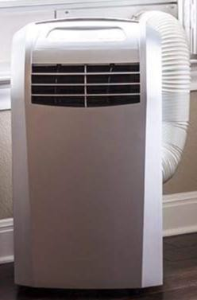
FRAUD ALERT: Heatwave Air Conditioner Scam
With temperatures rising, fraudsters are targeting people searching for affordable air conditioners and cooling devices online. Criminals are advertising heavily discounted products through social media and fake websites, only for victims to receive poor-quality items, products that don't work as advertised, or nothing at all.
Warning Signs -
- Prices significantly cheaper than major retailers.
- Claims that small devices can cool entire rooms within minutes.
- The seller only accepts bank transfer, cryptocurrency or other non-refundable payment methods.
- Limited time offers, countdown timers, and pressure to buy quickly.
- No genuine reviews, business address, or customer support details. Protect Yourself -
- Purchase from reputable retailers and established websites.
- Check independent customer reviews before buying.
- Pay by credit card where possible for additional consumer protection.
- Research the company and website before making a purchase.
- Be wary of social media adverts promoting heavily discounted cooling products.

If you have been a victim of any type of scam, then contact your Bank immediately, which you can do by calling 159 and reporting to Report Fraud at Reporting cyber crime and fraud or phishing attempts - Report Fraud or call 0300 123 2040.
Find out more by visiting our website at Advice about fraud | Kent Police and from the Home Office at Stop! Think Fraud - How to stay safe from scams

Kent Fraud Alert System
FRAUD ALERT: HOW TO SPOT A FAKE WEBSITE
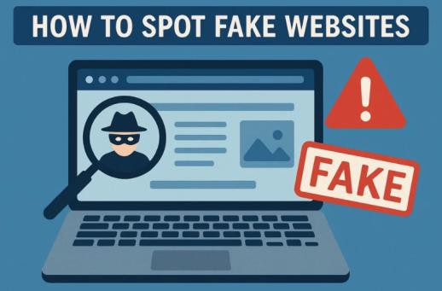
Many criminals operate fake websites, which will download viruses to your computer or are designed to steal passwords and personal information.
You can report fake websites to the National Cyber Security Centre by just simply going to - Report a suspicious website | National Cyber Security Centre

RED FLAGS TO LOOK FOR -
Prices that are too good to be true -
  - Huge discounts on popular items.
  - Investment opportunities offering guaranteed or unusually high returns.

Suspicious website address
  - Misspelled company names.
  - Extra words, letters or numbers in the web address.
  - Web addresses that look like a trusted brand.

Poor quality website -
  - Spelling and grammar mistakes.
  - Low-quality images.
  - Broken links or missing pages.

No company information -
  - No contact details.
  - No registered address.
  - Missing returns, refund or privacy policies.

Unsafe payment methods -
  - Requests for bank transfer payments.
  - Requests for cryptocurrency payments.
  - Refusal to accept credit or debit cards.
If you have been a victim of any type of scam, then contact your Bank immediately, which you can do by calling 159 and reporting to Report Fraud at Reporting cyber crime and fraud or phishing attempts - Report Fraud or call 0300 123 2040.

