Rogue Trader Arrests
Two men have been arrested following a report of rogue trading in Paddock Wood, as officers appeal for further potential victims to come forward.
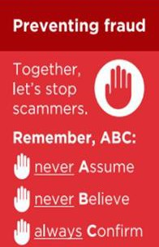
Kent Police was made aware of alleged fraudulent activity at an address in Willow Lane where two men carried out a series of work at the elderly victim's home throughout July and August 2026. It is reported that they repeatedly asked for more money and suggested additional jobs without properly completing the original work.
Officers launched an investigation and on Wednesday 19 August 2026, two men aged 35 and 49 from the local area were arrested on suspicion of fraud, theft and criminal damage. The 35 year old was further arrested on suspicion of possession of drugs. They have both been bailed pending further enquiries.
Further allegations of similar suspicious activity have also been brought to the attention of officers in the Staplehurst and Paddock Wood areas.
Kent Police is reminding residents to deter doorstep fraudsters, who often seek to carry out work which is either completely unnecessary or which is substandard, by taking the following action:
- Do not open the door to, nor engage with, cold callers or tradespeople
offering work on your home or garden. If you have any concerns, call the police.
- Genuine companies will not expect cash in advance or tell you to go to the bank to withdraw money.
- Use reputable traders who are members of the KCC Trading Standards approved trader scheme Trading Standards Checked.
- Ask for quotes in writing and check that the tradesperson is from the company they say they are from.
- Ring at least three traders to get a feel for an average price for the job.
- Reputable traders will not use pressure techniques for you to agree to the job on the spot.

If you have been a victim of any type of scam, then contact your Bank immediately, which you can do by calling 159 and reporting to Report Fraud at Reporting cyber crime and fraud or phishing attempts or call 0300 123 2040.
Find out more by visiting our website at Advice about fraud | Kent Police and from the Home Office at Stop! Think Fraud - How to stay safe from scams

Fraud Alert: Trusted Individuals Steal £51 Million from Pensioners
New figures from the City of London Police reveal that older and vulnerable people are losing millions of pounds to fraud committed by those closest to them. During 2025/26, £93.8 million was reported lost through Fraud by Abuse of Position in the UK, with victims aged 70 and over losing more than £51 million.
Fraud by Abuse of Position occurs when someone in a trusted role, such as a family member, friend, carer, employee, or attorney, exploits that position to steal money, assets, or property. A total of 3,812 reports were made during the year, with those aged 80-89 suffering the highest losses, totalling almost £24 million.
A significant concern is the misuse of Power of Attorney, with 764 reports resulting in losses of £34.6 million. There were also 444 reports involving social care workers, with losses reaching £13.3 million. Many cases involved offenders gaining access to bank cards, financial information, or accounts and making unauthorised withdrawals or transfers. Some reports also involved the manipulation of wills and estates following a victim's death.
The data highlights how offenders often target people during periods of vulnerability, including ill health, dementia, cognitive decline, and bereavement. Victims frequently relied on those around them for care, support, or financial management, giving offenders opportunities to abuse their trust.
Protect Yourself and Loved Ones
- Regularly check bank statements and financial accounts for unusual transactions.
- Be alert to unpaid bills, missing possessions, unexplained withdrawals, or unexpected changes to wills and financial arrangements.
- Discuss financial matters with trusted relatives and seek independent advice if concerns arise. If You Suspect Financial Abuse
- Contact your bank or card provider immediately.
- Raise concerns with your local authority's Adult Social Care team.
- Report concerns about misuse of a Power of Attorney to the Office of the Public Guardian.
Report suspected fraud to Report Fraud at Reporting cyber crime and fraud or phishing attempts or call 0300 123 2040. For more advice and to raise any concerns, contact - Office of the Public Guardian - GOV.UK
Remember: Financial abuse is often committed by someone known and trusted by the victim. Regular checks and early reporting can help protect vulnerable people from significant financial harm.

Fraud Alert: Telephone Number Spoofing
Fraudsters are using technology to make their calls appear as if they are coming from trusted organisations such as banks, the police, HMRC, utility companies, or telecom providers. The number displayed on your phone may look genuine, but it can be faked.
Criminals often claim there is a problem with your bank account, an unpaid bill, or suspicious activity that requires urgent action. They may try to obtain personal information, banking details, security codes, or persuade you to transfer money to a "safe account".
Protect Yourself:
- Never trust a caller simply because the number looks genuine.
- Never share passwords, PINs, or one-time passcodes over the phone.
- Be wary of any request to transfer money or download software.
- If in doubt, hang up and contact the organisation directly using a trusted number from their official website or correspondence.
- Take your time. Fraudsters often create a sense of urgency to pressure victims into acting quickly.
Banks, the police, and government organisations will never ask you to transfer money to a safe account or disclose your security credentials.
Remember - The number displayed on your phone is not proof of who is calling. If in doubt, hang up, verify independently, and never share sensitive information with an unexpected caller.
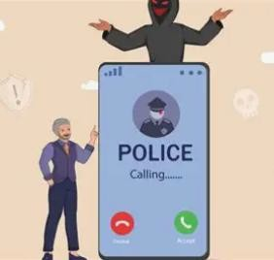
Watch Fraud Explained - National Crime Agency from the NCA for more information about impersonation fraud.

If you have been a victim of any type of scam, then contact your Bank immediately, which you can do by calling 159 and reporting to Report Fraud at Reporting cyber crime and fraud or phishing attempts or call 0300 123 2040.
Find out more by visiting our website at Advice about fraud | Kent Police and from the Home Office at Stop! Think Fraud - How to stay safe from scams

HALIFAX PHISHING EMAIL WARNING
Fraudsters are sending emails claiming customers need to verify or confirm their personal information. The email contains a link directing recipients to a fake Halifax website designed to steal personal and banking details.
These emails can appear genuine and may use Halifax branding, logos and language to encourage victims to act quickly. Information provided through these fraudulent websites can be used to gain access to accounts, commit identity fraud or facilitate further scams.

Protect Yourself - Remember ABC
- A - Never ASSUME
- Never assume an email is genuine because it contains official logos, branding or appears to come from a trusted organisation.

B - Never BELIEVE
- Never believe unexpected requests to click links, verify account details or provide personal information. Criminals rely on urgency and trust to encourage victims to act without thinking.

C - Always CONFIRM
- Always confirm requests independently. If you receive an email claiming to be from Halifax:

  - Do not click any links within the email.
  - Access your account through the official Halifax app or by typing the website address directly into your browser.
  - Contact Halifax using a trusted number obtained independently.
  - Forward suspicious emails to report@phishing.gov.uk. If You Have Responded
If you have clicked a link or entered personal or banking information, contact your bank immediately, change any compromised passwords and monitor your accounts for suspicious activity.
If you have been a victim of any type of scam, then contact your Bank immediately, which you can do by calling 159 and reporting to Report Fraud at Reporting cyber crime and fraud or phishing attempts or call 0300 123 2040.
Find out more by visiting our website at Advice about fraud | Kent Police and from the Home Office at Stop! Think Fraud - How to stay safe from scams

FRAUD ALERT: Celebrity Romance Scams
Have you received a private message on social media from a celebrity, actor, musician, TV personality or influencer?
Fraudsters are increasingly using Facebook, Instagram, TikTok, X and other social media platforms to target fans. They create fake profiles and build what appears to be a genuine friendship or romantic relationship before asking for money, gifts, cryptocurrency or personal information.
Criminals are now using Artificial Intelligence (AI) to make these scams more convincing. This can include AI-generated images, voice cloning, fake voice messages and deepfake video calls that appear to show or sound like a genuine celebrity.
- Do not assume a profile is genuine simply because it uses official photographs, has lots of followers, or sends convincing videos and voice messages. Fraudsters can now use AI technology to create highly realistic content.
- Do not believe claims that a celebrity is contacting you through a secret account, has chosen you for a private relationship, or needs your financial
help. Genuine celebrities will not ask fans for money, gift cards, cryptocurrency or banking information.
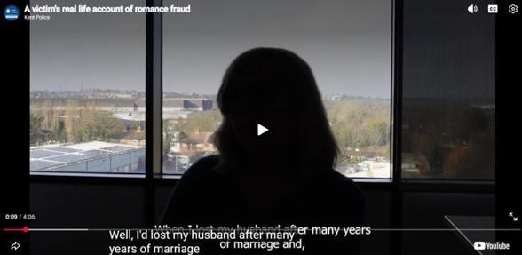
- Always confirm with whom you are communicating with. Never send money or share personal information with some one you have only met online, no matter what their reason is.
To see the devasting effect that these crimes have on their victims, then
see “a victim’s tale” - Bing Videos

Remember: Just because you can see them on a video call or hear their
voice does not mean they are real. AI technology can now convincingly clone both faces and voices.
If you have been a victim of any type of scam, then contact your Bank immediately, which you can do by calling 159 and reporting to Report Fraud at Reporting cyber crime and fraud or phishing attempts or call 0300 123 2040.
Find out more by visiting our website at Advice about fraud | Kent Police and from the Home Office at Stop! Think Fraud - How to stay safe from scams

