
Kent Fraud Alert System
Rogue Traders
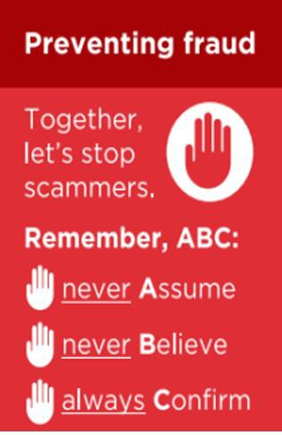
Doorstep criminals have been active this week in Tunbridge Wells, Tonbridge, Hythe and Rochester offering poor quality roofing, garden and/or plumbing work and intimidating residents into overpaying.
Please be alert and warn your vulnerable friends and family to never respond to cold callers as you will pay a high cost for unnecessary and poor-quality work.
Never respond to cold callers! Please warn your vulnerable friends and family to be alert. You can:
- Ask the visitor to return another time when someone can be with you
- Get three written quotes
- Ask family and friends for recommendations
- Agree payment arrangements and start and finish dates in writing beforehand and never pay in full until you are completely satisfied with the work.
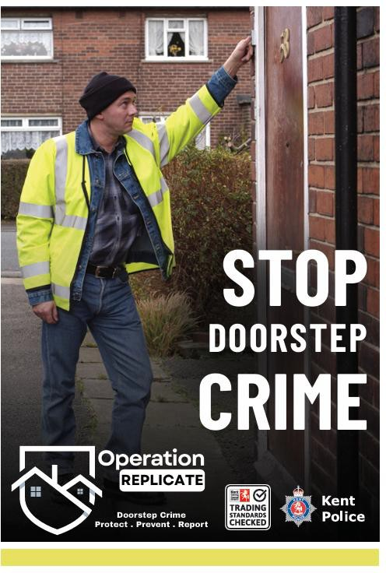
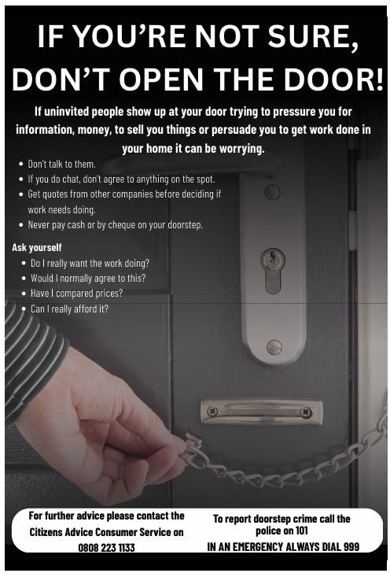
If you have been a victim of any type of scam, then contact your Bank immediately, which you can do by calling 159 and reporting to Report Fraud at Reporting cyber crime and fraud or phishing attempts - Report Fraud or call 0300 123 2040.
Find out more by visiting our website at Advice about fraud | Kent Police and also from the Home Office at Stop! Think Fraud - How to stay safe from scams

Kent Fraud Alert System
Fake text messages impersonating delivery companies
Just recently, we have seen an increase in reports for fake delivery scam text messages. Below is one such example.
The messages will normally be time sensitive to pressure you into clicking the link.
If you get a message like this, best advice is not to click on links, as you could download malicious malware.
If you are unsure if it is genuine, then contact the company using a trusted number you have sourced yourself.
If you have been a victim of any type of scam, then contact your Bank immediately, which you can do by calling 159 and reporting to Report Fraud at Reporting cyber crime and fraud or phishing attempts - Report Fraud or call 0300 123 2040.
Find out more by visiting our website at Advice about fraud | Kent Police and also from the Home Office at Stop! Think Fraud - How to stay safe from scams
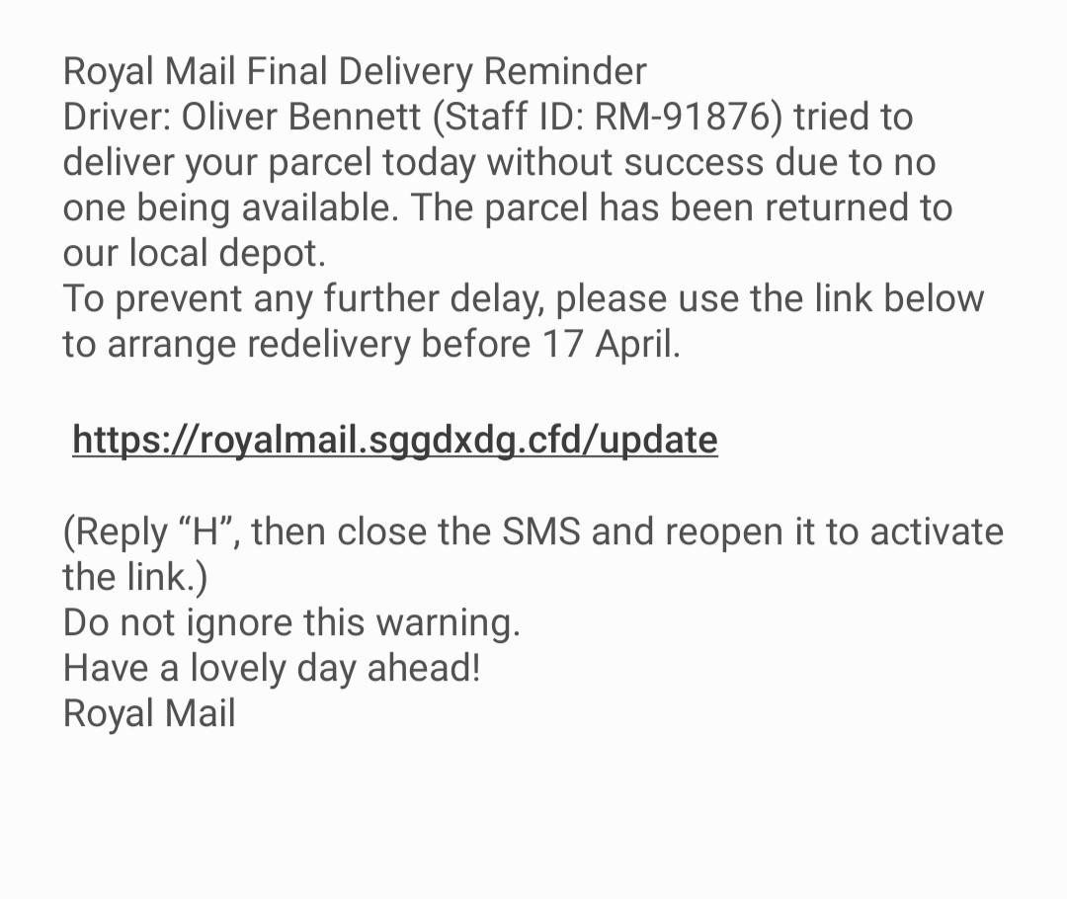

Kent Fraud Alert System

Kent Residents Warned After Investment Scams on Facebook Lead to Major Financial Losses
Kent County Council and Kent Trading Standards have recently warned residents to be on high alert following a spike in investment scams being promoted through Facebook adverts, with one Kent resident losing tens of thousands of pounds.
One scam advert appeared highly convincing and encouraged the victim to make an initial small investment. Over time, the individual was persuaded to invest increasing amounts of money, believing they would receive substantial financial returns.
In reality, the funds were converted into cryptocurrency by the scammers, and no returns were ever provided.
We are urging residents to remain cautious of investment opportunities promoted on social media platforms and to remember that legitimate investment firms will never pressure or rush individuals into making financial decisions.
Protect Yourself From Investment Scams
Residents are advised to follow these simple steps before making any investment:
- Stop – Do not rush into financial decisions
- Check – Use the Financial Services Register to verify any investment company
- Ignore – Unexpected or unsolicited investment opportunities
- Never share – Bank details, PINs, or one-time passcodes
- Talk – Speak to a trusted friend, family member or a qualified adviser before investing


If you have been a victim of any type of scam, then contact your Bank immediately, which you can do by calling 159 and reporting to Report Fraud at Reporting cyber crime and fraud or phishing attempts - Report Fraud or call 0300 123 2040.
Find out more by visiting our website at Advice about fraud | Kent Police and also from the Home Office at Stop! Think Fraud - How to stay safe from scams

Kent Fraud Alert System

Fraud Alert: Fake Driving Lesson Websites
Colleagues in neighbouring Forces are seeing reports of scammers impersonating legitimate driving schools to take upfront payments for driving lessons that never take place.
Fraudsters create convincing websites using the name and reputation of real driving schools. Victims are encouraged to pay in advance for a block of lessons, often at a discounted rate. Payments are usually taken via online payment links. After payment, instructors fail to attend booked lessons and contact details quickly become unreachable.
Protect Yourself
- Check website addresses carefully for small changes or unusual wording
- Be cautious of requests for upfront payment, especially discounted lesson blocks
- Verify driving schools through official websites and trusted reviews
- Avoid payment links

If you have been a victim of any type of scam, then contact your Bank immediately, which you can do by calling 159 and reporting to Report Fraud at Reporting cyber crime and fraud or phishing attempts - Report Fraud or call 0300 123 2040.
Find out more by visiting our website at Advice about fraud | Kent Police and also from the Home Office at Stop! Think Fraud - How to stay safe from scams

Kent Fraud Alert System
Fraud Alert: “Job Review” Scam
We are warning the public about a scam currently circulating on social media apps, where fraudsters pose as employers offering simple online work.

How the scam works -
Victims are contacted and offered what appears to be a legitimate job, often described as reviewing products, apps, or content.
They are told they must make a payment to “unlock tasks,” “release earnings” or “upgrade their account.”
In a recent case:
- The victim paid £300
- Fraudsters then demanded a further £800
- No wages or refunds were received
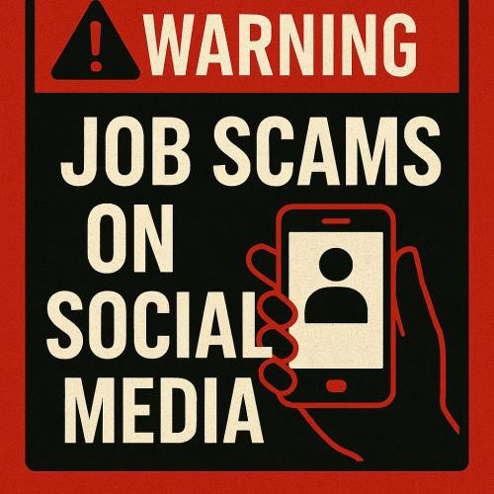
This is a payment-to-work scam. Genuine employers will never ask you to pay money to get paid.

If you have been a victim of any type of scam, then contact your Bank immediately, which you can do by calling 159 and reporting to Report Fraud at Reporting cyber crime and fraud or phishing attempts - Report Fraud or call 0300 123 2040.
Find out more by visiting our website at Advice about fraud | Kent Police and also from the Home Office at Stop! Think Fraud - How to stay safe from scams

