We are pleased to announce that cyber security talks are now available to book for the remainder of 2026.
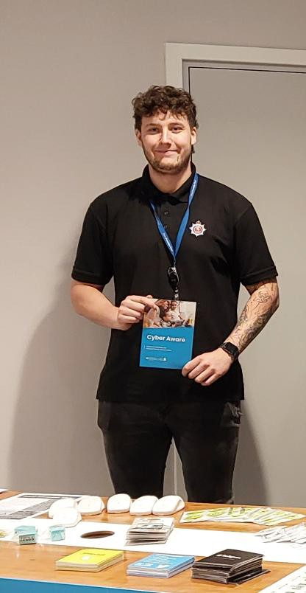
These free sessions are designed to help members of the public, community groups, and local organisations stay safe online and better understand the latest digital threats. I do not organise or create events myself. Instead, I am available to attend events that you organise — such as community meetings, school assemblies, group sessions, public engagement days, or similar gatherings — to deliver cyber safety presentations.
What the sessions cover:
- How to recognise scams and phishing attempts
- Protecting personal data and online accounts
- Safe browsing and social media practices
- Keeping devices secure
- Guidance for families, young people, and vulnerable individuals
- Q&A tailored to your group’s needs
Who can book?
- The talks are open to community groups, charities, schools, local businesses, and the general public.
How can I book?
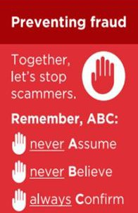
- Please email me, Arran Ostridge, at - 61736@kent.police.uk to get your Cyber presentation booked in now.
Find out more by visiting our website at Advice about fraud | Kent Police and from the Home Office at Stop! Think Fraud - How to stay safe from scams


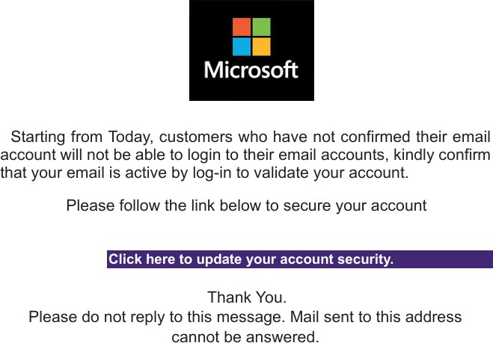
Fraudsters are sending emails claiming to be from Microsoft, warning that your email account will be suspended unless you "verify" or "validate" your account. These emails often use Microsoft logos and links to fake websites designed to steal your login details.
Warning Signs
- Generic messages that do not address you by name.
- Poor grammar or unusual wording.
- Urgent threats that your account will be suspended.
- Requests to click a link to "verify", "validate" or "secure" your account.
- No specific information about your account. How the Scam Works
The email directs you to a fake Microsoft sign-in page. If you enter your username and password, criminals can gain access to your email account and other online services.
Protect Yourself
- Do not click links in unexpected emails.
- Access your account by typing the official website address into your browser.
- Enable Two Factor Authentication (2FA).
Be wary of messages creating urgency or demanding immediate action.
If You Receive a Suspicious Email, forward it to report@phishing.gov.uk then delete it. Do not reply or click any links.
If You Have Already Clicked the Link -
- Change your password immediately.
- Enable 2FA if not already active.
- Check your account for suspicious activity. Remember
Microsoft will not ask you to verify your account through an unsolicited email link. If in doubt, go directly to the official Microsoft website.

Fraud Alert: Beware of "Lottery Winner Donation" Parcel Scams
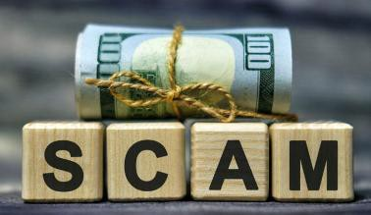
We have received a report of a scam in which a victim was contacted via social media by a person claiming to be a wealthy lottery winner who was donating money to selected individuals.
The victim was told that a parcel containing a large cash donation was being sent to them from overseas. Shortly afterwards, they were informed that the package had been stopped and that payment was required to release it through customs and tax processes.
The victim made payments towards alleged certificates, fees and gift cards. Additional demands for money were then made to secure the release of the parcel.
However, it was a SCAM.

Warning Signs
  - Unsolicited contact from strangers on social media.
  - Claims that a lottery winner, celebrity or wealthy individual wants to donate money to you.
  - Promises of large sums of cash with no legitimate reason.
  - Requests to pay fees, taxes, customs charges or certificates before receiving money.
  - Requests for payment via gift cards, bank transfers or other difficult-to-trace methods.
  - Pressure to make payments quickly to avoid losing the opportunity.

Protect Yourself
  - Be suspicious of anyone offering free money or large gifts.
  - Never send money to receive a prize, inheritance, donation or parcel.
  - Verify any unexpected claims independently.
  - Discuss unusual financial requests with family, friends or a trusted professional before making a payment.
  - Report suspicious messages on the social media platform where they were received.
If you have been a victim of any type of scam, then contact your Bank immediately, which you can do by calling 159 and reporting to Report Fraud at Reporting cyber crime and fraud or phishing attempts - Report Fraud or call 0300 123 2040. Find out more by visiting our website at Advice about fraud | Kent Police and from the Home Office at Stop! Think Fraud - How to stay safe from scams

FRAUD ALERT: THINK. ABC
Fraudsters are continuing to impersonate trusted organisations including HMRC, banks, Amazon, Sky, Royal Mail and parcel delivery companies to steal personal information, bank details and money. These scams commonly arrive by text message, email, phone call or social media.
Common Current Scams
- HMRC tax refund messages requesting you click a link to claim money.
- Bank impersonation scams claiming your account is at risk and asking you to move money.
- Amazon emails warning of suspicious account activity and directing you to a fake login page.
- Sky calls or emails offering discounts or account upgrades whilst requesting personal details.
- Parcel delivery and parking payment texts demanding small fees via fraudulent websites.
Protect Yourself – Remember ABC
A - Never assume a message, call or email is genuine simply because it appears to come from a trusted organisation.
B – Never believe claims that create urgency, fear or excitement, such as refunds, account problems, special offers or security threats.
C – Always confirm requests independently by contacting the organisation using trusted contact details that you have obtained yourself.
Stay Safe
- Do not click links in unexpected messages.
- Do not provide passwords, PINs or one-time passcodes.
- Do not transfer money because someone claims your account is at risk.
- If in doubt, talk to someone you trust before acting or ring your bank on 159.
- Report suspicious texts to 7726 and suspicious emails to report@phishing.gov.uk


Kent Fraud Alert System
FRAUD ALERT – INVESTMENT SCAMS
Investment scams are among the most financially damaging frauds in the UK, with victims often losing thousands of pounds and, in some cases, their life savings.

Common Investment Scams
- Cryptocurrency Scams - Fraudsters promise high returns from Bitcoin or other cryptocurrency investments.
- Fake Trading Platforms - Victims see false profits online and are persuaded to invest increasing amounts of money.
- Celebrity Endorsement Scams - Fake articles and adverts use well-known names to promote bogus investments.
- Recovery Scams - Criminals target previous victims, claiming they can recover lost money for an upfront fee.

Warning Signs
- Guaranteed profits.
- Little or no risk.
- Pressure to act quickly.
- Unsolicited calls, texts or social media messages.
- Requests to keep the opportunity confidential.
- Problems withdrawing your money.

Protect Yourself – Remember ABC
- Never Assume a professional website, advert or social media profile does not mean an investment is genuine.
- Never Believe promises of guaranteed returns or exclusive opportunities.
- Always Confirm before investing, check the company is authorised by the Financial Conduct Authority (FCA): https://register.fca.org.uk Never rely on contact details provided by the company. Use the FCA Register to find genuine contact information and verify who you are dealing with.

Stay Safe and Always
- Research before investing.
- Talk to someone you trust and/or seek independent financial advice.
- Be wary of unexpected investment opportunities.
- Take your time and never be pressured into making a decision.

Warning issued to solar panel owners following arrests for fraud

Detectives investigating reports of solar panel fraud around the country have arrested four people in Whitstable and Herne Bay.
The arrests follow reports that between 2023 and 2026, elderly people were cold-called and deceived into paying for unnecessary solar panel upgrades which were not carried out. In some cases, victims alleged that they were also not refunded their payments when requested.
Officers arrested a 36 year old man from Whitstable and a 39 year old man from Herne Bay on Tuesday 14 July 2026. A 37 year old woman from Whitstable was arrested on 9 July, and a 65 year old man was arrested last year.
All were arrested on suspicion of fraud and money laundering offences and have been released pending further enquiries. A further non-custodial interview was carried out with a man suspected of being involved in fraudulent activity.
As part of the investigation, four warrants have been executed at properties in Whitstable, Herne Bay and Cambridgeshire.
Residents with solar panels installed on their homes are being reminded to be wary when approached by cold callers.
Detective Constable Darren Ousby said:
‘Be cautious if you are contacted out of the blue by someone offering grants, upgrades or repairs on your solar panels, either at the door or by phone, letter or email. ‘Do not feel pressured into paying for a deal quickly. Legitimate companies will give you time to review the offer rather than insisting you accept it immediately. If an offer sounds too good to be true, it usually is.‘In most cases, the victims are elderly, so if you have
elderly relatives, friends or neighbours, take time to speak to them and ensure they are aware of the risk of fraud and what to do if they are approached. ‘If anything seems suspicious and you believe it might be a
scam, report it to police immediately.’
If you have been a victim of any type of scam, then contact your Bank immediately, which you can do by calling 159 and reporting to Report Fraud at Reporting cyber crime and fraud or phishing attempts - Report Fraud or call 0300 123 2040.
Find out more by visiting our website at Advice about fraud | Kent Police and from the Home Office at Stop! Think Fraud - How to stay safe from scams

