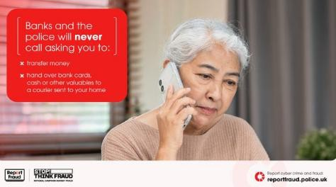
We have received a lot of reports this week of criminals contacting Kent residents whilst impersonating bank staff.
Residents are being told:
- Their bank account has been compromised.
- Fraudulent transactions have been detected on their account.
- Their bank card needs replacing.
- Their money is at risk and must be moved to a "safe account".
- They need to withdraw cash to assist with an investigation.
- A courier will attend to collect bank cards, cash, valuables or gold.
- Or even to withdraw their money at ATM’s or over the counter and post it to a safe address given to them by the criminal.
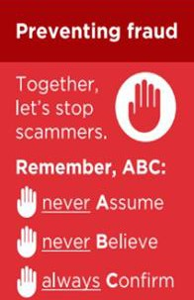
If you receive a call like this, then remember our ABC of fraud awareness and Never Assume or Believe and Always Confirm.
- If you receive an unexpected call from someone claiming to be the Police, your bank or any other organisation, take their details and end the call.
- If possible, use a different phone to call the organisation back using a trusted number.
- If you only have one phone, wait at least 5 minutes before making another call.
- Before calling back, ring a family member or friend to ensure the line has been disconnected.
- If you wish to verify a caller claiming to be a bank official, call 159.
- Never call a number provided by the caller.
- Never dial 159 whilst still on the call with the suspected fraudster.
- Always disconnect the original call before calling 101 or any other trusted number.
If you have been a victim of any type of scam, then contact your Bank immediately, which you can do by calling 159 and reporting to Report Fraud at
Reporting cyber crime and fraud or phishing attempts - Report Fraud or call 0300 123 2040.
Find out more by visiting our website at Advice about fraud | Kent Police and from the Home Office at Stop! Think Fraud - How to stay safe from scams

Kent Police is warning residents about a rise in convincing investment scams. Criminals are using fake investment platforms, cloned financial firms, and AI-generated videos of celebrities and well-known business figures to persuade people to invest their savings. These scams are often promoted through social media, online adverts, email, text messages, and WhatsApp.
Victims may initially see what appear to be genuine profits and account growth, encouraging them to invest more money. However, when they attempt to withdraw funds, they are often told to pay additional fees or discover that the investment never existed.

Warning Signs
  - Promises of guaranteed or unusually high returns.
  - Pressure to act quickly or risk missing out.
  - Contact through social media, WhatsApp, or unexpected phone calls.
  - Celebrity endorsements or success stories that cannot be independently verified.
  - Firms claiming FCA authorisation but providing different contact details from those listed on the FCA Register - Financial Services Register | FCA

Protect Yourself – Remember the ABC Message
- Never assume an investment opportunity is genuine because it looks professional, appears on social media, comes recommended online, or features a celebrity endorsement. Criminals can create convincing websites, adverts and videos.
- Never believe claims of guaranteed returns, low-risk investments, or exclusive opportunities available for a limited time. Genuine investments carry risk and reputable firms will not pressure you into making immediate decisions.
- Always check the firm's details on the FCA Register, verify contact details independently, and speak to a trusted friend or family member before transferring money or sharing financial information.
- Best advice, always seek advice from an independent financial advisor like your Bank.
If you have been a victim of any type of scam, then contact your Bank immediately, which you can do by calling 159 and reporting to Report Fraud at Reporting cyber crime and fraud or phishing attempts - Report Fraud or call 0300 123 2040.
Find out more by visiting our website at Advice about fraud | Kent Police and from the Home Office at Stop! Think Fraud - How to stay safe from scams

Kent Police is warning residents about an increase in smishing scams, where criminals send fraudulent text messages designed to steal personal, financial, or banking information. Criminals often impersonate trusted organisations and create a sense of urgency to encourage victims to click malicious
links.
Some of The Current Smishing Trends
- Parcel Delivery Scams Texts claiming a delivery from Royal Mail, Evri, DPD or Amazon has failed and requesting a small payment for redelivery or customs fees. The link directs victims to a fake website designed to steal personal and payment information.
- HMRC Tax Refund Scams Messages claiming you are owed a tax rebate or need to settle a tax issue. Victims are directed to fake websites where personal and banking details are harvested. HMRC warns it will never ask for personal or financial information via text message.
- DVLA Scams Texts claiming your driving licence needs renewing, updating, or verification to avoid fines or suspension. Victims are directed to convincing fake GOV.UK-style websites.
- Bank Impersonation Scams Messages claiming a new payee has been added, a suspicious payment has been detected, or an account has been locked. The aim is to steal online banking credentials.
- "Hi Mum/Hi Dad" Scams A text claiming to be from a son or daughter using a new phone number and urgently needing money. Victims are often pressured into making immediate bank transfers.
Criminals Commonly:
  - Create urgency and panic.
  - Spoof (copy) trusted organisation names.
  - Include links to fake websites.
  - Request personal, banking or card details.
  - Follow up texts with phone calls to add credibility. Protect yourself –
- Never click links in unexpected text messages.
- Never use contact details provided in the message.
- Always go directly to the official website or app and conform if unsure.
- Forward suspicious texts to 7726.

STOP and THINK ABC - Never Assume. Never Believe. Always Confirm.

Kent Police Fraud Alert: Be Careful When Searching for Customer Service Numbers
Virgin Media and O2 are warning customers to stay alert after reports that fraudsters are using AI tools and search engines to trick people into calling fake customer service numbers.
Criminals are creating fake websites, phone numbers and search results that appear to belong to trusted companies. When people call these numbers, fraudsters may try to steal personal information, banking details or obtain remote access to devices.
Protect Yourself -
- Always get contact numbers from the company's official website, app, bill or correspondence.
- Be cautious of phone numbers provided by search engines or AI tools.
- Never assume the first search result is genuine.
- Double-check website addresses before calling any number.
- Never give out passwords, PINs, one-time passcodes or online banking details over the phone.
- If something does not feel right, hang up and contact the company using a trusted number.

Remember -
Fraudsters are becoming increasingly sophisticated and are now exploiting AI-powered tools to make scams appear more convincing.

Stop. Think. Check.
Always verify customer service contact details before making a call.
If you have been a victim of any type of scam, then contact your Bank immediately, which you can do by calling 159 and reporting to Report Fraud at Reporting cyber crime and fraud or phishing attempts - Report Fraud or call 0300 123 2040.
Find out more by visiting our website at Advice about fraud | Kent Police and from the Home Office at Stop! Think Fraud - How to stay safe from scams



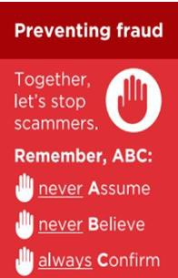
Kent Fraud Alert System

Report Fraud Alert: “Hi Mum / Hi Dad” Text Scam Returns
Report Fraud is urging people to be vigilant after reports of a variation of the well-known “Hi Mum / Hi Dad” impersonation scam.
Fraudsters are now exploiting the current hot weather by sending messages such as:
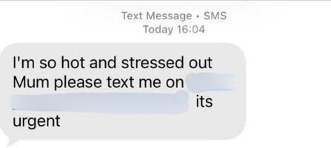
The scammer pretends to be a son or daughter whose phone has supposedly been lost, damaged or replaced, with the aim of building trust before requesting money.
What To Do -
- Do not reply to the message.
- Contact your loved one using their usual number to verify they are safe and that the message is genuine.
- Forward suspicious text messages to 7726 (the free spam-reporting service). Remember -
Criminals often use current events, weather conditions and other topical issues to make scams appear more believable. If a message asks you to contact a new number unexpectedly, always verify it independently before responding.
If you have been a victim of any type of scam, then contact your Bank immediately, which you can do by calling 159 and reporting to Report Fraud at Reporting cyber crime and fraud or phishing attempts - Report Fraud or call 0300 123 2040.
Find out more by visiting our website at Advice about fraud | Kent Police and from the Home Office at Stop! Think Fraud - How to stay safe from scams

